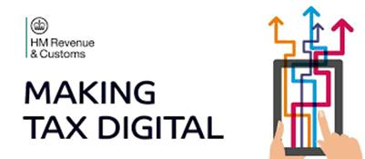
No. 17
May 2021

Update for Agents

Dear Agent
Welcome to edition number 17 of our Making Tax Digital (MTD) Update for Agents.

Please send any suggestions for topics you would like us to cover in future editions of this update to our mailbox at:
makingtaxdigital.mailbox@hmrc.gov.uk
This is also the email address to use to be added or removed from the distribution list.

Contents

- MTD for Income Tax Self Assessment (ITSA) – some coming changes.
- Agent Services Account – change to Home page.
- Agent Services Account – change Manage Account page.
- Agent viewer – a new service coming for MTD ITSA.
- Changes to contact details.
- Agent journey to sign clients up for MTD ITSA.
- Eligibility for MTD ITSA pilot.
- Useful Links.

- MTD for Income Tax Self Assessment (ITSA) – some coming changes.

Making Tax Digital for Income Tax Self Assessment
Making Tax Digital (MTD) for Income Tax Self Assessment is being piloted right now and the MTD Programme continues to make changes, based on user feedback, to further improve our digital services for agents.
Here are a couple that are coming that we would like to tell you about: -

- New clients – asking for authorisation & sign up your client to MTD for Income Tax Self Assessment (delivery Summer 21)
Agents will be able to use their Agent Services Account (ASA) to ask for a client authorisation for MTD for Income Tax before signing up the client. This wasn’t possible for MTD VAT, but we have acted on your feedback.
This will make it easier for agents who have new clients needing authorisation for MTD ITSA. Agents will be able to use their ASA to complete the authorisation and then proceed to signing up the client to MTD without delay.
If agents also need authorisation for the existing Self Assessment service, they can still use the Self Assessment for Agents online service and copy the relationship across to MTD using their ASA.

- Agent Services Account – we are making it easier for clients with a SA UTR to accept an agent authorisation request online for MTD Income Tax (delivery Summer 21)
We are removing the need for clients to be registered for Self Assessment online services before they can access the MTD ITSA authorisation request online and accept it. Clients will be able to use their Gateway ID they use for their Personal Tax Account.
For clients who don’t normally engage online with HMRC, we are changing the service to allow them to create a new Gateway ID and complete Identity Verification to enable them to accept the agent authorisation request. The new Gateway ID will allow those clients access to their Personal Tax Account, should they want to.

2. Agent Services Account (ASA) – change to Home page.

We have had a busy and productive period recently with several changes and improvements to the Agent Services Account coming along in April, May and June 2021.
There is a change on the Home page based on User Research to improve clarity as to what the ASA is used for, and what it is not used for.
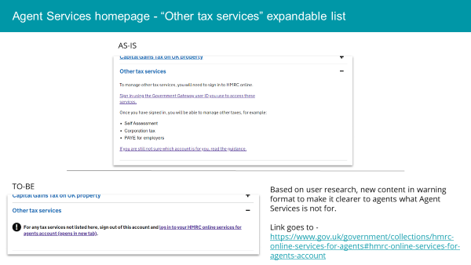

3. Agent Services Account – change to Manage Account page.

We have also completed a piece of work to add a new section in the Manage Account service in response to agent feedback. Here Agents will be able to view the details they used during subscription to their ASA.
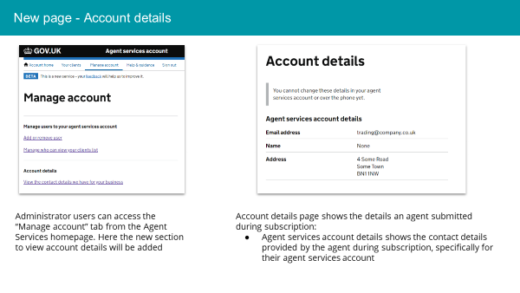

4. Agent viewer

In response to agent feedback we have developed the content on the Agent viewer within the ASA with regards to clients’ Income Tax details.
This is a new service and is available to Agents who have clients who have signed up to MTD ITSA. This will enable agents to view their ITSA clients’ tax calculation, obligations and payments.
When you start signing up your clients to MTD ITSA you will be able to use the new MTD Income Tax services we are building to enable you to manage your client’s tax account online. Attached is the first version of the account, we will continue to improve the design and add more services.
Agents who take part in the MTD ITSA pilot will be able to use this new service.
We hope this will be beneficial for agents.

5. Changes to contact details

We have also made improvements to the wording on these pages as User Research highlighted that some of the terms used could be confusing.
The attached PDF document shows the changes made and the background for them.
Again, we hope these changes are helpful to agents.

6. Agent journey to sign clients up for MTD ITSA

The attached PDF document shows the agent journey to sign up clients to MTD for Income Tax Self Assessment.

Improvements and simplifications have been made following feedback from agents.

7. Eligibility for MTD ITSA Pilot

We are running a pilot for MTD ITSA to work with software developers, agents and their clients to test the service and help identify and resolve any issues ahead of mandation in April 2023.
We are always happy to have more people join the pilot!
As a reminder of the eligibility to join the pilot, in addition to having digital records and compatible software, please look at the pages on GOV.UK.

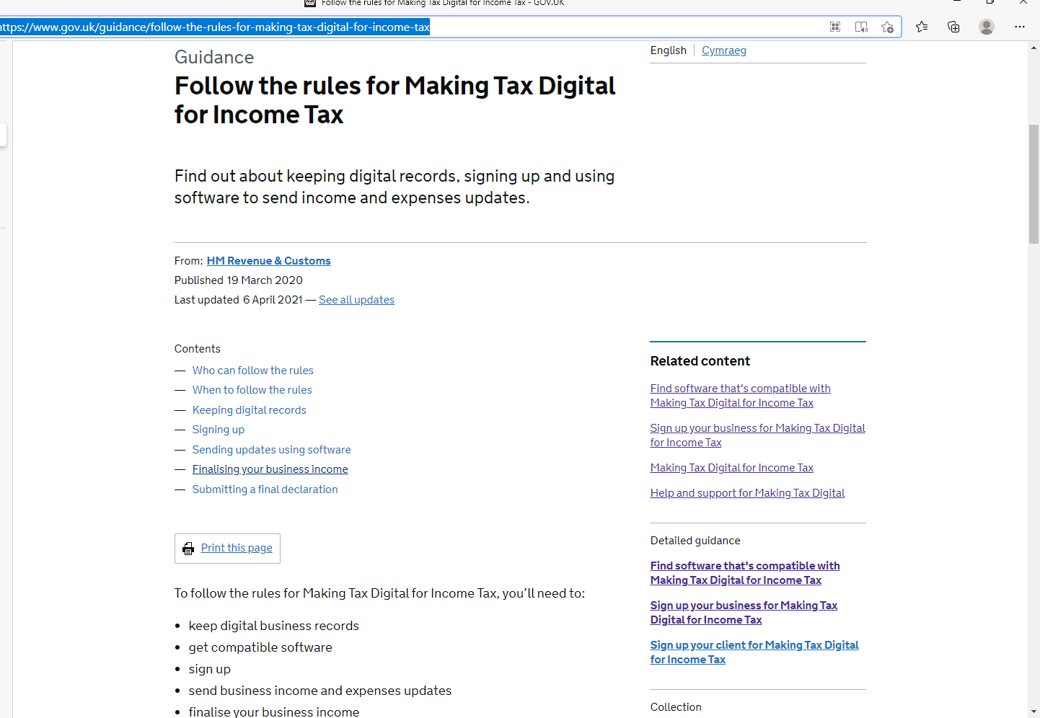
Follow the rules for Making Tax Digital for Income Tax - GOV.UK (www.gov.uk)

8. Useful Links
Help and support for Making Tax Digital
HMRC service availability and issues page on GOV.UK.

Sign in to your agent services account

Making Tax Digital for Corporation Tax

Consultations Making Tax Digital for Corporation Tax

Sign Your Client Up for Making Tax Digital ITSA

Follow the Rules for Making Tax Digital ITSA

Find Software that is Compatible with Making Tax Digital ITSA

Making Tax Digital for VAT

Making Tax Digital for VAT as an agent: step by step

Check when a business must follow the rules for Making Tax Digital for VAT

Sign up your client for Making Tax Digital for VAT

Keep digital records for Making Tax Digital for VAT

Sign your business up for Making Tax Digital for VAT

Making Tax Digital for VAT: service availability and issues

Follow the rules for Making Tax Digital for Income Tax - GOV.UK (www.gov.uk)

