
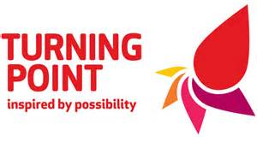
Project Budget Sheet
Innovation Fund
Project Budget
How much will your project cost and how much would you like from us?
Item or Activity | A. Total Cost | B. Amount requested from us
Total: | £ | £

Are the total costs more than the amount that you would like from us?
Yes No
If yes, where will you get the other funding from and have you secured it yet?

How have you worked out your costs? (Max 200 Words)

How will you meet the running costs of your project after the period to be funded by the grant has expired?

Please upload this to your Application form

