

FUNCTIONAL SKILLS

Maths Level 2

Area: Measures, shapes and space
Criterion: 19. Use coordinates in 2-D, positive and negative, to specify the positions of points

Reading and writing coordinates

The coordinate plan is made up of 2 crossing lines:
- the x-axis is the horizontal line
- the y-axis is the vertical line.

They meet in the middle, which is called the point of origin.

The axes contain both positive and negative numbers.

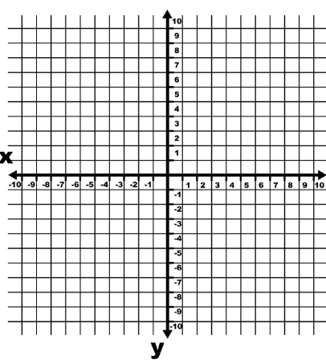
Y axis
X axis
Point of origin

Any given point on the grid can be identified by a pair of coordinates, written as (x,y).

The x-coordinate always comes before the y-coordinate.

The origin coordinates are (0,0).
Here are 4 steps to follow when reading and writing coordinates.

- Step 1: start at the origin
- Step 2: move along the X axis
- Step 3: move along the Y axis
- Step 4: record the coordinates (X,Y).

Top tip: Remember to ‘move along the corridor and take the stairs’.

For example:
Identify the coordinates of the square on the grid below.
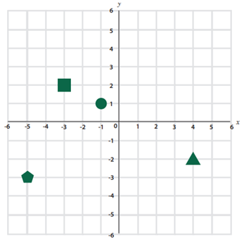
You can use a ruler and pencil to identify the coordinates on each axis.
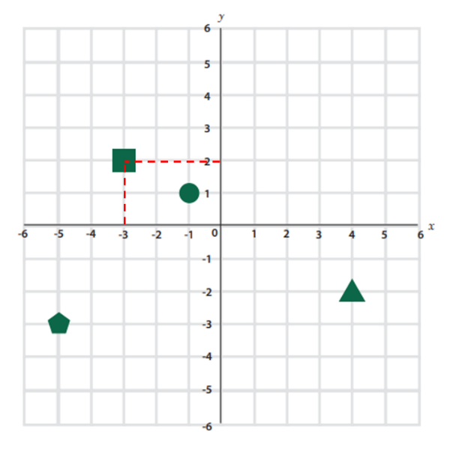

Step 1: start at the origin (0,0)

Step 2: move along the X axis
X = -3

Step 3: move along the Y axis
Y = 2

Step 4: record the coordinates (X,Y)
Answer = (-3,2)

Question 1

On the grid below, identify the coordinates of the triangle.

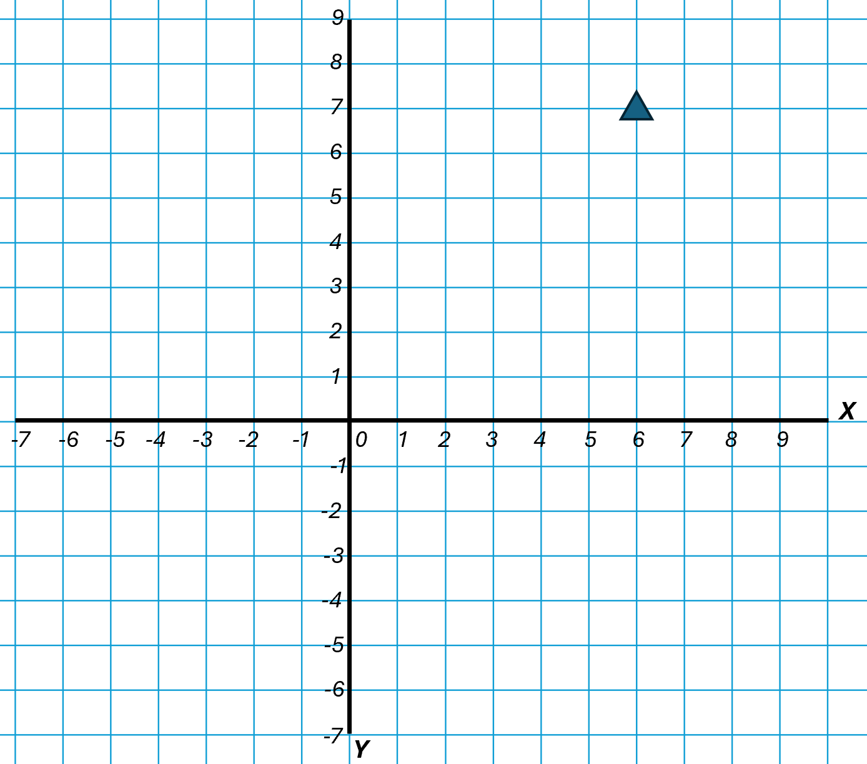

(1 mark)

Question 2

On the grid below, identify the coordinates of point ‘Z’.

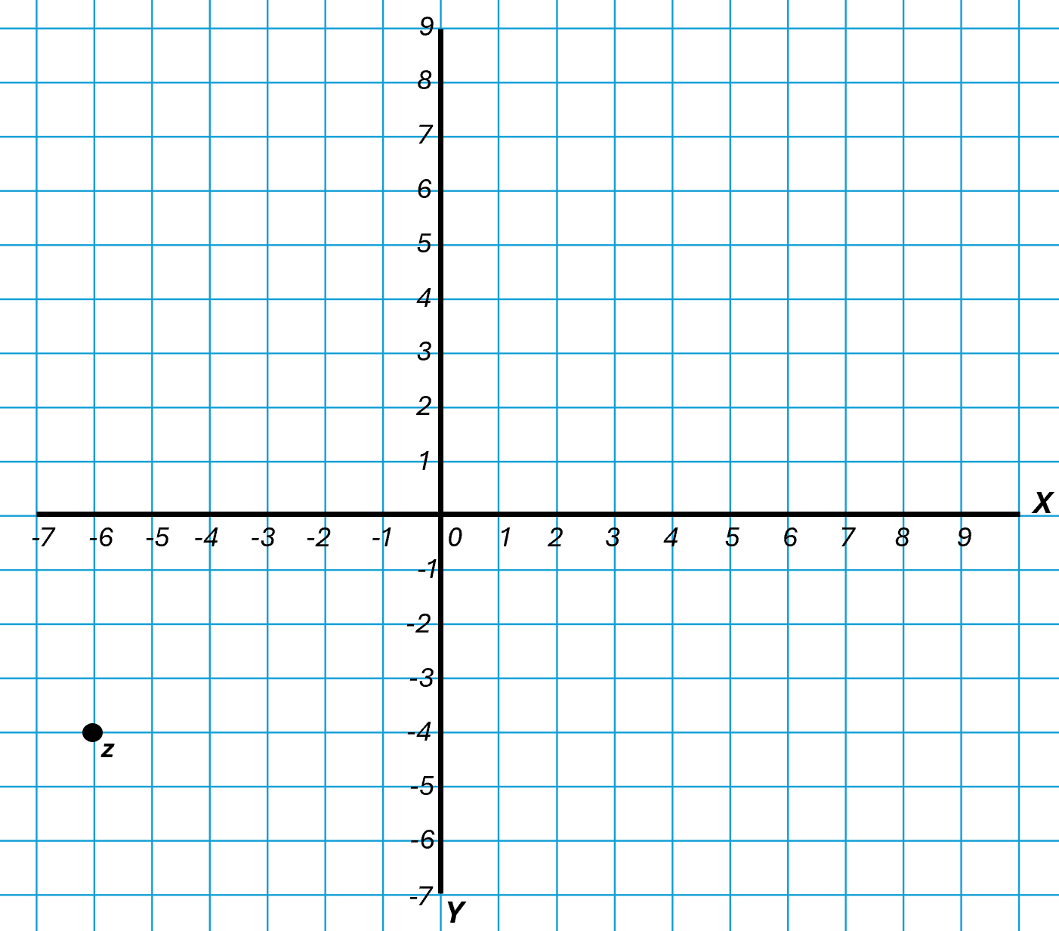

(1 mark)

Question 3

On the grid below, identify the coordinates of point ‘X’.

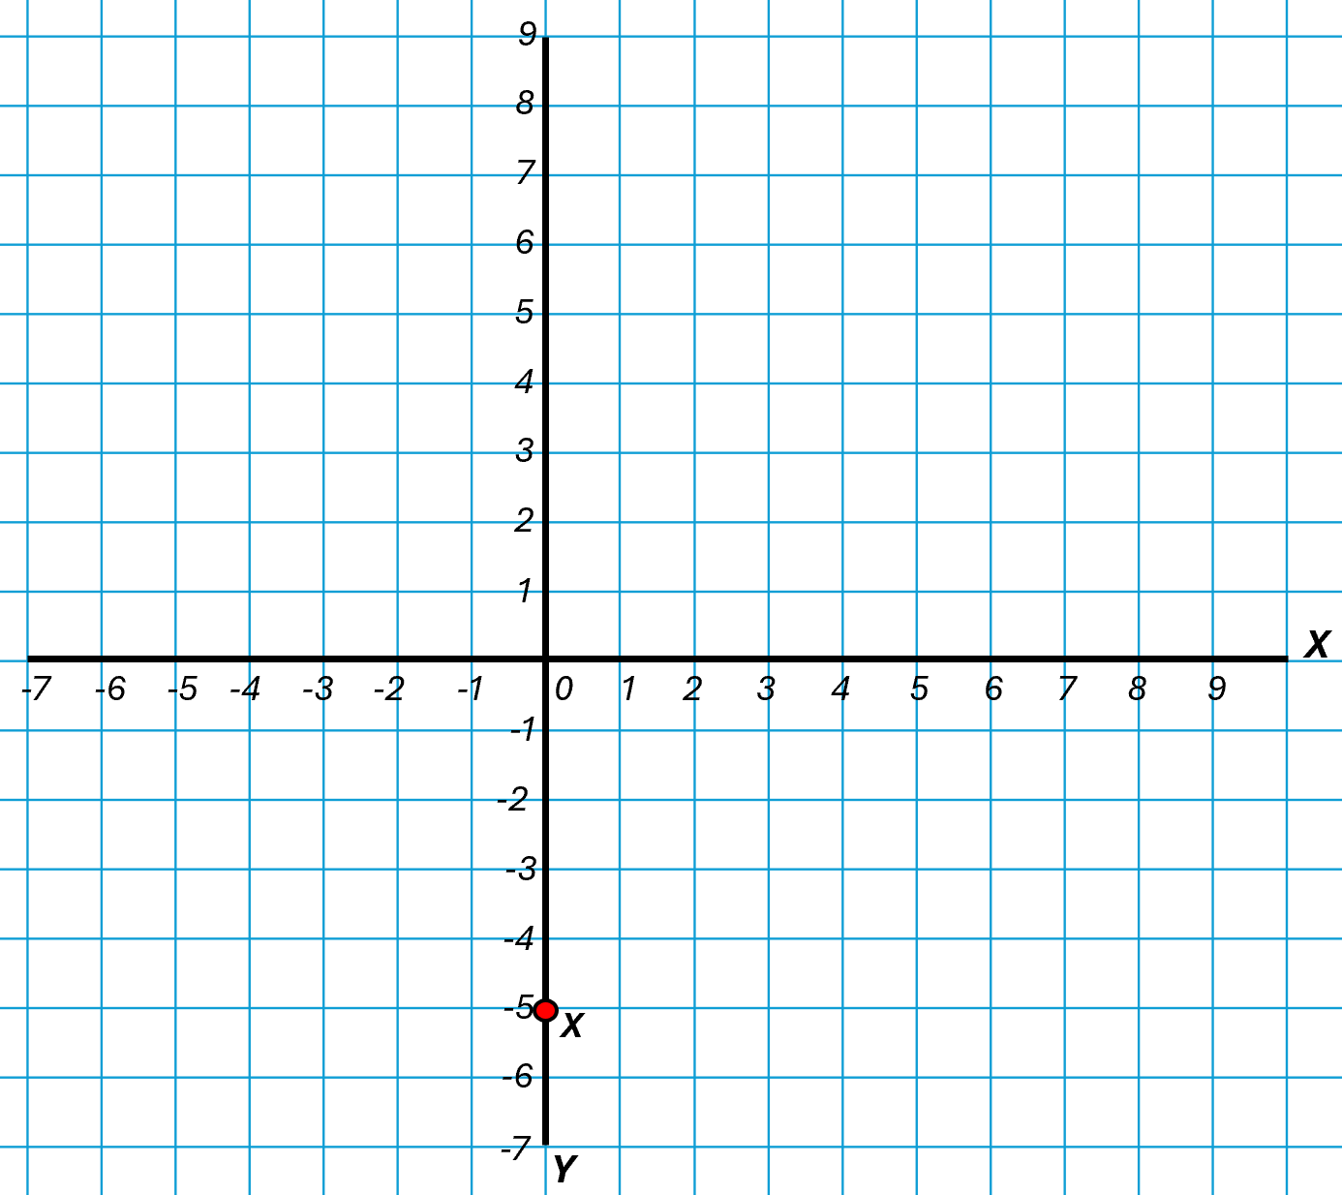

(1 mark)

Question 4

On the grid below, identify the coordinates of the:
- square
- circle
- hexagon

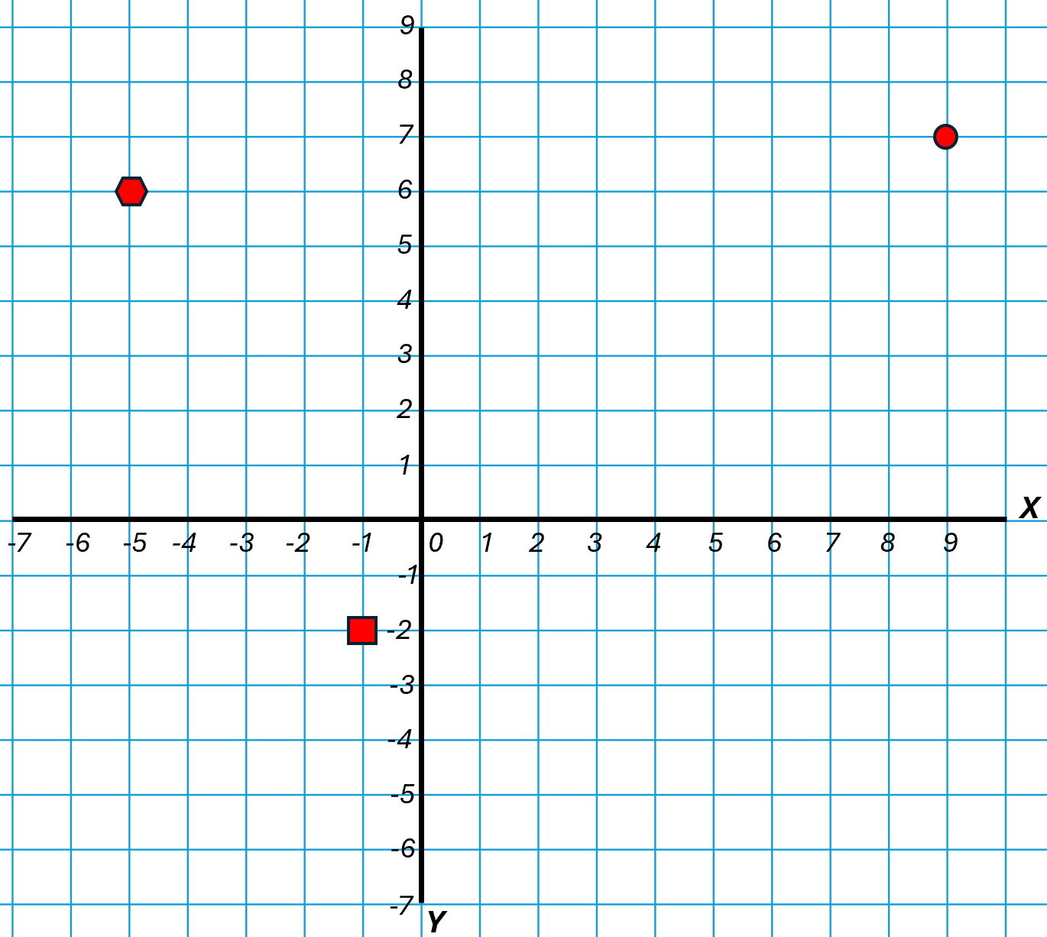

(3 marks)

Square:

Circle:

Hexagon:

Plotting coordinates

We also need to understand how to plot points. Let's look at an example.

The grid below shows 3 corners of a rectangle.

Identify and plot the coordinates of the 4th corner.

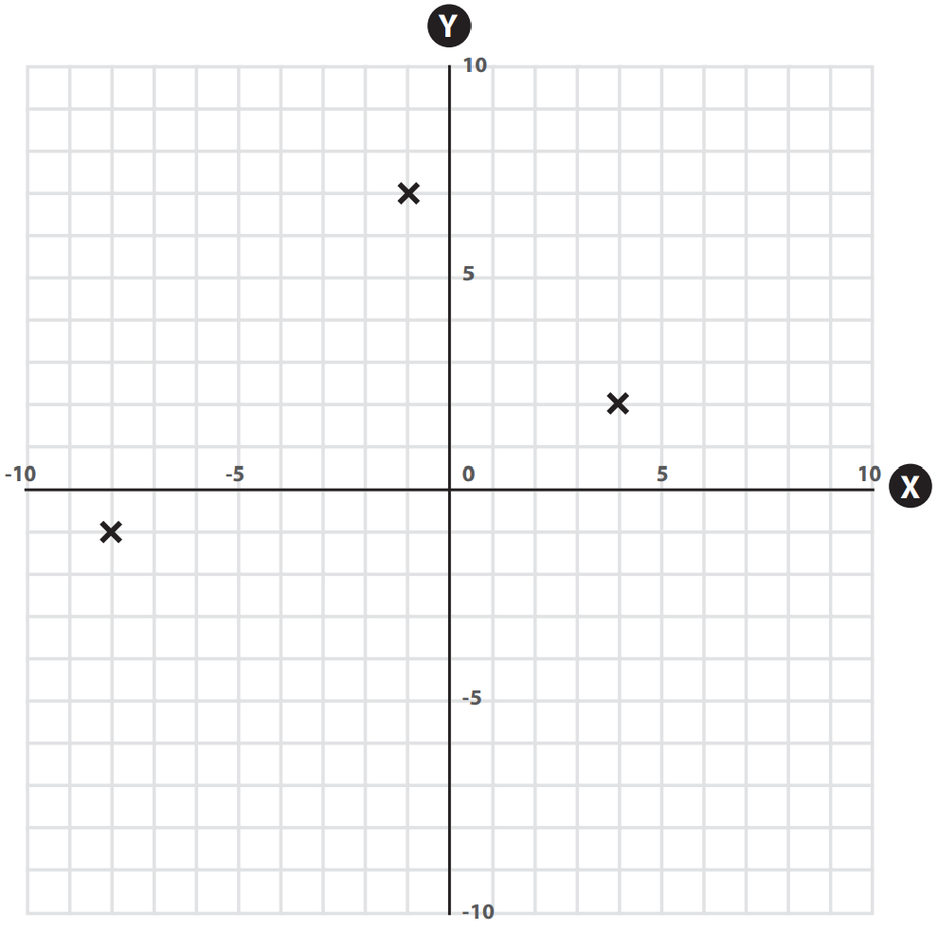

First, let’s use a ruler to join up the points of the rectangle we have already been given.

This will help us understand where the final point needs plotting.

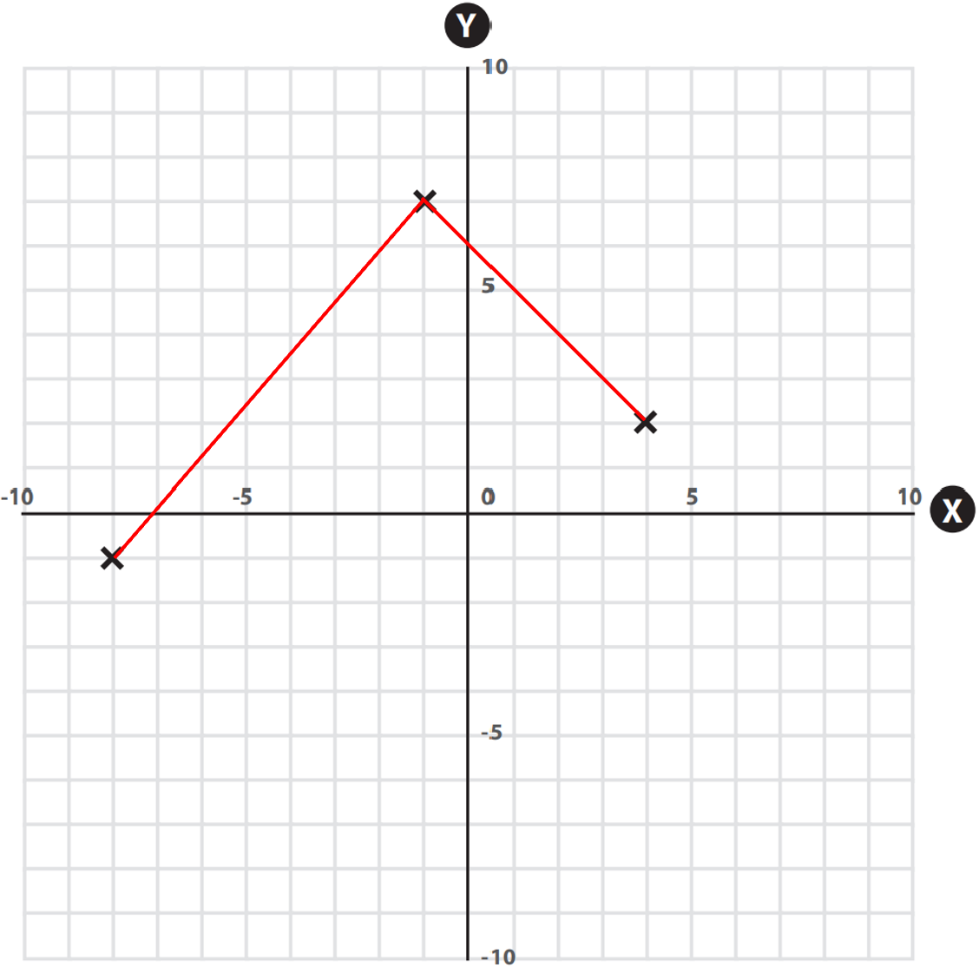

We can then make sure the fourth point is plotted the correct distance.

The fourth point is plotted the same distance away from the line parallel to it.

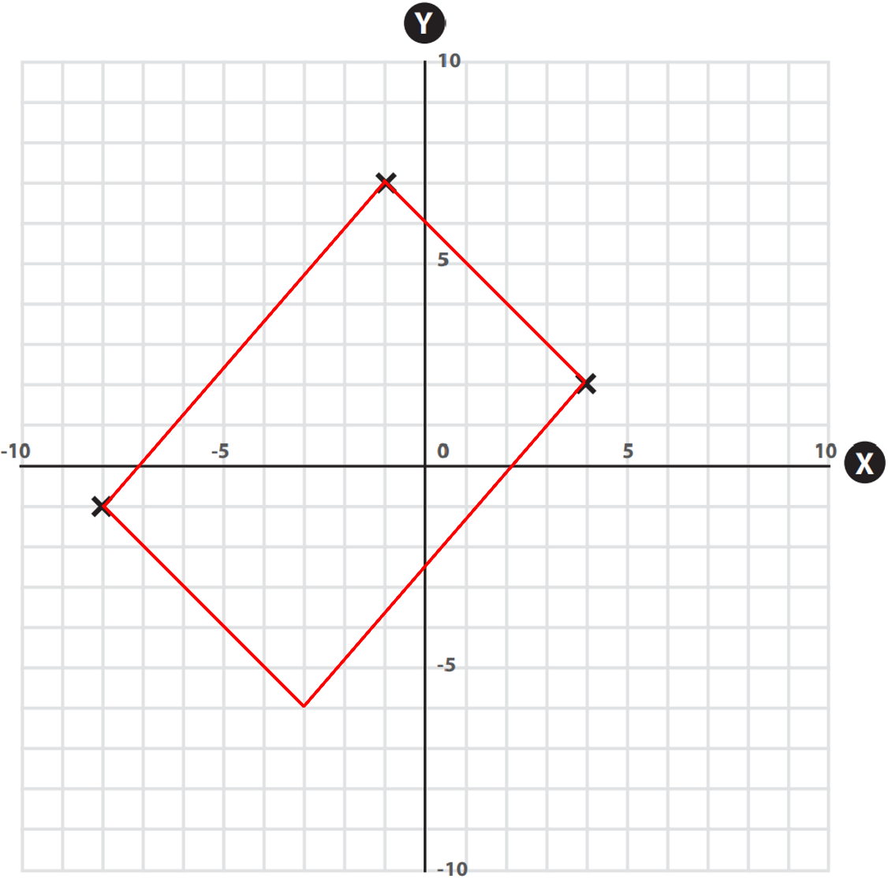

This shows us where the fourth coordinate should be plotted.

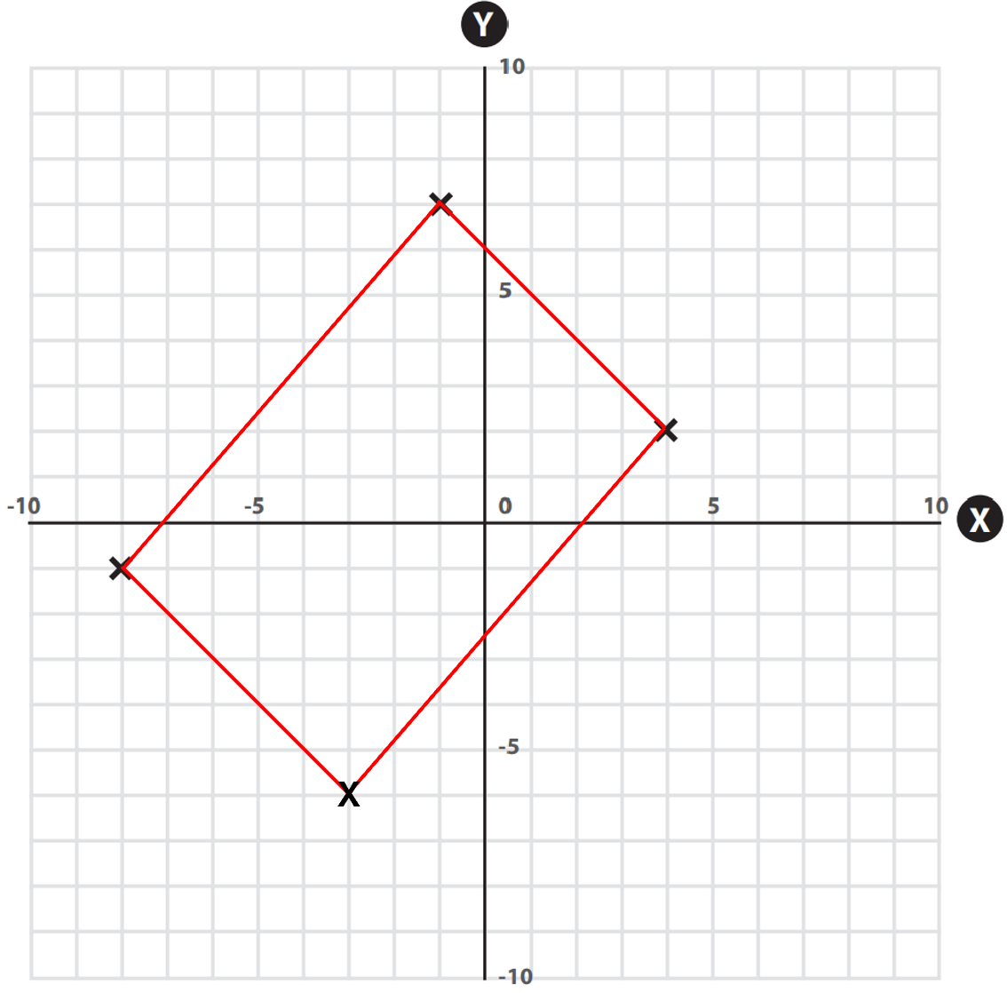

The rectangle has been drawn using the red lines, and the 4th corner has been marked with an ‘X’.

We can now read the X and Y axes and write down the coordinates of the fourth point:

Answer = (-3,-6)

Question 5

On the grid below are 3 corners of a square.

Identify and plot the coordinates of the fourth corner.

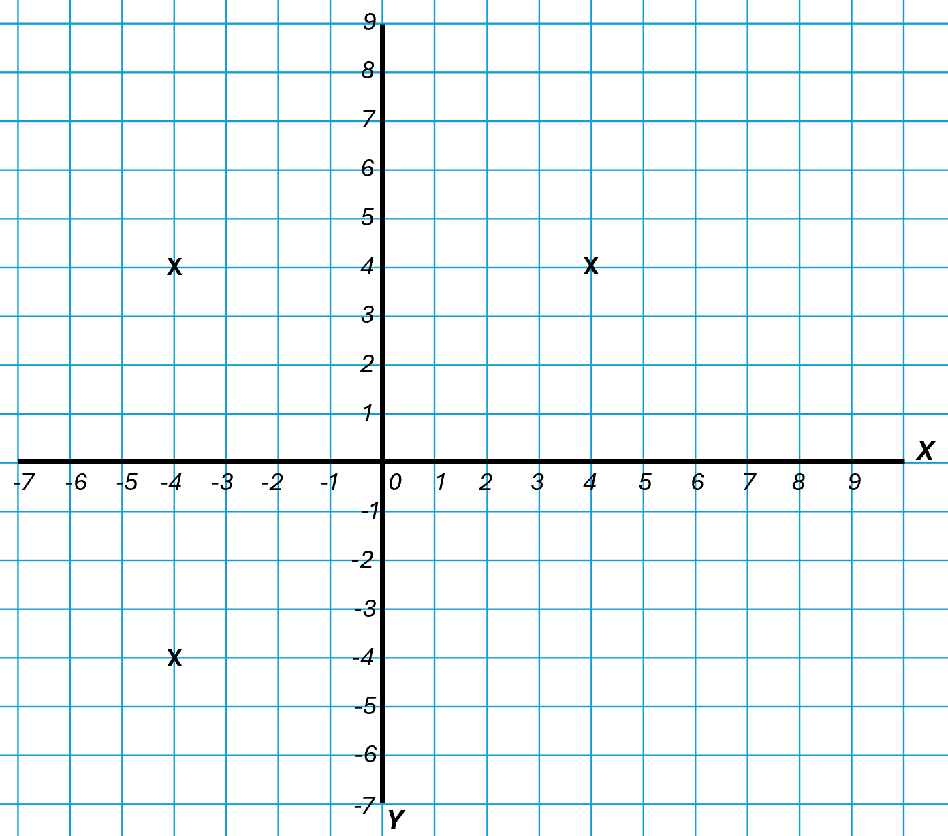
(2 marks)

Question 6

On the grid below are 3 corners of a square.

Identify and plot the coordinates of the fourth corner.

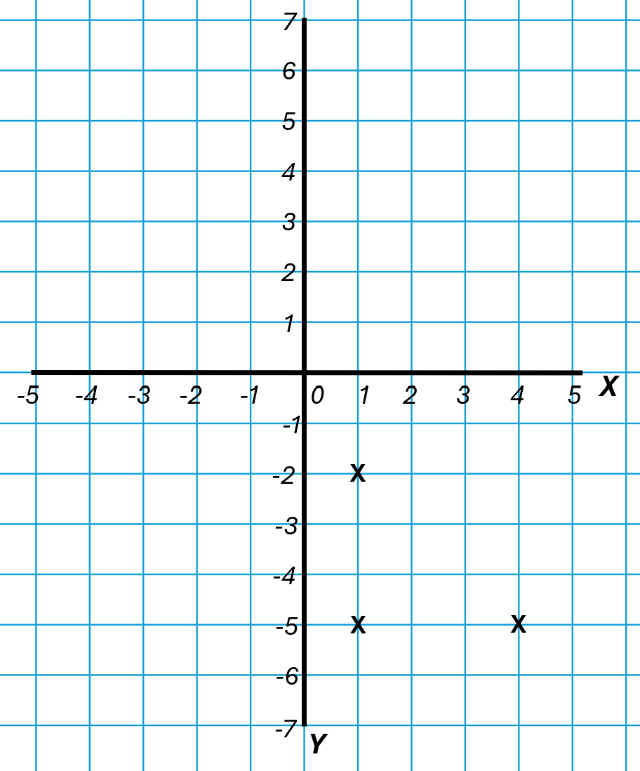
(2 marks)

Question 7

The grid below shows a hexagon.

Identify and plot the coordinates of the final corner.

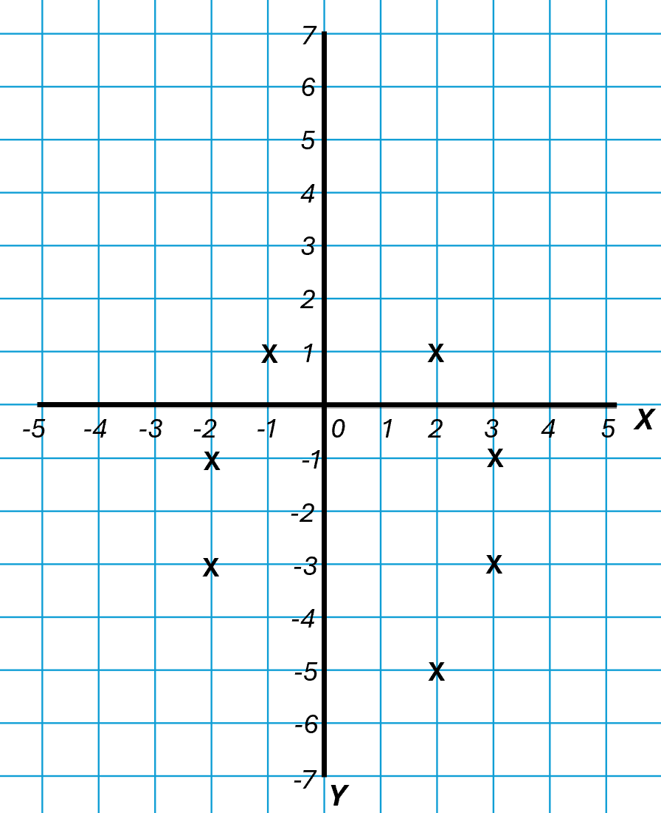
(2 marks)

Question 8

The grid below shows a rectangle.

Identify and plot the coordinates of the final corner.

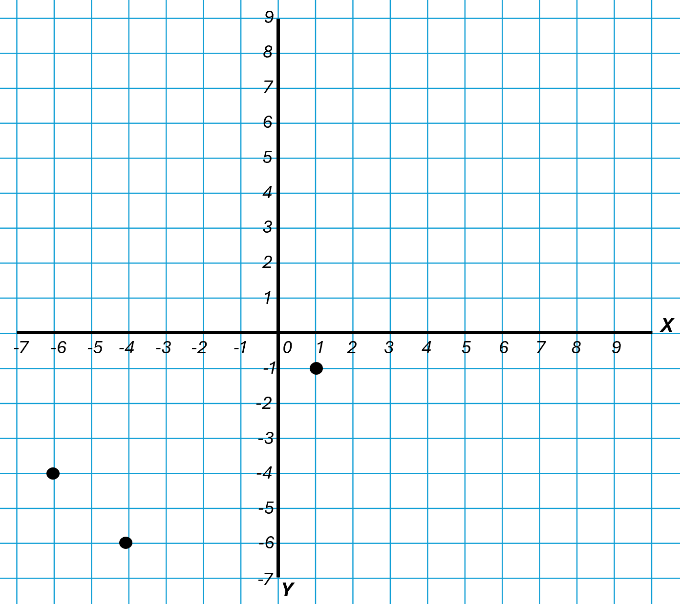
(2 marks)

Answers

Reading and writing coordinates

Question 1
(6,7)

Question 2
(-6,-4)

Question 3
(0,-5)

Question 4
Square: (-1,-2)
Circle: (9,7)
Hexagon: (-5,6)

Plotting coordinates

Question 5
(4,-4)

Question 6
(4,-2)

Question 7
(-1,-5)

Question 8
(-1,1)

Your functional skills exam

Your functional skills exams will consist of 2 papers.
These papers will take place over the following time periods:

- Non-calculator paper – 40 minutes
- Calculator – 1 hour 50 minutes

Further information on the format that your test will take can be obtained from your training provider.

Hints and tips

- Find out what format your exam will be in. It may be paper-based
or on-screen.
- Plan what you are going to revise in advance. Don’t leave it until the last minute.
- Do as many past papers as you can so you are prepared for the day. If possible, try to complete the past papers following the same format as the actual exam.
- Find a quiet place to study and revise. It helps to sit at a table or a desk, don’t revise in bed.
- Don’t stay up all night revising the night before your exam. It’s important to have a good rest so you feel refreshed and ready to go.
- Read the question 3 times. The first time to ensure you understand what is being asked, the second time to get an understanding of what you need to do, and a third time to figure out exactly what maths techniques you should be applying.
- If you are struggling with a question, skip it and come back to it later. Try not to sit getting worked up about a difficult question, it will only waste exam time. Move on and come back to it after you have answered the other questions.
- Take note of the number of marks available. This will give you an indication of how much working out you must show. For example, 1 mark will need an answer only and more marks will need you to show your working out.
- When you’ve finished the exam, go back and check your answers. If you still have time remaining, use it to check your answers and when you have checked your answers check them again.

