

FUNCTIONAL SKILLS

English Level 2

Area: Reading
Criterion: 16. Understand organisational features and use them to locate relevant information in a range of straightforward and complex sources

Organisational features

Organisational features are used in a text to present essential information to the reader in a straightforward manner. They help the reader to find information more easily.
Organisational features include:
- titles/headings
- straplines
- subheadings
- bullet points
- numbered lists
- columns
- paragraphs
Organisational features are more commonly found in non-fiction texts. Their purpose is to break up bigger sections of text and make the text easier to read.
Below is an example of a question on identifying organisational features.
Identify two organisational features used by the writer in Text A.
What information does one of these features help the reader to find?
(3 marks)

Organisational features summary
This table outlines some of the most common organisational features a writer might use and why they might use them.

Organisational features | Purpose | Example
Title/heading | The title or heading tells the reader what the text is about. | How to make pancakes
Straplines | Straplines are usually found in articles and adverts. They give additional information as to what the text is about, as well as setting the tone. | ‘Because you’re worth it’
Bullet points | Bullet points are an excellent way to break up information, making it more manageable for the reader. | You will need:  - eggs  - flour  - milk
Subheadings | Subheadings help to separate a text into logical parts and make specific information easier to find. | Introduction  The start of this text…
Tables | Tables help to display data clearly for the reader.
  Age range | 18-25​ | 26-30​ | 31+​
  Amount | 122​ | 856​ | 15​
Text boxes | Text boxes allow specific chunks of information to stand out. They are often used to help highlight an opinion or important information. | “It’s absolutely ridiculous”
Footnotes | Footnotes support a reader’s understanding of text-specific vocabulary or provide important information. | *Main = The most important or biggest.
Numbered lists | Numbered lists allow information or processes to be displayed in a clear order. They are commonly used in instructional leaflets or reports. | Here’s what you need to do:  - Mix the egg and flour  - Add the milk  - Pour the batter in the pan
Photo captions | Photo captions help to give more context to an image used in a text. This can help the reader gain a wider understanding of the text as a whole. |   Man (above) cuddles cat.

Example question

Let’s look at some of the organisational features that have been used in the following text. This will help us answer the first part of the exam question, which asks learners to identify organisational features.

Text A
Title

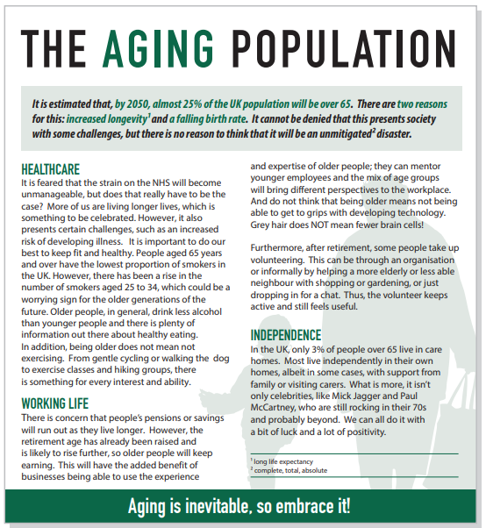

Subheadings

Text Box

Foot notes

Question 1

Identify the organisational features that have been used in the following text.

Use the options provided below.

Organisational features:

Heading Strapline Subheading Bullet points Text box

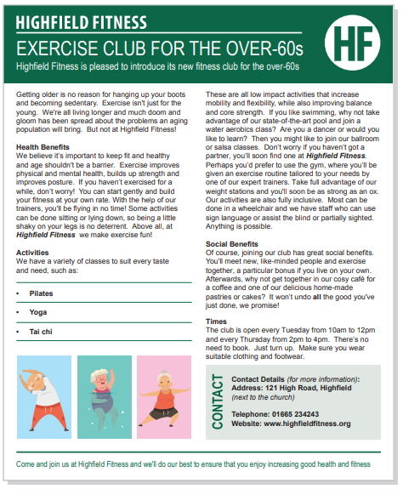

Example question

Now, let’s look at the second part of the exam question.

What information do these features help the reader to find?

Let’s look at an example from Text A.

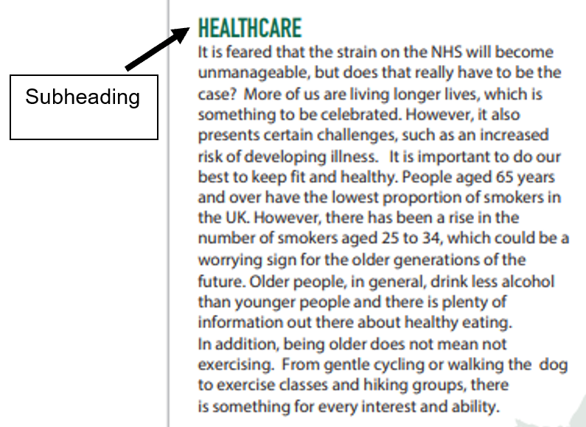

What information does the subheading help the reader to find?
Answer:
Subheadings help the reader to find the different sections in the text, such as healthcare.

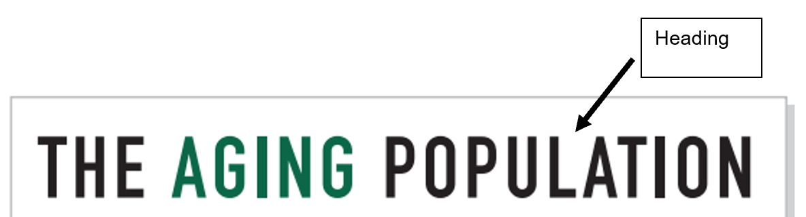

What information des the heading help the reader to find?
Answer:
The heading tells the reader that the text is about the aging population.

Question 2

Identify what information this text box helps the reader to find.

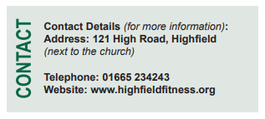

Question 3

Identify what information these bullet points help the reader to find.

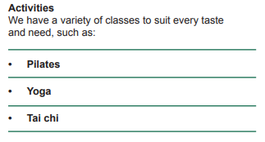

Key point

In your exam, you will need to:
- Identify two organisational features that have been used in the text
- State what information one of these organisational features helps the reader to find from the text
You must give an example of the information from the text, not just the purpose of the organisational feature.
For example, ‘The writer has used subheadings to identify the different sections in the text, like ‘Healthcare’ and ‘Working life’.
This answer is correct as the learner has said what the purpose of subheadings is and given an example of a subheading from the text.
Exam practice

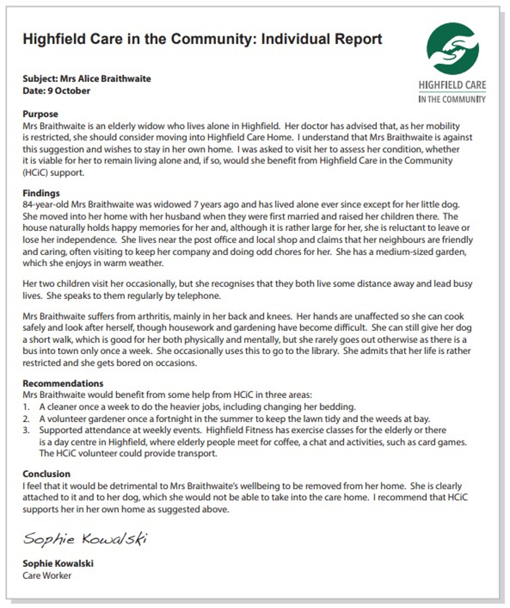
Read Text C.

Exam practice 1

Identify two organisational features used in Text C.
What information does one of these features help the reader to find?
(3 marks)

Organisational feature 1:

Organisational feature 2:

Information:

Read Text D:

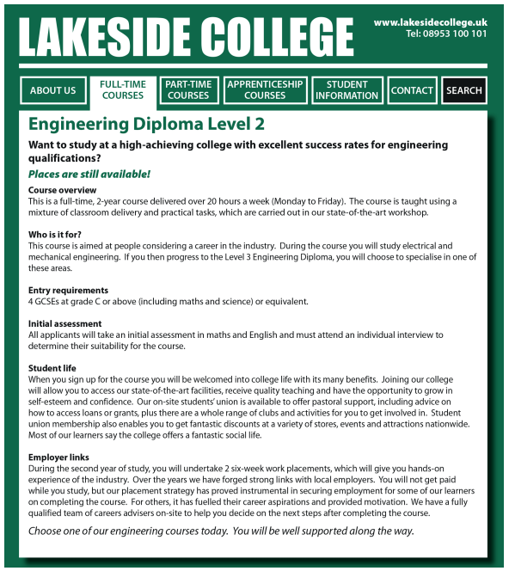
Exam practice 2

Identify two organisational features used in Text D.
What information does one of these features help the reader to find?
(3 marks)

Organisational feature 1:

Organisational feature 2:

Information:

Answers

Question 1

Heading

Strapline

Subheading

Bullet points

Text box

Question 2

This text box helps the reader to find contact information for the exercise club, such as their address and telephone number.

Question 3

These bullet points help to show the different classes people can take, such as yoga and Pilates.

Exam practice

Exam practice 1
Please note that this is an example answer and other correct answers may not be stated.

Organisational feature 1: Title
Organisational feature 2: Numbered list
Information: The numbered list displays information about the 3 recommended areas, such as ‘a cleaner needed once a week’

Exam practice 2
Please note that this is an example answer and other correct answers may not be stated.

Organisational feature 1: Strapline
Organisational feature 2: Subheading
Information: Subheadings break the text up into different sections, such as ‘course overview’ and ‘student life’.

Your functional skills exam

Your functional skills exams will consist of 2 papers.
These papers will take place over the following time periods:

- Reading – 60 minutes
- Writing – 60 minutes

Further information on the format that your test will take can be obtained from your training provider.

Hints and tips

- Find out what format your exam will be in. It may be paper-based
or on-screen.
- Plan what you are going to revise in advance. Don’t leave it until the last minute.
- Do as many past papers as you can so you are prepared for the day. If possible, try to complete the past papers following the same format as the actual exam.
- Find a quiet place to study and revise. It helps to sit at a table or a desk, don’t revise in bed.
- Don’t stay up all night revising the night before your exam. It’s important to have a good rest so you feel refreshed and ready to go.
- Read the question 3 times. The first time to ensure you understand what is being asked, the second time to get an understanding of what you need to do, and a third time to figure out exactly what maths techniques you should be applying.
- If you are struggling with a question, skip it and come back to it later. Try not to sit getting worked up about a difficult question, it will only waste exam time. Move on and come back to it after you have answered the other questions.
- Take note of the number of marks available. This will give you an indication of how much working out you must show. For example, 1 mark will need an answer only and more marks will need you to show your working out.
- When you’ve finished the exam, go back and check your answers. If you still have time remaining, use it to check your answers and when you have checked your answers check them again.

