

FUNCTIONAL SKILLS

English Level 1

Area: Writing
Criterion: 25. Write consistently and accurately in complex sentences, using paragraphs where appropriate

Simple, compound and complex sentences

Simple sentences
A simple sentence has one main idea, or independent clause. It includes a subject (noun) and a verb. The subject is who or what the sentence is about, and the verb is the action.
For example, ‘The cat sat on the mat.’
In this sentence, the cat is the subject and sat is the verb.
Compound sentences
A compound sentence has two main ideas (or independent clauses) joined by a
co-ordinating conjunction.
For example, ‘The acrobat jumped and the crowd cheered’.
In this sentence, there are two clauses, or parts. The first clauses is ‘The acrobat jumped’ and the second clause is ‘the crowd cheered’. Both clauses can be sentences on their own.
Here are some examples of co-ordinating conjunctions.
And | But
Or | So
You can use these to practise writing compound sentences.

Complex sentences
A complex sentence has one main idea (independent clause) and one idea that depends on the main idea (dependent clause). Dependent clauses give more detail about the main, or independent, clause.
A complex sentence is linked using a type of conjunction called a ‘subordinating conjunction’.
Here are some examples of subordinating conjunctions:
When | While
After | If
For example, ‘When you go to the shop, please get some milk’.
The first clause, ‘When you go to the shop,’ is the dependent clause, or extra idea. It doesn’t make sense on its own. It needs the main clause to complete the sentence.
‘When’ is the subordinating conjunction in this sentence. When the subordinating conjunction is at the start of the sentence, you need a comma after the first idea.
Complex sentences can also be switched around. This means that the independent clause and dependent clause can be swapped.
For example, ‘Please get some milk when you go to the shop’.
Using the information provided above, answer the following questions.

Question 1

Try writing a simple sentence, a compound sentence and a complex sentence.

For the compound sentence, use co-ordinating conjunctions to help you.
Co-ordinating conjunctions:
And | But
Or | So

For the complex sentence, use subordinating conjunctions to help you.
Subordinating conjunctions:
When | While
After | If

Simple sentence:

Compound sentence:

Complex sentence:

Paragraphs

Paragraphs are groups of sentences that help separate different ideas in your writing. This makes your writing clearer for the reader.
Paragraphs can be shown in two ways: by starting a new line and using an indent, which is a small space before the first word, or by leaving an empty line between paragraphs.
Each paragraph should start with a sentence that tells the reader what the paragraph is about. This is called the main idea.
The sentences that follow should add more details to help explain or expand on that main idea. There isn’t a set number of sentences needed, but you should aim for at least three sentences in a paragraph.
When you start a new idea, you should start a new paragraph.
Below is an example of a text that starts a new line for each new paragraph.
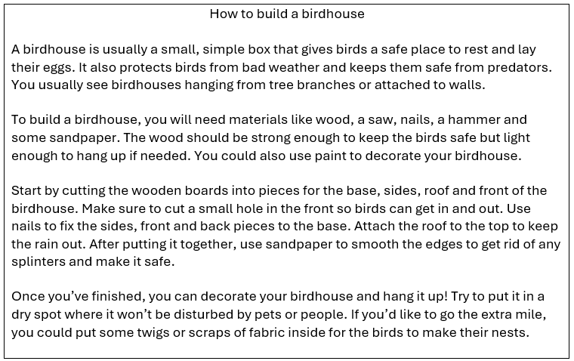

Using the information provided above, answer the following questions.

Question 2

Read the text below and decide where the new paragraphs should start.

To: alex@email.coz
From: jamie@email.coz
Subject: Weekend update
Date: 15th June 2020

Hi Alex,

I hope you had a good weekend! I finally decided to clean out my garage. It was a big mess, with old boxes, tools and things I haven’t used in ages. I thought it was time to clear it out and make some space. The first thing I did was take everything out of the garage and sort through it all. I made three piles: one for things to keep, one for things to donate and one for things to throw away. This made it easier to see what I actually needed and what was just taking up space. After I finished sorting, I started putting back the things I wanted to keep. I got some new shelves and storage boxes to organise things neatly. I put my all my tools in one corner and my camping gear in another, so now I know exactly where everything is. By the end of it, the garage looked so much better. It felt good to have a clean and organised space. I even found some old photo albums and spent some time looking through them, which was a nice surprise. Overall, it was a productive weekend, though I’m not in a hurry to do any more organising for a while!

You’ll have to come round to have a look!

All the best,
Jamie

Exam practice 1

Your friend has asked you for advice on riding a bike.

Write a letter to your friend including:
- what equipment they might need
- good places to practise
- tips on riding a bike

You should take approximately 30 minutes to complete this task.

Suggested word count 150-200 words.

Answers

Simple, compound and complex sentences

Question 1
Please note, these are examples of a learner response. Other answers may be correct.

Simple sentence:
Annie went to the shop.

Compound sentence:
Let’s go to the park so we can have a picnic.

Complex sentence:
If you see Fred, can you give him this book?

Paragraphs

Question 2

To: alex@email.coz
From: jamie@email.coz
Subject: Weekend update
Date: 15th June 2020

Hi Alex,

I hope you had a good weekend! I finally decided to clean out my garage. It was a big mess, with old boxes, tools and things I haven’t used in ages. I thought it was time to clear it out and make some space.

The first thing I did was take everything out of the garage and sort through it all. I made three piles: one for things to keep, one for things to donate and one for things to throw away. This made it easier to see what I actually needed and what was just taking up space.

After I finished sorting, I started putting back the things I wanted to keep. I got some new shelves and storage boxes to organise things neatly. I put my all my tools in one corner and my camping gear in another, so now I know exactly where everything is.

By the end of it, the garage looked so much better. It felt good to have a clean and organised space. I even found some old photo albums and spent some time looking through them, which was a nice surprise. Overall, it was a productive weekend, though I’m not in a hurry to do any more organising for a while!

You’ll have to come round to have a look!

All the best,
Jamie

Exam practice

Exam practice 1

Please note, this is an example of a learner response. Other answers may be correct.

Hi Ben,

It’s good to hear from you! I’ve been riding my bike for 15 years now, so I have plenty of tips.

Firstly, you’ll need some basic equipment. Obviously, you’ll need a bike, but you might want a helmet and even knee and elbow pads while you learn. You’ll also need comfortable clothes and good shoes so that you can move easily on the bike.

When it comes to practising, I suggest starting in a quiet, flat area. Try to avoid places with lots of people if you can, so that there’s less chance of you crashing into them. Parks are usually a good choice, especially if they have paths for bikes. Empty car parks or wide paths can also be good places to start, as long as it’s safe and legal to ride your bike there.

As for riding tips, start by finding your balance. Keep both hands on the handlebars and try to look forward, not down at the ground. Start by pedalling slowly until you feel comfortable, then you can pick up speed. Remember to practise using the brakes gently, so you can stop safely when you need to.

Good luck and have fun! Let me know how it goes.
Wishing you the best,
Ron

Your functional skills exam

Your functional skills exams will consist of 2 papers.
These papers will take place over the following time periods:

- Reading – 60 minutes
- Writing – 60 minutes

Further information on the format that your test will take can be obtained from your training provider.

Hints and tips

- Find out what format your exam will be in. It may be paper-based
or on-screen.
- Plan what you are going to revise in advance. Don’t leave it until the last minute.
- Do as many past papers as you can so you are prepared for the day. If possible, try to complete the past papers following the same format as the actual exam.
- Find a quiet place to study and revise. It helps to sit at a table or a desk, don’t revise in bed.
- Don’t stay up all night revising the night before your exam. It’s important to have a good rest so you feel refreshed and ready to go.
- Read the question 3 times. The first time to ensure you understand what is being asked, the second time to get an understanding of what you need to do, and a third time to figure out exactly what maths techniques you should be applying.
- If you are struggling with a question, skip it and come back to it later. Try not to sit getting worked up about a difficult question, it will only waste exam time. Move on and come back to it after you have answered the other questions.
- Take note of the number of marks available. This will give you an indication of how much working out you must show. For example, 1 mark will need an answer only and more marks will need you to show your working out.
- When you’ve finished the exam, go back and check your answers. If you still have time remaining, use it to check your answers and when you have checked your answers check them again.

