**FUNCTIONAL SKILLS**

Maths Level 2



**18. Calculate actual dimensions from scale drawings and create a scale diagram given actual measurements**

**Scale drawings**

Scale drawings are used to represent larger or smaller objects, drawings, images or maps.

**Scale factors and scale keys**

To scale up or down an image accurately, scale factors are used. Scale drawings will be shown with a key or a scale factor, these tell you what a dimension in the drawing is equal to in real life.

Usually, they are represented as ratios, with an = sign or as a line drawing as below:

1cm = 100m 1cm on the grid represents 100m

1:10000 1cm on the grid represents 10,000cm in real life

100m The distance marked represents 100m

**Calculating distances by measuring**

The scale drawing below shows a section of coastline.   
Calculate the distance between point A and point B.

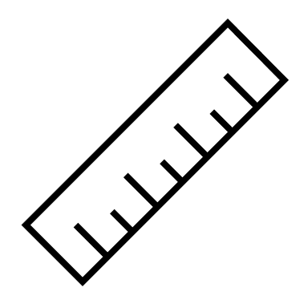

**= 0 km 5**

**A B**

Firstly, measure the length of the scale using a ruler; it is 1cm.

1cm on your ruler represents 5km in real life.

Then, measure the distance between A and B.   
The distance between A and B is 9.5cm.

1cm on the drawing represents 5km in real life.   
The distance between A and B in real life is:

9.5 x 5 = 47.5km

**Calculating distance on a grid**

The grid shows a map of an island.

Calculate the distance between point A and Point B.

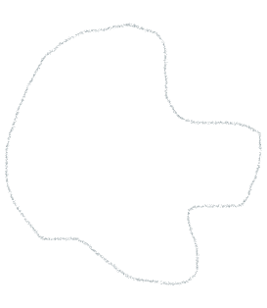

500  
miles

A

B

**2.5 x 500 = 1250 miles**

* We are given the scale as a line drawing so; we do not need to use a ruler
* Count the number of squares between the two points
* There are 2.5 squares
* To find the real-life distance between point A and point B multiply the distance represented by 1 square (**500 miles**) by the number of squares between the two points

**Working out the scale**

****You may be asked to find the scale on a map or drawing,   
given a distance.

The diagram below is a scale drawing of a classic car.   
The length of the car in real life is 3.6m.

Calculate the scale used in the drawing. Give your answer as a ratio.

We need to measure the length of the car using a centimetre ruler.

The length of the car is 6cm on the drawing.

Both measurements need to be the same unit so, convert the length

of the car from 3.6m to 360cm.

We can now write this as a ratio:

Drawing length : Real-life length = 6:360

Simplify the ratio by dividing both sides by 6 : 1:60

(1cm on the drawing represents 60cm in real life)

**Making a scale drawing**

To make a scale drawing, first work out what the dimensions should be.

Example: Draw a rectangle on the grid below, with a height 1.5m and a width of 2m. Use the scale 1:50,.Each square is 1cm by 1cm.

* The grid is in cm, so, convert the dimensions   
  of the rectangle into cm

Real height: 1.5 x 100 = 150cm

Real width: 2 x 100 = 200cm

* 1:50 means that 1cm on the grid represents 50cm in real life
* Divide the real dimensions by 50 to find the dimensions of the scale drawing

Real height: 150 ÷ 50 = 3cm

Real width: 200 ÷ 50 = 4cm

**Using the information provided, work out the answers to the following questions.**

**Question 1**

This is a scale diagram of a living room. The scale factor is 1: 150.

|  |
| --- |
| 6.5cm  7.5cm |

*NOT TO SCALE*

Calculate the actual length and width of the living room.

(Show your working out)

|  |
| --- |
|  |

**Question 2**

Use the grid provided to draw a scale diagram of a garden that has a rectangular shape and measures 6.5m by 3.5m.

Each of the squares measures 0.5 x 0.5cm.

|  |  |  |  |  |  |  |  |  |  |  |  |  |  |  |
| --- | --- | --- | --- | --- | --- | --- | --- | --- | --- | --- | --- | --- | --- | --- |
|  |  |  |  |  |  |  |  |  |  |  |  |  |  |  |
|  |  |  |  |  |  |  |  |  |  |  |  |  |  |  |
|  |  |  |  |  |  |  |  |  |  |  |  |  |  |  |
|  |  |  |  |  |  |  |  |  |  |  |  |  |  |  |
|  |  |  |  |  |  |  |  |  |  |  |  |  |  |  |
|  |  |  |  |  |  |  |  |  |  |  |  |  |  |  |
|  |  |  |  |  |  |  |  |  |  |  |  |  |  |  |
|  |  |  |  |  |  |  |  |  |  |  |  |  |  |  |

**1cm:1m**

**Question 3**

The diagram shows a scale drawing of a garden.

The scale is 1cm:1.27m.

**9.2cm 3.05cm**

**5.3cm**

**6.8cm**

Calculate the actual perimeter of the garden

(Show your working out)

|  |
| --- |
|  |

**Question 4**

The map shows part of the UK and part of France.

The scale of this map is 1cm: 20km

Calculate the approximate distance between Dover and Calais in km if the distance on the map is 2.1cm.

(Show your working out)

|  |
| --- |
|  |

**Question 5**

The scale drawing of this tree is 1:500. The height of the tree on paper is 50.8 cm.

**Height = 50.8cm**



Calculate the actual height of the tree.

(Show your working out)

|  |
| --- |
|  |

**Question 6**

The distance between two villages on a map measures 8 centimetres.

The map has a scale of 1:25000.

Calculate the actual distance between the two villages in kilometres.

(Show your working out)

|  |
| --- |
|  |

**Exam Question 1 - Calculator**

You make several craft items which you sell online.   
One of the items you make is a wooden photo frame.

The photo frame is made of:

* a back board measuring 40cm x 25cm
* a top and a bottom piece measuring 45cm x 5cm each
* two side pieces measuring 20cm x 5cm each

Make a plan of the pieces of wood that will make up the frame. Use the graph paper on the next page to draw the 5 pieces of wood. Use a scale of 1:5.

(Show any workings in the box below)

***(2 marks)***

|  |
| --- |
|  |

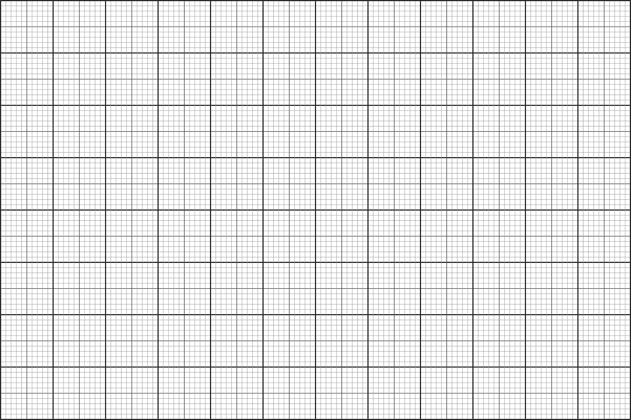

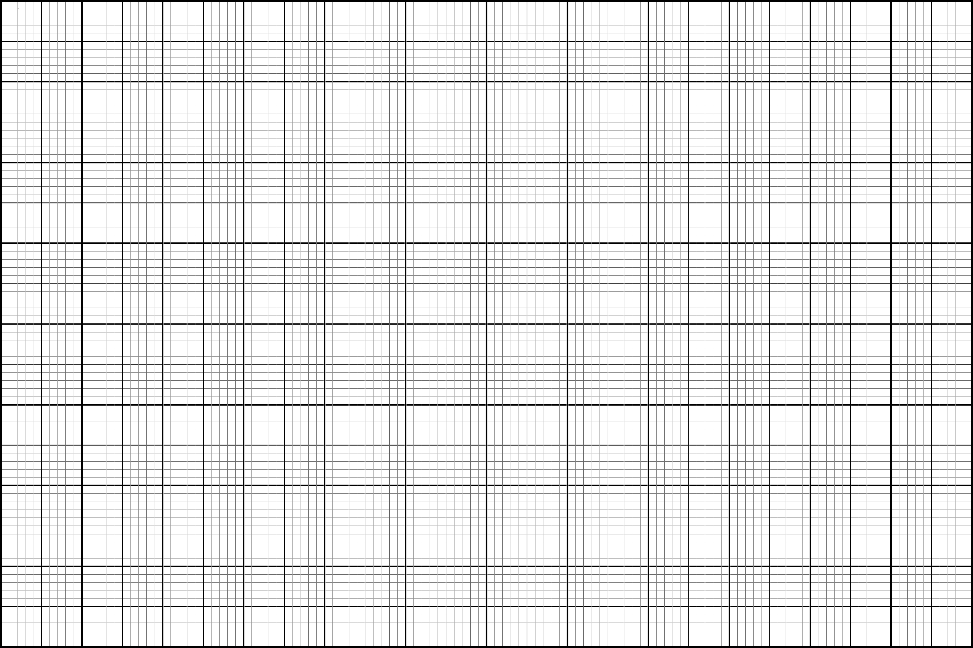

**Exam Question 2 – Calculator**

An estate agent needs to know the area of a plot of building land.   
This plan shows the building land.

**Calculate the area of the building land.**

(Show any workings in the box below)

***(3 marks)***

|  |
| --- |
|  |

**Your functional skills exam**

Your functional skills exams will consist of 2 papers.   
These papers will take place over the following time periods:

* Calculator paper – 40 minutes
* Non-calculator – 1 hour 50 minutes

Further information on the format that your test will take can be obtained from your training provider.

**Hints and tips**

* Find out what format your exam will be in. It may be paper-based   
  or on-screen.
* Plan what you are going to revise in advance. Don’t leave it until the last minute.
* Do as many past papers as you can so you are prepared for the day. If possible, try to complete the past papers following the same format as the actual exam.
* Find a quiet place to study and revise. It helps to sit at a table or a desk, and don’t revise in bed.
* Don’t stay up all night revising the night before your exam. It’s important to have a good rest so you feel refreshed and ready to go.
* Read the question 3 times. The first time to ensure you understand what is being asked, the second time to get an understanding of what you need to do, and a third time to figure out exactly what maths techniques you should be applying.
* If you are struggling with a question, skip it and come back to it later. Try not to sit getting worked up about a difficult question, it will only waste exam time. Move on and come back to it after you have answered the other questions.
* Take note of the number of marks available. This will give you an indication of how much working out you must show. For example, 1 mark will need an answer only and more marks will need you to show your working out.
* When you’ve finished the exam, go back and check your answers. If you still have time remaining, use it to check your answers and when you have checked your answers check them again.