

FUNCTIONAL SKILLS

English Level 2

Area: Writing
Criterion: 26. Convey clear meaning and establish cohesion using organisational markers effectively

Organisational marker | Example | Effect
Straplines | ‘Because you’re worth it’ | Straplines are usually found in articles and give the reader a clue as to what the article will be about, as well as setting the tone of the text.
Bullet points | You will need:  - eggs  - flour  - milk | Bullet points are an excellent way to chunk information, making it more manageable for the reader.
Numbered lists | Here’s what you need to do:  - Email the manager  - Attach the file  - Copy in HR | Numbered lists allow information or processes to be displayed in a clear order. They are commonly used in instructional leaflets or reports.
Subheadings | Introduction  The start of this text… | Subheadings help to separate a text into logical parts and make specific information easier to find.
Tables |  | Tables help to display data or information concisely for the reader.
  18-25​ | 26-30​ | 31+​
  122​ | 856​ | 15​
Text boxes | “It’s absolutely ridiculous” | Text boxes allow specific chunks of information to stand out. They are often used to help highlight an opinion or viewpoint.
Illustrations |  | Illustrations draw a reader in but also help to aid understanding and support an idea or viewpoint.
Photo captions |   Man (above) cuddles cat | Photo captions help to give more context to an image used in a text. This can help the reader gain a wider understanding of the text as a whole.
Headers | Document version 1 John Jones | Headers are useful in reports as they give important pieces of information that can give the text context before the main body of information is explored. These are different to titles and headings as they are usually at the very top of the document.
Footnotes | *Main = The most important or biggest. | Footnotes support a reader’s understanding of text-specific vocabulary.

Using the information provided above, answer the following questions.

Question 1

Using the vocabulary bank, label organisational markers on the text below.
Illustrations text box subheadings bullet points strapline

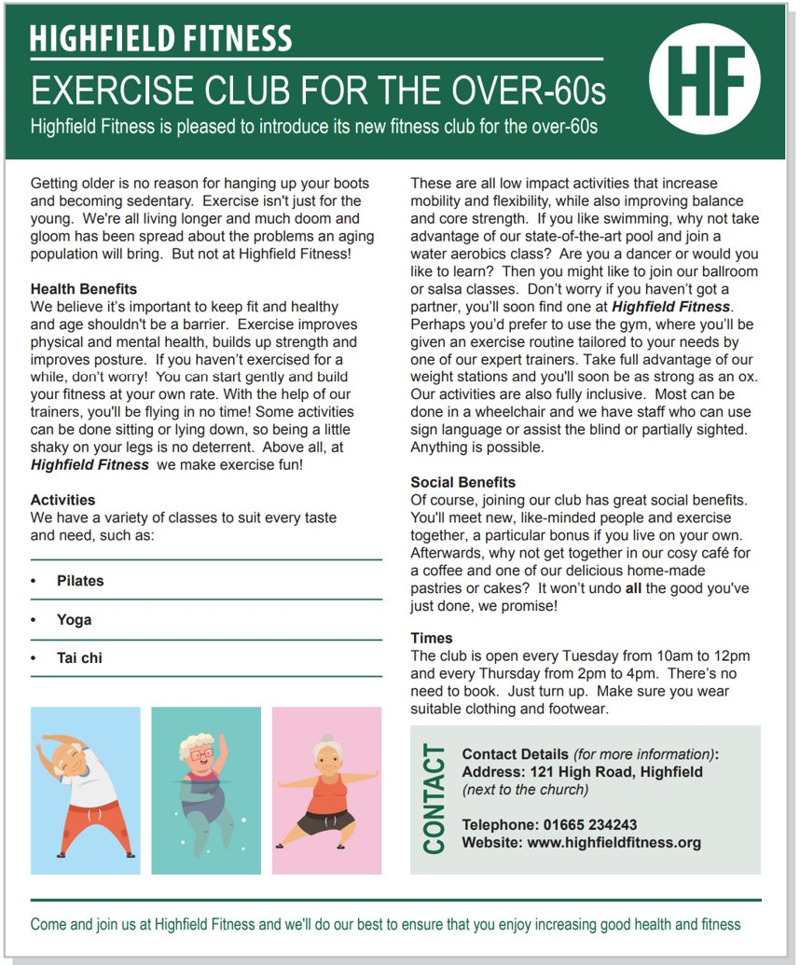

Question 2

Subheadings are the most used organisational marker in a variety of texts.
Look at the article below and add appropriate subheadings in the spaces provided. The first one has been done for you.
New course available: Woodworking Level 2
Course overview
This is a full time, 2-year course delivered over 15 hours a week (Monday to Thursday). The course will be taught using a hybrid approach consisting of classroom delivery and practical lessons, which will be carried out in our purpose-built workshops.

________________
This course is aimed at people considering a career in carpentry with opportunities to work in industry with real employers. You must be creative, organised and have a passion for woodwork.

________________
3 GCSEs at grade C or above or equivalent.

________________
When you sign up for the course, you will be welcomed into a life at college with many benefits. You’ll have access to state-of-the-art facilities, receive quality teaching and have the opportunity to forge long lasting friendships with your peers. For pastoral support, you can head over to out student’s union, where you’ll find all of the support and guidance you need. You’ll also have the chance to join a range of fantastic clubs and take part in some exciting extracurricular activities with your peers.

So, what are you waiting for? Sign up today!

The College Times
The best place to get your up-to-date college info!

Exam practice 1

You write for the local newspaper and receive the following leaflet:

You can help us in our fight against poverty.
Did you know:
- thousands of families are left with out access to food, water and adequate clothing
- families are being hit with heavy tax rates, despite having low income
- many families have been separated, their children going into foster care, leaving the parents homeless
Please help us in our fight to keep families together and end poverty.
To donate, call: 01234 567 890
For more information, visit: www.fightpoverty.org

Write an article for the newspaper highlighting the problem of poverty and encouraging readers to help with the fight against poverty.

Suggested word count 250-300 words.
You should include as many appropriate organisational markers as you can.
(27 marks)
Planning space:

Write your article here:

Answers

Question 1
Strapline

Subheadings

Text box

Bullet points

Illustration/image

Question 2
Please note that there are other possible correct answers: these are examples.
New course available: Woodworking Level 2
Course overview
This is a full time, 2-year course delivered over 15 hours a week (Monday to Thursday). The course will be taught using a hybrid approach consisting of classroom delivery and practical lessons, which will be carried out in our purpose-built workshops.

Who is this course for?
This course is aimed at people considering a career in carpentry with opportunities to work in industry with real employers. You must be creative, organised and have a passion for woodwork.

Requirements
3 GCSEs at grade C or above or equivalent.

Benefits, support and opportunities
When you sign up for the course, you will be welcomed into a life at college with many benefits. You’ll have access to state-of-the-art facilities, receive quality teaching and have the opportunity to forge long lasting friendships with your peers. For pastoral support, you can head over to our student’s union, where you’ll find all the support and guidance you need. You’ll also have the chance to join a range of fantastic clubs and take part in some exciting extracurricular activities with your peers.

So, what are you waiting for? Sign up today!

The College Times
The best place to get your up-to-date college info!

Exam practice 1

Please note that this is an example response: there are a wide variety of possible answers.

Help us in the fight for poverty
Find out what you can do to make a difference!
Written by Joe Bloggs (5th February 2024)

Poverty is an ever-growing problem in our society: it affects thousands of families across the country- and world- every single day. Many people are struggling to meet their basic needs (such as food, water and clothing). This is a reality for too many families; it’s time for us to act!

The harsh reality
- Thousands of families are left without access to basic necessities on a daily basis
- Heavy tax rates are hitting families with low incomes, which in turn has made it even more difficult for them to survive
- Family separation rates are rising every day


This devastating cycle of poverty can tear families apart and leave people in desperate situations. One reader, who volunteers once a week at their local food bank, said, ‘times are bad. Really bad. We need to help one another as a nation- as human beings- if we are to thrive!’ However, there is hope, and you can make a difference.

How you can help
Volunteers at the local food bank.
Below are some simple ways you can support people.
- Donate – Even a small amount can help a family in need
- Volunteer – Offer your time to local charities and food banks
- Raise Awareness – Share information with friends, family and on social media

Every contribution counts in keeping families together and helping them rebuild their lives.
For more information or to donate, please call 01234 567 890 or visit www.fightpoverty.coz

Note: learners are not expected to draw images or text boxes in their exam as this may be time consuming. Learners may mark down in their response where an image, caption, text box or columns would be used and what these would contain. For example, ‘Image of food and drink’.

Your functional skills exam

Your functional skills exams will consist of 2 papers.
These papers will take place over the following time periods:

- Reading – 60 minutes
- Writing – 60 minutes

Further information on the format that your test will take can be obtained from your training provider.

Hints and tips

- Find out what format your exam will be in. It may be paper-based
or on-screen.
- Plan what you are going to revise in advance. Don’t leave it until the last minute.
- Do as many past papers as you can so you are prepared for the day. If possible, try to complete the past papers following the same format as the actual exam.
- Find a quiet place to study and revise. It helps to sit at a table or a desk, don’t revise in bed.
- Don’t stay up all night revising the night before your exam. It’s important to have a good rest so you feel refreshed and ready to go.
- Read the question 3 times. The first time to ensure you understand what is being asked, the second time to get an understanding of what you need to do, and a third time to figure out exactly what maths techniques you should be applying.
- If you are struggling with a question, skip it and come back to it later. Try not to sit getting worked up about a difficult question, it will only waste exam time. Move on and come back to it after you have answered the other questions.
- Take note of the number of marks available. This will give you an indication of how much working out you must show. For example, 1 mark will need an answer only and more marks will need you to show your working out.
- When you’ve finished the exam, go back and check your answers. If you still have time remaining, use it to check your answers and when you have checked your answers check them again.

