

FUNCTIONAL SKILLS

Maths Level 2

Area: Measures, shapes and space
Criterion 22: Calculate values of angles and/or coordinates with 2-D and 3-D shapes.
Calculating angles of triangles
A triangle has 3 sides and 3 angles.
The sum of the interior angles of any triangle is always 180°.
There are different types of triangles and they each have different properties, for example:
Equilateral triangles have 3 angles that are all equal. Each angle measures 60°.
Right-angle triangles all contain a right-angle, which measures 90°.
Isosceles triangles have 2 equal angles.

There are 2 steps we can use to help us calculate the missing angle in a triangle. These are shown below.

Step 1: identify the known angles.
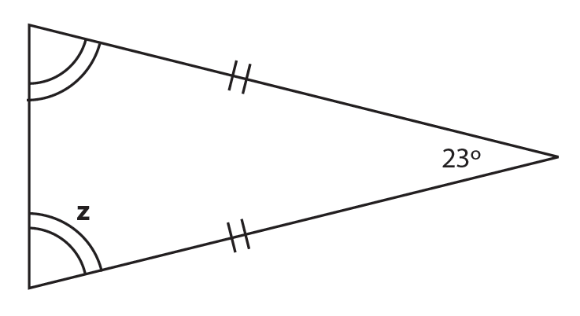
In this example, we can see that there is an
angle that measures 25°.
25°

We can also see that there are 2 angles that
are the same (or equal).

Step 2: find the missing angle.

We can use this information to help us calculate the missing angle. In this example, we need to calculate the angle z.

To find out the combined value of the 2 angles that are the same, we need to subtract 25° from 180°.

180 – 25 = 155°

Finally, we know that the remaining 2 angles are the same. Therefore, we need to divide 155 by 2 to work out the value of missing angle z.

155 ÷ 2 = 77.5°

Remember that the interior angles in a triangle always total 180°.

Question 1

Answer the questions below to test your knowledge of different types of triangles.

1a) In a right-angle triangle, what is the value of the right angle?

1b) What are the properties of the angles in an equilateral triangle?

1c) What is the defining property of the angles in an isosceles triangle?

Question 2

Calculate the value of angle x.

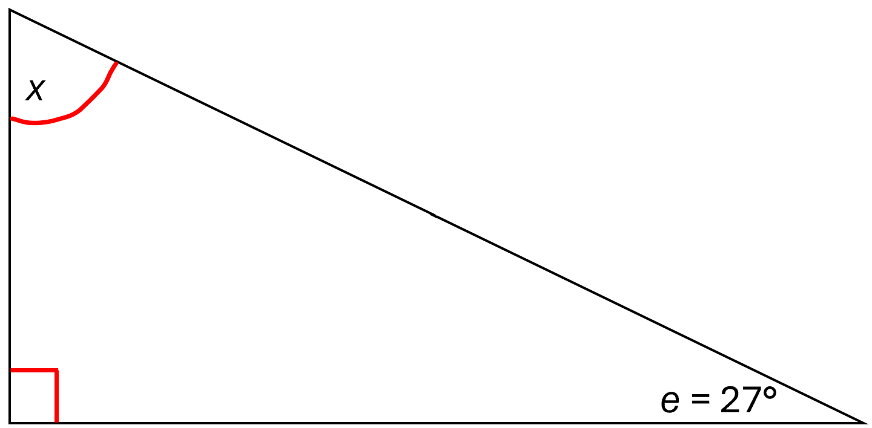
Diagram not drawn to scale

(Show your working out.)
(1 mark)

Question 3

Calculate the value of angle Y.

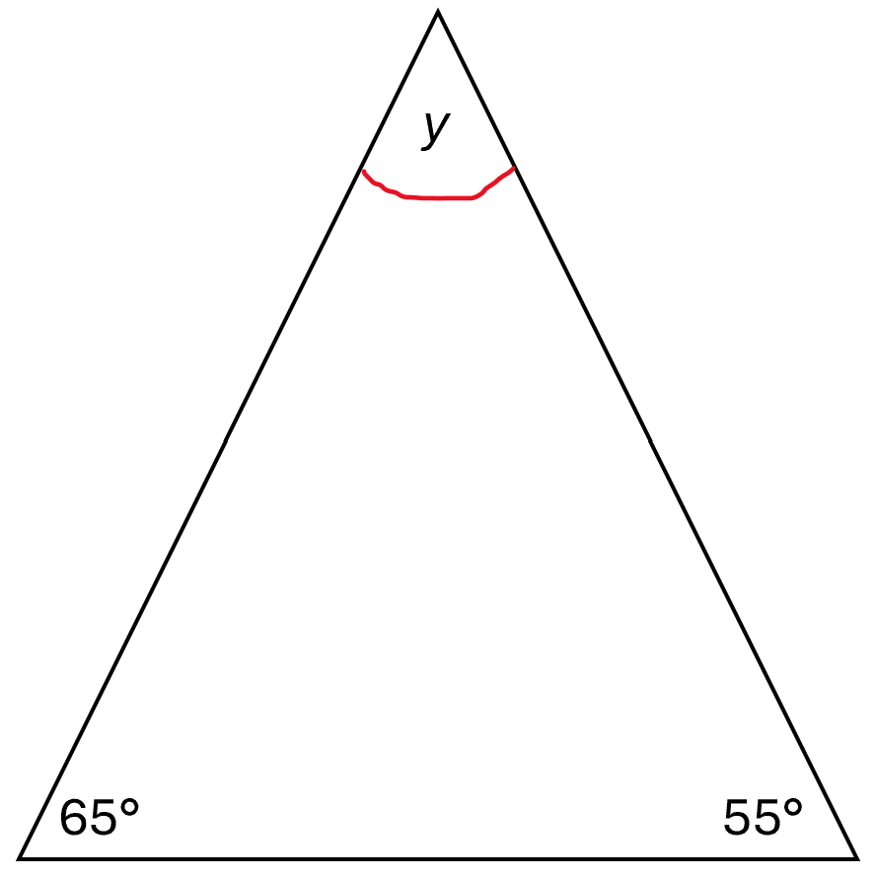
Diagram not drawn to scale

(Show your working out.)
(1 mark)

Question 4

Calculate the value of angle T.
Diagram not drawn to scale
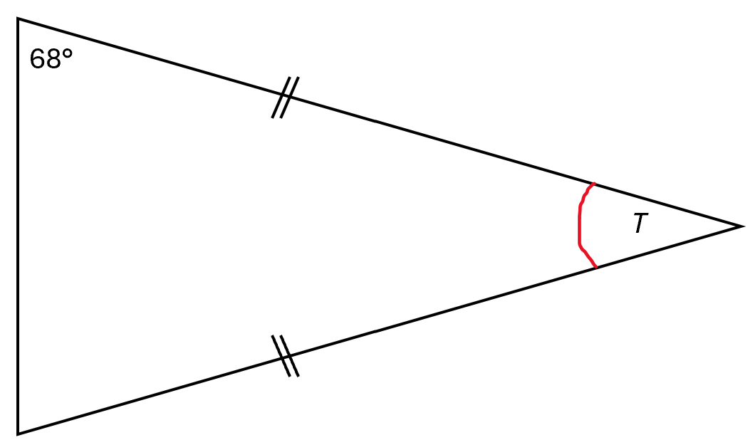
(Show your working out.)
(1 mark)

Calculating angles in quadrilaterals
Quadrilaterals have 4 sides and 4 angles that always add up to 360°.

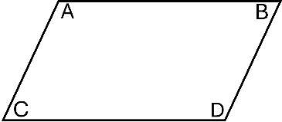

Therefore, we can say that A + B + C + D = 360°

Squares and rectangles always have 4 right angles.

For other types of quadrilaterals, such as parallelograms, rhombuses or trapeziums, we will be given some angles and will need to find the missing angle.

To do this, we can use the same formula:

A + B + C + D = 360°

Let’s look at an example.

Calculate the value of angle g.

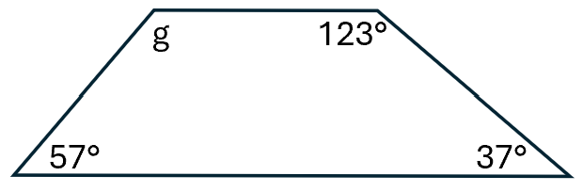

This quadrilateral does not have 4 equal angles.

Use the formula above to calculate the missing angle ‘g’.

First, we need to add up the angles we know:

57 + 37 + 123 = 217°

Remember that all the angles in a quadrilateral total 360°.

Therefore, to find the missing angle, we need to subtract the known angles from 360°

360° – 217° = 143°

Or

360 – 57 – 37 – 123 = 143°

Question 5
Calculate the value of angle R.
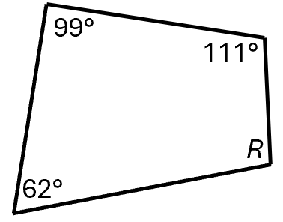
Diagram not drawn to scale
(Show your working out.)
(1 mark)

Question 6
Calculate the value of angle D.

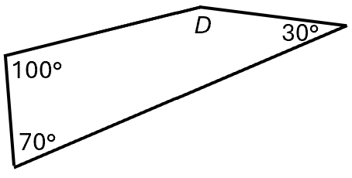
Diagram not drawn to scale

(Show your working out.)
(1 mark)

Question 7
Calculate the value of angle V.

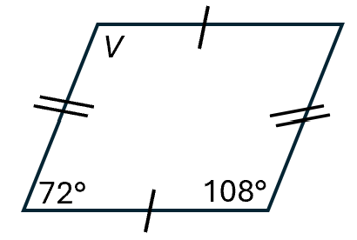
Diagram not drawn to scale

(Show your working out.)
(1 mark)

Calculating angles in polygons
For any polygon with n sides, use the formula (n−2) ×180 to find the sum of the interior angles.

We can use the following formula to find the total of the interior angles:

(n – 2) x 180

n = number of sides.

Let’s look at an example.

This is a pentagon.

It has 5 sides and 5 angles.

Let’s use the formula to calculate the sum of the interior angles in the pentagon.

(5 – 2) x 180

5 – 2 = 3

3 x 180 = 540°

Therefore, the angles in a 5 sided shape, or pentagon, need to add up to 540°.

Question 8
Calculate the value of angle H.

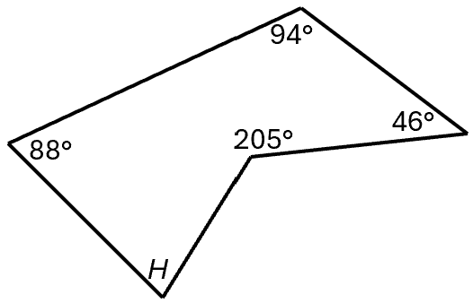
Diagram not drawn to scale

(Show your working out.)
(1 mark)

Question 9
Calculate the value of angle K. Round your answer to 2 decimal places.

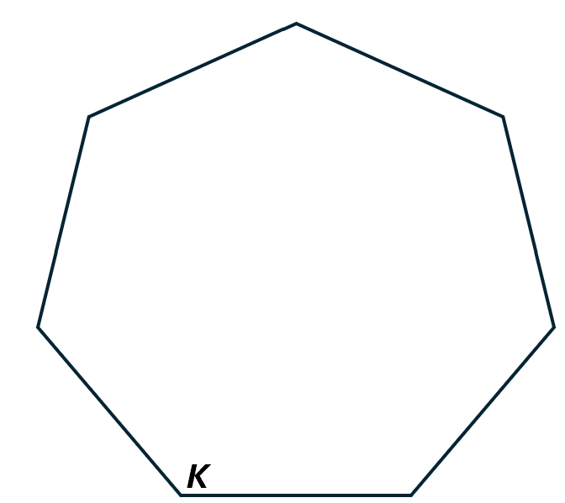
Diagram not drawn to scale

(Show your working out.)
(2 marks)

Question 10
Calculate the value of angle P.

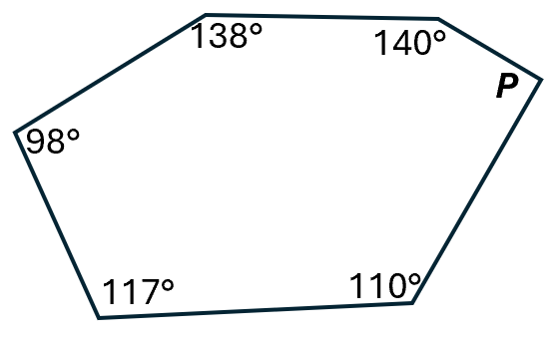
Diagram not drawn to scale

(Show your working out.)
(1 mark)

Measuring angles using a protractor
We use a protractor to accurately measure the size of an angle.
To measure angles accurately using a protractor, you will need to follow these steps:
- Place the protractor: position the midpoint of the protractor at the vertex, or point, of the angle.

The midpoint is the cross in the middle of the protractor.

- Align the base line: ensure 1 side of the angle aligns with the 0 line on the protractor.

Some protractors will not show a 0: instead, they will show 360°.

If this is the case, align 1 side of the angle with the 360° line.

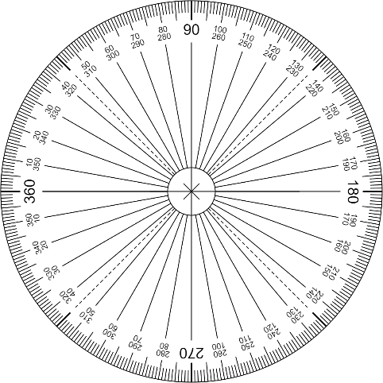
Base line
Midpoint

- Read the angle: look at the other side of the angle and read the number that the line runs up.

In the example below, you can see that the other side of the angle, the blue line, reads 109° on the protractor.

Angle H measures 109°.
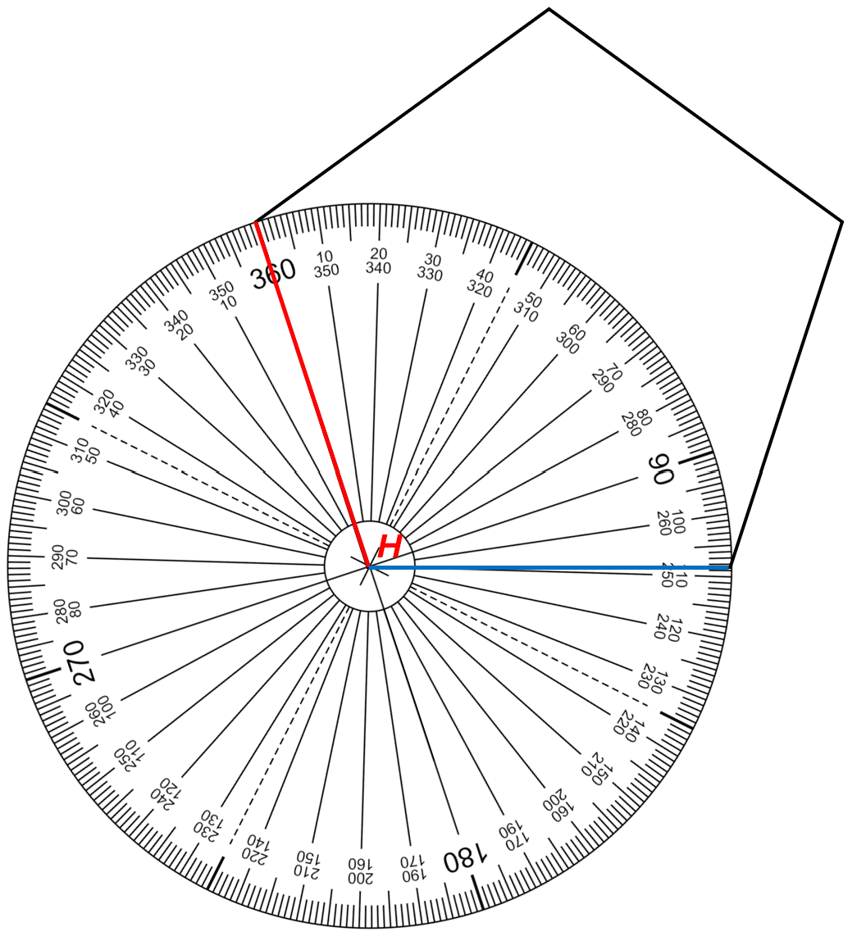

Question 11

Using a protractor, measure angle ‘F’.

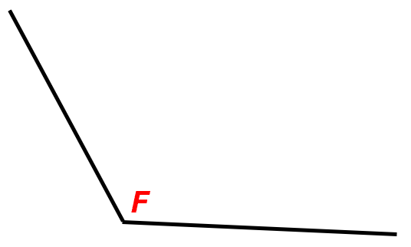

(Show your working out.)
(1 mark)

Question 12

Use a protractor to measure the angle ‘Z’ on the shape below.

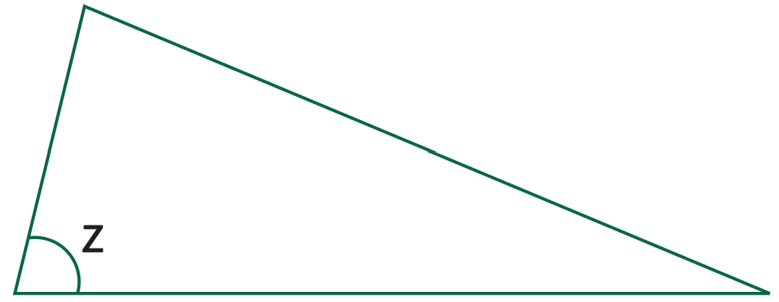

(Show your working out.)
(1 mark)

Question 13

Use a protractor to measure angle ‘B’.

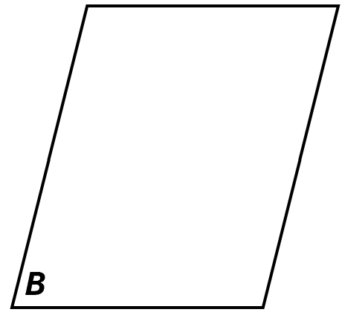

(Show your working out.)
(1 mark)

Question 14

Use a protractor to measure the angle ‘A’.
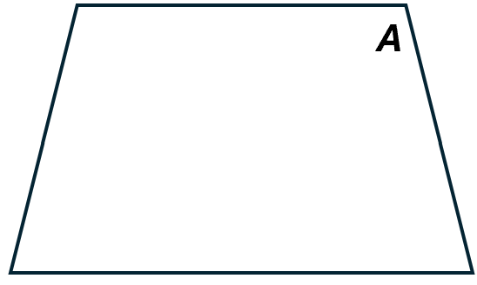

(Show your working out.)
(1 mark)

Find missing coordinates of 3-D shapes
3-D coordinates are used to specify the location of a point in a three-dimensional space.
2-D coordinates have 2 values (X and Y). However, 3-D coordinates have 3 values: X, Y, and Z.
The X axis is the horizontal axis.

The Y axis is the vertical axis.

The Z axis is the axis that comes out of (or goes into) the plane formed by the X and Y axes. It is perpendicular to both the X and Y axes.

The origin is the point where all 3 axes meet or intersect.
It is always denoted as (0, 0, 0).
It is always written with the X coordinate first, then the Y coordinate and finished with the Z coordinate.
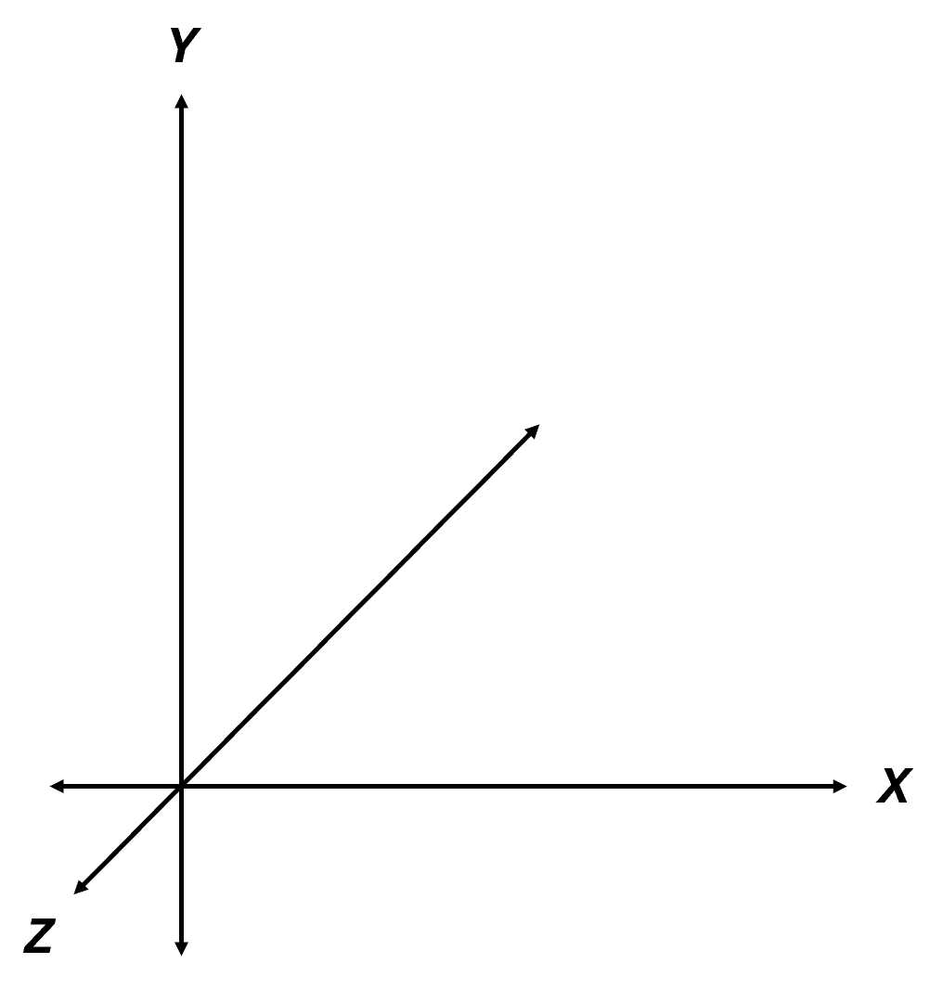
Origin

A point in 3-D space is represented by an ordered triplet (x, y, z), where:
- x is the distance along the X-axis
- y is the distance along the Y-axis
- z is the distance along the Z-axis

Let’s look at an example. Find the missing coordinates of point ‘D’.

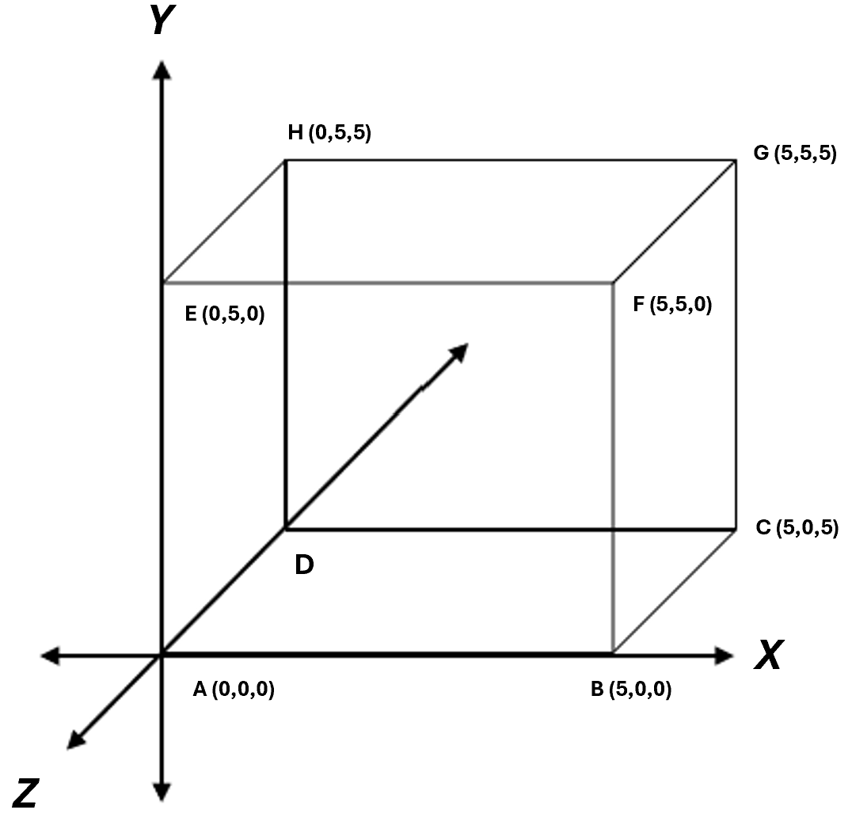

First, we need to make a list of all the known coordinates:
- A = (0,0,0)
- B = (5,0,0)
- C = (5,0,5)
- D = unknown
- E = (0,5,0)
- F = (5,5,0)
- G = (5,5,5)
- H = (0,5,5)

Next, look at all the combinations and find the missing coordinates of point ‘D’.

Let’s look at ‘D’. It may help you to visualise the cube head on.

Point ‘D’ has not moved left or right from the start of the X axis. Therefore, the first coordinate is 0.

It has also not moved up from the Y axis (it is still on the same level as point A).

Therefore, the second coordinate is 0.

Finally, when we look at axis Z, we can see that point ‘D’ has more depth: it moved backwards, so the Z coordinate is 5.

X coordinate = 0
Y coordinate = 0
Z coordinate = 5

Point D’s coordinates are (0,0,5).
Question 15

Find the missing coordinates of point ‘C’.
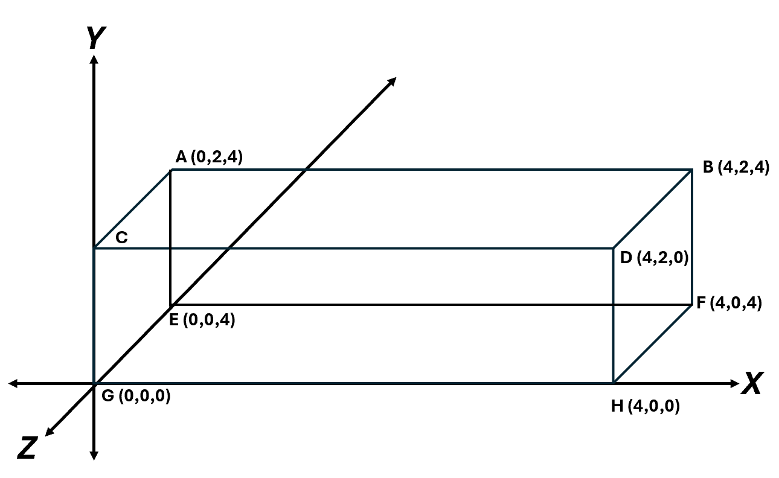

(Show your working out.)
(1 mark)

Question 16

Find the missing coordinates of point ‘A’.
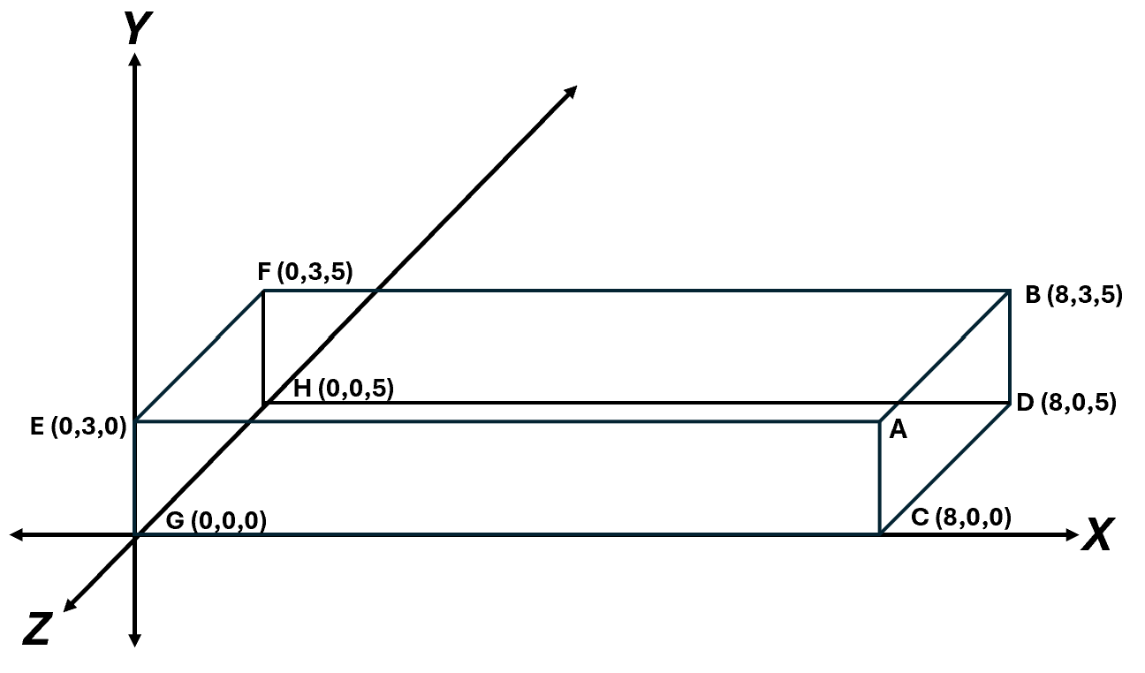

(Show your working out.)
(1 mark)

Question 17

Find the missing coordinates of point ‘E’.
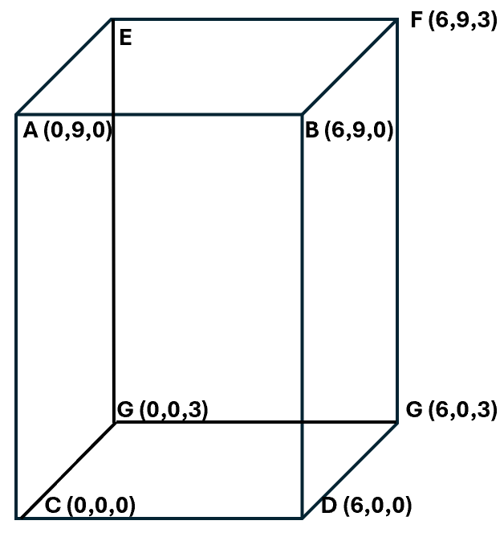
(Show your working out.)
(1 mark)

Answers

Calculating angles of triangles

Question 1

1a) All right angles measure 90°.

1b) All of the sides/angles are equal. Each angle measures 60°.

1c) There are 2 equal angles in an isosceles triangle.

Question 2

90 + 27 = 117°

180 – 117 = 63

X = 63°

Question 3

65 + 55 = 120°

180 – 120 = 60

Y = 60°

Question 4

68 x 2 = 136°

180 – 136 = 44

T = 44°

Calculating angles of quadrilaterals

Question 5

99 + 111 + 62 = 272°

360 – 272 = 88°

R = 88°

Question 6

100 + 30 + 70 = 200°

360 – 200 = 160

D = 160°

Question 7

Opposite angles in parallelograms are the same. We know this because of the parallel lines on the side of the shape, and the lines at the top and bottom of the shape.

Therefore, angle V measures 108°.

Calculating angles of polygons

Question 8
This shape has 5 sides: it is an irregular pentagon.

(n – 2) x 180

5 – 2 = 3

3 x 180 = 540°

88 + 94 + 46 + 205 = 433°

540 – 433 = 107

H = 107°

Question 9
This shape has 7 sides that are all the same length. It is a regular heptagon.

(n – 2) x 180

7 – 2 = 5

5 x 180 = 900°

To calculate the size of 1 angle, we need to divide the total (900) by the number of angles (7).

900 ÷ 7 = 128.571429

Rounded to 2 decimal places = 128.57°

Question 10
This shape has 6 sides: it is an irregular hexagon.

(n – 2) x 180

6 – 2 = 4

4 x 180 = 720°

To calculate P, we need to subtract the other angles from the total value (720).

138 + 140 + 110 + 117 + 98 = 603

720 – 603 = 117

P = 117°

Measuring angles using a protractor

Question 11

120°

Question 12

76°

Question 13

76°

Question 14

104°

Finding missing coordinates of 3-D shapes

Question 15

C = (0,2,0)

Question 16

A = (8,3,0)

Question 17

(0,9,3)

Your functional skills exam

Your functional skills exams will consist of 2 papers.
These papers will take place over the following time periods:

- Non-calculator paper – 40 minutes
- Calculator – 1 hour 50 minutes

Further information on the format that your test will take can be obtained from your training provider.

Hints and tips

- Find out what format your exam will be in. It may be paper-based
or on-screen.
- Plan what you are going to revise in advance. Don’t leave it until the last minute.
- Do as many past papers as you can so you are prepared for the day. If possible, try to complete the past papers following the same format as the actual exam.
- Find a quiet place to study and revise. It helps to sit at a table or a desk, don’t revise in bed.
- Don’t stay up all night revising the night before your exam. It’s important to have a good rest so you feel refreshed and ready to go.
- Read the question 3 times. The first time to ensure you understand what is being asked, the second time to get an understanding of what you need to do, and a third time to figure out exactly what maths techniques you should be applying.
- If you are struggling with a question, skip it and come back to it later. Try not to sit getting worked up about a difficult question, it will only waste exam time. Move on and come back to it after you have answered the other questions.
- Take note of the number of marks available. This will give you an indication of how much working out you must show. For example, 1 mark will need an answer only and more marks will need you to show your working out.
- When you’ve finished the exam, go back and check your answers. If you still have time remaining, use it to check your answers and when you have checked your answers check them again.

