

FUNCTIONAL SKILLS

Maths Level 2

Area: Measure, shape and space
Criterion: Calculate perimeters and areas of 2-D shapes including triangles and circles and composite shapes including non-rectangular shapes (formulae given except for triangles and circles)

Calculating the perimeter of a square

Perimeter is the distance around the outside of a shape.

Each side of a square is the same length. Therefore, the formula for calculating the perimeter of a square is:

Perimeter = length x 4
#
or
P = 4L

For example, each side of this square has a
length of 3cm.
3cm

A square has 4 sides that are all the same length.

3 x 4 = 12cm
or
3 + 3 + 3 + 3 = 12cm

Question 1

Calculate the perimeter (P) of this square.
P = 4L

Diagram not to scale
#
Length (L):
10cm

(Show your working out.)
(1 mark)

Question 2

Calculate the perimeter (P) of this square.
P = 4L
Diagram not to scale
Length (L):
25m
#

(Show your working out.)
(1 mark)

Question 3

A garden has a perimeter (P) of 400m. The garden is a square shape.
Calculate the length (L) of 1 side of the garden.
P = 4L

(Show your working out.)
(1 mark)

Calculating the perimeter of a rectangle

Rectangles have 4 sides. Each of the opposite sides are always the same length.
For example, here you can see the 2 longest lengths are both 11cm long, and the 2 widths (shortest lengths) are both 3.7cm.

11cm

3.7cm
3.7cm

11cm

The formula for working out the perimeter of a rectangle is:
P = perimeter
L = length
W = width

P = 2(L+W)

To calculate the perimeter of the rectangle above:
- substitute the numbers into the formula
P = 2 (11 + 3.7)

- follow the order of precedence (BODMAS) to calculate the rectangle’s perimeter

Calculate the addition in the brackets
11 + 3.7 = 14.7
P = 2 (14.7)

Multiply the brackets by 2
2 x 14.7 = 29.4cm
P = 29.4cm

Question 4

Calculate the perimeter (P) of this rectangle.
P = 2(L+W)

Diagram not to scale
L = 2cm
#

W = 7cm

(Show your working out.)
(1 mark)

Question 5

Calculate the perimeter (P) of this rectangle.
P = 2(L+W)

Diagram not to scale
L = 1cm
#

W = 16cm

(Show your working out.)
(1 mark)

Question 6

A rectangle has a length (L) of 34cm and a width of 23.3cm.
Calculate the perimeter (P) of the rectangle.
P = 2(L+W)

(Show your working out.)
(1 mark)

Calculating the perimeter of a triangle

The formula for calculating the perimeter of a triangle is:
P = a + b + c

P = perimeter
a = side a
b = side b
c = side c
a = 5cm

b = 4cm

c = 3cm

First, substitute the lengths into the formula.
P = 5 + 4 + 3

Next, add the numbers together to work out the perimeter.
5 + 4 + 3 = 12cm
P = 12cm

Equilateral triangles have 3 sides that are all the same length.
Therefore, you only need to know the length of 1 side to calculate the perimeter.
For example:

4cm

Each side of this triangle will have a length of 4cm.
Perimeter can be calculated by adding this length 3 times, or multiplying by 3.

P = 4 + 4 + 4
P = 12cm
or
P = 4 x 3
P = 12cm

The formula for calculating the perimeter of a triangle will not be given during the exam.

Question 7

Calculate the perimeter of this triangle.
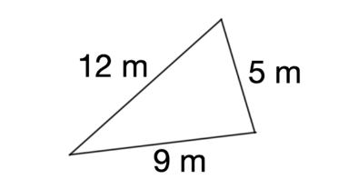

Diagram not to scale

(Show your working out.)
(2 marks)

Question 8

Calculate the perimeter of this triangle.
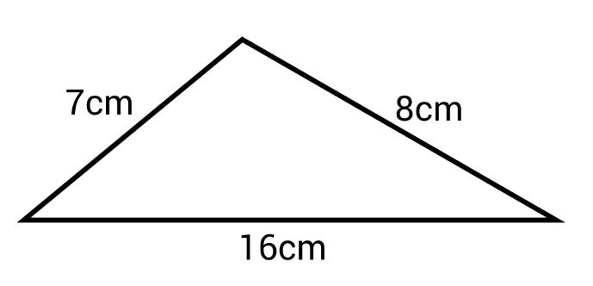
Diagram not to scale

(Show your working out.)
(2 marks)

Question 9

Calculate the perimeter of this equilateral triangle.

Diagram not to scale
7.1cm

(Show your working out.)
(2 marks)

Calculating the circumference of a circle

Circumference is the name given to the perimeter of a circle.
It is the distance around the outside of a circle.

The formula for calculating the circumference of a circle is:
C = 2πr

C = circumference
π = 3.14
r = radius

Radius is the distance from the centre of the circle to the edge of the circle.
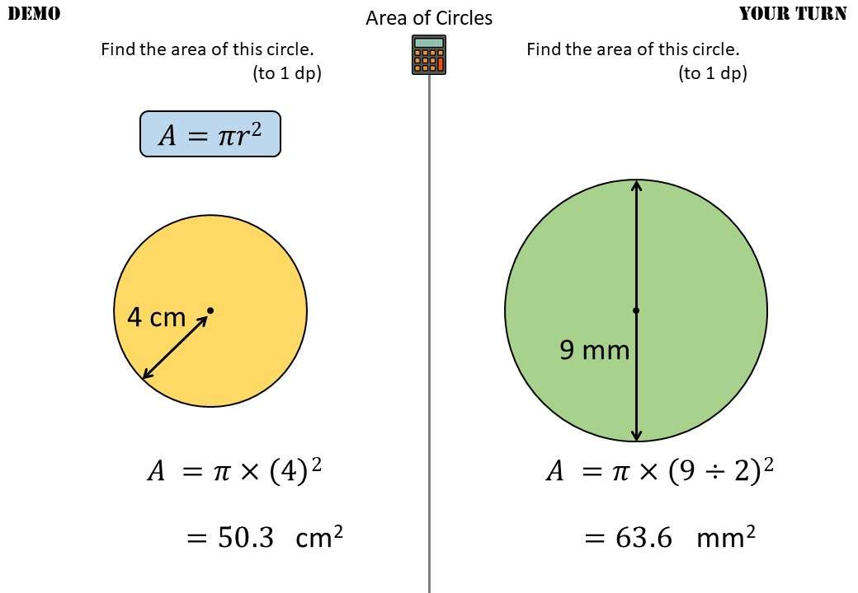

To calculate the circumference of this circle, we must first substitute the values into the formula.

C = 2πr
π = 3.14
r = 4cm

C = 2 x 3.14 x 4cm

Circumference = 25.12cm

The formula for calculating circumference will not be given during exams.

Question 10

Calculate the circumference of this circle.
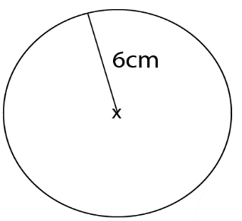

Diagram not to scale

(Show your working out.)
(2 marks)

Question 11

Calculate the circumference of this circle.
Round your answer to the nearest whole number.
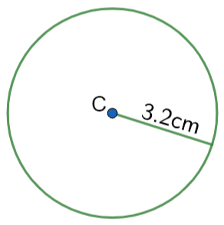
Diagram not to scale

(Show your working out.)
(3 marks)

Question 12

Calculate the circumference of a circle with a radius of 20m.

(Show your working out.)
(2 marks)

Calculating the area of squares and rectangles

Area is the amount of space inside a 2-D shape.
The units for area is always followed by the squared (²) symbol.

The formula for calculating the area of squares and rectangles is:
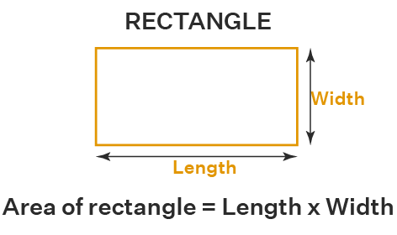
A = L X W

A = area
L = length
W = width

For example, calculate the area of this rectangle.
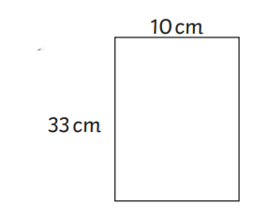

First, substitute the values into the formula:
A = L X W
A = 33 x 10

Next, complete the multiplication:
33 x 10 = 330
Area = 330cm²

Question 13

Calculate the area of this rectangle.
Area = length x width
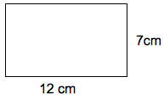

Diagram not to scale

(Show your working out.)
(1 mark)

Question 14

Calculate the area of this square.
Area = length x width
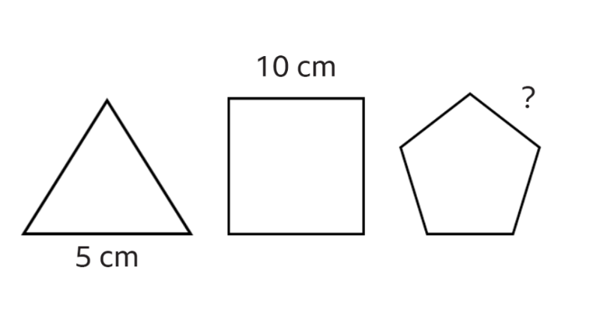

Diagram not to scale

(Show your working out.)
(1 mark)

Question 15

The square’s length is half of the rectangle’s length. Calculate the area of the square.
A = L x W

(Show your working out.)
(2 marks)

Calculating the area of composite shapes

A composite shape is a shape that is made up of 2 or more 2-D shapes.

The easiest way to calculate the area of a composite shape is to split the shape into its original shape/shapes.

For example, this composite shape is made up of 2 rectangles.
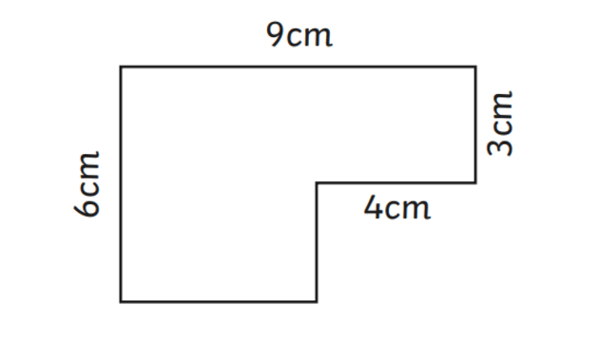

2nd rectangle

1st rectangle

If we calculate the area of the 1st rectangle and the area of the 2nd rectangle, we can add these 2 areas together to work out the area of the composite shape.

First, calculate the area of the 1st rectangle.

Looking at the diagram, we can see that 9cm is the total length of the composite shape: we only need the measurement of the 1st rectangle.

If we look across (adjacent) from the 9cm length, we can see that the small rectangle has a length of 4cm.
If we subtract this from the 9cm, we will work out the measurement of the 1st rectangle’s length.

9cm – 4cm = 5cm

2nd rectangle

1st rectangle

5cm

A = L x W
A = 6 x 5
A = 30cm²

Next, calculate the area of the 2nd rectangle.

2nd rectangle

1st rectangle

5cm

A = L x W
A = 4 x 3
A = 12cm²

Finally, add the area of the 2 rectangles together to find the total area of the composite shape.

30 + 12 = 42cm²

Question 16

Calculate the area of this composite shape.
Area = length x width
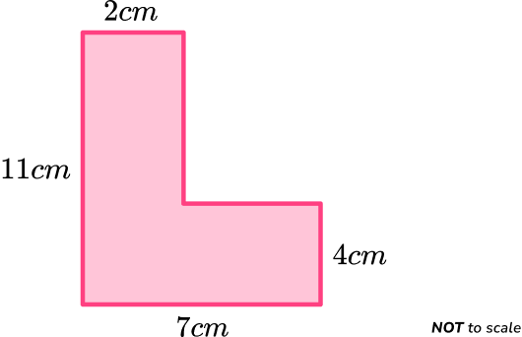

Diagram not to scale

(Show your working out.)
(3 marks)

Question 17

Calculate the area of this composite shape.
Area = length x width
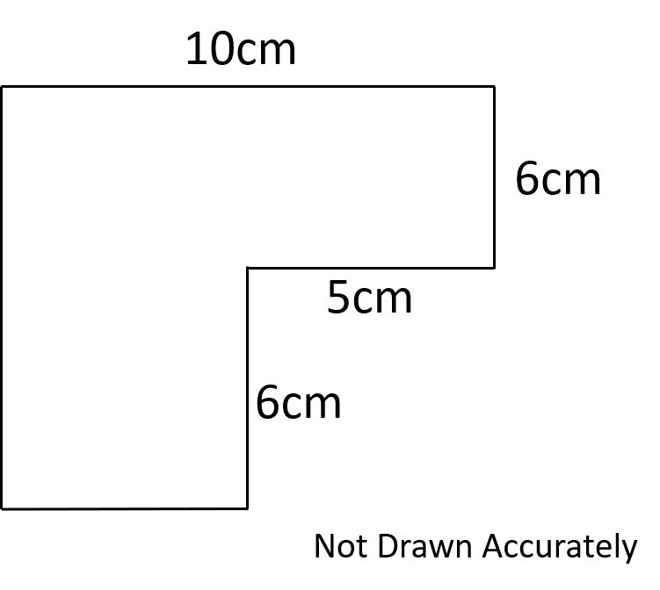

Diagram not to scale

(Show your working out.)
(3 marks)

Calculating the area of a triangle

The formula for calculating the area of a triangle is:
A = ½bh

A = area
B = base
H = height

Triangles are half of a square or rectangle. This is why we use ½

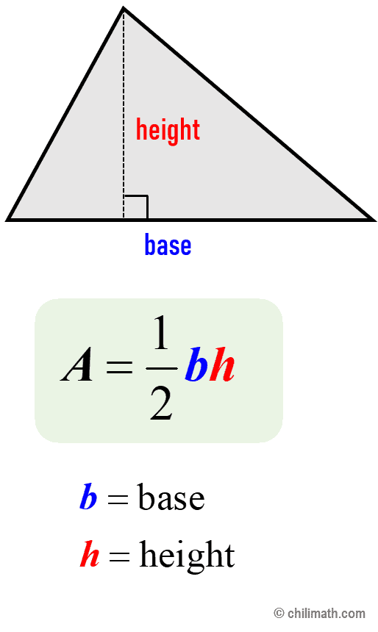

For example, calculate the area of this triangle.
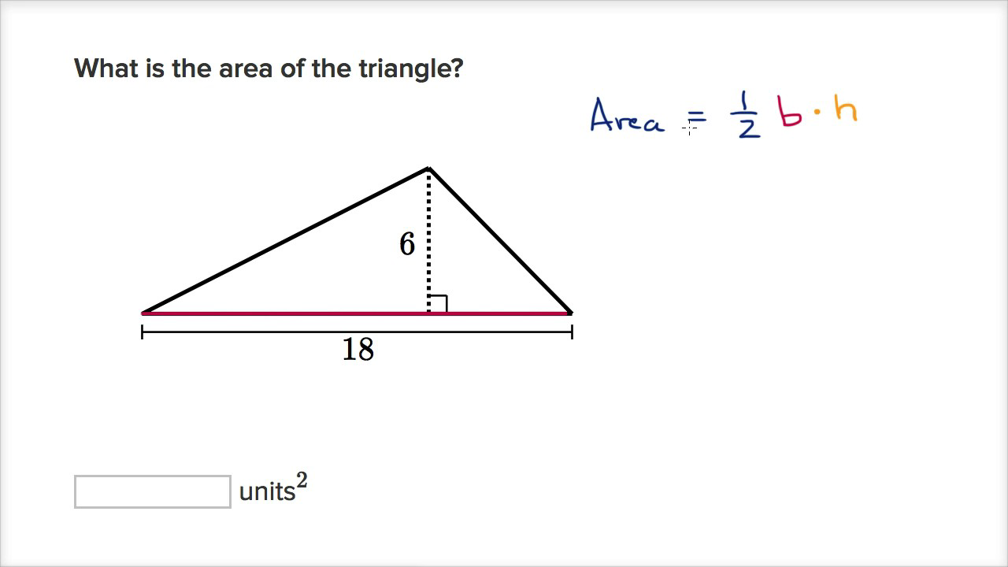

H = 6cm

B = 18cm

First, substitute the values into the formula.
A = ½bh
A = 0.5 (18 x 6)

Next, complete the calculations.
A = 0.5 x 108
A = 54cm²

Please note that the formula for calculating the area of triangles will not be given in exams.
Question 18

Calculate the area of this triangle.
Area = length x width

Diagram not to scale

H = 12cm

B = 23cm

(Show your working out.)
(3 marks)

Question 19

Calculate the area of this triangle.
Area = length x width

Diagram not to scale
H = 5cm

B = 31cm

(Show your working out.)
(3 marks)

Calculating the area of a circle

The formula for calculating the area of a circle is:
A = πr²

A = area
π = 3.14
r = radius

Radius is the distance from the middle of the circle to the edge.

Please note that the ² symbol represents ‘squared’. This means we multiply the number by itself.
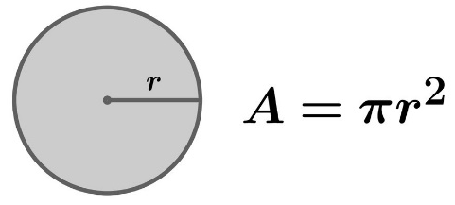

For example, calculate the area of this circle.

R = 3cm

First, substitute the values into the formula.
A = πr²
A = 3.14 x (3 x 3)

Next, complete the calculation to work out the area.
A = 3.14 x 9
A = 28.26cm²

Please note that the formula for calculating the area of a circle will not be given in exams.
Question 20

Calculate the area of this circle.
π = 3.14

Diagram not to scale

(Show your working out.)
(2 marks)

Question 21

Calculate the area of a circle with a radius of 13.2cm.
Round your answer to 2 decimal places.
π = 3.14

(Show your working out.)
(3 marks)

Question 22

Calculate the area of a circle with a diameter of 18cm.
π = 3.14
Radius = diameter ÷ 2

(Show your working out.)
(3 marks)

Exam practice 1

Calculate the perimeter and area of the shape below.
Diagram not to scale

6.9cm
6.2cm
3cm

14.6cm
(Show your working out and write your answers in the box below.)
(5 marks)
Perimeter: ______________________ cm

Area: ______________________ cm²

Exam practice 2

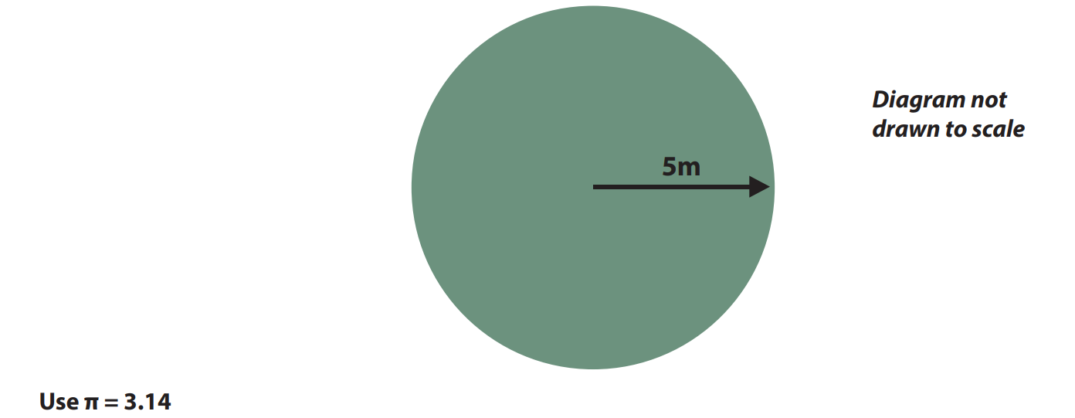

(Show your working out.)
(2 marks)

Answers

Calculating the perimeter of a square

Question 1
10 x 4 = 40cm

Question 2
25 x 4 = 100m

Question 3
400 ÷ 4 = 100m

Calculating the perimeter of a rectangle

Question 4
P = 2(L+W)
2 + 7 = 9
2 x 9 = 18
P = 18cm

Question 5
P = 2(L+W)
1 + 16 = 17
2 x 17 = 34
P = 34cm

Question 6
P = 2(L+W)

Calculating the perimeter of a triangle

Question 7
P = a + b + c
P = 12 + 9 + 5
P = 26m

Question 8
P = a + b + c
P = 7 + 8 + 16
P = 31cm

Question 9
P = a + b + c
P = 7.1 + 7.1 + 7.1
P = 21.3cm

Calculating the circumference of a circle

Question 10
C = 2πr
C = 2 x 3.14 x 6
C = 37.68cm

Question 11
C = 2πr
C = 2 x 3.14 x 3.2
C = 20.096cm
C = 20cm

Question 12
C = 2πr
C = 2 x 3.14 x 20
C = 125.6m

Calculating the area of squares and rectangles

Question 13
A = L x W
A = 12 x 7
A = 84cm²

Question 14
A = L x W
A = 10 x 10
A = 100cm²

Question 15
A = L x W
Rectangle’s length = 12cm
Half of the rectangle’s length = 6cm
A = 6 x 6
A = 36cm²

Calculating the area of composite shapes

Question 16
A = L x W

First rectangle
L = 11 – 4 = 7
W = 2
7cm
A = 7 x 2
A = 14cm²

Second rectangle
L = 7
W = 4
A = 7 x 4
A = 28cm²

14 + 28 = 42cm²

or

First rectangle
L = 11
W = 2
A = 11 x 2
A = 22cm²

Second rectangle
L = 7 – 2 = 5
W = 4
5cm
A = 5 x 4
A = 20cm²

22 + 20 = 42cm²

Question 17

A = L x W

First rectangle
L = 6 + 6
L = 12
W = 10 – 5
W = 5
A = 12 x 5
A = 60cm²

Second rectangle
L = 6
W = 5
A = 6 x 5
A = 30cm²

Total area = 60 + 30 = 90cm²

or

First rectangle
L = 10
W = 6
A = 10 x 6
A = 60cm²

Second rectangle
L = 6
W = 10 – 5
W = 5
A = 6 x 5
A = 30cm²

Total area = 60 + 30 = 90cm²

Calculating the area of a triangle

Question 18
First, substitute the values into the formula.
A = ½bh
A = 0.5 (23 x 12)

Next, complete the calculations.
A = 0.5 x 276
A = 138cm²

Question 19
First, substitute the values into the formula.
A = ½bh
A = 0.5 (31 x 5)

Next, complete the calculations.
A = 0.5 x 155
A = 77.5cm²

Calculating the area of a circle

Question 20
First, substitute the values into the formula.
A = πr²
A = 3.14 x (4 x 4)

Next, complete the calculation to work out the area.
A = 3.14 x 16
A = 50.24cm²

Question 21
First, substitute the values into the formula.
A = πr²
A = 3.14 x (13.2 x 13.2)

Next, complete the calculation to work out the area.
A = 3.14 x 174.24
A = 547.1136cm²
Rounded to 2 decimal places = 547.11cm²

Question 22
First, calculate the radius.
Radius = diameter ÷ 2
18 ÷ 2 = 9

Then, substitute the values into the formula.
A = πr²
A = 3.14 x (9 x 9)

Next, complete the calculation to work out the area.
A = 3.14 x 81
A = 254.34cm²

Exam practice

Exam practice 1

Calculate the perimeter
Perimeter = the total of all sides of the shape.

Calculate the missing sides (shown in red).
Add up all the shape’s values:

6.2 + 14.6 + 3 + 6.9 + 3.2 + 7.7 = 41.6cm

7.7cm
3.2cm
6.9cm
6.2cm
3cm

14.6cm

Calculate the area
Area = L x W

Calculate the area of rectangle 1
A = 7.7 x 6.2
A = 47.74

Calculate the area of rectangle 2
A = 6.9 x 3
A = 20.7

Calculate the total area of the composite shape
A = 47.74 + 20.7
A = 68.44cm²

Exam practice 2

First, substitute the values into the formula.
A = πr²
A = 3.14 x (5 x 5)

Next, complete the calculation to work out the area.
A = 3.14 x 25
A = 78.5cm²

Your functional skills exam

Your functional skills exams will consist of 2 papers.
These papers will take place over the following time periods:

- Non-calculator paper – 40 minutes
- Calculator – 1 hour 50 minutes

Further information on the format that your test will take can be obtained from your training provider.

Hints and tips

- Find out what format your exam will be in. It may be paper-based
or on-screen.
- Plan what you are going to revise in advance. Don’t leave it until the last minute.
- Do as many past papers as you can so you are prepared for the day. If possible, try to complete the past papers following the same format as the actual exam.
- Find a quiet place to study and revise. It helps to sit at a table or a desk, don’t revise in bed.
- Don’t stay up all night revising the night before your exam. It’s important to have a good rest so you feel refreshed and ready to go.
- Read the question 3 times. The first time to ensure you understand what is being asked, the second time to get an understanding of what you need to do, and a third time to figure out exactly what maths techniques you should be applying.
- If you are struggling with a question, skip it and come back to it later. Try not to sit getting worked up about a difficult question, it will only waste exam time. Move on and come back to it after you have answered the other questions.
- Take note of the number of marks available. This will give you an indication of how much working out you must show. For example, 1 mark will need an answer only and more marks will need you to show your working out.
- When you’ve finished the exam, go back and check your answers. If you still have time remaining, use it to check your answers and when you have checked your answers check them again.

