

FUNCTIONAL SKILLS

Maths Level 1

Area: Using numbers and the number system

Criterion 8: Read, write, order and compare common fractions and mixed numbers

Criterion 9: Find fractions of whole number quantities or measurements

Read and write common fractions and mixed numbers

The top number (the numerator) shows how many parts you have.

$$\frac{1}{2}$$

The bottom number (the denominator) shows how many parts there are in total.

Common fractions
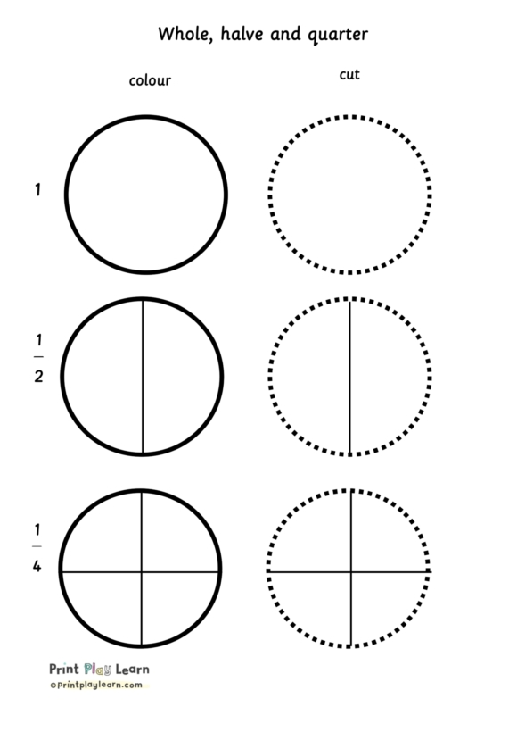
Halves
e.g. $\frac{1}{2}$

Quarters
e.g. $\frac{1}{4}$
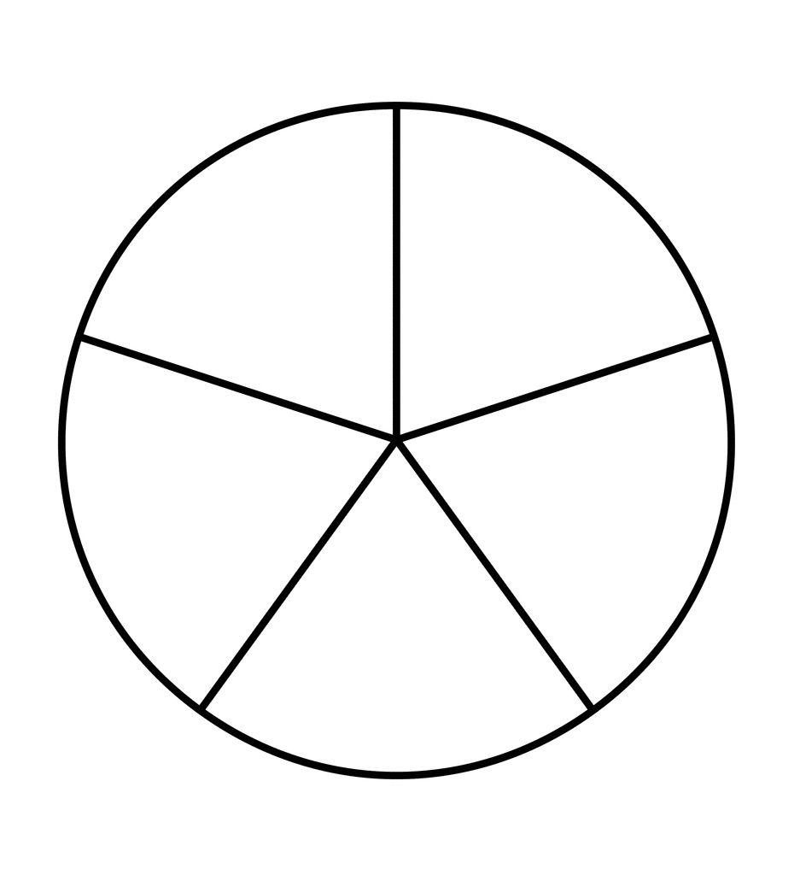

Fifths
e.g. $\frac{1}{5}$

Read and write common fractions and mixed numbers

Mixed numbers
Mixed numbers are when whole numbers and fractions are combined into a single amount.

2 $\frac{1}{2}$

Improper fractions
Improper fractions are just another way of writing mixed numbers, but with the whole numbers combined with the numerator.
3 $\frac{1}{4}$

Step 1
Whole number x denominator
3 x 4 = 12

Step 2
Add this to numerator
12 + 1 = 13

Step 3
Place back over denominator
3 $\frac{1}{4}$ = $\frac{13}{4}$

Question 1

Write ‘three quarters’ as a fraction (using numbers).
(1 mark)

Question 2

Write ‘two fifths’ as a fraction (using numbers).
(1 mark)

Question 3

Write ‘four and a half’ as a mixed number (using numbers).
(1 mark)

Order and compare fractions and mixed numbers against each other

To order and compare fractions and mixed numbers, sometimes we need to change how they look.

Which is larger?
$\frac{7}{3}$ or 2 $\frac{2}{3}$

Turning an improper fraction into a mixed number
Step 1
Divide the numerator by the denominator
7 ÷ 3 = 2 (remainder 1)

Step 2
Place back into fraction
2 $\frac{1}{3}$

Step 3
Answer the question
Therefore, 2 $\frac{2}{3}$ is larger

Converting between fractions and mixed numbers that have different denominators

Comparing $\frac{1}{2}$ and $\frac{3}{4}$

Step 1
Find lowest common denominator (find the lowest number that both denominators can divide into)
The denominators we have are 2 and 4. Both numbers can divide into 4
4 ÷ 2 = 2
4 ÷ 4 = 1
So the lowest common denominator is 4

Step 2
Form the new fractions
As 4 is already the denominator for three quarters, we can leave this fraction as it is.

$\frac{1}{2}$ has 2 as the denominator.
We changed this to 4, multiplying it by 2
2 x 2 = 4

As we have multiplied the denominator by 2 we must also multiply the numerator by 2
1 x 2 = 2 so $\frac{1}{2}$ becomes $\frac{2}{4}$

Step 3
Compare the fractions
$\frac{3}{4}$ is larger than $\frac{1}{2}$ (or $\frac{2}{4}$ )

Question 4

Write these fractions and mixed numbers in order, with the largest first.
$\frac{1}{2}$ 1 $\frac{1}{2}$ $\frac{3}{4}$
(1 mark)

Question 5

Write these fractions in order, with the smallest first.
$\frac{1}{4}$ $\frac{10}{8}$ $\frac{1}{2}$
(1 mark)

Question 6

Which of these is the smallest?
$\frac{15}{10}$ $\frac{5}{10}$ $\frac{10}{10}$
(1 mark)

Find fractions of amounts (numbers and measurements)

Finding fractions of amounts mean using a fraction to find a portion of a certain number or measurement.

Finding $\frac{3}{4}$ of 140

Method 1

Step 1
Divide the amount by the denominator (bottom number) then multiply by the numerator (top number)
140 ÷ 4 = 35 therefore one quarter of 140 is 35

Step 2
We now multiply 35 by the numerator to see what three quarters of 140 is.
35 x 3 = 105 so $\frac{3}{4}$ of 140 is 105

Method 2

Step 1
We can convert the fraction to a decimal by dividing the numerator by the denominator
$\frac{3}{4}$ = 3 ÷ 4 = 0.75

Step 2
Now we multiply the amount by the decimal to find $\frac{3}{4}$ of 140
0.75 x 140 = 105

Question 7

What is $\frac{1}{4}$ of 120?
(2 marks)

Question 8

What is $\frac{3}{10}$ of 75cm?
(2 marks)

Exam practice 1

Which of the following is smaller?

$\frac{3}{4}$ or $\frac{4}{10}$

(2 marks)

Exam practice 2

Calculate $\frac{2}{5}$ of 400m.
(2 marks)

Answers

Read and write common fractions and mixed numbers

Question 1
$$\frac{3}{4}$$
Question 2
$$\frac{2}{5}$$
Question 3
4 $\frac{1}{2}$

Order and compare fractions and mixed numbers against each other

Question 4
Largest: 1 $\frac{1}{2}$ $\frac{3}{4} \frac{1}{2}$
Question 5
Smallest: $\frac{1}{4} \frac{1}{2}$ $\frac{10}{8}$
Question 6
Smallest: $\frac{5}{10}$

Find fractions of amounts (numbers and measurements)

Question 7
120 ÷ 4 = 30

Question 8
75 ÷ 10 x 3 = 22.5cm

Exam practice

Exam practice 1
$\frac{3}{4}$ = $\frac{15}{20}$ and $\frac{4}{10}$ = $\frac{8}{20}$
$\frac{4}{10}$ is the smallest

Exam practice 2
400 ÷ 5 x 2 = 160
Your functional skills exam

Your functional skills exams will consist of 2 papers.
These papers will take place over the following time periods:

- Non-calculator paper – 40 minutes
- Calculator – 1 hour 50 minutes

Further information on the format that your test will take can be obtained from your training provider.

Hints and tips

- Find out what format your exam will be in. It may be paper-based
or on-screen.
- Plan what you are going to revise in advance. Don’t leave it until the last minute.
- Do as many past papers as you can so you are prepared for the day. If possible, try to complete the past papers following the same format as the actual exam.
- Find a quiet place to study and revise. It helps to sit at a table or a desk, don’t revise in bed.
- Don’t stay up all night revising the night before your exam. It’s important to have a good rest so you feel refreshed and ready to go.
- Read the question 3 times. The first time to ensure you understand what is being asked, the second time to get an understanding of what you need to do, and a third time to figure out exactly what maths techniques you should be applying.
- If you are struggling with a question, skip it and come back to it later. Try not to sit getting worked up about a difficult question, it will only waste exam time. Move on and come back to it after you have answered the other questions.
- Take note of the number of marks available. This will give you an indication of how much working out you must show. For example, 1 mark will need an answer only and more marks will need you to show your working out.
- When you’ve finished the exam, go back and check your answers. If you still have time remaining, use it to check your answers and when you have checked your answers check them again.

