

FUNCTIONAL SKILLS

Maths Level 1

Area: Numbers and the number system
Criterion 16: Recognise and calculate equivalencies between common fractions, percentages and decimals

What fractions, percentages and decimals represent and their equivalencies

Fractions represent parts of a whole. For example, ¹/₂ means 1 part out of 2 equal parts.
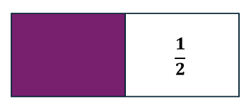

Decimals express fractions in a different way using place value. For example, 0.5 is the decimal form of ¹/₂

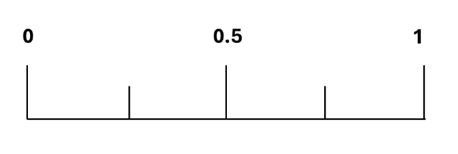
Percentages show a part out of 100. For example, 50% means 50 out of 100
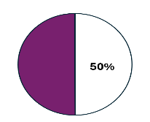

It’s helpful to memorise the decimal and percentage forms of common fractions like ¹/₂, ¹/₄, ³/₄, ¹/₁₀, and ¹/₅

For example:

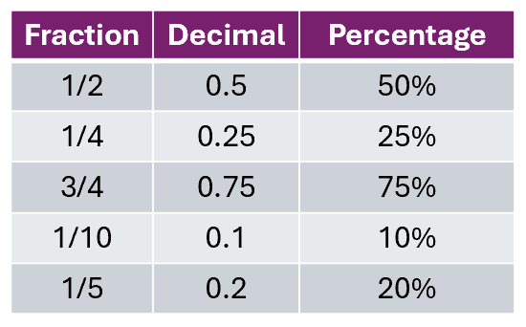

Question 1

Which of these is equivalent to 25%?

- 0.2
- $\frac{1}{4}$
- $\frac{3}{4}$

(Show your working out.)
(1 mark)

Question 2

Which of these is equivalent to 0.15?

- $\frac{3}{20}$
- 150%
- $\frac{1}{5}$

(Show your working out.)
(1 mark)

Question 3

Which of these is equivalent to $\frac{3}{5}$ ?

- 3.5
- 60%
- 35%

(Show your working out.)
(1 mark)

Convert fractions into decimals and percentages

To convert fractions to decimals:
- divide the top number (numerator) by the bottom number (denominator)
- for example, to convert ¹/₂ to a decimal:
1 ÷ 2 = 0.5
To convert fractions to percentages:
- first convert the fraction to a decimal, then multiply by 100
- for example, to convert ¹/₂ to a percentage:
1 ÷ 2 = 0.5 x 100 = 50%

Question 4

Convert $\frac{3}{5}$ into a decimal and percentage.

(Show your working out.)
(2 marks)

Question 5

Covert $\frac{18}{20}$ into a decimal and percentage.

(Show your working out.)
(2 marks)

Question 6

Convert $\frac{2}{3}$ into a decimal and percentage.

(Show your working out.)
(2 marks)

Convert percentages into fractions and decimals

To convert percentages to decimals:
- divide by 100. For example, 25% becomes 0.25 (25 ÷ 100 = 0.25)

To convert percentages to fractions:
- write the percentage over 100 and simplify if possible
- for example, 25% as a fraction is $\frac{25}{100}$ which simplifies to $\frac{1}{4}$
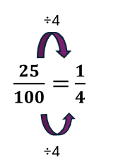

Question 7

Convert 10% into a fraction and a decimal.

(Show your working out.)
(2 marks)

Question 8

Convert 45% into a fraction and a decimal.

(Show your working out.)
(2 marks)

Question 9

Convert 5% into a fraction and a decimal.

(Show your working out.)
(2 marks)

Convert decimals into fractions and percentages

To convert decimals to percentages:
- multiply by 100
- for example, 0.75 becomes 75% (0.75 × 100 = 75%)

To convert decimals to fractions:
- use place value to write the decimal as a fraction and simplify if possible
- for example, 0.5 can be written as $\frac{50}{100}$ or $\frac{5}{10}$ which simplifies to $\frac{1}{2}$

Question 10

Convert 0.02 into a fraction and a percentage.

(Show your working out.)
(2 marks)

Question 11

Convert 0.4 into a fraction and a percentage.

(Show your working out.)
(2 marks)

Question 12

Convert 0.12 into a fraction and a percentage.

(Show your working out.)
(2 marks)

Exam practice 1

You are keeping track of the battery level on your mobile phone.

You use $\frac{1}{4}$ of the battery in the morning.

You use a further 40% in the afternoon.

How much battery do you have left?

Give your answer as a percentage.

(Show your working out.)
(3 marks)

Exam practice 2

You attend a football match, and during halftime, there is a giveaway.

Out of 100 attendees, 1 is randomly chosen to win a prize.

You, along with your 2 friends, Mia and Jake, each have 1 ticket.

  - Calculate the probability of winning by yourself
  - Calculate the combined probability of you or one of your friends winning

Give your answers as fractions and decimals.

(Show your working out.)
(4 marks)

Exam practice 3

You and your friends attend a charity dinner where a painting is raffled off.

There are 80 guests, and each guest, including you, is given 1 ticket.

You agree to share your tickets with Sam, Lee and Kim to increase your chances.

  - Calculate the probability of winning if you share tickets only with Sam
  - Calculate the probability of winning if you share tickets with Sam, Lee and Kim

Give your answers as fractions and decimals.

(Show your working out.)
(4 marks)

Exam practice 4

You are travelling on a road trip over 4 days.

On the first day, you travel $\frac{1}{8}$ of the total distance of the road trip.

On the second day, you travel 20% of the total distance of the road trip.

On the third day, you travel 0.3 of the total distance of the road trip.

What percentage of the road trip do you need to travel on the fourth day?

(Show your working out.)
(4 marks)

Answers

Question 1
b) $\frac{1}{4}$

Question 2
a) $\frac{3}{20}$

Question 3
b) 60%

Question 4
$\frac{3}{5}$ = 0.6 = 60%

Question 5
$\frac{18}{20}$ = 0.9 = 90%

Question 6
$\frac{2}{3}$ = 0.67 = 66.67% (or 67%)

Question 7
10% = $\frac{1}{10}$ = 0.1

Question 8
45% = $\frac{9}{20}$ = 0.45

Question 9
5% = $\frac{1}{20}$ = 0.05

Question 10
0.02 = $\frac{1}{50}$ = 2%

Question 11
0.4 = $\frac{2}{5}$ = 40%

Question 12
0.12 = $\frac{3}{25}$ = 12%

Exam practice

Exam practice 1
$\frac{1}{4}$ = 25%
100% - 25% - 40% = 35%

Exam practice 2
By yourself: Probability = $\frac{1}{100}$ = 0.01
With friends: Probability = $\frac{3}{100}$ = 0.03

Exam practice 3
With Sam: Probability = $\frac{2}{80}$ = $\frac{1}{40}$ = 0.025
With Sam, Lee and Kim: Probability = $\frac{4}{80}$ = $\frac{1}{20}$ = 0.05

Exam practice 4
$\frac{1}{8}$ = 0.125 x 100 = 12.5%
0.3 x 100 = 30%
12.5% + 20% + 30% = 62.5%

Fourth day: 100% - 62.5% = 37.5%

Your functional skills exam

Your functional skills exams will consist of 2 papers.
These papers will take place over the following time periods:

- Non-calculator paper – 40 minutes
- Calculator – 1 hour 50 minutes

Further information on the format that your test will take can be obtained from your training provider.

Hints and tips

- Find out what format your exam will be in. It may be paper-based
or on-screen.
- Plan what you are going to revise in advance. Don’t leave it until the last minute.
- Do as many past papers as you can so you are prepared for the day. If possible, try to complete the past papers following the same format as the actual exam.
- Find a quiet place to study and revise. It helps to sit at a table or a desk, don’t revise in bed.
- Don’t stay up all night revising the night before your exam. It’s important to have a good rest so you feel refreshed and ready to go.
- Read the question 3 times. The first time to ensure you understand what is being asked, the second time to get an understanding of what you need to do, and a third time to figure out exactly what maths techniques you should be applying.
- If you are struggling with a question, skip it and come back to it later. Try not to sit getting worked up about a difficult question, it will only waste exam time. Move on and come back to it after you have answered the other questions.
- Take note of the number of marks available. This will give you an indication of how much working out you must show. For example, 1 mark will need an answer only and more marks will need you to show your working out.
- When you’ve finished the exam, go back and check your answers. If you still have time remaining, use it to check your answers and when you have checked your answers check them again.

