

FUNCTIONAL SKILLS

Maths Level 1

Area: Using common measures, shape and space
Criterion 23: Calculate the volumes of cubes and cuboids

What is volume?

Volume is the amount of space inside a 3-D shape.
It tells you how much an object can hold.

Examples in everyday life:

- how much water fits in a fish tank
- how many boxes can fit in a van
- how much soil is needed to fill a plant pot
- how much a storage box can hold

Volume is used when you're dealing with things that have length, width and height, or anything that takes up space.

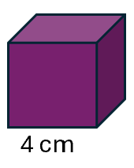
The volume formulae for a cube:
All sides of a cube are the same length.

Volume = length × length × length

This can also be written as length³

This means the length is multiplied by itself three times.

For example, a cube has sides that are 4cm long.

Find the cube’s volume by doing the following calculation:

4 x 4 x 4 = 64cm³

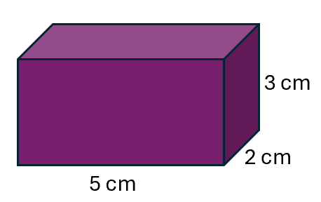
The volume formulae for a cuboid:

A cuboid has different lengths, widths and heights
(like a cereal box or a drawer).

Volume = length × width × height

For example, a cuboid has a length of 5cm, a width of 2cm and a height of 3cm.

Find the cuboid’s volume by doing the following calculation:

5 x 2 x 3 = 30cm³

Here are some steps you can follow to help you work out the volume.

- Identify the shape: is it a cube or a cuboid?

- Write down the measurements: check the units (for example, cm or m) and convert these if needed

- Use the correct formula:
Cube: length × length × length
Cuboid: length × width × height

- Multiply the values

- Write your answer: make sure you use the correct units (for example, cm³)

Question 1

What is the volume of a cube with a length of 3cm?

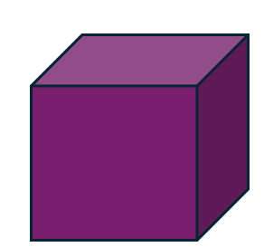
3cm

(Show your working out.)
(2 marks)

Question 2

A cuboid has a length of 8cm, a width of 5cm and a height of 2cm.

What is the volume of the cuboid?

2cm
5cm
8cm

(Show your working out.)
(2 marks)

Question 3

What is the volume of a cube with a length of 5m?

(Show your working out.)
(2 marks)

Question 4

Find the volume of a cuboid that is:
- 10cm long
- 3cm wide
- 4cm high

(Show your working out.)
(2 marks)

Question 5

The base of a cuboid is 10cm by 6cm. It is 12cm high.

What is the volume?

(Show your working out.)
(2 marks)

Solving everyday volume problems

You may be asked to use volume to solve real-life problems, such as:

- how many litres of paint are needed to fill a tank
- how many small boxes fit into a large container
- whether a package meets postal size limits

To solve these problems, follow the steps below.

- Work out the volume of the object(s)

- Check what the question is asking (for example, is it asking you to calculate the total volume, compare volumes or whether one object will fit into another?)

- Use estimation, if needed, to check if your answer makes sense

- Give your final answer with the correct units

Question 6

A parcel has a volume of 45,000cm³

It needs to be placed in a storage box measuring 0.6m × 0.5m × 0.2m

Will the parcel fit in the storage box?

Give your answer in cm³

(Show your working out.)
(4 marks)

Question 7

A storage bin has a volume of 70,000cm³

Can it fit in a space that is 0.7m high, 0.3m wide, and 0.4m deep?

(Show your working out.)
(4 marks)

Question 8

A small box has a volume of 5,000cm³

It needs to be stored in a cupboard that is 0.4m high, 0.4m wide and 0.4m deep.

Will the box fit in the cupboard?

Give your answer in cm³

(Show your working out.)
(4 marks)

Exam practice 1

A box has a volume of 140,000cm³

You want to store it in your kitchen cupboard.

The cupboard is 0.5m high, 0.6m wide and 0.4m deep.

Will the box fit inside the cupboard?

(Show your working out.)
(4 marks)

Exam practice 2

A crate has a volume of 0.08m³

Will it fit into a van compartment that measures:
- 50cm high
- 80cm wide
- 30cm long?

(Show your working out.)
(4 marks)

Exam practice 3

A wooden box is 0.35m high, 0.4m wide and 0.3m long.

What is its volume?

Give your answer in cm³

(Show your working out.)
(3 marks)

Exam practice 4

A cardboard box is 45cm long, 35cm wide and 25cm high.

What is its volume?

Give your answer in m³

(Show your working out.)
(3 marks)

Answers

Question 1
Volume = 3 × 3 × 3 = 27cm³

Question 2
Volume = 8 × 5 × 2 = 80cm³

Question 3
Volume = 5 x 5 x 5 = 125m³

Question 4
Volume = 10 x 3 x 4 = 120cm³

Question 5
Volume = 10 × 6 × 12 = 720cm³

Solving everyday problems

Question 6
Convert to cm: 0.6m = 60cm, 0.5m = 50cm, 0.2m = 20cm
Volume = 60 × 50 × 20 = 60,000cm³
45,000cm³ is less than 60,000cm³

Yes, the parcel will fit.

Question 7
Convert to cm: 0.7m = 70cm, 0.3m = 30cm, 0.4m = 40cm
Volume = 70 × 30 × 40 = 84,000cm³
70,000cm³ is less than 84,000cm³

Yes, it will fit.

Question 8
Convert to cm: 0.4m = 40cm
Volume = 40 × 40 × 40 = 64,000cm³
5,000cm³ is less than 64,000cm³

Yes, the box will fit.

Exam practice

Exam practice 1
Convert: 0.5m = 50cm, 0.6m = 60cm, 0.4m = 40cm
Volume = 50 × 60 × 40 = 120,000cm³
120,000cm³ is less than 140,000cm³

No, the box will not fit inside the cupboard.

Exam practice 2
Convert compartment to m: 0.5m × 0.8m × 0.3m = 0.12m³
0.08m³ is less than 0.12m³

Yes, it will fit.

Exam practice 3
Convert to cm: 35cm × 40cm × 30cm = 42,000cm³

Exam practice 4
Convert to m: 0.45m × 0.35m × 0.25m = 0.039375m³

Your functional skills exam

Your functional skills exams will consist of 2 papers.
These papers will take place over the following time periods:

- Non-calculator paper – 40 minutes
- Calculator – 1 hour 50 minutes

Further information on the format that your test will take can be obtained from your training provider.

Hints and tips

- Find out what format your exam will be in. It may be paper-based
or on-screen.
- Plan what you are going to revise in advance. Don’t leave it until the last minute.
- Do as many past papers as you can so you are prepared for the day. If possible, try to complete the past papers following the same format as the actual exam.
- Find a quiet place to study and revise. It helps to sit at a table or a desk, don’t revise in bed.
- Don’t stay up all night revising the night before your exam. It’s important to have a good rest so you feel refreshed and ready to go.
- Read the question 3 times. The first time to ensure you understand what is being asked, the second time to get an understanding of what you need to do, and a third time to figure out exactly what maths techniques you should be applying.
- If you are struggling with a question, skip it and come back to it later. Try not to sit getting worked up about a difficult question, it will only waste exam time. Move on and come back to it after you have answered the other questions.
- Take note of the number of marks available. This will give you an indication of how much working out you must show. For example, 1 mark will need an answer only and more marks will need you to show your working out.
- When you’ve finished the exam, go back and check your answers. If you still have time remaining, use it to check your answers and when you have checked your answers check them again.

