

FUNCTIONAL SKILLS

English Level 2

Area: Reading
Criterion: Identify different styles of writing and writer’s voice

Styles of writing

Style of writing refers to the way an author uses language and linguistic techniques, such as word choice, to meet a specific purpose. Texts can have multiple styles of writing.
Styles of writing include:
- formal or informal
- explanatory
- informative
- expository
- factual
- instructional
- descriptive
- persuasive

Text A
The aging population

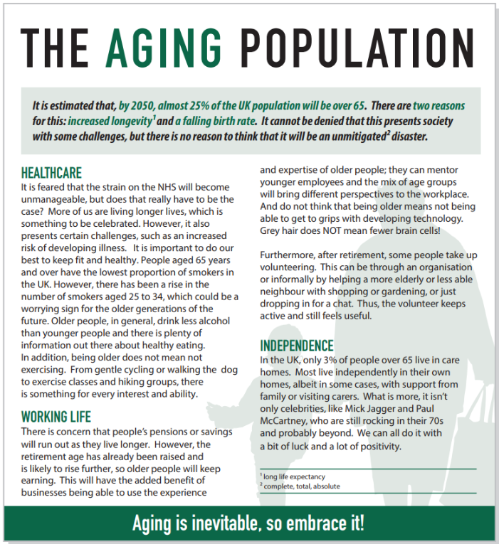

Text B
Highfield care in the community: individual report

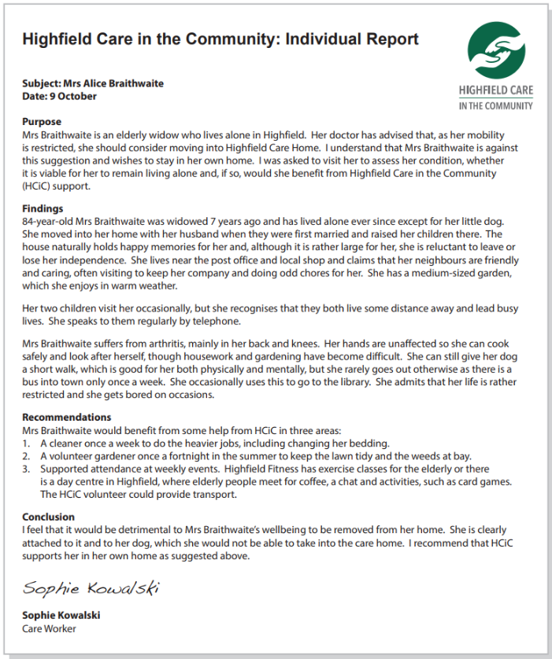

Text C
Boost your everyday skills!
Boost your everyday skills!
Elevate your daily life with our Essential Skills Course. In just 6 weeks, learn crucial numeracy, literacy, digital skills and problem-solving techniques that will enhance both your personal and professional life.
Key highlights:
Flexible evening and weekend classes.
Hands-on learning from expert instructors.
Competitive pricing with financial assistance options.
Benefits:
Manage finances better.
Communicate effectively.
Navigate the digital world with ease.
Solve problems efficiently.
Spaces are limited! Register now to secure your spot and unlock your potential. Visit our website or call us today for more information!



Using the information provided above, answers the following questions.

Question 1

Look at Text C. The style of writing in this text is persuasive.
Find two examples from the text to support your answer.

Example 1:

Example 2:

Question 2

Text C also has an informative writing style.
Find two examples from the text to support your answer.

Example 1:

Example 2:

Exam practice 1

What style of writing is used in Text A? Give two examples from the text to support your answer.
(3 marks)
Style of writing:

Example 1:

Example 2:

Exam practice 2

What style of writing is used in Text B? Give two examples from the text to support your answer.
(3 marks)

Style of writing:

Example 1:

Example 2:

Tone of voice

The writer's voice, or tone of voice, is expressed through the writer’s use of language and word choice. The writer uses language to convey their ideas, opinions and emotions. Examples of tone of voice include:
- friendly
- personal
- positive or optimistic
- enthusiastic
- emotional
- empathetic
- negative or pessimistic
- frustrated or angry

Using the information provided above, answers the following questions.

Question 3

Look at Text C. The writer has an enthusiastic tone of voice.
Find two examples from the text to support your answer.

Example 1:

Example 2:

Exam practice 3

What tone of voice has the writer of Text A used?
Provide two examples from the text to support your answer.
(3 marks)

Tone of voice:

Example 1:

Example 2:

Exam practice 4

What tone of voice has the writer of Text B used?
Provide two examples from the text to support your answer.
(3 marks)

Tone of voice:

Example 1:

Example 2:

Answers

Style of writing

Question 1
Please note that there may be other correct examples within the text.

Example 1: ‘Spaces are limited! Register now to secure your spot and unlock your potential.’ This creates a sense of urgency and encourages immediate action, persuading the reader to enroll quickly to avoid missing out.
Example 2: ‘Manage finances better. Communicate effectively. Navigate the digital world with ease. Solve problems efficiently.’ By listing these benefits, the text persuades the reader, appealing to their desire for personal and professional improvement.

Question 2
Please note that there may be other correct examples within the text.

Example 1: ‘Elevate your daily life with our Essential Skills Course. In just 6 weeks, learn crucial numeracy, literacy, digital skills and problem-solving techniques that will enhance both your personal and professional life.’ This provides specific information about the course duration and the skills covered, informing the reader about what to expect from the programme.
Example 2: ‘Flexible evening and weekend classes. Hands-on learning from expert instructors. Competitive pricing with financial assistance options.’ This section gives detailed information about the class schedule, teaching style and financial options, helping the reader make an informed decision about enrolling.

Exam practice 1
Please note that there may be other correct examples within the text.

Styles of writing could include:
- expository
- persuasive

Expository example answers include:
- expository example 1: ‘People aged 65 years and over have the lowest proportion of smokers in the UK. However, there has been a rise in the number of smokers aged 25 to 34, which could be a worrying sign for the older generations of the future.’ This provides factual information and statistics to inform the reader about smoking habits across different age groups.
- expository example 2: ‘In the UK, only 3% of people over 65 live in care homes. Most live independently in their own homes, albeit in some cases, with support from family or visiting carers.’ This section explains the living arrangements of older people in the UK, providing clear and informative details to the reader.

Persuasive example answers include:
- persuasive example 1: ‘Aging is inevitable, so embrace it!’ This statement encourages the reader to adopt a positive attitude towards aging.
- persuasive example 2: ‘Grey hair does NOT mean fewer brain cells!’ This directly addresses and counters a common stereotype, persuading the reader to reconsider their views on older people and technology.

Exam practice 2
Please note that there may be other correct examples within the text.

Styles of writing could include:
- factual
- informative

Factual example answers include:
- factual example 1: ‘84-year-old Mrs Braithwaite was widowed 7 years ago and has lived alone ever since except for her little dog.’ This provides clear, objective facts about Mrs. Braithwaite's background.
- factual example 2: ‘Mrs Braithwaite suffers from arthritis, mainly in her back and knees.’ This statement gives factual information about her health and abilities.

Informative example answers include:
- informative example 1: ‘I was asked to visit her to assess her condition, whether it is viable for her to remain living alone and, if so, if she would benefit from Highfield Care in the Community (HCiC) support.’ This gives information about the report and the assessment process.
- informative example 2: ‘Mrs Braithwaite would benefit from some help from HCiC in three areas: 1. A cleaner once a week to do the heavier jobs, including changing her bedding.’ This provides informative recommendations based on the findings, detailing the specific support she needs.

Tone of voice

Question 3
Please note that there may be other correct examples within the text.

Example 1: the opening line ‘Boost your everyday skills! Elevate your daily life with our Essential Skills Course.’ uses enthusiastic language to excite the reader about the course.
Example 2: ‘Spaces are limited! Register now to secure your spot and unlock your potential.’ - This call to action is delivered with enthusiasm, encouraging immediate action and highlighting the positive outcome of unlocking one's potential.

Exam practice 3
Please note that there may be other correct examples within the text.

Correct tone of voice may include:
- positive
- encouraging
- optimistic
- supportive

Examples from the text include:
- ‘Aging is inevitable, so embrace it!’ - This statement encourages readers to accept and embrace ‘More of us are living longer lives, which is something to be celebrated.’ - This emphasises the positive aspect of increased life expectancy and encourages a celebratory attitude.
- ‘Do not think that being older means not being able to get to grips with developing technology. Grey hair does NOT mean fewer brain cells!’ - This challenges stereotypes about aging with an optimistic and encouraging tone.
- ‘What is more, it isn’t only celebrities, like Mick Jagger and Paul McCartney, who are still rocking in their 70s and probably beyond. We can all do it with a bit of luck and a lot of positivity.’ - This example encourages readers by highlighting the achievements of older celebrities and suggesting that everyone can maintain an active and positive lifestyle.

Exam practice 4
Please note that there may be other correct examples within the text.

Correct tone of voice may include:
- empathetic
- supportive
- understanding
- compassionate

Examples from the text include:
- ‘I feel that it would be detrimental to Mrs Braithwaite’s wellbeing to be removed from her home. She is clearly attached to it and to her dog, which she would not be able to take into the care home.’ - This shows empathy by recognising the emotional importance of Mrs Braithwaite's home pet.
- ‘The house naturally holds happy memories for her and, although it is rather large for her, she is reluctant to leave or lose her independence.’ – This shows empathy for Mrs Braithwaite’s past memories and home.
- ‘Mrs Braithwaite would benefit from some help from HCiC in three areas: 1. A cleaner once a week to do the heavier jobs, including changing her bedding. 2. A volunteer gardener once a fortnight in the summer to keep the lawn tidy and the weeds at bay. 3. Supported attendance at weekly events.’ - This provides detailed, supportive recommendations to improve her quality of life while staying in her home.

Your functional skills exam

Your functional skills exams will consist of 2 papers.
These papers will take place over the following time periods:

- Reading – 60 minutes
- Writing – 60 minutes

Further information on the format that your test will take can be obtained from your training provider.

Hints and tips

- Find out what format your exam will be in. It may be paper-based
or on-screen.
- Plan what you are going to revise in advance. Don’t leave it until the last minute.
- Do as many past papers as you can so you are prepared for the day. If possible, try to complete the past papers following the same format as the actual exam.
- Find a quiet place to study and revise. It helps to sit at a table or a desk, don’t revise in bed.
- Don’t stay up all night revising the night before your exam. It’s important to have a good rest so you feel refreshed and ready to go.
- Read the question 3 times. The first time to ensure you understand what is being asked, the second time to get an understanding of what you need to do, and a third time to figure out exactly what maths techniques you should be applying.
- If you are struggling with a question, skip it and come back to it later. Try not to sit getting worked up about a difficult question, it will only waste exam time. Move on and come back to it after you have answered the other questions.
- Take note of the number of marks available. This will give you an indication of how much working out you must show. For example, 1 mark will need an answer only and more marks will need you to show your working out.
- When you’ve finished the exam, go back and check your answers. If you still have time remaining, use it to check your answers and when you have checked your answers check them again.

