

FUNCTIONAL SKILLS

Maths Level 1

Area: Using common measures, shape and space
Criterion 22: Calculate the area and perimeter of simple shapes including those that are made up of a combination of rectangles

Perimeter

Perimeter is the distance all the way around the outside of a two-dimensional (flat) shape.
Think of it like the fence around a garden – it tells you how much fencing you would need to go all the way around.

- Perimeter is usually measured in units such as millimetres (mm), centimetres (cm), metres (m) or kilometres (km)

- Perimeter is always a length, not an area

To calculate the perimeter of a rectangle:

Add up the lengths of all 4 sides.

Formula:
Perimeter = length + width + length + width
or
Perimeter = 2 x (length + width)
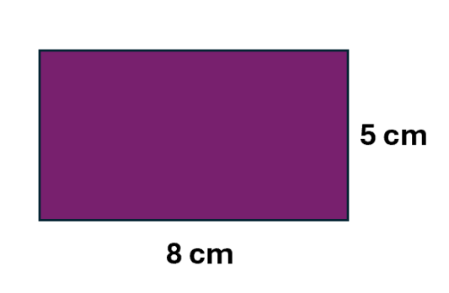
Perimeter = 8 + 5 + 8 + 5 = 26cm
or
Perimeter = 2 x (8 + 5) = 2 x 13 = 26 cm

To calculate the perimeter of a square:

A square has 4 sides that are all the same length.

Formula:
Perimeter = 4 x side

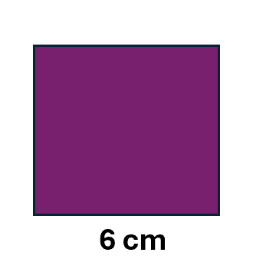
Perimeter = 4 x 6 = 24cm

To calculate the perimeter of a triangle:

A triangle has 3 sides.

Formula:
Perimeter = side a + side b + side c

Example 1:
5cm

5 x 3 = 15cm

Example 2: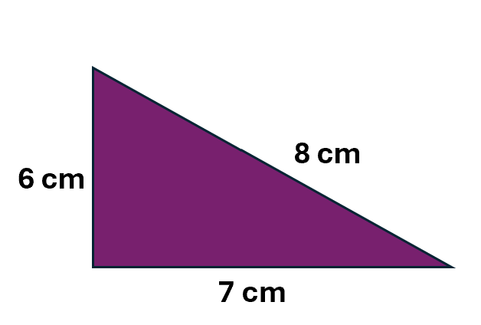
6 + 7 + 8 = 21cm

To calculate the perimeter of a compound shape:

- add up all the outside edges
- be careful – some sides may not be labelled directly, so you might have to calculate missing sides first
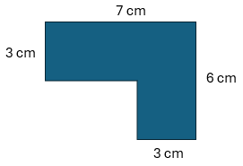
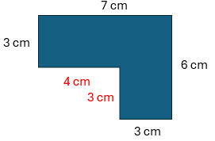
7 + 6 + 3 + 3 + 4 + 3 = 26cm

Question 1

Calculate the perimeter of this square.
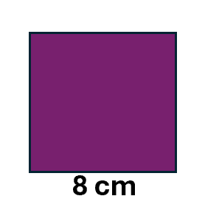

(Show your working out.)
(2 marks)

Question 2

Calculate the perimeter of this rectangle.
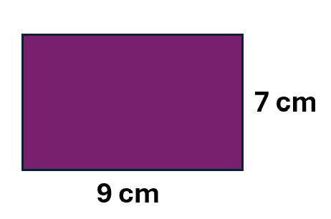

(Show your working out.)
(2 marks)

Question 3

Calculate the perimeter of this triangle.
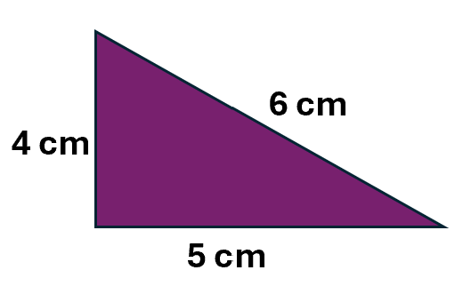
(Show your working out.)
(2 marks)

Question 4

Calculate the perimeter of this compound shape.
12cm

5cm
9cm

5cm

(Show your working out.)
(3 marks)

Area

Area is the amount of space inside a two-dimensional shape.
Think of it like how much grass covers your garden or how much carpet you would need for a room.

- Area is measured in square units such as mm², cm², m² or km²

- Tip: The small number ² (called ‘squared’) shows you are measuring area, not just a length

To calculate the area of a rectangle or square:

Multiply the length by the width.

Formula:
Area = length × width
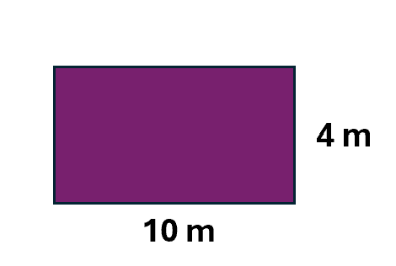
Area = 10 x 4 = 40m²

To calculate the area of a triangle:

A triangle can be seen as half of a rectangle or square, therefore, you could use the same method to calculate the area and then divide your answer by 2.

For triangles, the terms base and height are used, as opposed to length and width.

Formula:
Area = ½ base x height
Or
Area = (base x height) ÷ 2
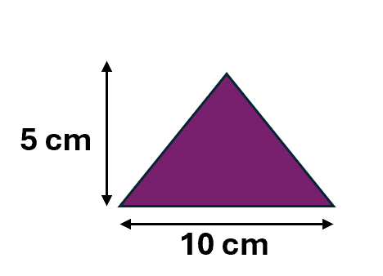
(10 x 5) ÷ 2
50 ÷ 2 = 25cm²

To calculate the area of a compound shape:

- break the shape into smaller parts
- draw lines if needed to show where the shapes are separated
- work out the area of each rectangle separately
- use the area formula: length × width
- add the areas together to find the total area
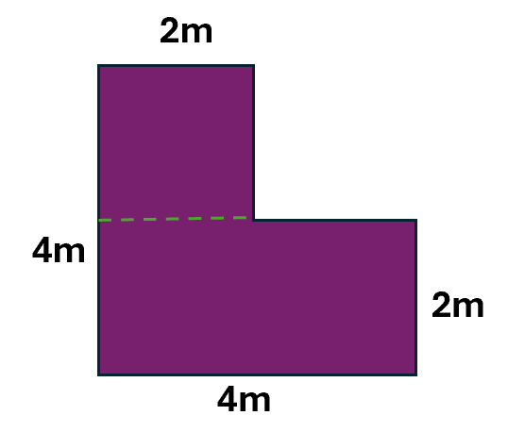
- Find the area of each rectangle separately
- Add the 2 areas together to find the total area
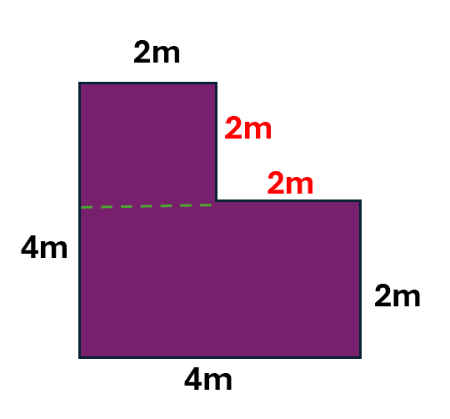
2m x 2m = 4m²
4m x 2m = 8m²
Area = (2m x 2m) + (4m x 2m) = 12m²

Question 5
Calculate the area of this square.
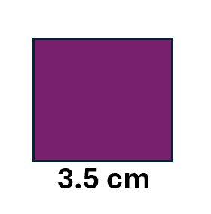
(Show your working out.)
(2 marks)

Question 6
Calculate the area of this rectangle.
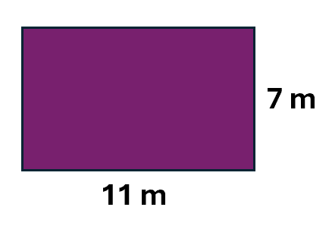
(Show your working out.)
(2 marks)

Question 7
Calculate the area of this triangle.
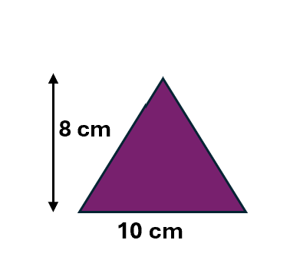
(Show your working out.)
(2 marks)

Question 8

Calculate the area of this compound shape.

12 cm

5 cm
9 cm

5 cm

(Show your working out.)
(3 marks)

Exam practice 1

Calculate the perimeter of this compound shape.
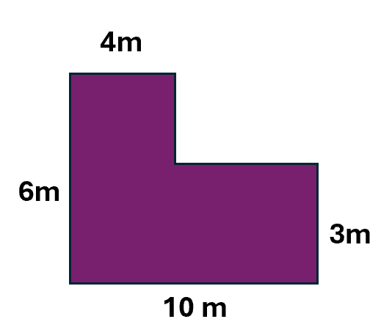
(Show your working out.)

(3 marks)

Exam practice 2
area
Calculate the of this compound shape.
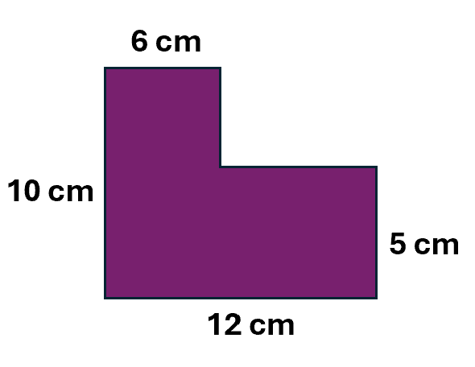

(Show your working out.)
(3 marks)

Answers

Perimeter

Question 1
8 + 8 + 8 + 8 = 32cm

Question 2
2 x (9 + 7) = 32cm

Question 3
4 + 5 + 6 = 15cm

Question 4
12 + 9 + 5 + 4 + 7 + 5 = 42cm

Area

Question 5
3.5 x 3.5 = 12.25cm²

Question 6
11 x 7 = 77m²

Question 7
(8 x 10) ÷ 2 = 40cm²

Question 8
12 x 5 = 60 and 5 x 4 = 20
60 + 20 = 80cm²
Or
9 x 5 = 45 and 5 x 7 = 35
45 + 35 = 80cm²

Exam practice

Exam practice 1
4 + 3 + 6 + 3 +10 + 6 = 32m

Exam practice 2
(6 x 5 = 30) + (12 x 5 = 60) = 90cm²
Or
(10 x 6 = 60) + (6 x 5 = 30) = 90cm²

Your functional skills exam

Your functional skills exams will consist of 2 papers.
These papers will take place over the following time periods:

- Non-calculator paper – 40 minutes
- Calculator – 1 hour 50 minutes

Further information on the format that your test will take can be obtained from your training provider.

Hints and tips

- Find out what format your exam will be in. It may be paper-based
or on-screen.
- Plan what you are going to revise in advance. Don’t leave it until the last minute.
- Do as many past papers as you can so you are prepared for the day. If possible, try to complete the past papers following the same format as the actual exam.
- Find a quiet place to study and revise. It helps to sit at a table or a desk, don’t revise in bed.
- Don’t stay up all night revising the night before your exam. It’s important to have a good rest so you feel refreshed and ready to go.
- Read the question 3 times. The first time to ensure you understand what is being asked, the second time to get an understanding of what you need to do, and a third time to figure out exactly what maths techniques you should be applying.
- If you are struggling with a question, skip it and come back to it later. Try not to sit getting worked up about a difficult question, it will only waste exam time. Move on and come back to it after you have answered the other questions.
- Take note of the number of marks available. This will give you an indication of how much working out you must show. For example, 1 mark will need an answer only and more marks will need you to show your working out.
- When you’ve finished the exam, go back and check your answers. If you still have time remaining, use it to check your answers and when you have checked your answers check them again.

