

FUNCTIONAL SKILLS

Maths Level 2

Area: Measure, shape and space
Criterion: 15. Use formulae to find volumes and surface areas of 3-D shapes including cylinders (formulae to be given for 3-D shapes other than cylinders)

Underpinning knowledge

Underpinning knowledge of the following is required before attempting this workbook:
- order of precedence: BIDMAS (or BODMAS)
- converting between metres and centimetres
- area of a circle
- area of a square
- area of a rectangle

Calculating the volume of cubes

Volume is the amount of space within a 3-D shape or an object.

The formula for calculating the volume of a cube is: V = L x W x H.

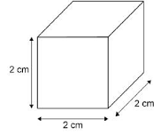

V = volume
L = length
W = width
H = height

The L (length) is 2cm, the W (width) is 2cm and the H (height) is 2cm.

Volume = 2cm x 2cm x 2cm = 8cm³
Therefore, the volume of the cube = 8cm³.

A cube’s volume is found when we multiply a number by itself and then itself again. The symbol for cubed is ³.

Each face of a cube is made up of a square, so each side will have the same length. This is because a square’s sides are all the same length. Therefore, you only need to be given 1 measurement to calculate the volume of a cube.

The formula for calculating a cube’s volume will be given in your exam.

Question 1

Calculate the volume of this cube.

Formula = length x width x height

Diagram not to scale

W = 6cm

(Show your working out.)
(2 marks)

Answer: ________cm³

Question 2

Calculate the volume of this cube.

Formula = length x width x height

H = 14m
Diagram not to scale

(Show your working out.)
(2 marks)

Answer: ________m³

Question 3

A cube has a height of 12cm. Calculate the volume of the cube.

Formula = length x width x height

(Show your working out.)
(2 marks)

Answer: ________cm³

Calculating the volume of cuboids

The formula for calculating the volume of a cuboid is the same as the formula for calculating the volume of a cube: V = L x W x H.

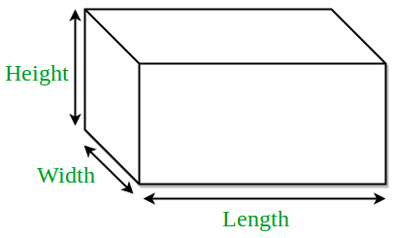
V = volume
4 cm
L = length
W = width
H = height
3 cm
9 cm

The L (length) is 9cm, the W (width) is 3cm and the H (height) is 4cm.

Volume = 9cm x 3cm x 4cm = 108cm³
Therefore, the volume of the cuboid = 108cm³.

Although cuboids use the same formula as cubes to calculate volume, their length, width and height will all be different.

The formula for calculating a cube’s volume will be given in your exam.

Question 4

Calculate the volume of this cuboid.

Formula = length x width x height

H = 7cm
Diagram not to scale

W = 6cm
L = 14cm

(Show your working out.)
(2 marks)

Answer: ________cm³

Question 5

Calculate the volume of this cuboid.

Formula = length x width x height

H = 4cm
Diagram not to scale

W = 4cm
L = 8cm

(Show your working out.)
(2 marks)

Answer: ________cm³

Question 6

What is the volume of a cuboid with the following measurements?
- Length = 21cm
- Width = 9cm
- Height = 10cm

Formula = length x width x height

(Show your working out.)
(2 marks)

Answer: ________cm³

Calculating the volume of cylinders

The formula for calculating the volume of a cylinder is:

v = π r² h
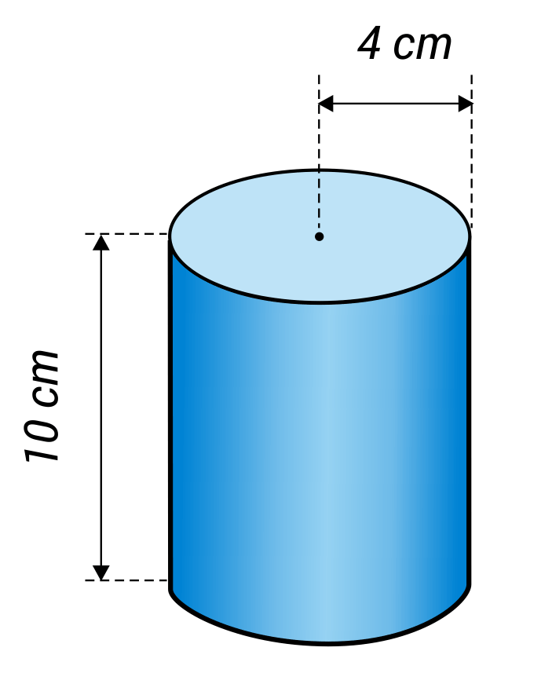
- v = volume
- π = 3.14
- r = radius
- h = height

For example, the cylinder shown has:

- a height of 10cm
- a radius of 4cm

Therefore, the volume = 3.14 x (4 x 4) x 10

Volume = 3.14 x 16 x 10
Volume = 502.4cm³

The formula for calculating the volume of a cylinder will not be given in your exam.
Question 7

Calculate the volume of a cylinder with a radius of 4.5cm and height of 18cm.

π = 3.14
r = 4.5cm

Diagram not to scale
h = 18cm

(Show your working out.)
(4 marks)

Answer: ________cm³

Question 8

Calculate the volume of a cylinder with a radius of 12cm and height of 42cm?

π = 3.14

r = 12cm

Diagram not to scale
h = 42cm

(Show your working out.)
(4 marks)

Answer: ________cm³

Question 9

What is the volume of a cylinder with a radius of 7.5cm and height of 10cm?

π = 3.14

r = 7.5cm

Diagram not to scale
h = 10cm

(Show your working out.)
(2 marks)

Answer: ________cm³

Surface area of a cube

Surface area is the area of each side of a 3-D shape.

For example, cubes have 6 faces.

To calculate the surface area, find the surface area of 1 face and then multiply the answer by how many faces the 3-D shape has.

Calculating the surface area of a cube

The formula for calculating the surface area of a cube is:

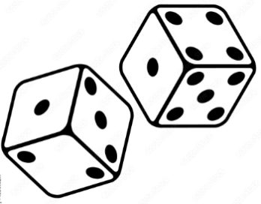
SA = 6a²

SA = surface area
a = length of 1 side
a² = area of of a cube’s face

For example, the surface area of a cube is worked out as follows:
Surface area = 6a²
Surface area = 6 x (12 x 12)
12 x 12 = 144
6 x 144 = 864
Surface area = 864cm²

Question 10

Calculate the surface area of this cube. Each side is 20cm long.

Surface area = 6a²
a = length of 1 side

a = 20cm
Diagram not to scale

(Show your working out.)
(3 marks)

Answer: ________cm²

Question 11

Calculate the surface area of this cube. Each side measures 15cm.

Surface area = 6a²
a = length of 1 side

a = 15cm
Diagram not to scale

(Show your working out.)
(3 marks)

Answer: ________cm²

Question 12

Calculate the surface area of a cube. Each side measures 19cm.

Surface area = 6a²
a = length of 1 side

(Show your working out.)
(3 marks)

Answer: ________cm³

Surface area of a cuboid

The formula for calculating the surface area of a cuboid is:

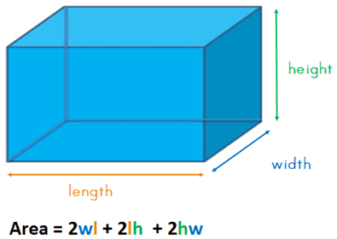
SA = 2wl + 2lh + 2hw

- SA = surface area
- w = width
- l = length
- h = height

The surface area of the cuboid below is worked out as follows:
- l = 5cm
- w = 3cm
- h = 2cm

SA = 2lw + 2lh + 2hw

Substitute the length, width and height into the formula.
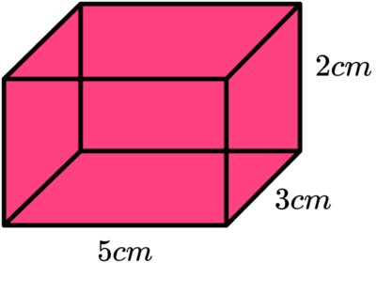
SA = 2(5x3) + 2(5x2) + 2(2x3)

Multiply out the brackets
SA = (2 x 15) + (2 x 10) + (2 x 6)

Finally, complete the calculations in the brackets.

SA = 30cm + 20cm + 12cm = 62cm²

Question 13

Calculate the surface area of this cuboid.

Surface area = 2wl + 2lh + 2hw
Diagram not to scale

h = 7cm
w = 3.5cm
l = 14cm

(Show your working out.)
(4 marks)

Answer: ________cm²

Question 14

Calculate the surface area of this cuboid.

Surface area = 2wl + 2lh + 2hw

h = 18cm
Diagram not to scale
w = 2cm
l = 4.8cm

(Show your working out.)
(4 marks)

Answer: ________cm²

Question 15

Calculate the surface area of a cuboid with the following measurements:
- Length = 36cm
- Width = 15cm
- Height = 9cm

Surface area = 2wl + 2lh + 2hw

(Show your working out.)
(4 marks)

Answer: ________cm³

Calculating the surface area of open cylinders

An open cylinder is a cylinder that does not have any ends.

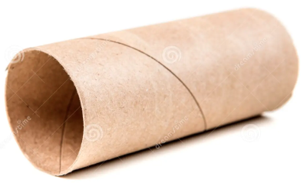

The formula for calculating the surface area of an open cylinder is:
Surface area = 2πrh
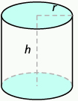
- SA = surface area
- π = 3.14
- r (radius)
- h (height)

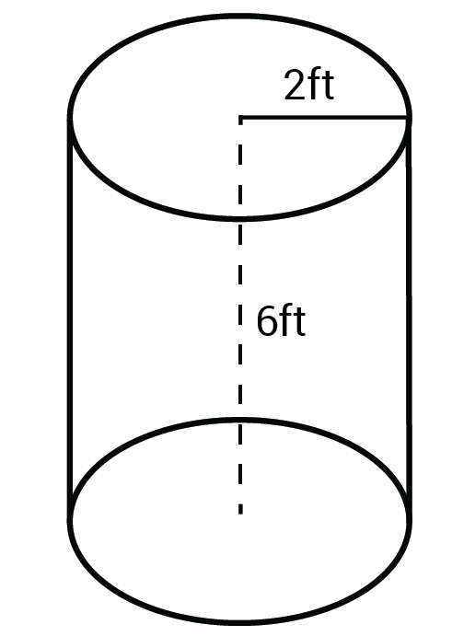
Calculate the surface area of this open cylinder.

Surface area = 2πrh
π = 3.14

Radius = 2ft
Height = 6ft

Surface area = 2 x 3.14 x 2 x 6
= 75.36ft²

Question 16

Calculate the surface area of an open cylinder with a radius (r) of 7cm and a height (h) of 20cm?

π = 3.14

(Show your working out.)
(3 marks)

Answer: ________cm²

Question 17

Calculate the surface area of an open cylinder with a radius (r) of 12cm and a height (h) of 36cm? Round your answer to the nearest whole number.

π = 3.14

(Show your working out.)
(4 marks)

Answer: ________cm²

Question 18

Calculate the surface area of an open cylinder with a diameter (d) of 6cm and a height (h) of 10cm?

π = 3.14
r = d ÷ 2

(Show your working out.)
(4 marks)

Answer: ________cm³

Calculating the surface area of closed cylinders

A closed cylinder is a cylinder that has ends on both sides.
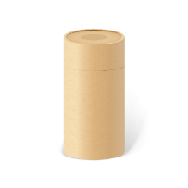

Calculate the surface area of a closed cylinder

The formula for calculating the surface area of a closed cylinder is:

Surface area = 2πrh + 2πr²
π = 3.14
r = radius
h = height

Calculate the surface area of this open cylinder.

Surface area = 2πrh + 2πr²
π = 3.14

Radius = 2ft
Height = 6ft

Surface area = (2 x 3.14 x 2 x 6) + (2 x 3.14 x (2 x 2))
= 75.36ft + 25.12ft
= 100.48ft²

Question 19

Calculate the surface area of this closed cylinder with a radius (r) of 9cm and a height (h) of 15cm.

π = 3.14

(Show your working out.)
(4 marks)

Answer: ________cm²

Question 20

Calculate the surface area of this closed cylinder with a radius (r) of 3cm and a height (h) of 22cm.

π = 3.14

(Show your working out.)
(4 marks)

Answer: ________cm²

Question 21

Calculate the surface area of this closed cylinder with a radius (r) of 5cm and a height (h) of 8.5cm. Round your answer to the nearest whole number.

π = 3.14

(Show your working out.)
(3 marks)

Answer: ________cm²

Exam practice 1

Food packaging supplies are delivered in the following boxes.
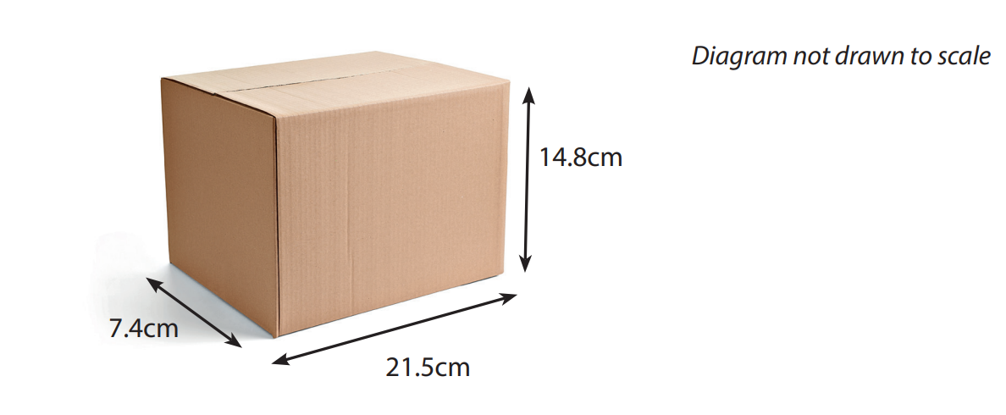

Formula = length x width x height

Estimate the volume of the box by rounding each measurement to the nearest 10cm.

(Show your working out.)

(4 marks)

Answer: ________cm³

Exam practice 2

Calculate the surface area of the following cuboid.
0.9m
Diagram not to scale
2.2m

5.7m

Surface area (SA) = 2wl + 2lh + 2hw

(Show your working out.)
(3 marks)

Answer: ________m²

Answers

Calculating the volume of cubes

Question 1
6 x 6 x 6 = 216cm³

Question 2
14 x 14 x 14 = 2,744m³

Question 3
12 x 12 x 12 = 1,728cm³

Calculating the volume of cuboids

Question 4
14 x 7 x 6 = 588cm³

Question 5
8 x 4 x 4 = 128cm³

Question 6
21 x 9 x 10 = 1,890 cm³

Calculating the volume of cylinders

Question 7
First, calculate r²
4.5 x 4.5 = 20.25
Multiply by the height.
20.25 x 18 = 364.5
Multiply by π
π = 3.14
364.5 x 3.14 = 1,144.53cm³

Question 8
First, calculate r²
12 x 12 = 144
Multiply by the height.
144 x 42 = 6,048
Multiply by π
π = 3.14
6,048 x 3.14 = 18,910.72cm³

Question 9
First, calculate r²
7.5 x 7.5 = 56.25
Multiply by the height.
56.25 x 10 = 562.5
Multiply by π
π = 3.14
562.5 x 3.14 = 1,766.25cm³

Surface area of a cube

Question 10
SA = 6a²
a = 20cm
20 x 20 = 400
6 x 400 = 2,400cm²

Question 11
SA = 6a²
a = 15cm
15 x 15 = 225
6 x 225 = 1,350cm²

Question 12
SA = 6a²
a = 19cm
19 x 19 = 361
6 x 361 = 2,166cm²

Surface area of a cuboid

Question 13
SA = 2wl + 2lh + 2hw
= 2(3.5 x 14) + 2(14 x 7) + 2(7 x 3.5)
= (2 x 49) + (2 x 98) + (2 x 24.5)
= 98 + 196 + 49
= 343cm²

Question 14
SA = 2wl + 2lh + 2hw
= 2(2 x 4.8) + 2(4.8 x 18) + 2(18 x 2)
= (2 x 9.6) + (2 x 86.4) + (2 x 36)
= 19.2 + 172.8 + 72
= 264cm²

Question 15
SA = 2wl + 2lh + 2hw
= 2(15 x 36) + 2(36 x 9) + 2(9 x 15)
= (2 x 540) + (2 x 324) + (2 x 135)
= 1,080 + 648 + 270
= 1,998cm²

Surface area of an open cylinder

Question 16
Surface area = 2πrh
π = 3.14
2 x 3.14 x 7 x 20
= 879.2cm²

Question 17
Surface area = 2πrh
π = 3.14
2 x 3.14 x 12 x 36
= 2,712.96cm²
= 2,713cm²

Question 18
Surface area = 2πrh
π = 3.14
Radius is half of diameter.
6 ÷ 2 = 3cm
2 x 3.14 x 3 x 10
= 188.4 cm²

Surface area of a closed cylinder

Question 16
Surface area = 2πrh + 2πr²
= (2 x 3.14 x 9 x 15) + (2 x 3.14 x (9 x 9))
= 847.8 + 508.68
= 1,356.48cm²

Question 17
Surface area = 2πrh + 2πr²
= (2 x 3.14 x 3 x 22) + (2 x 3.14 x (3 x 3))
= 414.48 + 56.52
= 471cm²

Question 18
Surface area = 2πrh + 2πr²
= (2 x 3.14 x 5 x 8.5) + (2 x 3.14 x (5 x 5))
= 266.9 + 157
= 423.9cm²
Rounded to the nearest whole number = 424cm²

Exam practice

Exam practice 1
Round each number to the nearest 10cm.
7.4cm ≈ 10cm
21.5cm ≈ 20cm
14.8cm ≈ 10cm
Use the formula v = l x w x h
= 20 x 10 x 10
= 2,000cm³

Exam practice 2
Substitute the numbers into the formula.
Surface area (SA) = 2wl + 2lh + 2hw
= 2(0.9 x 5.7) + 2(5.7 x 2.2) + 2(2.2 x 0.9)
= 10.26 + 25.08 + 3.96
= 39.3cm³

Your functional skills exam

Your functional skills exams will consist of 2 papers.
These papers will take place over the following time periods:

- Non-calculator paper – 40 minutes
- Calculator – 1 hour 50 minutes

Further information on the format that your test will take can be obtained from your training provider.

Hints and tips

- Find out what format your exam will be in. It may be paper-based
or on-screen.
- Plan what you are going to revise in advance. Don’t leave it until the last minute.
- Do as many past papers as you can so you are prepared for the day. If possible, try to complete the past papers following the same format as the actual exam.
- Find a quiet place to study and revise. It helps to sit at a table or a desk, don’t revise in bed.
- Don’t stay up all night revising the night before your exam. It’s important to have a good rest so you feel refreshed and ready to go.
- Read the question 3 times. The first time to ensure you understand what is being asked, the second time to get an understanding of what you need to do, and a third time to figure out exactly what maths techniques you should be applying.
- If you are struggling with a question, skip it and come back to it later. Try not to sit getting worked up about a difficult question, it will only waste exam time. Move on and come back to it after you have answered the other questions.
- Take note of the number of marks available. This will give you an indication of how much working out you must show. For example, 1 mark will need an answer only and more marks will need you to show your working out.
- When you’ve finished the exam, go back and check your answers. If you still have time remaining, use it to check your answers and when you have checked your answers check them again.

