

FUNCTIONAL SKILLS

Maths Level 1

Area: Handling information and data
Criterion 30: Understand probability on a scale from 0 (impossible) to 1 (certain) and use probabilities to compare the likelihood of events

What is probability?

Probability is a way of describing how likely something is to happen.

- Probability measures the chance of something happening
- It can be shown as a number, a fraction, a decimal, a percentage or with words

Example:
The chance of picking a red sweet from a bag with 5 red sweets and 5 blue sweets is ½, 0.5, or 50%.

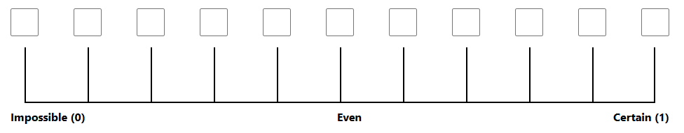

Probability is shown on a scale from 0 (impossible) to 1 (certain)

- 0 means the event will never happen (impossible)
- 1 means the event will definitely happen (certain)
- Numbers between 0 and 1 show different levels of likelihood:
- the closer to 0, the less likely it is
- the closer to 1, the more likely it is

Common words and where they sit on the probability scale:

- impossible (0) → no chance of happening
- unlikely (close to 0 but not 0) → not expected but still possible
- even chance (0.5) → equally likely to happen or not happen
- likely (close to 1 but not 1) → probably will happen
- certain (1) → guaranteed to happen

Probability can be written in 3 formats – fractions, decimals and percentages.
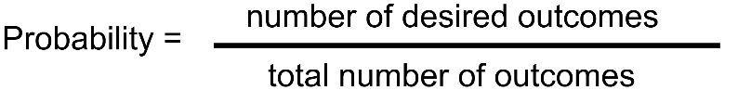
Fractions:

Decimals: Divide the numerator (top number) by the denominator (bottom number).

Percentages: Multiply the decimal by 100

Example:
Rolling a 3 on a fair die = 1 desired outcome out of 6 = ¹/₆
¹/₆ = 1 ÷ 6 = 0.166… (about 0.17)
0.17 x 100 = 17%

Question 1

Mark the probability scale below with the correct terms: Even Chance, Impossible, Certain, Unlikely, Likely.
(1 mark)

Question 2

A bag contains 8 blue marbles and 2 red marbles.
If you pick 1 marble at random, what is the probability it will be red?

Give your answer as a fraction.

(Show your working out.)
(1 mark)

Question 3

You roll a fair 6-sided die.
What is the probability of rolling an even number?

Give your answer as a fraction.

(Show your working out.)
(1 mark)

Question 4

The probability of picking a red sweet from a jar is ³/₄​
Write this probability as a decimal.

(Show your working out.)
(1 mark)

Question 5

The probability of rolling a number greater than 4 on a fair 6-sided die is ¹/₃

Write this probability as a decimal.

(Show your working out.)
(1 mark)

Question 6

The probability of winning a prize in a raffle is ²/₅​
Write this probability as a percentage.

(Show your working out.)
(1 mark)

Question 7

The probability of it raining tomorrow is ⁷/₁₀​
Write this probability as a percentage.

(Show your working out.)
(1 mark)

Question 8

The probability of rolling a number greater than 2 on a fair 6-sided die is ²/₃

The probability of tossing a coin and it landing on heads is 0.5

Which is more likely to happen?

(Show your working out.)
(1 mark)

Question 9

You pick a random day of the week.

What is the probability that the day you pick is a weekend?

(Show your working out.)
(1 mark)

Question 10

A bag has 100 marbles: 90 are blue, 10 are green.

You pick a marble out at random.

- What is the probability that the marble you pick will be green?

(Show your working out.)
  - marks)

- Mark this with an ‘x’ on the probability scale below.

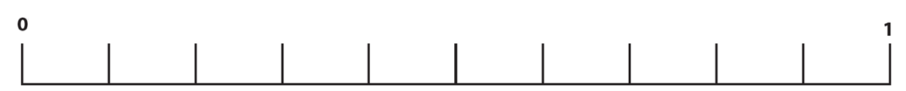

Exam practice 1

You are a driver for a delivery service.
The company has 7 small vans, 2 medium vans and 1 large van.
Each morning you take a set of keys at random.

On the scale below, mark an ‘X’ to indicate the probability that the keys you take will be for a small van.

(Show your working out.)
(3 marks)

Exam practice 2

The company has 4 electric vans, 3 petrol vans and 3 diesel vans.
Each morning you take a set of keys at random.

On the scale below, mark an ‘X’ to indicate the probability that the keys you take will be for a petrol van.

(Show your working out.)

(3 marks)

Answers

Question 1
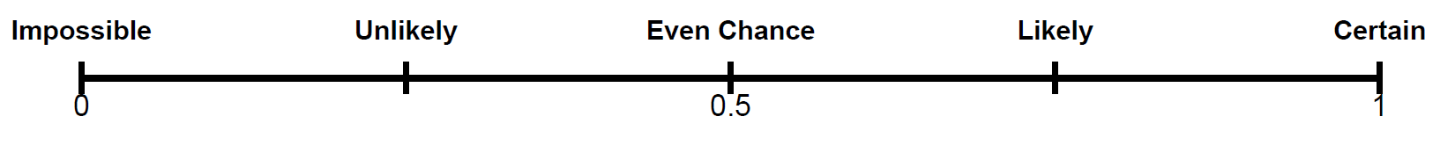
Question 2
²/₁₀ or ¹/₅

Question 3
³/₆ or ¹/₂

Question 4
0.75

Question 5
0.333 recurring

Question 6
²/₅ = 0.4 = 40%

Question 7
⁷/₁₀ = 0.7 = 70%

Question 8
Rolling a number greater than 2 on a fair 6-sided die.

Question 9
²/₇ or 0.2857 or 28.57%

Question 10
¹⁰/₁₀₀ or ¹/₁₀ = 0.01 or 10%

Exam practice

Exam practice 1
Total vans: 7 + 2 + 1 = 10

Probability (small van) = ⁷/₁₀ = 0.7

Exam practice 2
Total vans: 4 + 3 + 3 = 10

Probability (petrol van) = ³/₁₀ = 0.3

Your functional skills exam

Your functional skills exams will consist of 2 papers.
These papers will take place over the following time periods:

- Non-calculator paper – 40 minutes
- Calculator – 1 hour 50 minutes

Further information on the format that your test will take can be obtained from your training provider.

Hints and tips

- Find out what format your exam will be in. It may be paper-based
or on-screen.
- Plan what you are going to revise in advance. Don’t leave it until the last minute.
- Do as many past papers as you can so you are prepared for the day. If possible, try to complete the past papers following the same format as the actual exam.
- Find a quiet place to study and revise. It helps to sit at a table or a desk, don’t revise in bed.
- Don’t stay up all night revising the night before your exam. It’s important to have a good rest so you feel refreshed and ready to go.
- Read the question 3 times. The first time to ensure you understand what is being asked, the second time to get an understanding of what you need to do, and a third time to figure out exactly what maths techniques you should be applying.
- If you are struggling with a question, skip it and come back to it later. Try not to sit getting worked up about a difficult question, it will only waste exam time. Move on and come back to it after you have answered the other questions.
- Take note of the number of marks available. This will give you an indication of how much working out you must show. For example, 1 mark will need an answer only and more marks will need you to show your working out.
- When you’ve finished the exam, go back and check your answers. If you still have time remaining, use it to check your answers and when you have checked your answers check them again.

