

FUNCTIONAL SKILLS

Maths Level 2

Area: Numbers and the number system
Criterion: 10. Add, subtract, multiply and divide decimals up to three decimal places.

Adding decimals

To add decimals, you need to make sure the decimal points in all the numbers are aligned one below the other. Then you can perform the addition as you would with whole numbers
For example,
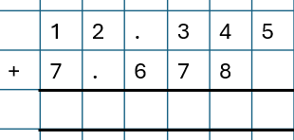
12.345 + 7.678
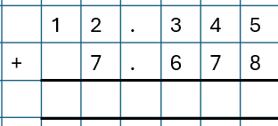
In the example to the right, the decimal points
are not aligned correctly.
The numbers cannot be accurately added.
However, in this example, the decimal points
are correctly aligned.
The numbers can now be accurately added.
Here is the completed calculation:
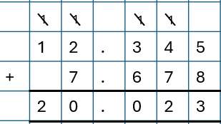
Remember that we must work from right to left when we add decimals.

Subtracting decimals

When we subtract decimals, we must make sure we align the decimal points below one another before completing the subtraction.
For example,
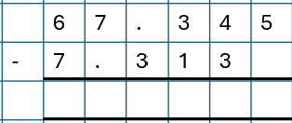
67.345 - 7.313
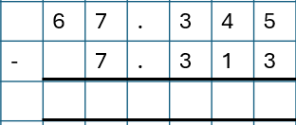
In the example to the right, the decimal points
are not aligned correctly.
The numbers cannot be accurately subtracted.
However, in this example, the decimal points
are correctly aligned.
The numbers can now be accurately subtracted.
Here is the completed calculation:
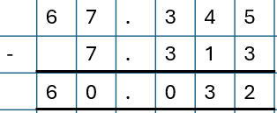
Remember that we must work from right to left when we subtract decimals.

Question 1

Calculate 15.678 + 9.123

(Show your working out.)
(1 mark)

Question 2

Calculate 20.456 + 10.789

(Show your working out.)

(1 mark)

Question 3

Calculate 12.345 - 6.789

(Show your working out.)
(1 mark)

Question 4

Calculate 65.123 - 12.789

(Show your working out.)
(1 mark)

Multiplying decimals

Follow the steps to correctly multiply decimals.
Below is an example question to help you understand the steps.
Calculate 3.456 x 2.3
Step 1: Remove the decimal points
Remove the decimal point from each number. Treat the numbers as whole numbers and multiply them.
  - 2.3 becomes 3456 x 23
Step 2: Multiplying the numbers
Multiply the numbers as though they are whole numbers.
When using this method, multiply from right to left.
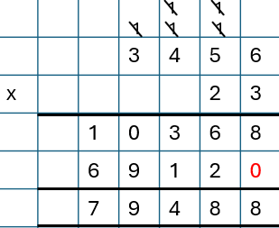
Remember to include a place holder if you are multiplying by a number that has 2 digits.

Step 3: Count the total number of decimal places
Count how many decimal places each of the original numbers had.
3.456 has 3 decimal places.
2.3 has 1 decimal place.
Add these together. This will tell you how many decimal places you need in your answer.
3 decimal places + 1 decimal place = 4 decimal places.
Step 4: Place the decimal point
Place the decimal point in the final answer, or product. Remember that you need to count the number of places from the right.
79488 becomes 7.9488

Dividing decimals

Follow the steps to correctly divide decimals. Below is an example question to help you understand the steps.
Calculate 9.693 ÷ 0.3
Step 1: Set up the division

Write down the division problem in the long division format. For example,

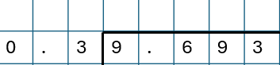

Step 2: Remove the decimal from the divisor
Move the decimal point in the divisor to the right until it's a whole number.
Remember the divisor is the number outside of the ‘bus stop’.
Move the decimal point in the dividend the same number of places to the right.
For example, if dividing 9.693 by 0.3:
- move the decimal point in 0.3 one place to the right to get 3
- move the decimal point in 9.693 one place to the right to get 96.93
Now your division problem looks like this: 96.93 ÷ 3

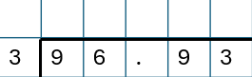

Step 3: Divide as usual
Divide the numbers. Write out the multiples of the divisor to help you if you need to.
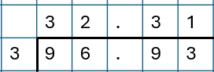
Don’t forget to place a decimal point on the top row.

Step 4: Place the decimal point
Since we moved the decimal points in both the divisor and dividend by the same amount, your answer doesn't need any further adjustment.
96.93 ÷ 3 = 32.31
Question 5

Calculate 2.345 × 4.2

(Show your working out.)
(1 mark)

Question 6

Calculate 9.123 × 1.5

(Show your working out.)
(1 mark)

Question 7

Calculate 9.36 ÷ 4

(Show your working out.)
(1 mark)

Question 8

Calculate 2.88 ÷ 1.2

(Show your working out.)
(1 mark)

Exam practice 1

A runner completes a race in 2.349 hours. The race was 7.9866 miles long.
What was the runner's average speed in miles per hour (mph)?

Speed = Distance
Time

(Show your working out.)

(2 marks)

Exam practice 2

A piece of wood measuring 4.568 metres is cut into 4 equal parts. What is the length of each part?

(Show your working out.)
(2 marks)

Exam practice 3

Calculate the value of S

$$S=\frac{0.34 x 0.086}{0.8}$$

(Show your working out.)
(2 marks)

Answers

Adding and subtracting decimals

Question 1
15.678 + 9.123 = 24.801

Question 2
20.456 + 10.789 = 31.245
Question 3
12.345 - 6.789 = 5.556
Question 4
65.123 - 12.789 = 52.334

Multiplying and dividing decimals

Question 5
2.345 × 4.2 = 9.849

Question 6
9.123 × 1.5 = 13.6845

Question 7
9.36 ÷ 4 = 2.34

Question 8
2.88 ÷ 1.2 = 2.4

Exam practice

Exam practice 1
Average speed = 7.9866 ÷ 2.349 = 3.4 miles per hour

Exam practice 2
Length of each part = 4.568 ÷ 4 = 1.142 metres

Exam practice 3
0.34 x 0.086 = 0.02924
0.02924 ÷ 0.8 = 0.03655

Your functional skills exam

Your functional skills exams will consist of 2 papers.
These papers will take place over the following time periods:

- Non-calculator paper – 40 minutes
- Calculator – 1 hour 50 minutes

Further information on the format that your test will take can be obtained from your training provider.

Hints and tips

- Find out what format your exam will be in. It may be paper-based
or on-screen.
- Plan what you are going to revise in advance. Don’t leave it until the last minute.
- Do as many past papers as you can so you are prepared for the day. If possible, try to complete the past papers following the same format as the actual exam.
- Find a quiet place to study and revise. It helps to sit at a table or a desk, don’t revise in bed.
- Don’t stay up all night revising the night before your exam. It’s important to have a good rest so you feel refreshed and ready to go.
- Read the question 3 times. The first time to ensure you understand what is being asked, the second time to get an understanding of what you need to do, and a third time to figure out exactly what maths techniques you should be applying.
- If you are struggling with a question, skip it and come back to it later. Try not to sit getting worked up about a difficult question, it will only waste exam time. Move on and come back to it after you have answered the other questions.
- Take note of the number of marks available. This will give you an indication of how much working out you must show. For example, 1 mark will need an answer only and more marks will need you to show your working out.
- When you’ve finished the exam, go back and check your answers. If you still have time remaining, use it to check your answers and when you have checked your answers check them again.

