

FUNCTIONAL SKILLS

Maths Level 2

Area: Using common measures, shape and space
Criterion: 24. Draw 2-D shapes and demonstrate an understanding of line symmetry and knowledge of the relative size of angles

Identify and draw basic 2-D shapes

A 2-D shape, or two-dimensional shape, is a flat figure that has only 2 dimensions: length and width.

Common examples of 2-D shapes include:
- squares
- rectangles
- triangles
- circles
- pentagons
- hexagons

Key properties of a square

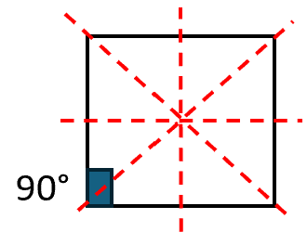

Sides: 4 equal sides
Angles: 4 right angles (90° each)
Symmetry: 4 lines of symmetry

Key properties of a rectangle
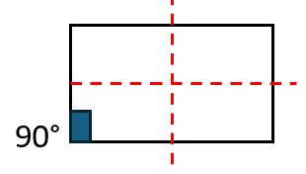

Sides: 4 sides (opposite sides are equal)
Angles: 4 right angles (90° each)
Symmetry: 2 lines of symmetry

Key properties of a triangle
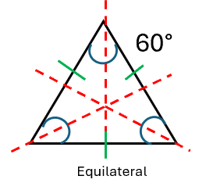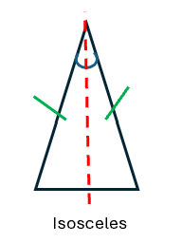
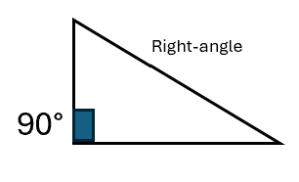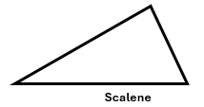
Sides: Always 3 sides
Angles: 3 angles (can be any size, including right-angles)
Symmetry: Can have 0, 1 or 3 lines of symmetry depending on the type of triangle
- Equilateral: 3 lines of symmetry
- Isosceles: 1 line of symmetry
- Right-angle or scalene: 0 lines of symmetry

Key properties of a circle
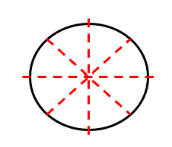

Sides: No sides (continuous curve)
Angles: No angles
Symmetry: Infinite lines of symmetry (any line through the centre)

Key properties of a pentagon
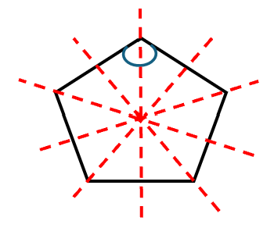
Sides: 5 sides
Angles: 5 angles (all the same if equilateral)
Symmetry: 5 lines of symmetry (if equilateral)

Key properties of a hexagon
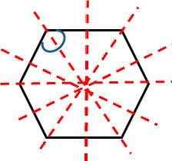
Sides: 6 sides
Angles: 6 angles (all the same if equilateral)
Symmetry: 6 lines of symmetry (if equilateral)

Question 1

What is a 6-sided shape called?

(1 mark)

Question 2

What type of triangle is this?

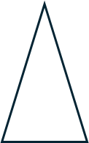

(1 mark)

Question 3

What is the name of this shape?

(1 mark)

Question 4

How many sides does a circle have?

(1 mark)

Question 5

What is the measurement of any angle in a square?

(1 mark)

Question 6

How many lines of symmetry does an equilateral pentagon have?

(1 mark)

Angles

Squares and rectangles
- Always 4 angles
- Always 90° each
- Always total 360°

Triangles
- Always 3 angles
- Always total 180°
- Equilateral: 3 x 60° angles
- Isosceles: 2x equal angles, 1 different
- Right-angled: 1x angle of exactly 90°
- Scalene: all 3 angles are different

Circles
- No angles

Pentagons
- Equilateral: all 5 angles are equal
- Always total 540°

Hexagons
- Equilateral: all 6 angles are equal
- Always total 720°

Question 7

What is the size of the angle marked ‘x’ in this equilateral triangle?
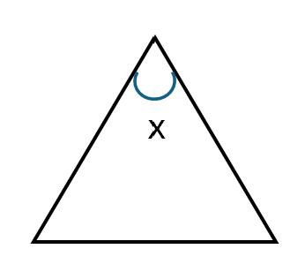
(1 mark)

Question 8

What is the total sum of angles in the shape below?

(Show your working out.)
(1 mark)

Question 9

How many angles are there in a pentagon?

(Show your working out.)
(1 mark)

Lines of symmetry

A line of symmetry is a line that splits a shape into 2 parts that are mirror images of each other.

A shape is symmetrical if it can be divided by one or more lines of symmetry.

Types of symmetry:
Vertical symmetry: The line of symmetry runs vertically (top to bottom).
Horizontal symmetry: The line of symmetry runs horizontally (left to right).
Diagonal symmetry: The line of symmetry runs diagonally (corner to corner).

Question 10

Which shape has exactly 2 lines of symmetry.

(Show your working out.)

(1 mark)
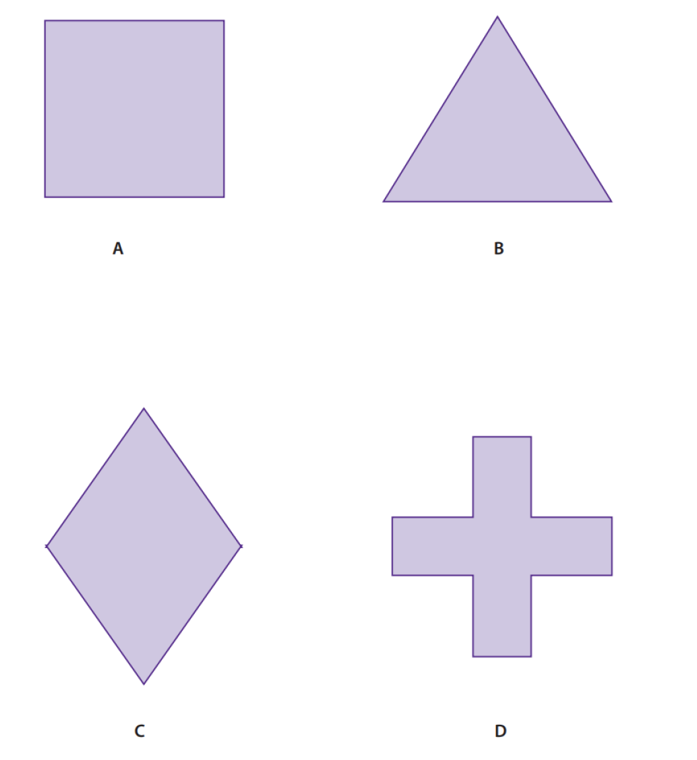

Question 11

How many lines of symmetry does an equilateral triangle have?

(Show your working out.)
(1 mark)

Question 12

How many lines of symmetry does a rectangle have?

(Show your working out.)
(1 mark)

Exam practice 1

How many lines of symmetry does the equilateral shape below have?

(1 mark)

Exam practice 2

One angle in an isosceles triangle measures 38°

The other 2 angles are identical in size.

What size are the other 2 angles?

(Show your working out.)
(2 marks)

Answers

Drawing and identifying 2-D shapes

Question 1
Hexagon

Question 2
Isosceles triangle

Question 3
Rectangle

Question 4
0

Question 5
90°

Question 6
5

Angles

Question 7
60°

Question 8
360°

Question 9
A pentagon has 5 angles

Lines of symmetry

Question 10
C (diamond)

Question 11
3 lines of symmetry

Question 12
2 lines of symmetry

Exam practice

Exam practice 1
5 lines of symmetry

Exam practice 2
180° - 38° = 142°
142° ÷ 2 = 71° each

Your functional skills exam

Your functional skills exams will consist of 2 papers.
These papers will take place over the following time periods:

- Non-calculator paper – 40 minutes
- Calculator – 1 hour 50 minutes

Further information on the format that your test will take can be obtained from your training provider.

Hints and tips

- Find out what format your exam will be in. It may be paper-based
or on-screen.
- Plan what you are going to revise in advance. Don’t leave it until the last minute.
- Do as many past papers as you can so you are prepared for the day. If possible, try to complete the past papers following the same format as the actual exam.
- Find a quiet place to study and revise. It helps to sit at a table or a desk, don’t revise in bed.
- Don’t stay up all night revising the night before your exam. It’s important to have a good rest so you feel refreshed and ready to go.
- Read the question 3 times. The first time to ensure you understand what is being asked, the second time to get an understanding of what you need to do, and a third time to figure out exactly what maths techniques you should be applying.
- If you are struggling with a question, skip it and come back to it later. Try not to sit getting worked up about a difficult question, it will only waste exam time. Move on and come back to it after you have answered the other questions.
- Take note of the number of marks available. This will give you an indication of how much working out you must show. For example, 1 mark will need an answer only and more marks will need you to show your working out.
- When you’ve finished the exam, go back and check your answers. If you still have time remaining, use it to check your answers and when you have checked your answers check them again.

