**FUNCTIONAL SKILLS**

Maths Level 2

**7. Order, add, subtract and compare amounts or quantities using proper and improper fractions and mixed numbers**

**Fractions**

Fractions show a part of something:

* They are split into the top (**called the numerator**) and the bottom (**called the denominator**).
* The bottom shows the total number of parts, and the top shows how many of those parts are part of this calculation.



A fraction is just a division.

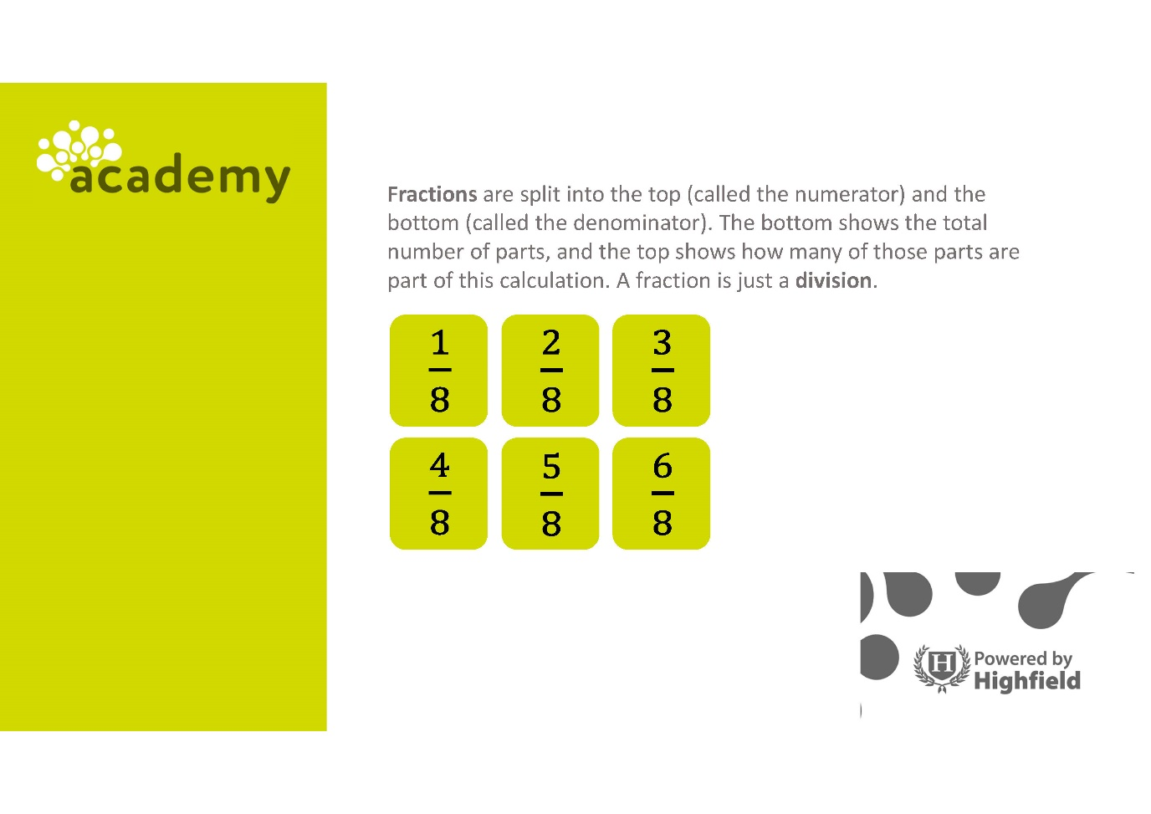

**Proper Fraction**

A fraction where the **numerator** is less than the **denominator** is known

as a proper fraction.



The value of the proper fraction after further simplification is always less than 1.

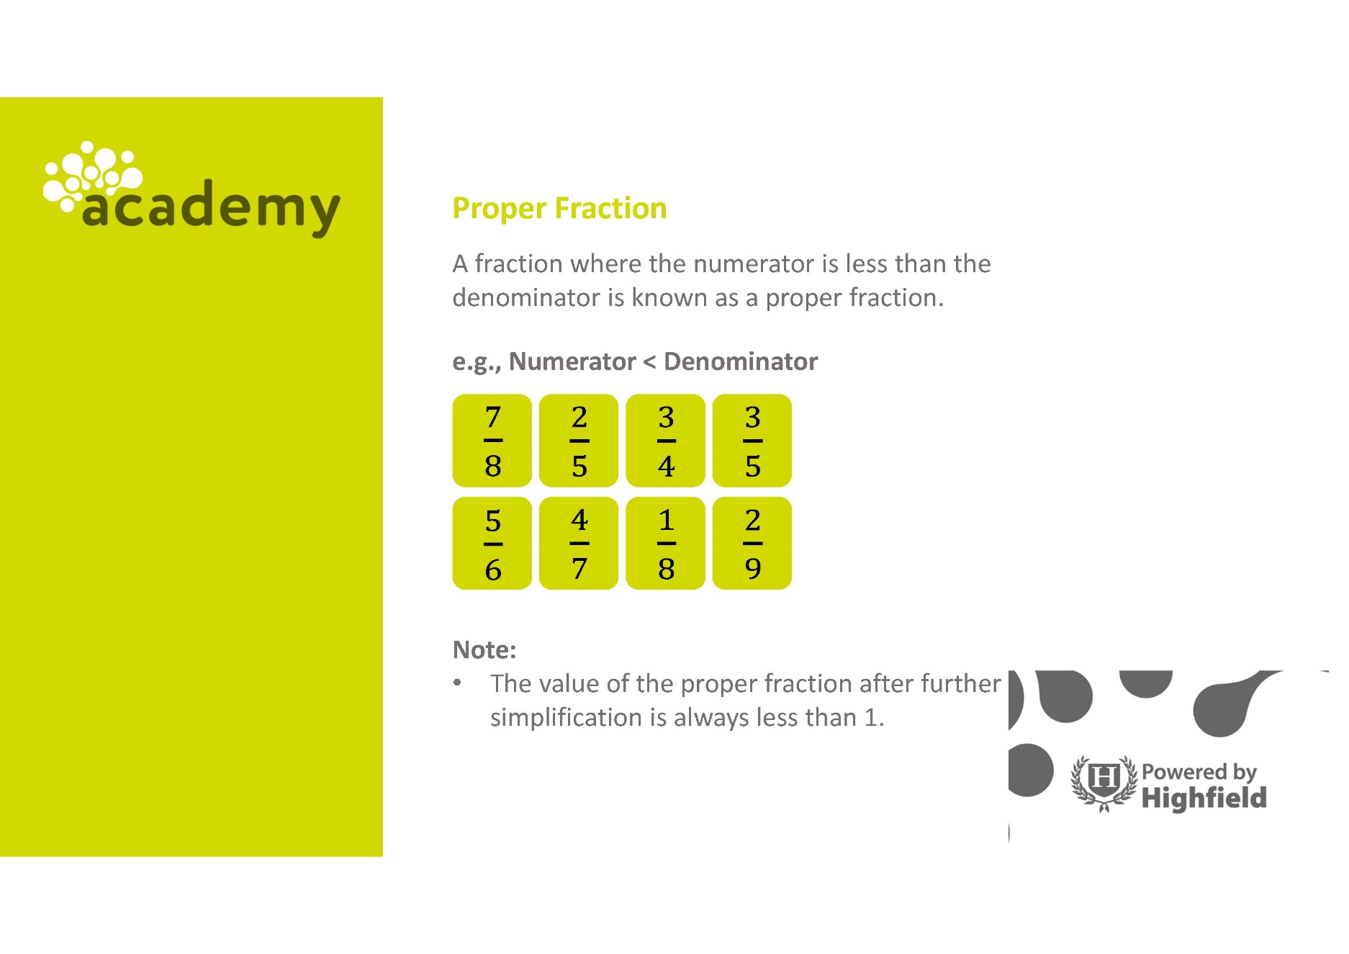

**Using the information provided, work out the answers to the following questions.**

**Question 1**

Identify the proper fraction.

$\frac{5}{4}$ or $\frac{4}{5}$ or $\frac{11}{5}$

|  |
| --- |
|  |

**Question 2**

Identify which is **not** a proper fraction.

$\frac{1}{2}$ or $\frac{5}{4}$ or $\frac{998}{999}$ or $\frac{5}{50}$

|  |
| --- |
|  |

**Question 3**

Identify all the proper fractions.

$\frac{7}{10} \frac{2}{9}$ $\frac{12}{11} \frac{5}{2} \frac{9}{4} \frac{3}{14} \frac{1}{2}$

|  |
| --- |
|  |

**Improper Fraction**

A fraction where the **numerator** is greater than the **denominator** is

known as an improper fraction.

**e.g. Numerator > Denominator**

The simplification of improper fraction results   
in a value which is equal to or greater than 1,   
but not less than 1.

**Using the information provided, work out the answers to the following questions.**

**Question 4**

Identify the improper fractions.

$\frac{10}{111} \frac{110}{111} \frac{11}{110}$ $\frac{110}{11}$

|  |
| --- |
|  |

**Question 5**

Identify the improper fractions.

$\frac{12}{13}$ $\frac{9}{4}$ $\frac{5}{6}$ $\frac{14}{4}$ $\frac{15}{5}$ $\frac{22}{23}$

|  |
| --- |
|  |

**Question 6**

Identify the improper fractions.

$\frac{3}{4} \frac{9}{8} \frac{10}{7}$ $\frac{14}{13}$

|  |
| --- |
|  |

**Mixed Number**

A mixed number is the combination of a whole number and a fraction.

Mixed numbers can always be converted   
into a fraction**,** an improper fraction can be converted into a mixed number anda mixed number is always greater than 1.

**Converting between improper fractions and mixed numbers**

Improper fractions and mixed numbers can be converted, e.g.

Write $\frac{25}{4}$ as a mixed number.

A fraction is just a division. So,

$\frac{25}{4}$ = 25/4

25 divided by 4 = 6 remainder 1 $=6\frac{1}{4}$

**Example**

Write $5\frac{2}{3}$ as an improper fraction

When converting from a mixed number to an improper fraction, we need to multiply the whole number by the bottom (**denominator**) and add the top (**numerator**).

5 x 3 = 15  
15 + 2 = 17

Then, this number goes above the bottom number of the original fraction:

$5\frac{2}{3}$ = $\frac{17}{3}$

**Using the information provided, work out the answers to the following questions.**

**Question 7**

Convert $\frac{20}{7}$ into a mixed number.

(Show you working out)

|  |
| --- |
|  |

**Question 8**

Convert $\frac{37}{5}$ into a mixed number

(Show you working out)

|  |
| --- |
|  |

**Question 9**

Convert $\frac{9}{8}$ into a mixed number

(Show you working out)

|  |
| --- |
|  |

**Adding Fractions**

To add fractions, you need to ensure that they have the same bottom number **(a common denominator).**

If the fractions do not have the same bottom number (**denominator**), you will need to turn them into equivalent fractions with the same number on the bottom.

Then you can simply add the top numbers (**numerators**).

*=*

One way you can find a **common denominator** is to multiply the **denominators** in the two fractions together.

Once the following step is complete:

$$\frac{3}{5} = \frac{3}{5} x \frac{4}{4} = \frac{12}{20}$$

$\frac{1}{4}$*= $\frac{1}{4}$ $x$ $\frac{5}{5} = \frac{5}{20}$*

Now you can add the **numerators** together:

Subtraction is done in the same way, except you subtract the top number at the end.

**Using the information provided, work out the answers to the following questions.**

**Question 10**

Calculate $\frac{3}{4}$ + $\frac{2}{5}$

(Show your working out)

|  |
| --- |
|  |

**Question 11**

Calculate $\frac{2}{5}$ + $\frac{3}{4}$ + $\frac{1}{2}$

(Show your working out)

|  |
| --- |
|  |

**Question 12**

Calculate $\frac{3}{4}$ + $\frac{2}{3}$ + $\frac{4}{5}$ + $\frac{1}{2}$

(Show your working out)

|  |
| --- |
|  |

**Subtracting Fractions**

In the same way as adding fractions, you can only subtract if the **denominators** are the same. (If the **denominators** are not the same, you will need to use equivalent fractions with the same number at the bottom. Then you can subtract the **numerators**. The **denominator** remains the same).

**Example:** What is $\frac{3}{5} - \frac{1}{2}?$

The bottom numbers are not the same use equivalent fractions to find a fraction with the same **denominator**.

$\frac{3}{5}$ x $\frac{2}{2}$ = $\frac{6}{10}$ THEN $\frac{1}{2}$ x =

- =

**Using the information provided, work out the answers to the following questions.**

**Question 13**

Calculate $\frac{4}{5}$- $\frac{2}{5}$

(Show your working out)

|  |
| --- |
|  |

**Question 14**

Calculate $\frac{4}{5}$- $\frac{2}{5}$- $\frac{1}{5}$

(Show your working out)

|  |
| --- |
|  |

**Question 15**

Calculate $\frac{15}{9}$- $\frac{4}{9}$- $\frac{7}{9}$

(Show your working out)

|  |
| --- |
|  |

**Comparing fractions**

All types of fractions can be compared, whether they have different numbers on the bottom, or they are improper fractions or mixed numbers. We can determine which ones are bigger and put them in order of size by converting between mixed numbers and improper fractions and using equivalent fractions.

**Example:** Which is bigger $\frac{7}{5} or 1\frac{1}{3}?$

The fraction needs to be in the same form, so convert $1\frac{1}{3}$

Improper fractions are easier to compare than mixed numbers…

$$1\frac{1}{3} = \frac{4}{3}$$

The bottom numbers (**denominators**) remain different, so you will need to find equivalent fractions:

$$\frac{7}{5} or \frac{4}{3}$$

**Using the information provided, work out the answers to the following questions.**

**Question 16**

### Identify which is bigger $\frac{3}{8}$ or $\frac{5}{12}$

### 

### (Show your working out)

|  |
| --- |
|  |

**Question 17**

### Identify which is bigger 7 $\frac{1}{8}$ or 6 $\frac{4}{8}$

### (Show your working out)

|  |
| --- |
|  |

**Question 18**

### Identify which is bigger $\frac{6}{3}$ or $\frac{2}{3}$

### (Show your working out)

|  |
| --- |
|  |

**Finding Fractions ‘Of’ Something**

You might need to calculate the ‘fraction of’ something.

In these cases, ‘of’ means ‘times’ (multiply).

Example: **What is $\frac{1}{32}$ of 14,656?**

1. ‘Of’ means ‘times’ (X), so $\frac{1}{32} of 14,656$  
   is the same as $\frac{1}{32} x 14,656$
2. So the full calculation you need to do is:

$$1 divided by 32 x 14 656=458$$

**Using the information provided, work out the answers to the following questions.**

**Question 19**

Calculate $\frac{3}{4}$ of 36

### (Show your working out)

|  |
| --- |
|  |

**Question 20**

Calculate $\frac{1}{7}$ of 28

### (Show your working out)

|  |
| --- |
|  |

**Question 21**

Calculate $\frac{3}{5}$ of 62

### (Show your working out)

|  |
| --- |
|  |

**Exam style question 1 - Calculator**

Calculate 2 $\frac{5}{8}$**+ $\frac{11}{16}$**

**Give your answer as a mixed number.**

Write the answer in the box below.

***(2 mark)***

|  |
| --- |
|  |

**Exam style question 2 - Non-calculator**

When Highfield Transport gets busy it offers overtime to a driver.

There are 5 drivers at Highfield Transport. The probability of there being overtime available in any given week is ¼.

The driver allocated overtime is chosen at random.

**What is the probability of you being allocated overtime next week?   
Give your answer as a fraction AND a percentage.**

Show your working out and write the answer in the box below.

***(3 marks)***

|  |
| --- |
|  |

**Your functional skills exam**

Your functional skills exams will consist of 2 papers.

These papers will take place over the following time periods:

* Calculator paper – 40 minutes
* Non-calculator – 1 hour 50 minutes

Further information on the format that your test will take can be obtained from your training provider.

**Hints and tips**

* Find out what format your exam will be in. It may be paper-based   
  or on-screen.
* Plan what you are going to revise in advance. Don’t leave it until the last minute.
* Do as many past papers as you can so you are prepared for the day. If possible, try to complete the past papers following the same format as the actual exam.
* Find a quiet place to study and revise. It helps to sit at a table or a desk, don’t revise in bed.
* Don’t stay up all night revising the night before your exam. It’s important to have a good rest so you feel refreshed and ready to go.
* Read the question 3 times. The first time to ensure you understand what is being asked, the second time to get an understanding of what you need to do, and a third time to figure out exactly what maths techniques you should be applying.
* If you are struggling with a question, skip it and come back to it later. Try not to sit getting worked up about a difficult question, it will only waste exam time. Move on and come back to it after you have answered the other questions.
* Take note of the number of marks available. This will give you an indication of how much working out you must show. For example, 1 mark will need an answer only and more marks will need you to show your working out.
* When you’ve finished the exam, go back and check your answers. If you still have time remaining, use it to check your answers and when you have checked your answers check them again.