

FUNCTIONAL SKILLS

Maths Level 1

Area: Data handling
Criterion 28: Group discrete data and represent grouped data graphically

Identifying discrete data

Data can be grouped into 2 categories: discrete data and continuous data.

Discrete data consists of distinct, separate values. It is often counted and uses whole numbers.

For example, number of pets or shoe sizes.

Continuous data can take any value within a range. It is often measurable and uses decimals.

For example, someone’s height or a room’s temperature.

Top tip: discrete data is counted, while continuous data is measured.

Question 1

Which of the following is an example of discrete data?

- The number of people in the queue at a bank
- The weights of babies
- The temperature over a period of 7 days

(1 mark)

Question 2

Which of the following is not an example of discrete data?

- Days someone is absent in a year
- The number of holiday days someone uses
- The height of different employees
(1 mark)

Grouping and representing discreet data

Grouping helps make large sets of data easier to understand.

Discrete data can be grouped in intervals or categories.

For example, if you have a list of shoe sizes, you could group them in intervals:
- sizes 1–3
- sizes 4–6
- sizes 7–9

If the data involves categories, the grouping is based on each category.

For example, people’s favourite colours can be grouped into categories such as red, blue and green.
Steps to group data:
- Look at the range of values or categories in the data
- Decide whether to group them using intervals or categories
- Ensure interval groups don’t overlap
For example, 1–2 and 3-4, not 1–2, 2–3 and 3-4.

Question 3

Should the following data be grouped using intervals or categories?

The different mobile phone models people own.
(1 mark)

Question 4

Should the following data be grouped using intervals or categories?

The distance employees travel to work.
(1 mark)

Frequency tables

A frequency table shows how often each group or category appears in the data.

Below is a grouped frequency table showing different people’s shoe sizes.

It includes 2 columns:
- groups or categories: shoe sizes 1-3, 4-6, 7-9, 10-12
- frequency: how often each shoe size has been chosen

Shoe size | Frequency
1-3 | 4
4-6 | 7
7-9 | 6
10-12 | 3

Question 5

A class of students recorded the number of books they read last month.

1 | 2 | 2 | 3 | 3 | 3 | 4
4 | 4 | 4 | 5 | 5 | 6 | 7

Represent this data in the frequency table below, using equal groups.

Number of books | Frequency
1-2
3-4
5-6
7-8
Total:

(Show your working out.)
(3 marks)

Question 6

A group of people are asked to record the colour of their vehicle.

Below are the results.

Red | Blue | White | Black | White | Red | Black
Blue | Blue | Black | Red | Silver | Orange | Black
Green | White | Red | Black | White | Black | Black

Represent this data in the frequency table below.

Colour | Frequency
Total:

(Show your working out.)
(3 marks)

Choosing an appropriate graph

Graphs help make data visual and easier to understand. It’s important to choose a graph or chart that will correctly present the data.

Bar charts

Bar charts are typically suited for showing grouped data.

For example, shoe sizes.

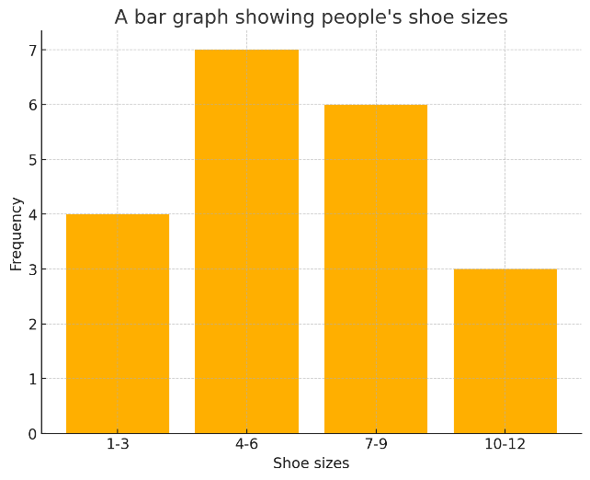
Labelled axes
Correct intervals used
Title
Data plotted accurately
Pictograms

Pictograms are useful for showing data in categories.

For example, favourite colours.

A pictogram showing people’s favourite colours
Title

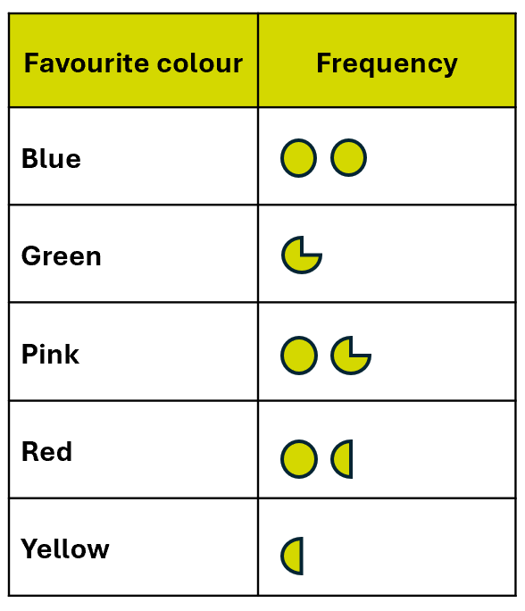
Correct categories used
Labelled headings
Data plotted accurately
Key
= 4 people

Key features of bar charts, pictograms and other graphs include:

- a clear title
- axes or headings labelled correctly
- bars or symbols that match the data

Below are some steps you can use to help you draw a graph or chart.

- Decide which type of graph works best for the data
- Include a title
- Label the axes or headings of the graph
- Use the frequency table to plot the bars or symbols accurately

Once you have created your graph or chart, you can use it to answer questions about the data.

For example,

- How many people have a shoe size between 4-6?

Here, we can find the bar for shoe sizes 4-6 and then read across to the left to check the frequency.

7 people have a 4-6 shoe size.

- How many more people have size 1-3 shoes than size 10-12 shoes?

This question is asking us to find the difference. We will need to subtract.

4 people have size 1-3 shoes.
3 people have size 10-12 shoes.
4 – 3 = 1

The answer is 1

Question 7

You ask a different group of students how many books they have read in the past month.

Books read | Frequency
1-2 | 4
3-4 | 6
5-6 | 3
7+ | 1

Draw a graph to show the number of books the students have read.

(4 marks)


Question 8

You ask people what pets they own.

Below are the results.

Dog | Cat | Cat | Cat | Dog
Snake | Dog | Cat | Rabbit | Hamster
Hamster | Snake | Cat | Rabbit | Hamster
Dog | Cat | Dog | Dog | Cat
Cat | Dog | Cat | Cat | Dog

Create a pictogram to show the different pets people own.

(4 marks)

Pets | Frequency

Key =
Exam practice 1

The table below shows the number of hours students studied for an exam.

Hours studied | Frequency
0-2 | 5
3-5 | 8
6-8 | 4
9+ | 3

- Draw a bar chart to represent this data. (4 marks)

Use the bar chart to answer the following questions.

- How many students studied for 6 or more hours?

(1 mark)

- How many students studied for 5 hours or less?
(1 mark)

Exam practice 2

A survey recorded the number of pets owned by 20 families.

0 | 2 | 5 | 5 | 3
1 | 3 | 6 | 7 | 4
1 | 6 | 4 | 8 | 10
2 | 3 | 4 | 6 | 6

a) Complete the grouped frequency table to show the number of pets owned by 20 families.

Number of pets | Frequency
0-2
3-5
Total: | 20

- marks)

b) Draw a bar chart to represent the grouped data.

(4 marks)

Answers

Identifying discrete data

Question 1

a) The number of people in the queue at a bank

Question 2

c) The height of different employees

Grouping and representing discrete data

Question 3

Categories.

Question 4

Intervals.

Frequency tables

Question 5

Number of books | Frequency
1-2 | 3
3-4 | 7
5-6 | 3
7-8 | 1
Total: | 14

Question 6

Colour | Frequency
Red | 4
Blue | 3
White | 4
Black | 7
Silver | 1
Orange | 1
Green | 1
Total: | 21

Choosing an appropriate graph

Question 7

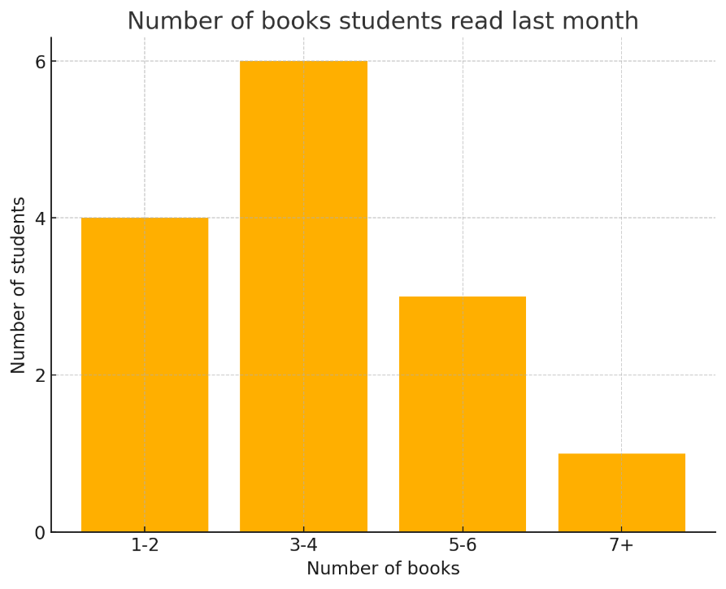

Question 8

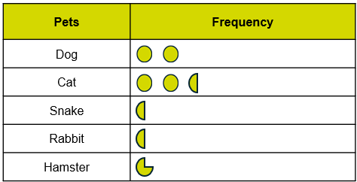

Key
= 4 people

Exam practice

Exam practice 1

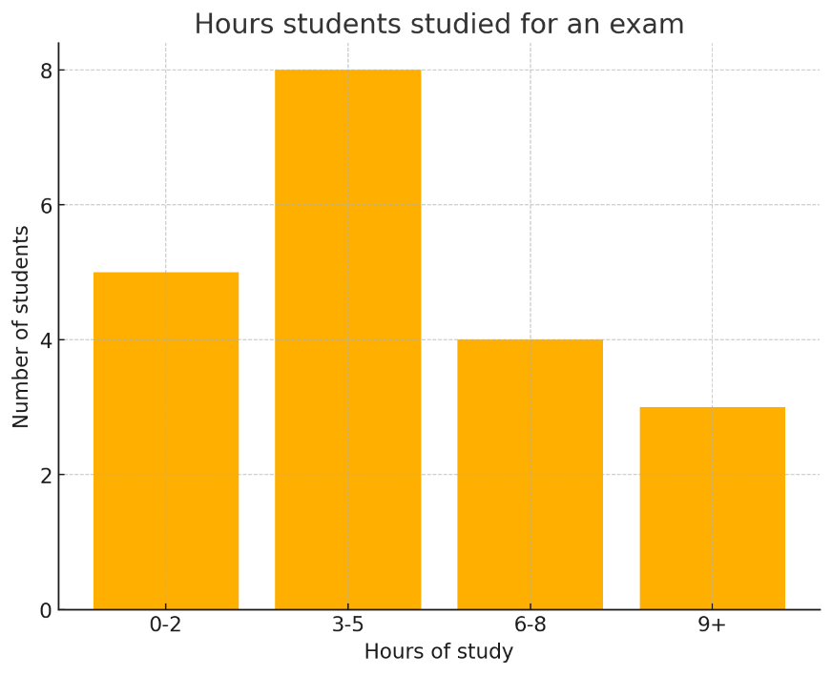

- 7 students
- 13 students

Exam practice 2

a)
Number of pets | Frequency
0-2 | 5
3-5 | 8
6-8 | 6
9+ | 1
Total: | 20

b)
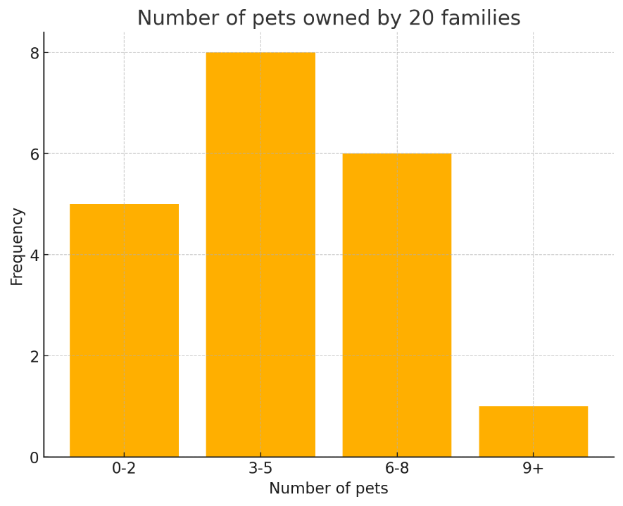

Your functional skills exam

Your functional skills exams will consist of 2 papers.
These papers will take place over the following time periods:

- Non-calculator paper – 40 minutes
- Calculator – 1 hour 50 minutes

Further information on the format that your test will take can be obtained from your training provider.

Hints and tips

- Find out what format your exam will be in. It may be paper-based
or on-screen.
- Plan what you are going to revise in advance. Don’t leave it until the last minute.
- Do as many past papers as you can so you are prepared for the day. If possible, try to complete the past papers following the same format as the actual exam.
- Find a quiet place to study and revise. It helps to sit at a table or a desk, don’t revise in bed.
- Don’t stay up all night revising the night before your exam. It’s important to have a good rest so you feel refreshed and ready to go.
- Read the question 3 times. The first time to ensure you understand what is being asked, the second time to get an understanding of what you need to do, and a third time to figure out exactly what maths techniques you should be applying.
- If you are struggling with a question, skip it and come back to it later. Try not to sit getting worked up about a difficult question, it will only waste exam time. Move on and come back to it after you have answered the other questions.
- Take note of the number of marks available. This will give you an indication of how much working out you must show. For example, 1 mark will need an answer only and more marks will need you to show your working out.
- When you’ve finished the exam, go back and check your answers. If you still have time remaining, use it to check your answers and when you have checked your answers check them again.

