

FUNCTIONAL SKILLS

Maths Level 2

Area: Handling information and data
Criterion: Work out the probability of combined events including the use of diagrams and tables, including two-way tables
Express probabilities as fractions, decimals and percentages

Probability

Probability is the calculation of how likely an event is to happen.
If something has a low probability, it is unlikely to happen.
If something has a high probability, it is likely to happen.
Probabilities are always shown as fractions, decimals or percentages.
Formula:
$$The probability of an event = \frac{Number of ways for something to happen}{Total number of possible outcomes }$$

For example,

Work out the probability of selecting a vowel from the word HIGHFIELD.
Give your answer as a fraction in its simplest form.

To find the probability, first work out how many of these letters are vowels.
(Vowels are A, E, I, O and U.)

There are 3 vowels in the word HIGHFIELD.

Next, count how many letters there are in HIGHFIELD.

There are 9

Therefore, the probability of selecting a vowel is $\frac{3}{9}$

In its simplest form, $\frac{3}{9}$ becomes $\frac{1}{3}$

To convert a fraction to a percentage, divide the numerator by the denominator, then multiply the answer by 100

1 ÷ 3 = 0.333
0.333 x 100 = 33.3%

Question 1a

Work out the probability of selecting a vowel from the word FUNCTIONAL.
Give your answer as a fraction in its simplest form.

(Show your working out.)
(2 marks)

Question 1b

Convert your answer from 1a into a percentage.

(Show your working out.)
(1 mark)

Question 2

A bag contains 12 different colour counters: 5 red, 4 white, 2 blue and 1 pink.
What is the probability of selecting a blue counter?
Give your answer as a fraction in its simplest form.

(Show your working out.)
(2 marks)

Question 2b

Convert your answer from 2a into a percentage.

(Show your working out.)
(1 mark)

Question 3a

A die is numbered 1 to 6.
What is the probability of rolling an odd number?
Show your answer as a fraction.

(Show your working out.)
(1 mark)

Question 3b

Show your answer to 3a as a decimal and a percentage.

(Show your working out.)
(2 marks)

Question 4

You select a random card from a deck of 52 cards. What is the probability that you have selected a red card?
Give your answer as a percentage.

(Show your working out.)
(1 mark)

Question 5

You select a random card from a deck of 52 cards. What is the probability that you will select a picture card?
Give your answer as a fraction.

(Show your working out.)
(2 marks)

The probability of events not happening

If you know the probability of something happening, you can work out the probability that it will not happen.

You can calculate this by subtracting the probability of something happening from one.
Here is the formula:

Probability that an event will not happen = 1 – the probability the event will happen

If your probability is a percentage, replace the 1 with 100.

For example,

Alex forgot to water their plant before going on holiday.
There is a 43% chance the plant will have wilted when they return.
What is the probability that the plant will not have wilted?

100% - 43% = 57%
There is a 57% chance that the plant will not have wilted.

Here is another example.

Work out the probability of not selecting a vowel from the word HIGHFIELD.
Give your answer as a fraction in its simplest form.

To find the probability, first work out how many of these letters are vowels.
(Vowels are A, E, I, O and U.)

There are 3 vowels in the word HIGHFIELD.

Next, count how many letters there are in HIGHFIELD.

There are 9 letters in total. Therefore, the probability of selecting a vowel is $\frac{3}{9}$

However, the question asks for the probability of not selecting a vowel.

Therefore, we must subtract the probability of selecting a vowel from 1.

1 = $\frac{9}{9}$

$\frac{9}{9}$ - $\frac{3}{9}$ = $\frac{6}{9}$

In its simplest form, $\frac{3}{9}$ becomes $\frac{2}{3}$

To convert this fraction to a percentage, divide the numerator by the denominator, then multiply the answer by 100

2 ÷ 3 = 0.666
0.666 x 100 = 66.6%

Question 6

You roll a die. What is the probability of not rolling a 6?

(Show your working out.)
(2 marks)

Question 7

You win a prize from a school tombola.
The prizes are as follows:
- 3 bars of chocolate
- 2 cans of pop
- 4 bags of sweets
- 7 bags of crisps
What is the probability of not winning a bag of sweets?

(Show your working out.)
(2 marks)

Probability from tables and diagrams

You may need to use a diagram or table to find the information you need.

The numbers you require may be in a table or diagram. You may need to add or subtract data within the table, for example, the rows, columns or entire table.

For example, a shop sells toy cars.
The table shows the colour and price of the toy cars.
The manager chooses a car at random to put on display.
What is the probability that the car they choose costs more than £5?

 | Yellow | Blue
Under £5 | 8 | 6
More than £5 | 5 | 3

First, we need to calculate how many cars there are in total.
8 + 6 + 5 + 3 = 22

Next, we need to work out how many of the cars cost more than £5
5 + 3 = 8

Therefore, the probability of the manager choosing a car than costs more than £5 is $\frac{8}{22}$

This can be simplified by dividing by the highest common multiple, which is 2

$\frac{8}{22}$÷ 2 = $\frac{4}{11}$

As a decimal:
8 ÷ 22 = 0.3636

As a percentage:
0.3636 x 100 = 36.36%

You can also use a diagram or table to record multiple events.

For example,

2 dice are rolled and the outcomes are added together. The table below shows the possible results. What is the probability that the result is a 7?

 |  | Die 1 results
 |  | 1 | 2 | 3 | 4 | 5 | 6
Die 2 results | 1 | 2 | 3 | 4 | 5 | 6 | 7
Die 2 results | 2 | 3 | 4 | 5 | 6 | 7 | 8
Die 2 results | 3 | 4 | 5 | 6 | 7 | 8 | 9
Die 2 results | 4 | 5 | 6 | 7 | 8 | 9 | 10
Die 2 results | 5 | 6 | 7 | 8 | 9 | 10 | 11
Die 2 results | 6 | 7 | 8 | 9 | 10 | 11 | 12

To calculate the probability of the 2 dice totalling 7, we can use the values in the table.

First, we need to work out the total number of different possible outcomes.
There are 36 possible outcomes.

Next, we need to count the number of 7s that are shown in the table.
There are 6 chances out of the 36 possible outcomes to get a result of 7.
Therefore, the probability of the result being 7 is $\frac{6}{36}$
In its simplest form, $\frac{6}{36}$ becomes $\frac{1}{6}$

As a decimal:
6 ÷ 36 = 0.1666

As a percentage:
0.1666 x 100 = 16.66%

Question 8

Two dice are rolled and the outcomes are added together. The table below shows the possible results. What is the probability that the result is 11?
Give your answer as a percentage.

 |  | Die 1 results
 |  | 1 | 2 | 3 | 4 | 5 | 6
Die 2 results | 1 | 2 | 3 | 4 | 5 | 6 | 7
Die 2 results | 2 | 3 | 4 | 5 | 6 | 7 | 8
Die 2 results | 3 | 4 | 5 | 6 | 7 | 8 | 9
Die 2 results | 4 | 5 | 6 | 7 | 8 | 9 | 10
Die 2 results | 5 | 6 | 7 | 8 | 9 | 10 | 11
Die 2 results | 6 | 7 | 8 | 9 | 10 | 11 | 12

(Show your working out.)
(3 marks)

Question 9

Two spinners are spun and the results of each are added together.
The possible outcomes are shown in the table below.
What is the probability that the result is a 9?

 |  | Spinner 1 results
 |  | 2 | 3 | 4 | 5
Spinner 2 results | 2 | 4 | 5 | 6 | 7
Spinner 2 results | 3 | 5 | 6 | 7 | 8
Spinner 2 results | 4 | 6 | 7 | 8 | 9
Spinner 2 results | 5 | 7 | 8 | 9 | 10

(Show your working out.)
(2 marks)

Exam practice 1

You are helping at Highfield Sweet Shop.
A customer buys a bag of mixed sweets.
The bag contains 18 toffees, 14 mints, 3 jelly beans and 5 caramels.
The customer shakes the bag and picks a sweet at random.
What is the probability that they pick a jelly bean?

(Show your working out.)
(2 marks)

Exam practice 2

A box contains sweets that are either covered with dark chocolate or milk chocolate.
There are twice as many sweets covered in dark chocolate than there are covered in milk chocolate.

The sweets have different flavoured centres: strawberry, lemon and cherry.
There are an equal number of each flavour.

This diagram shows options of picking each chocolate and the flavour.

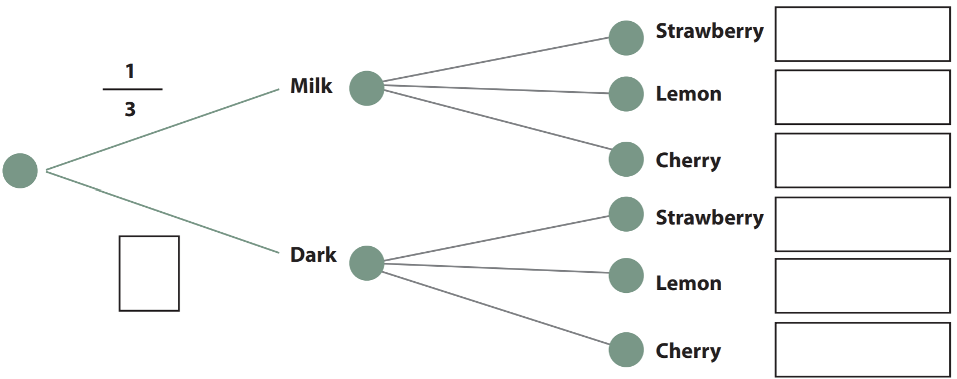

$$\frac{2}{3}$$

Complete the diagram with the probability of each branch.

Use the diagram to find the probability of picking a cherry flavour sweet with dark chocolate.

(Show your working out.)
(4 marks)

Exam practice 3

You work as a driver for Highfield Transport.

When Highfield Transport gets busy, it offers overtime to a driver.

There are a total of 3 drivers at Highfield Transport. The probability of there being overtime available in any given week is $\frac{1}{5}$ .

The driver allocated overtime is chosen at random.

What is the probability of you being allocated overtime next week? Give your answer as a fraction and a percentage.

(Show your working out.)
(3 marks)

Exam practice 4

There is a spinning wheel at a school event. Children have the chance to win a prize.

10 boys and 10 girls each have a spin.

What is the probability that a girl spins and does not win a prize.

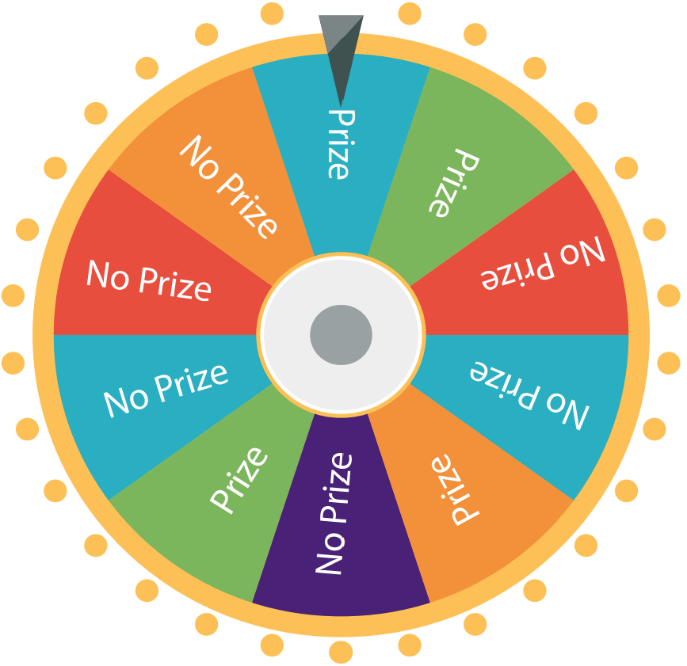

(Show your working out.)
(4 marks)

Answers

Probability

Question 1a
$\frac{4}{10}$ = $\frac{2}{5}$

Question 1b
2 ÷ 5 = 0.4
0.4 x 100 = 40%

Question 2a
$\frac{2}{12}$ = $\frac{1}{6}$

Question 2b
1 ÷ 6 = 0.1666
0.1666 x 100 = 16.66%

Question 3a
$\frac{3}{6}$
Also accept $\frac{1}{2}$

Question 3b
Decimal = 0.5
Percentage= 50%

Question 4a
Half of the cards in a deck are red, and half are blue
$\frac{1}{2}$ is the same as 50%

Question 5
There are 12 picture cards in a standard deck of cards: a Jack, Queen and King in each of the 4 suits.
Therefore, the probability of choosing a picture (or face) card is $\frac{12}{52}$
Also accept simplified fractions, such as $\frac{6}{26}$ and $\frac{3}{13}$

The probability of events not happening

Question 6
A die has 6 sides. The probability of rolling a 6 is $\frac{1}{6}$
1 = $\frac{6}{6}$

$\frac{6}{6}$ - $\frac{1}{6}$ = $\frac{5}{6}$

Therefore, the probability of not rolling a 6 is $\frac{5}{6}$

As a decimal, $\frac{5}{6}$ = 5 ÷ 6 = 0.833

As a percentage, $\frac{5}{6}$ = 5 ÷ 6 = 0.833
0.833 x 100 = 83.3%

Question 7
There are 16 prizes in total.
There is a 4 in 16 chance of winning a bag of sweets = $\frac{4}{16}$
1 = $\frac{16}{16}$
Therefore, the probability of not winning a bag of sweets is $\frac{16}{16}$ - $\frac{4}{16}$= $\frac{12}{16}$

As a decimal, $\frac{12}{16}$ = 12 ÷ 16 = 0.75

As a percentage, $\frac{12}{16}$ = 12 ÷ 16 = 0.75
0.75 x 100 = 75%

Probability from tables and diagrams

Question 8
First, work out the total number of different possible outcomes, which is 36

Next, count the number of 11s that are shown in the table.
2 chances out of the 36 = $\frac{2}{36}$
As a percentage, $\frac{2}{36}$ = 2 ÷ 36 = 0.0555

0.0555 x 100 = 5.55%

Question 9
Total possible outcomes = 16
Possible outcomes that give a result of 9 = 2
The probability of the result being 9 is therefore $\frac{2}{16}$
$\frac{2}{16}$ in its simplest form is $\frac{1}{8}$

As a decimal, $\frac{1}{8}$ = 2 ÷ 16 = 0.125

As a percentage
0.125 x 100 = 12.5%

Exam practice

Exam practice 1

The total number of sweets is 40
The fraction of jelly beans available is therefore $\frac{3}{40}$

As a decimal, the probability of choosing a jelly bean is 3 ÷ 40 = 0.075

As a percentage, the probability of choosing a jelly bean is 0.075 x 100 = 7.5%

Exam practice 2

$$\frac{2}{9}$$
$$\frac{2}{9}$$
$$\frac{2}{9}$$
$$\frac{1}{9}$$
$$\frac{1}{9}$$
$$\frac{1}{9}$$
$$\frac{2}{3}$$

Dark chocolate is $\frac{2}{3}$
Therefore, milk chocolate is $\frac{1}{3}$ as this totals $\frac{3}{3}$, or 1 whole.
To calculate the probability of choosing a milk chocolate filled sweet, divide $\frac{1}{3}$ by 3
This is because there are 3 possible milk chocolate fillings (strawberry, lemon and cherry), all with an equal chance of being chosen.
$\frac{1}{3}$÷ 3 = $\frac{1}{9}$
To calculate the probability of choosing a milk chocolate filled sweet, divide $\frac{2}{3}$ by 3
This is because there are 3 possible dark chocolate fillings, each with an equal chance of being chosen.
$\frac{2}{3}$÷ 3 = $\frac{2}{9}$
Therefore, the probability of choosing a dark chocolate sweet with cherry filling is $\frac{2}{9}$

Exam practice 3

$\frac{1}{5}$ x $\frac{1}{3}$ = $\frac{1}{15}$

As a percentage, $\frac{1}{15}$ = 1 ÷ 15 = 0.0666
0.0666 x 100 = 6.66%

Exam practice 4

Calculate the probability of landing on a ‘no prize’ section.
There are 10 sections and 6 of these are ‘no prize’ sections.
0.6, $\frac{6}{10}$ or $\frac{3}{5}$

Calculate the probability of the wheel being spun by a girl.
There are 10 boys and 10 girls, so the probability is 0.5, $\frac{5}{10}$ or $\frac{1}{2}$

Calculate the probability of a girl spinning the wheel and not winning a prize.
$\frac{3}{5}$ x $\frac{1}{2}$ = $\frac{3}{10}$

or

0.6 x 0.5 = 0.3

0.3 x 100 = 30%
Your functional skills exam

Your functional skills exams will consist of 2 papers.
These papers will take place over the following time periods:

- Non-calculator paper – 40 minutes
- Calculator – 1 hour 50 minutes

Further information on the format that your test will take can be obtained from your training provider.

Hints and tips

- Find out what format your exam will be in. It may be paper-based
or on-screen.
- Plan what you are going to revise in advance. Don’t leave it until the last minute.
- Do as many past papers as you can so you are prepared for the day. If possible, try to complete the past papers following the same format as the actual exam.
- Find a quiet place to study and revise. It helps to sit at a table or a desk, don’t revise in bed.
- Don’t stay up all night revising the night before your exam. It’s important to have a good rest so you feel refreshed and ready to go.
- Read the question 3 times. The first time to ensure you understand what is being asked, the second time to get an understanding of what you need to do, and a third time to figure out exactly what maths techniques you should be applying.
- If you are struggling with a question, skip it and come back to it later. Try not to sit getting worked up about a difficult question, it will only waste exam time. Move on and come back to it after you have answered the other questions.
- Take note of the number of marks available. This will give you an indication of how much working out you must show. For example, 1 mark will need an answer only and more marks will need you to show your working out.
- When you’ve finished the exam, go back and check your answers. If you still have time remaining, use it to check your answers and when you have checked your answers check them again.

