

FUNCTIONAL SKILLS

Maths Level 1

Area: Using common measures, shape and space
Criterion 25: Interpret plans, elevations and nets of simple 3-D shapes

Recognise common 3-D shapes

You should be able to name and describe everyday 3-D shapes. These are solid shapes with depth, width and height.

Here are some key shapes to know:

- cube – all sides (faces) are equal squares

- cuboid – like a box, it has rectangular faces (some may be squares)

- pyramid – has a flat base and triangular faces that meet at a point

- cylinder – has two circular ends and one curved surface (like a can)

- cone – has a circular base and a pointed top (like an ice-cream cone).

Tip: learn how many faces, edges and vertices (corners) each shape has to help you tell them apart.

Question 1

What is the name of this 3-D shape?

(1 mark)

Question 2

What is the name of this 3D shape?

(1 mark)

Question 3

What is the name of this 3-D shape?

(1 mark)

Understand plans, front elevations and side elevations

These are 2-D drawings that show what a 3-D shape looks like from different views:

- plan view – a view from the top (like you're looking down from above)

- front elevation – a view from the front (as if you’re standing in front of it)

- side elevation – a view from the side (looking from the left or right)
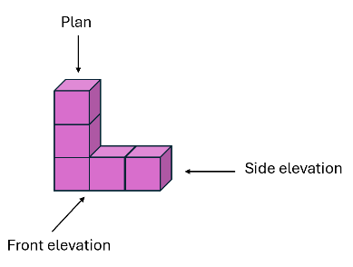
These drawings help you understand what a 3-D shape looks like without seeing the whole object.

Tip: focus on the outlines and shapes of the faces you can see in each view.

Question 4
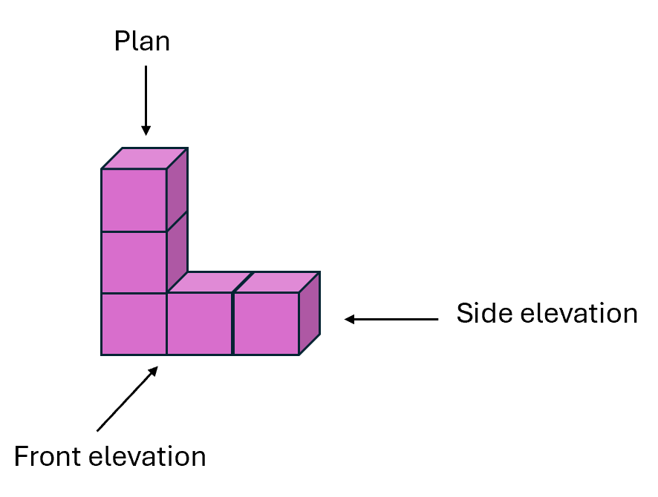

Is the shape below the plan, front elevation or side elevation of the 3-D shape above?
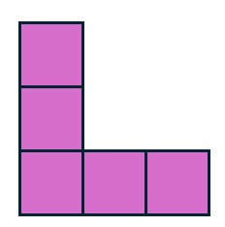
(1 mark)

Match a 3-D shape to its correct plan and elevations

To match a 3-D shape to its correct plan and elevations, you will need to look at the 2-D views, the plan, the front and the side, and figure out which 3-D shape they belong to.
Steps to follow:
- Look at the shapes in each elevation (are they a square, rectangle, triangle or circle?)
- Think about which 3-D shape could have those shapes for its faces
- Match the views to the correct 3-D shape using what you know about that shape’s faces
For example, if the plan shows a square and the front and side views also show squares, the shape is a cube.

Question 5

Which 3-D shape does this plan view represent?
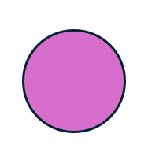
(1 mark)

Understand what a net is

A net is a 2-D shape that can be folded to make a 3-D shape. It shows all the faces of the shape laid out flat.

- A cube’s net has 6 equal squares.
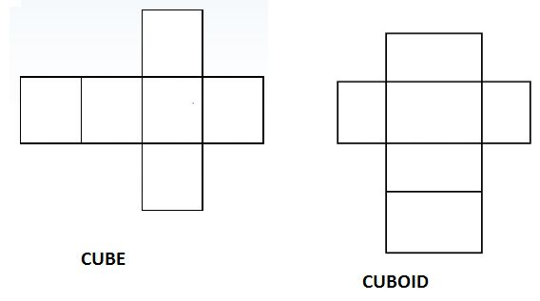
- A cuboid’s net has 6 rectangles (some may be squares)

- A pyramid’s net has a square or triangle base and triangular sides
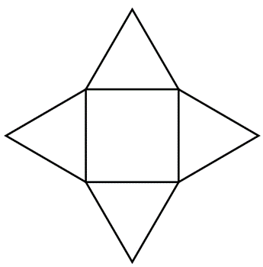
Question 6

Match the nets to the correct 3-D shapes. (5 marks)

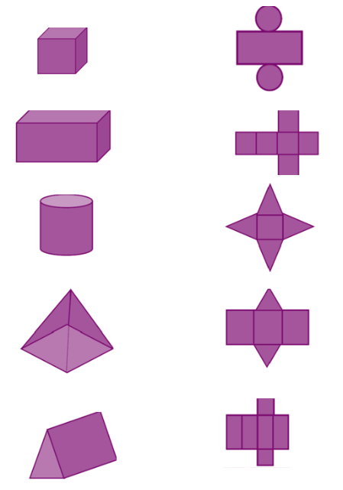
Exam practice 1

Which of these nets can be folded to form a cuboid?

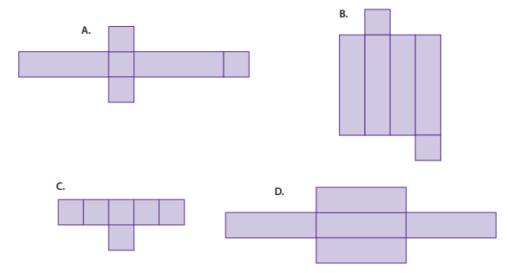
(1 mark)

Exam practice 2

Which of these shows the net of a cube?
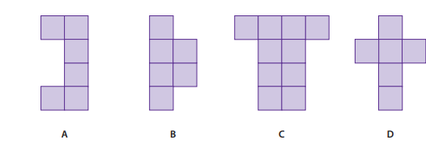

(1 mark)

Answers

Recognise common 3-D shapes

Question 1
Cuboid

Question 2
Cylinder

Question 3
Cone

Understand plans, front elevations and side elevations

Question 4
Front elevation

Match a 3-D shape to its correct plan and elevations

Question 5
Cylinder

Match nets to the correct 3-D shape

Question 6

Exam practice

Exam practice 1
B

Exam practice 1
D
Your functional skills exam

Your functional skills exams will consist of 2 papers.
These papers will take place over the following time periods:

- Non-calculator paper – 40 minutes
- Calculator – 1 hour 50 minutes

Further information on the format that your test will take can be obtained from your training provider.

Hints and tips

- Find out what format your exam will be in. It may be paper-based
or on-screen.
- Plan what you are going to revise in advance. Don’t leave it until the last minute.
- Do as many past papers as you can so you are prepared for the day. If possible, try to complete the past papers following the same format as the actual exam.
- Find a quiet place to study and revise. It helps to sit at a table or a desk, don’t revise in bed.
- Don’t stay up all night revising the night before your exam. It’s important to have a good rest so you feel refreshed and ready to go.
- Read the question 3 times. The first time to ensure you understand what is being asked, the second time to get an understanding of what you need to do, and a third time to figure out exactly what maths techniques you should be applying.
- If you are struggling with a question, skip it and come back to it later. Try not to sit getting worked up about a difficult question, it will only waste exam time. Move on and come back to it after you have answered the other questions.
- Take note of the number of marks available. This will give you an indication of how much working out you must show. For example, 1 mark will need an answer only and more marks will need you to show your working out.
- When you’ve finished the exam, go back and check your answers. If you still have time remaining, use it to check your answers and when you have checked your answers check them again.

