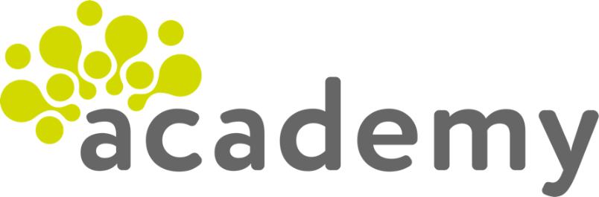

FUNCTIONAL SKILLS

English Level 2

Area: Reading
Criterion 12: Compare information, ideas and opinions in different texts, including how they are conveyed

Comparing information, ideas and opinions

The first section of this workbook focuses on the first part of this criterion: comparing information, ideas and opinions. The second section of the workbook will cover the next part of this criterion (how information, ideas and opinions are conveyed).

This criterion is assessed using the final two questions of your reading exam paper.

When we compare 2 or more things, we are identifying what is similar and what is different between them. Below is an example comparison question.

Compare Text B and Text C.
Identify two similarities or differences about therapy assistance dogs. (2 marks)

Comparing information becomes easier when you break the question into smaller sections. Here are some tips to help you:
- read the question carefully. You should focus on where the topic (for example, therapy assistance dogs) is discussed in each text.
- look at the first text and identify the main points about the topic.
- look at the second text and identify the main points about the topic.
- compare the information – do the writers of the texts agree with each other or do they have opposite views?

To get full marks, you need to compare both texts twice. Let’s look at an example answer based on the texts below.

Example Text A
Therapy assistance dogs provide invaluable support to individuals suffering from mental health conditions. These dogs reduce anxiety and help alleviate symptoms of depression. Their presence can create a positive, calming effect.

Example Text B
While therapy assistance dogs can offer emotional support, they are not a cure-all. Their effectiveness varies from person to person, and not everyone responds positively to animal-assisted therapy.

Example answer

Comparison 1: Text A says that ‘Their presence can create a positive, calming effect’. However, Text B says that ‘not everyone responds positively to animal-assisted therapy’. (1 mark)

Comparison 2: Text A also states that therapy assistance dogs ‘can provide invaluable support’. Similarly, Text B says they ‘can offer emotional support’.
(1 mark)

This answer compares both texts twice. It offers a difference, as well as a similarity, in the information, ideas and opinions that both writers have shared.

Conjunctions

Conjunctions are words that join clauses or ideas together. They can clearly and quickly show whether a comparison is a similarity or a difference.

By using conjunctions in your answer, you are showing that you have made a comparison between both texts and understand the similarities or differences.

Conjunctions used to show a similarity:
Similarly
Likewise
Equally

Conjunctions used to show a difference:

However
But
Whereas

In the example answer below, the conjunction ‘however’ has been used. This immediately shows that the comparison is a difference, rather than a similarity.

Text A offers benefits of therapy assistance dogs, such as ‘Their presence can create a calming effect’. However, Text B concentrates on the disadvantages of therapy assistance dogs, such as ‘not everyone responds positively to animal-assisted therapy’.

Using the information provided above, answer the following questions.

Question 1

Use the following conjunctions to complete the sentences below.

State whether each answer is a similarity or a difference.

However
Likewise
Similarly
Whereas
But

An example has been provided for you:

- John likes strawberry ice cream. However, Mary likes chocolate ice cream.

This is a difference.

- Catie thinks that exercise is important. ____________, Mark says you should do at least 30 minutes of exercise a day.

This is a _______________.

- Tim states that you need a balanced diet, ___________ Julie does not eat fruit or vegetables.

This is a _______________.

- Megan says that running can damage your knees, ____________ Lee says that running is good for your joints.

This is a ________________.

- Steve thinks that smoking is bad for you. __________, Dee says that smoking can take 10 years off your life expectancy.

This is a ________________.

Comparing similarities and differences

Read both texts very carefully before you start answering comparison questions.

To help you answer the question, identify and highlight specific words and phrases in the text that are relevant to the topic. This will help you make a comparison.

However, be careful not to highlight too much as this can make it difficult to pick out shorter quotes for comparison.

Let’s look at an example question.

Compare Text C and Text D.
Identify two similarities or differences about healthy living. (2 marks)

To answer this question effectively, we first need to consider what both Text C and Text D say about healthy living.

Text C uses the phrase ‘Health issues such as heart disease’.

Text D also refers to the heart when it says ‘Your heart is the most important muscle in your body. You need to keep it healthy!’.

As you can see, these 2 statements relate to the heart and healthy living. Therefore, they can be compared.

Read both texts carefully, then move on to question 2.

Text C

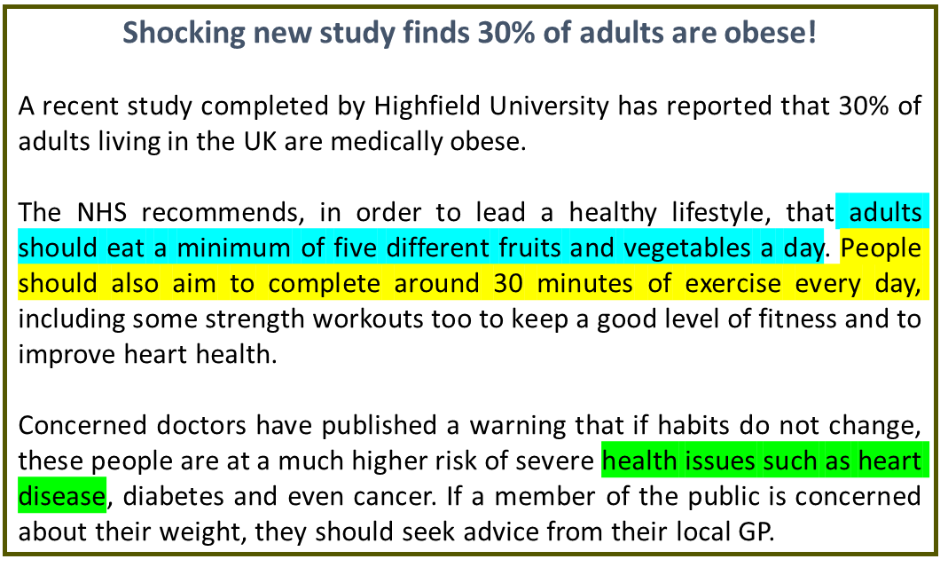
Text D


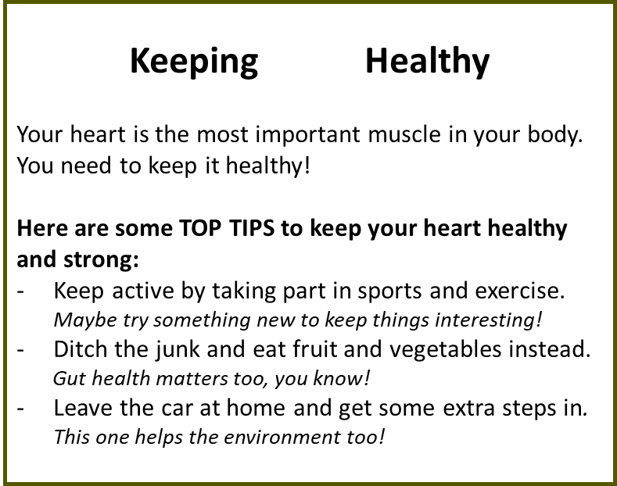

Question 2

Find a statement in Text D that is similar to the statement highlighted in Text C.

The first has been completed for you.

- Text C: Adults should eat a minimum of five different fruits and vegetables a day

Text D: __________________________________________________

- Text C: People should also aim to complete around 30 minutes of exercise every day

Text D: __________________________________________________

Top tips

Here are some top tips to follow when answering an exam comparison question:

- say whether the information you are providing is from Text A, Text B or Text C

- ensure you mention both texts in each comparison

- use small quotes in your comparison, rather than large paragraphs

- use conjunctions to make the comparisons clear

- make sure you include 2 separate comparisons

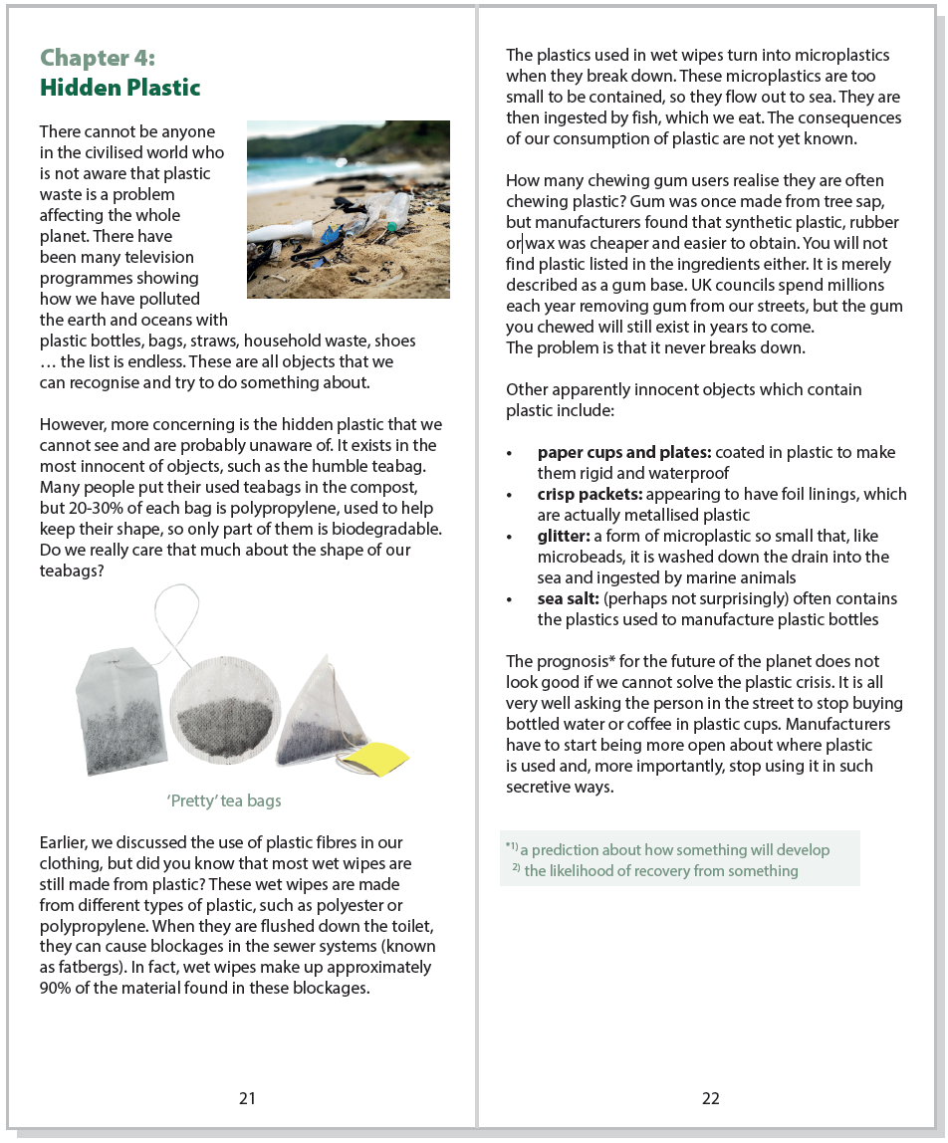
Text E

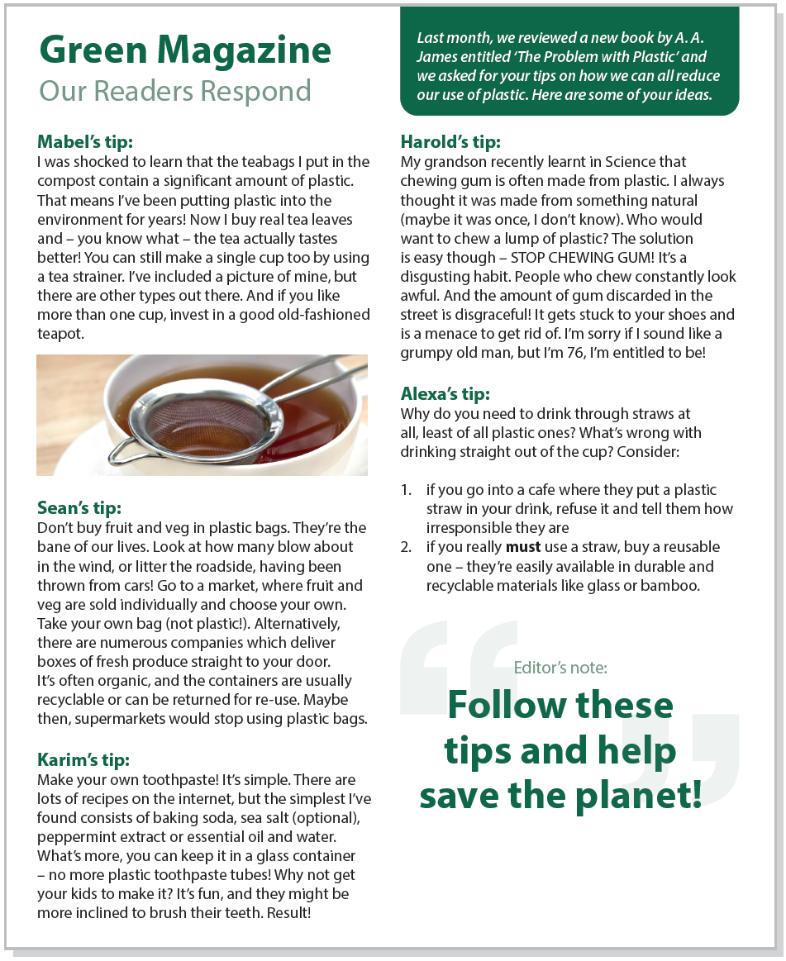
Text F

Using the information provided above, answer the following questions.

Exam practice 1

Compare Text C and Text D.
Identify two similarities or differences about hidden plastics.
(2 marks)

Comparison 1:

Comparison 2:

How information, ideas and opinions are conveyed

This section of the workbook will focus on the second part of the subject content: how information, ideas and opinions are conveyed.

Another way of saying conveyed is ‘how information, ideas and opinions are put across’.

Writers use different techniques to convey information to the reader. For example:
- humour may be used to entertain the reader.
- subheadings may be used to break the text into sections so it is easier to understand.
- the writer’s voice (or tone of voice) may be used to show how the writer is feeling. For example, in a letter of complaint the writer may use a frustrated or negative voice.

In your exam, you will be asked to identify how information, ideas and opinions have been put across in different texts.

Below is an example question on how information, ideas and opinions are conveyed.

Compare two ways the information has been conveyed in Text A and Text B.

In your answer, you could consider the use of:

• vocabulary
• style of writing
• tone of voice
(2 marks)

Although the question references vocabulary, style of writing and tone of voice, these are not the only answers.

There are different ways that you can answer this question:

Writing style
Formal, informal, explanatory, persuasive and so on.

Textual devices
Statistics, direct address, 3rd person perspective, emotive language and so on.
Writer’s voice
Positive, negative, friendly, frustrated and so on.
How texts convey ideas, opinions, and information

Vocabulary
Specialist, non-specialist, factual, opinionated and so on.

Organisational features
Bullet points, subheadings, textboxes, headlines or numbered lists and so on.

When answering a question about how information is conveyed, choose a topic from those listed above that you are more confident with.

You must compare the same type of feature from both texts to be awarded a mark.

Please note that this question does not cover bias. Marks will not be awarded to learners who reference bias when answering this question.
Read Text A below.

How has the writer conveyed the information to the reader in Text A?
Heading
Text A

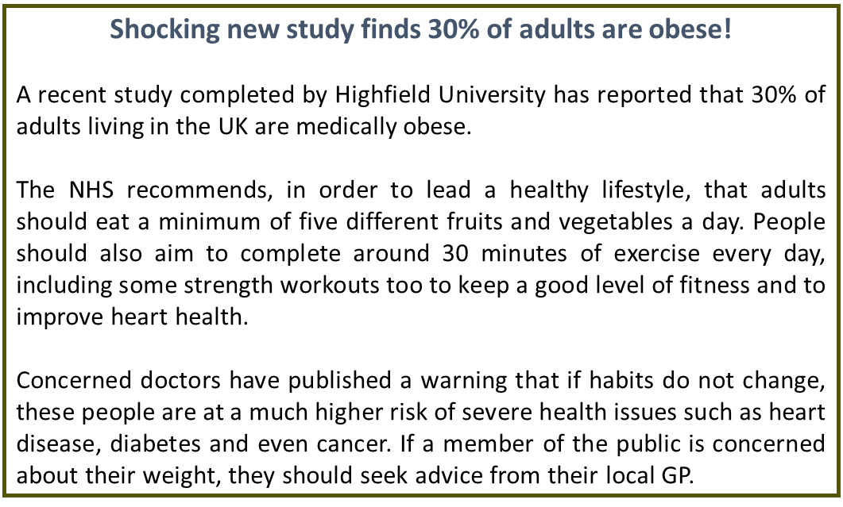
Negative voice
Statistics
Formal style

Example answers

Organisational features
The information has been conveyed using a headline to grab the reader’s attention.

Textual devices
The information has been conveyed using statistics to emphasise the points being made in the text.

Style of writing
The information has been conveyed using a formal style due to the important and serious nature of the topic.

Writer’s voice
The information has been conveyed using a negative tone of voice to outline the serious consequences of not following a healthy lifestyle.

Question 3

How has the writer conveyed the information to the reader in Text B?

Using the options below, label the text with how the information has been conveyed.

Options:

Direct address Bullet points Informal style Positive voice

Question 5

Choose one of the above options to compare the texts and complete this statement.

In Text A, information has been conveyed using a negative tone of voice.
However, in Text B, information has been conveyed using _______________.

Example answers

Let’s look at how we can use the information as an answer to the exam question.

Compare two ways the information has been conveyed in Text A and Text B.

In your answer, you could consider the use of:

• vocabulary
• style of writing
• tone of voice
(2 marks)
Comparison 1:
The information in Text A has been conveyed using statistics to emphasise the points being made in the text. However, Text B does not use statistics.

Here, we can see that the answer compares the use of statistics.

Comparison 2:
Text A is formal. However, Text B uses an informal style to encourage people to keep healthy.

In this second comparison, the formality of the texts has been compared.

Remember to read both texts very carefully.

Identify specific words and phrases in the text and make a comparison.

If one text uses first person perspective, does the second text also do this, or does it use second (or third) person perspective instead?

Exam tips on how information, ideas and opinions are conveyed

- Make it clear which text you are referring to (for example, Text A and Text B)
- You can refer to ‘both texts’ if you are giving a similarity (for example, both texts use a formal style)
- Make sure your comparison is about the same type of feature
- Give two different similarities and/or differences
- Compare how the information has been conveyed in each text: consider the use of textual devices, writing style, writer’s voice, vocabulary or organisational features

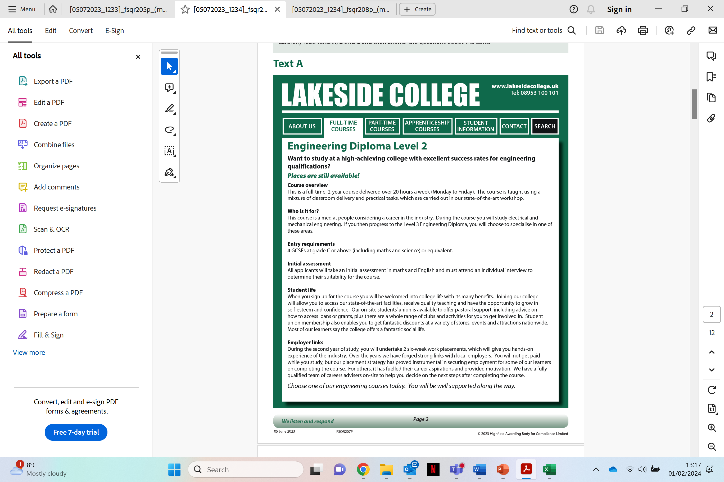
Text C

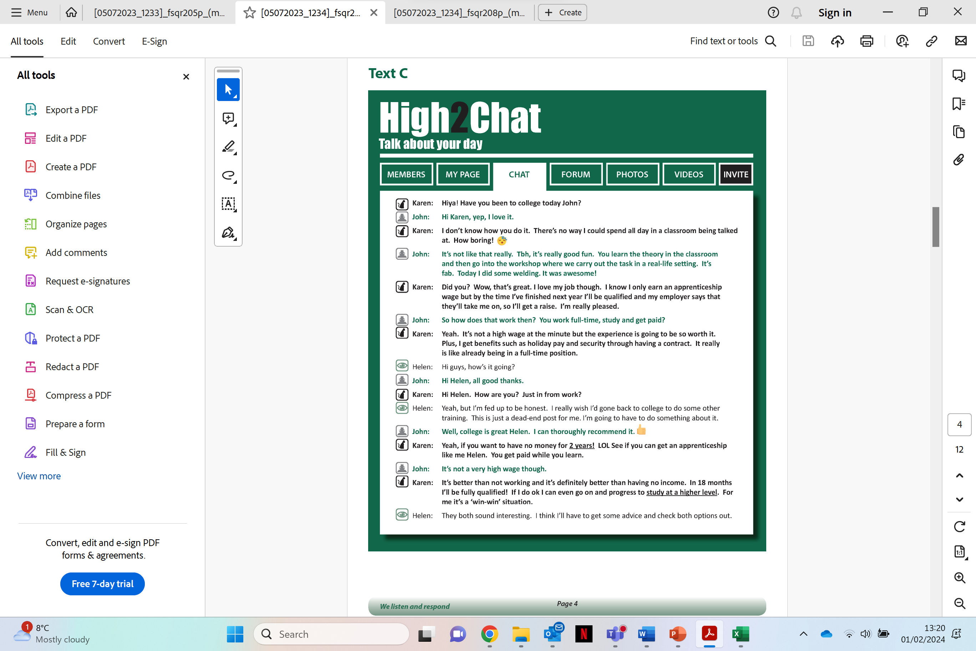
Text D

Exam practice 2

Compare two ways the information has been conveyed in Text C and Text D.

In your answer, you could consider the use of:
• vocabulary
• style of writing
• tone of voice
(2 marks)

Exam practice 3 and 4

These texts and question have been included as part of the Level 2 English SC12 video exam practice to ensure learners are able to read and access them efficiently.
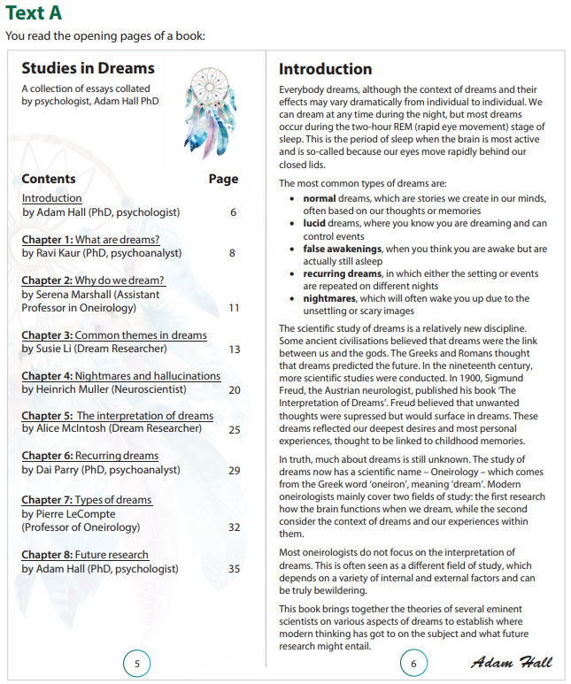
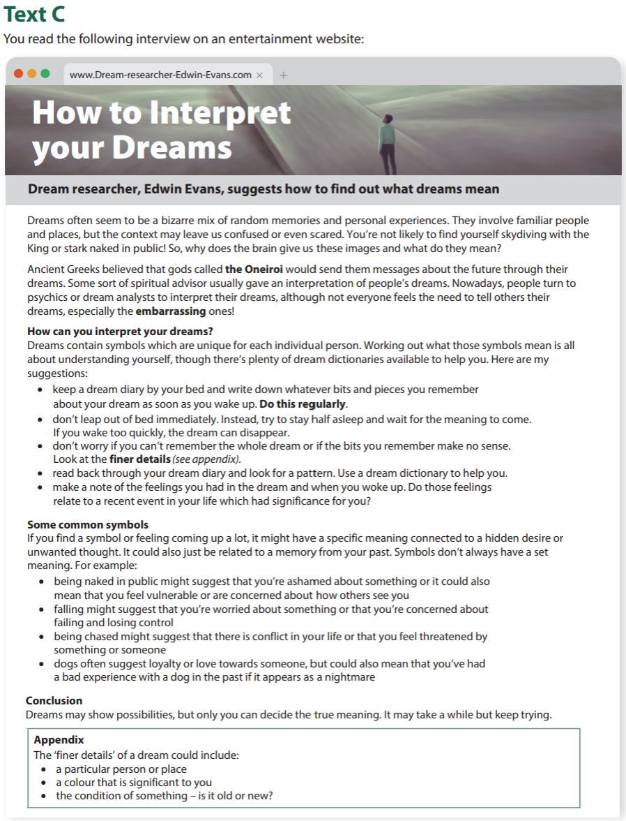

Exam practice 3

Compare Text A and Text C.

Identify two similarities or differences about dreams.

(2 marks)

Exam practice 4

Compare two ways the information has been conveyed in Text A and Text C.

In your answer, you could consider the use of:
• vocabulary
• style of writing
• tone of voice
(2 marks)

Answers

Comparing information, ideas and opinions

Conjunctions

Question 1

- John likes strawberry ice cream. However, Mary likes chocolate ice cream.

This is a difference.

- Catie thinks that exercise is important. Similarly/Likewise, Mark says you should do at least 30 minutes of exercise a day.

This is a similarity.

- Tim states that you need a balanced diet, whereas/but Julie does not eat fruit or vegetables.

This is a difference.

- Megan says that running can damage your knees, but/whereas Lee says that running is good for your joints.

This is a difference.

- Steve thinks that smoking is bad for you. Likewise/Similarly, Dee says that smoking can take 10 years off your life expectancy.

This is a similarity.

Comparing similarities and differences

Question 2

Find a statement in Text D that is similar to the statement highlighted in Text C.

The first has been completed for you.

- Text C: Adults should eat a minimum of five different fruits and vegetables a day

Text D: Ditch the junk and eat fruit and vegetables instead.

- Text C: People should also aim to complete around 30 minutes of exercise every day

Text D: Keep active by taking part in sports and exercise.

Exam practice

Exam practice 1
Please note that there may be other answers that correctly compare the 2 texts.

- Text E says that ‘20-30% of each tea bag is polypropylene’. Similarly, Text F says tea bags ‘contain a significant amount of plastic’.
- Text E states that ‘many people put their used tea bags in the compost, but only part of them are biodegradable’. Likewise, in Text F, Mabel was shocked to learn she had been ‘putting plastic into the environment for years’.
- Text E asks how many ‘chewing gum users realise they are often chewing plastic’. Similarly, Text F says that Harold’s grandson recently learnt in Science that ‘chewing gum is often made from plastic’.

How information, ideas and opinions are conveyed

Question 3

Direct address
Informal style

Bullet points
Positive voice

Question 5

In Text A, information has been conveyed using a negative tone of voice.
However, in Text B, information has been conveyed using a positive tone of voice.

Exam practice 2

Learners will receive 1 mark for each correct comparison of how ideas and opinions have been conveyed.

Please note that there may be other answers that are not stated below.

Answers include:
- Text C is formal, whereas Text D is informal
- Text C includes facts/factual statements, whereas Text D includes opinions with facts to support their arguments

Exam practice 3

This question is taken from the Level 2 English SC12 practice video.

Please note that there may be other answers that are not stated below.

- In Text A, it says that the Greeks believed that dreams could predict the future, whereas Text C says that the Ancient Greeks believed that gods would send messages through dreams. Text A says that normal dreams are often based on our memories. Similarly, Text C says that dreams often have a bizarre mix of random memories.

Exam practice 4

This question is taken from the Level 2 English SC12 practice video.

Please note that there may be other answers that are not stated below.

Answers include:

- Text A is formal, whereas Text C is informal
- Both Text A and Text C use bullet points
- Text A uses a factual style of writing, whereas Text C uses imperatives
Your functional skills exam

Your functional skills exams will consist of 2 papers.
These papers will take place over the following time periods:

- Reading – 60 minutes
- Writing – 60 minutes

Further information on the format that your test will take can be obtained from your training provider.

Hints and tips

- Find out what format your exam will be in. It may be paper-based
or on-screen.
- Plan what you are going to revise in advance. Don’t leave it until the last minute.
- Do as many past papers as you can so you are prepared for the day. If possible, try to complete the past papers following the same format as the actual exam.
- Find a quiet place to study and revise. It helps to sit at a table or a desk, don’t revise in bed.
- Don’t stay up all night revising the night before your exam. It’s important to have a good rest so you feel refreshed and ready to go.
- Read the question three times. The first time to ensure you understand what is being asked, the second time to get an understanding of what you need to do, and a third time to figure out exactly what techniques you should be applying.
- If you are struggling with a question, skip it and come back to it later. Try not to sit getting worked up about a difficult question, it will only waste exam time. Move on and come back to it after you have answered the other questions.
- Take note of the number of marks available. This will give you an indication of how much working out you must show. For example, 1 mark will need an answer only and more marks will need you to show your working out.
- When you’ve finished the exam, go back and check your responses.

