

FUNCTIONAL SKILLS

Maths Level 2

Area: Numbers and the number system
Criterion 4: Identify and know the equivalence between fractions, decimals and percentages

Fractions, decimals and percentages

Fractions
Fractions represent parts of a whole.

The numerator (top number) tells you how many parts you have.

The denominator (bottom number) tells you how many parts the whole is split into.

For example, $\frac{1}{2}$ means 1 part out of 2 equal parts.
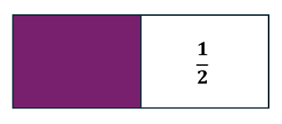
$\frac{3}{4}$ means 3 parts out of 4 equal parts.
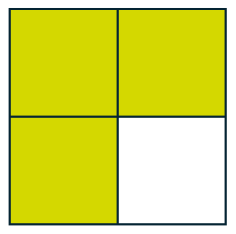

Percentages
Percentages show a part out of 100
‘Per cent’ means per hundred.
For example, 50% means 50 out of 100 (the same as $\frac{1}{2}$ or 0.5).
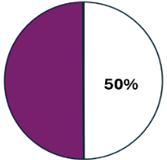

25% is 25 out of 100 and 75% is 75 out of 100

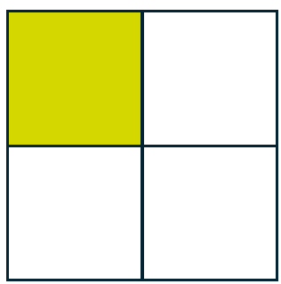

Decimals
Decimals express fractions in a different way using place value.
For example, 0.5 is the decimal form of $\frac{1}{2}$
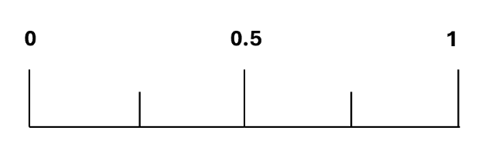
Some fractions, decimals and percentages represent the same value. For example:

$\frac{1}{2}$ = 0.5 = 50%

$\frac{1}{4}$ = 0.25 = 25%

$\frac{3}{4}$ = 0.75 = 75%

The following steps will help you recognise equivalencies between fractions, decimals and percentages.

Step 1. Memorise common equivalents.
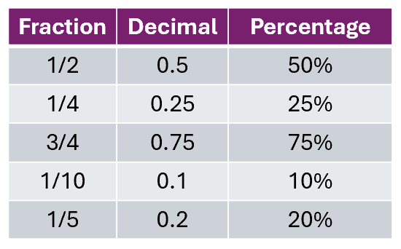

Step 2. Look for patterns in numbers.
You can use your knowledge of multiplication tables to help you work out equivalences.
For example:
0.2 is the same as 20% and $\frac{20}{100}$
You could multiply both by 3 to find out that 0.6 is the same as 60% and $\frac{60}{100}$

Question 1

Write the following percentages as fractions out of 100

73% 60% 42% 3% 99% 100% 178%

(Show your working out.)
(7 marks)

Question 2

Match the percentage to its equivalent decimal.

62% |  | 0.5
5% |  | 0.05
83% |  | 0.38
50% |  | 0.62
38% |  | 0.83

(Show your working out.)
(5 marks)

Converting fractions, decimals and percentages

Converting fractions to decimals
To convert a fraction to a decimal, divide the numerator (top number) by the denominator (bottom number).
For example, $\frac{1}{4}$ = 1 ÷ 4 = 0.25
If you are doing this without a calculator, you may want to try using the bus stop method. More information on this method can be found under level 2 maths criterion 10
Convert $\frac{1}{4}$ into a decimal.
First, put the number you want to divide inside the bus stop. In this example, this is the numerator, 1
Then, put the number you are dividing by on the outside to the left. In this example, this is the denominator, 4
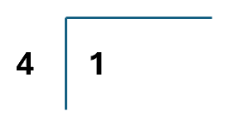
Now you are ready to divide 1 by 4
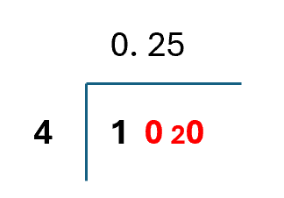
As you can see, 1 divided by 4 does not work. Place a zero above the 1 in the bus stop and add a decimal point after it.
Next, put a 0 next to the 1 inside the bus stop.
This makes the number 10
Now, do 10 divided by 4
10 ÷ 4 = 2 remainder 2
Place the whole number of the answer, 2, on top.
The remainder, or amount left over, is 2. We need to add this number inside the bus stop.
We cannot do 2 divided by 4. Again, we add a 0 after the 2 inside the bus stop. This makes 20

The next calculation is 20 ÷ 4 or 4 into 20
20 ÷ 4 = 5
Write the 5 on top of the bus stop.
There are no more numbers to divide, meaning we now have the answer.
1 ÷ 4 = 0.25

Question 3

Convert $\frac{1}{2}$ into a decimal.

(Show your working out.)
(1 mark)

Question 4

Convert $\frac{3}{30}$ into a decimal.

(Show your working out.)
(1 mark)

Question 5

Show the following fraction as a decimal.

$$\frac{1}{8}$$

(Show your working out.)
(1 mark)

Question 6

Show the following fraction as a decimal.

$$\frac{16}{20}$$

(Show your working out.)
(1 mark)

Converting decimals to percentages
To convert decimals to percentages, multiply the decimal by 100 and add a percentage sign (%). Here are some examples.

Convert 0.25 into a percentage.
First, multiply 0.25 by 100
0.25 x 100 = 25
Next, add a percentage sign.
25 becomes 25%.
0.25 = 25%

Convert 6.75 into a percentage.
6.75 x 100 = 675
6.75 is equivalent to 675%.

Show 0.03 as a percentage.
0.03 x 100 = 3
0.03 is equivalent to 3%.

Question 7

Write the following decimals as percentages.

0.1 0.01 1.81 0.86 1.69 0.09 9.43

(Show your working out.)
(7 marks)

Converting percentages to fractions
To convert percentages to fractions, write the percentage as a fraction out of 100
Please note that you may be asked to simplify the fraction if possible.

For example:
Convert 25% into a fraction. Give your answer in its simplest form.
25 percent = 25 out of 100 = $\frac{25}{100}$

25% is the same as 25 out of 100
Both 25 and 100 are multiples of 25, so we can divide both numbers to simplify the fraction.
25 ÷ 25 = 1
100 ÷ 25 = 4
When simplified, 25 out of 100 becomes $\frac{1}{4}$
We will cover simplifying fractions in more detail later in the workbook.

Question 8

Convert 76% into a fraction.

(Show your working out.)
(1 mark)

Question 9

Convert 55% into a fraction. Give your answer in its simplest form.

(Show your working out.)
(2 marks)

Question 10

Which of the following percentages is equivalent to $\frac{20}{50}$ ?

4% 140% 40% 44%

(Show your working out.)
(3 marks)

Simplifying fractions

Simplifying means making the fraction smaller but keeping its value the same.

To simplify a fraction, divide the numerator and denominator by their highest common factor (HCF).

The highest common factor is the highest number that both numbers can be divided by. Let’s look at an example.
$$\frac{20}{100}$$

Both 20 and 100 can be divided by 1, 2, 4, 5, 10 and 20

The highest common factor (HCF) is 20

Now, we need to divide the numerator and denominator by the HFC.

20 ÷ 20 = 1
100 ÷ 20 = 5

This gives us the fraction $\frac{1}{5}$

We can check that the fraction has been simplified as much as possible by trying to divide the answer by their HCF.

1 and 5 are only divisible by 1
We cannot make them any smaller.
Therefore, $\frac{1}{5}$is the simplest fraction.

Sometimes, you will be asked to convert a decimal or percentage into a fraction and show it in its simplest form.

To do this:
- convert the percentage or decimal into a fraction
- find the HCF
- divide the numerator and denominator by the HFC
- check the new fraction can’t be divided any further

Let’s look at an example.
Write 30% as a fraction in its simplest form.

60% = $\frac{60}{100}$

HCF:
60 = 1, 2, 3, 5, 6, 10, 15, 20, 30, 60
100 = 1, 2, 4, 5, 10, 20, 25, 50, 100

The HCF is 20

60 ÷ 20 = 3
100 ÷ 20 = 5
= $\frac{3}{5}$

Check it cannot be simplified further:
3 = 1, 3
5 = 1, 2, 5
Question 11

Write each fraction in its simplest form.

$\frac{16}{24}$ $\frac{86}{100}$ $\frac{6}{18}$ $\frac{12}{96}$ $\frac{51}{99}$

(Show your working out.)
(5 marks)

Question 12

Convert 0.3 into a fraction. Give your answer in its simplest form.

(Show your working out.)
(2 marks)

Question 13

Convert 56% into a fraction. Give your answer in its simplest form.

(Show your working out.)
(2 marks)

Question 14

Show 0.75 as a fraction in its simplest form.

(Show your working out.)
(2 marks)

Question 15

Show 52% as a fraction in its simplest form.

(Show your working out.)
(2 marks)

Question 16

Match each of the boxes on the left to its equivalent on the right.

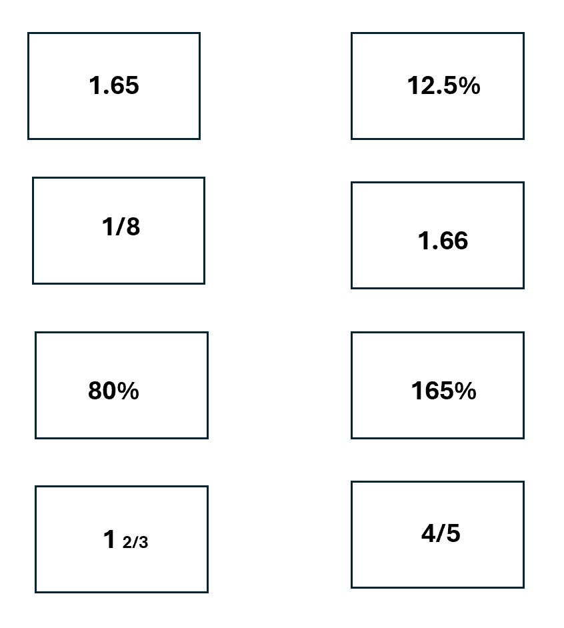
(Show your working out.)
(4 marks)

Question 17

Which of the following is not equivalent to 62%?

$\frac{62}{100}$ $\frac{31}{50}$ $\frac{15}{25}$ $\frac{124}{200}$

(Show your working out.)
(1 mark)

Do not use a calculator for questions 18 and 19

Question 18

Convert $\frac{3}{5}$ into a percentage.

(Show your working out.)
(1 mark)

Question 19

Convert 4 $\frac{3}{4}$ into a percentage.

(Show your working out.)
(1 mark)

Question 20

1 in 5 people said they cycle to work.

What is this as a percentage?

(Show your working out.)
(1 mark)

Question 21

Show $\frac{21}{84}$ as a fraction in its simplest form.
Convert it into a decimal and a percentage.

(Show your working out.)
(3 marks)

Question 22

Show $\frac{8}{24}$ as a fraction in its simplest form.
Convert it into a decimal and a percentage.

(Show your working out.)
(3 marks)

Compare and order fractions, decimals and percentages

To compare or order values, they must all be in the same format (fractions, decimals or percentages).

Convert all the numbers into the same format and then order them appropriately.

Top tip: most people find converting the values into decimals easiest but find a way that works best for you.

Here is an example.

Order the following from smallest to largest:
$\frac{3}{4}$ 70% 0.8

First, convert the values.

In this example, we will convert the values so they are all decimals.

$\frac{3}{4}$ = 0.75

70% = 0.7

  - = 0.8

Next, order the decimals from smallest to largest:

0.7 0.75 0.8

Next, give the answer by displaying each decimal value in its original form:

70% $\frac{3}{4}$ 0.8

Question 23

Ordering the following values from smallest to largest.

$\frac{31}{50}$ 61% 1.6

(Show your working out.)
(2 marks)

Question 24

Order the values from largest to smallest.

0.43 34% 304% 4 $\frac{3}{100}$

(Show your working out.)
(2 marks)

Question 25

Which value is the largest?

2 $\frac{1}{8}$ or 215%

(Show your working out.)
(1 mark)

Exam practice 1

Order the following from largest to smallest.

67% $\frac{2}{3}$ 0.76 $\frac{6}{7}$

(Show your working out.)
(2 marks)

Exam practice 2

Which of the following is equivalent to 85%?

0.58 0.085 $\frac{17}{20}$ $\frac{8}{5}$

(Show your working out.)
(1 mark)

Exam practice 3

You want to book a hotel for your holiday.

You find a hotel which has ratings from two different comparison sites.

On which site does the hotel have a higher rating?

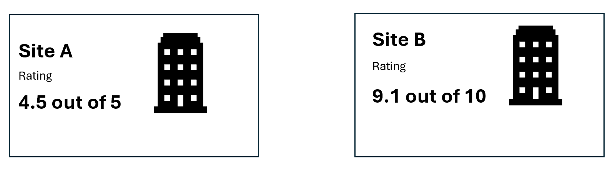

(Show your working out.)
(3 marks)

Exam practice 4

You see this sweatshirt on 2 different websites.
Which shop offers a bigger discount?



(Show your working out and write your answer in the box below.)
(3 marks)
Answers

Fractions, decimals and percentages

Question 1

73% = 73 out of 100 = $\frac{73}{100}$

60% = 60 out of 100 = $\frac{60}{100}$

42% = 42 out of 100 = $\frac{42}{100}$

3% = 3 out of 100 = $\frac{3}{100}$

99% =99 out of 100 = $\frac{99}{100}$

100% = 100 out of 100 (or 1 whole) = $\frac{100}{100}$ = 1

178% = 178 out of 100 = $\frac{178}{100}$

Question 2

62% = 0.62

5% = 0.05

83% = 0.83

50% = 0.5

38% = 0.38

Converting fractions to decimals

Question 3

$\frac{1}{2}$ = 0.5

Question 4

$\frac{3}{30}$ = 0.1

Question 5

$\frac{1}{8}$ = 0.125

Question 6

$\frac{16}{20}$ = 0.8

Converting decimals to percentages

Question 7

  - = 10%

0.01 = 1%

1.81 = 181%

0.86 = 86%

1.69 = 169%

0.09 = 9%

9.43 = 943%

Converting percentages to fractions

Question 8

76% = $\frac{76}{100}$ or any equivalent fraction, such as $\frac{19}{25}$

Question 9

55% = $\frac{55}{100}$ in its simplest form = $\frac{11}{20}$

Question 10

40% = $\frac{40}{100}$ = $\frac{20}{50}$

Simplifying fractions

Question 11

$\frac{16}{24}$ = $\frac{2}{3}$ (HFC = 8)

$\frac{86}{100}$ = $\frac{43}{50}$ (HFC = 2)

$\frac{6}{18}$ = $\frac{1}{3}$ (HFC = 6)

$\frac{12}{96}$ =$\frac{1}{8}$ (HFC = 12)

$\frac{51}{99}$ = $\frac{17}{33}$ (HFC = 3)

Question 12

0.3 = $\frac{30}{100}$ = $\frac{3}{10}$ (HFC = 10)

Question 13

56% = $\frac{56}{100}$ = $\frac{14}{25}$ (HFC = 4)

Question 14

0.75 = $\frac{75}{100}$ = $\frac{3}{4}$ (HFC = 25)

Question 15

52% = $\frac{52}{100}$ = $\frac{13}{25}$ (HFC = 4)

Question 16
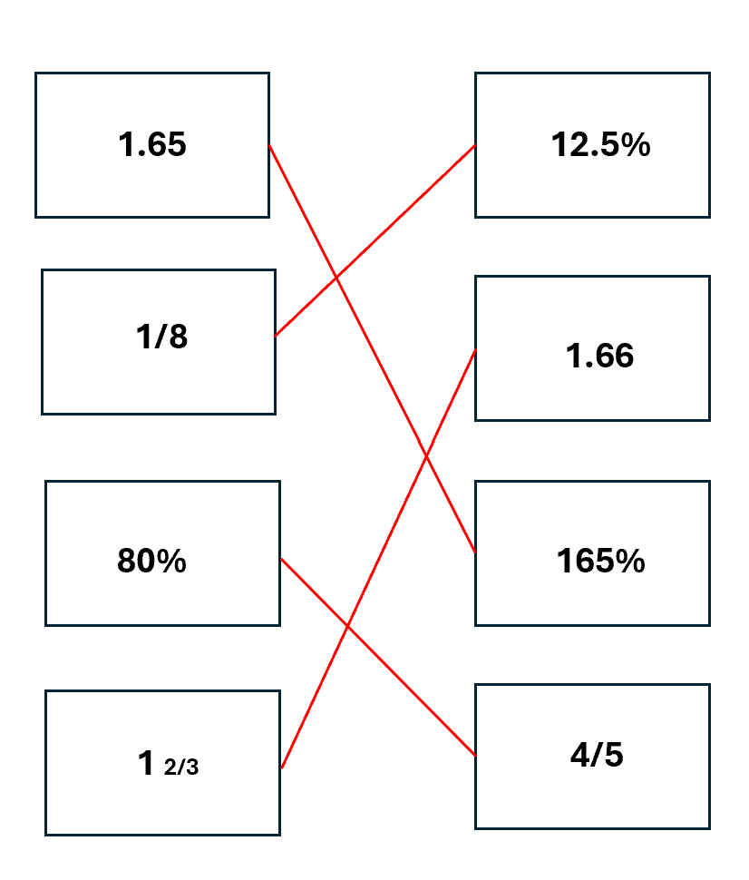

Question 17

$$\frac{15}{25}$$

Question 18

$\frac{3}{5}$ = $\frac{60}{100}$ = 60%

Question 19

4 $\frac{3}{4}$ = $\frac{475}{100}$ = 475%

Question 20

1 in 5 = $\frac{1}{5}$ = $\frac{20}{100}$ = 20%

Question 21

$\frac{21}{84}$ = $\frac{1}{4}$ = 0.25 = 25%

Question 22

$\frac{8}{24}$ = $\frac{1}{3}$ = 0.3333 x 100 = 33.33%

Compare and order fractions, decimals and percentages

Question 23

$\frac{31}{50}$ = $\frac{62}{100}$ = 0.62

61% = 0.61

1.6 = 1.6

Smallest to largest = 0.61, 0.62 and 1.6

Smallest to largest in its original form = 61%, $\frac{31}{50}$ 1.6

Question 24

0.43 = 0.43

34% = 0.34

304% = 3.04

4 $\frac{3}{100}$ = 4.03

Largest to smallest = 4.03, 3.04, 0.43 and 0.34

Largest to smallest in its original form = 4 $\frac{3}{100}$ 304%, 0.43, 34%

Question 25

2 $\frac{1}{8}$

$\frac{1}{8}$ = 0.125

2 + 0.125 = 2.125

215% = 2.15

215% (or 2.15) is the largest.

Exam practice

Exam practice 1

68% = 0.68

$\frac{2}{3}$ = 0.66

0.76 = 0.76

$\frac{6}{7}$ = 0.86

Largest to smallest in decimal form = 0.86, 0.76, 0.68 and 0.67

Answer from largest to smallest in the original form = $\frac{6}{7}$ 0.76, 68%, $\frac{2}{3}$

Exam practice 2

$\frac{17}{20}$

Exam practice 3

4.5 out of 5 = $\frac{9}{10}$ = 0.9 = 90%

9.1 out of 10 = 0.91 = 91%

Site B has a higher rating.

Exam practice 4

Shop A:

30% = 0.3

Shop B:

$\frac{1}{3}$ = 33.33%

Shop B has a larger discount as 0.33 is larger than 0.3

Your functional skills exam

Your functional skills exams will consist of 2 papers.
These papers will take place over the following time periods:

- Non-calculator paper – 40 minutes
- Calculator – 1 hour 50 minutes

Further information on the format that your test will take can be obtained from your training provider.

Hints and tips

- Find out what format your exam will be in. It may be paper-based
or on-screen.
- Plan what you are going to revise in advance. Don’t leave it until the last minute.
- Do as many past papers as you can so you are prepared for the day. If possible, try to complete the past papers following the same format as the actual exam.
- Find a quiet place to study and revise. It helps to sit at a table or a desk, don’t revise in bed.
- Don’t stay up all night revising the night before your exam. It’s important to have a good rest so you feel refreshed and ready to go.
- Read the question 3 times. The first time to ensure you understand what is being asked, the second time to get an understanding of what you need to do, and a third time to figure out exactly what maths techniques you should be applying.
- If you are struggling with a question, skip it and come back to it later. Try not to sit getting worked up about a difficult question, it will only waste exam time. Move on and come back to it after you have answered the other questions.
- Take note of the number of marks available. This will give you an indication of how much working out you must show. For example, 1 mark will need an answer only and more marks will need you to show your working out.
- When you’ve finished the exam, go back and check your answers. If you still have time remaining, use it to check your answers and when you have checked your answers check them again.

