

FUNCTIONAL SKILLS

English Level 1

Area: Reading
Criterion: Identify and understand the main points, ideas and details in texts

Identifying main points and ideas

Main point: This is the main idea that the writer wants to communicate. Depending on the type of text, the writer might use a title or subheadings to clearly mark their points.
Key ideas and details: The writer will include smaller ideas and details in the body of the text to support the main point.

Top tips:
- read the question carefully
- underline or make note of the key words in the question
- look for signposting, such as ‘Look at the third paragraph’
- check how many answers are needed in short-answer questions

Please be aware that this criterion is tested using both multiple-choice questions and short-answer questions.

Using the information provided above, answer the following questions.

Text A
456 Main Street
Bristol
BS8 2SQ

123 Park Lane
Bristol
BS1 5TL

11th July 2024

Dear residents,

Upcoming Community Park Clean-Up Event

I am writing to inform you about our upcoming community park clean-up event on Saturday, 20th July 2024, from 10:00 AM to 2:00 PM at Park Lane Community Park. This event is a fantastic opportunity to keep our park clean and enjoyable for everyone.

During the event, we will be picking up litter, trimming bushes and planting flowers. All necessary tools and gloves will be provided. Refreshments, including tea, coffee and snacks, will also be available for all volunteers.

We encourage everyone to participate and help make a difference in our community. Your involvement will not only enhance the beauty of our park but also foster a strong sense of community spirit.

We look forward to seeing you there!

Best regards,

John Smith
Community Coordinator
Question 1

Look at the second paragraph in Text A.
Identify two things that will be provided to volunteers.
(2 marks)

Text B

To: eventsteam@lowland.co.uk
From: maggiebrown@lowlwand.co.uk
Subject: Event actions – Bonfire on the 25th April
13th April 2025 14:56

Hello team,
Following our massively productive meeting, I thought I’d send a quick email to confirm actions for the upcoming weeks to prepare for the care home’s fundraiser event.

First of all, Jan, as our resident health and safety officer, please could you prepare a training session on fire safety? We have 15 fantastic volunteers from across the company ready to take on the responsibilities of the high-vis vest.

Tim has kindly offered his equipment and services for the day. He will be bringing his outdoor grill to cook up some delicious burgers and hot dogs! If anyone is available to help move and set up the equipment, please contact me. Your help would be greatly appreciated.

Rodger, please could you use your graphic design skills to create some inviting and family-oriented bonfire invitations? We want to encourage as many people as possible to attend this event.

Finally, if we could all contribute some time to manage the apple bobbing stall and the crafts area, we’ll all have plenty of time to have a walk round and enjoy the festivities. A time sheet will be posted in the break room for everyone to sign up.

Thank you all for your time and cooperation. Let’s make this bonfire a memorable and successful event!
Kind regards,
Maggie Brown

Question 2

Look at Text B.
Who has volunteered to cook burgers and hot dogs at the bonfire?
(1 mark)
Tick (ü) one box.
A | Jan
B | Tim
C | Rodger
D | Maggie

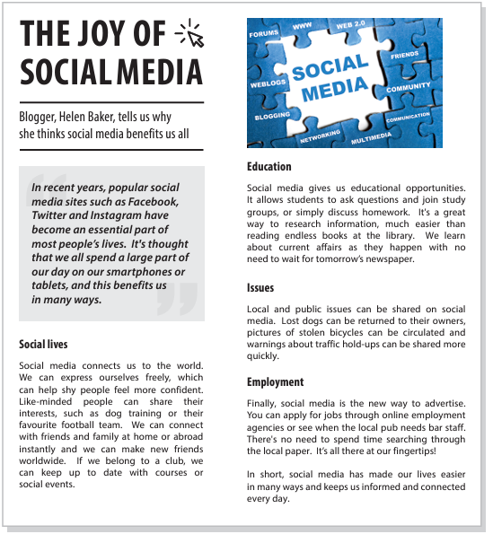
Exam practice text

Exam practice 1

Look at the ‘Social lives’ section in the exam practice test.
Who might gain confidence from using social media?
(1 mark)
Tick (ü) one box.
A | Someone who belongs to a club
B | A dog trainer
C | A shy person
D | Someone with a friend living abroad

Exam practice 2

Look at the ‘Education’ section in the exam practice test.
Identify two things students can use social media for.
(2 marks)

Answers

Identifying main points, ideas and details

Question 1
1 mark for a correct identification, up to a maximum of 2 marks.
Accept any of the following:
- tools
- gloves
- refreshments (tea, coffee, snacks)

Question 2
B) Tim

Exam practice

Exam practice 1
C) A shy person

Exam practice 2
1 mark for a correct identification, up to a maximum of 2 marks.
Accept any of the following:
- ask questions
- join study groups
- discuss homework
- research information

Your functional skills exam

Your functional skills exams will consist of 2 papers.
These papers will take place over the following time periods:

- Reading – 60 minutes
- Writing – 60 minutes

Further information on the format that your test will take can be obtained from your training provider.

Hints and tips

- Find out what format your exam will be in. It may be paper-based
or on-screen.
- Plan what you are going to revise in advance. Don’t leave it until the last minute.
- Do as many past papers as you can so you are prepared for the day. If possible, try to complete the past papers following the same format as the actual exam.
- Find a quiet place to study and revise. It helps to sit at a table or a desk, don’t revise in bed.
- Don’t stay up all night revising the night before your exam. It’s important to have a good rest so you feel refreshed and ready to go.
- Read the question 3 times. The first time to ensure you understand what is being asked, the second time to get an understanding of what you need to do, and a third time to figure out exactly what maths techniques you should be applying.
- If you are struggling with a question, skip it and come back to it later. Try not to sit getting worked up about a difficult question, it will only waste exam time. Move on and come back to it after you have answered the other questions.
- Take note of the number of marks available. This will give you an indication of how much working out you must show. For example, 1 mark will need an answer only and more marks will need you to show your working out.
- When you’ve finished the exam, go back and check your answers. If you still have time remaining, use it to check your answers and when you have checked your answers check them again.

