

FUNCTIONAL SKILLS

Maths Level 1

Area: Numbers and the number system
Criterion 3: Multiply and divide whole numbers and decimals by 10, 100, 1000

Multiplying whole numbers by 10, 100 and 1000

When we multiply a number by 10, 100 or 1000, the digits in the original number move to the left.

This makes the number larger.

The number of places a number moves depends on the number of place holders in 10, 100 and 1000

10 has 1 place holder.

100 has 2 place holders.

1,000 has 3 place holders.

Let’s look at some examples.

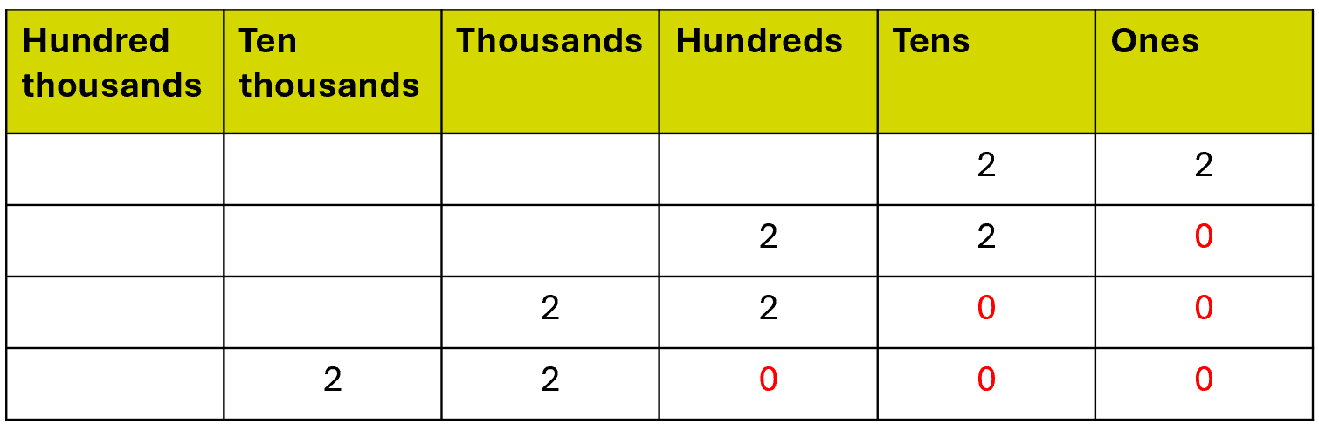
x 100
x 1000
x 10

22 x 10

The number 10 has 1 place holder, or zero.

Therefore, 22 moves 1 place to the left.

We need to add a place holder to the end of the answer to make sure the numbers stay in the correct place.

Therefore 22 x 10 = 220

22 x 100

The number 100 has 2 place holders, so 22 moves 2 places to the left.

We need to add 2 place holders to the end of the answer.

Therefore 22 x 100 = 2,200

22 x 1000

The number 1,000 has 3 place holders, so 22 moves 3 places to the left.

We need to add 3 place holders to the end of the answer.

Therefore 22 x 1,000 = 22,000

Below is a place value chart you can use to help you answer the questions in this section.

Hundred thousands | Ten thousands | Thousands | Hundreds | Tens | Ones

Question 1

Use the place value chart to multiply 831 by:

- 10
- 100
- 1,000
(3 marks)

Hundred thousands | Ten thousands | Thousands | Hundreds | Tens | Ones

Question 2

Calculate: 78 x 1,000

(Show your working out.)
(1 mark)

Question 3

Calculate: 7 x 10

(Show your working out.)
(1 mark)

Question 4

Calculate: 56 x 100

(Show your working out.)
(1 mark)

Question 5

Calculate: 930 x 1,000

(Show your working out.)
(1 mark)

Question 6

Steve has thirty-six 10p coins.

How much money does he have in total?

Give your answer in pounds or pence.

(Show your working out.)
(3 marks)

Multiplying decimals by 10, 100 and 1000

When you multiply a decimal by 10, 100 or 1000, the number also gets bigger.

This means the digits will also move to the left.

The decimal point does not move.

Let’s look at some examples.

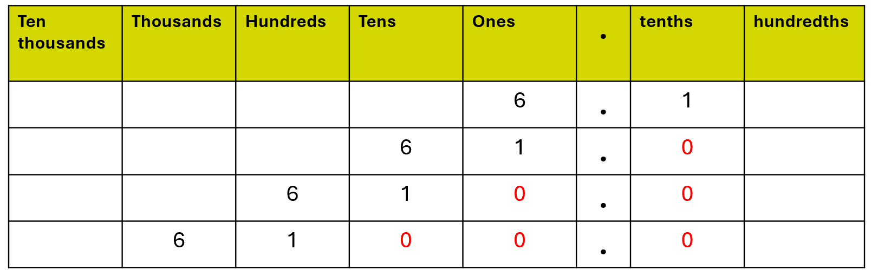
x 10
x 1000
x 100

6.1 x 10

The number 10 has 1 place holder, or zero, so 6.1 moves 1 place to the left.

6.1 x 10 = 61 or 61.0

6.1 x 100
The number 100 has 2 place holders, so 6.1 moves 2 places to the left.

6.1 x 100 = 610

6.1 x 1,000

The number 1,000 has 3 place holders, so 6.1 moves 3 places to the left.

6.1 x 1,000 = 6,100

Below is a place value chart you can use to help you answer the questions in this section.

Ten thousands | Thousands | Hundreds | Tens | Ones | . | tenths | hundredths | thousandths | Ten thousandths
 |  |  |  |  | .
 |  |  |  |  | .
 |  |  |  |  | .
 |  |  |  |  | .

Question 7

Use the place value chart to multiply 90.4 by:

- 10
- 100
- 1,000
(3 marks)

Ten thousands | Thousands | Hundreds | Tens | Ones | . | tenths | hundredths | thousandths | Ten thousandths
 |  |  |  |  | .
 |  |  |  |  | .
 |  |  |  |  | .
 |  |  |  |  | .

Question 8

Calculate: 5.6 x 100

(Show your working out.)
(1 mark)

Question 9

Calculate: 17.9 x 1,000

(Show your working out.)
(1 mark)

Question 10

Calculate: 3.21 x 10

(Show your working out.)
(1 mark)

Question 11

Calculate: 78.426 x 1,000

(Show your working out.)
(1 mark)

Dividing whole numbers by 10, 100 and 1,000

Dividing by 10, 100 or 1000 moves the digits to the right.

This makes the number smaller.

The decimal point does not move.

Again, the number of places we move the digits depends on the number of place holders.

When we divide a whole number, or integer, by 10, 100 or 1,000, the answer may become a decimal.

Let’s use a place value chart to help us look at some examples.

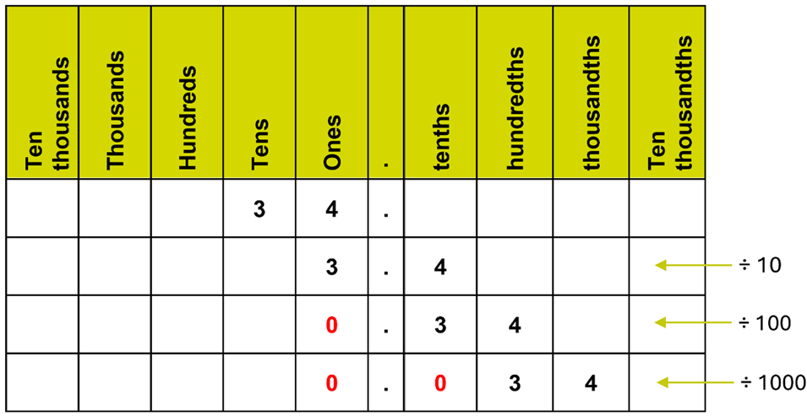

34 ÷ 10

There is 1 place holder, or zero, in the number 10

Since we are dividing, the digits will move 1 place to the right.

34 ÷ 10 = 3.4

Because there’s still a whole number before the decimal point, we do not need to place a zero at the start.

34 ÷ 100

There are 2 place holders in the number 100, so the digits will move 2 places to the right.

34 ÷ 100 = 0.34

There is no whole number before the decimal point, so we must place a zero at the start.

34 ÷ 1,000

There are 3 place holders in the number 1,000, so the digits will move 3 places to the right.

34 ÷ 1,000 = 0.034

Again, there is no whole number before the decimal point, so we must place a zero at the start.

We also need to place a zero in the tenth’s column.

Without this, the number would be read as 0.34, which is incorrect.

Below is a place value chart you can use to help you answer the questions in this section.

Ten thousands | Thousands | Hundreds | Tens | Ones | . | tenths | hundredths | thousandths | Ten thousandths
 |  |  |  |  | .
 |  |  |  |  | .
 |  |  |  |  | .
 |  |  |  |  | .

Question 12

Use the place value chart to divide 37 by:

- 10
- 100
- 1,000
(3 marks)

Ten thousands | Thousands | Hundreds | Tens | Ones | . | tenths | hundredths | thousandths | Ten thousandths
 |  |  |  |  | .
 |  |  |  |  | .
 |  |  |  |  | .
 |  |  |  |  | .

Question 13

Calculate: 640 ÷ 10

(Show your working out.)
(1 mark)

Question 14

Calculate: 35 ÷ 1,000

(Show your working out.)
(1 mark)

Question 15

Calculate: 5 ÷ 100

(Show your working out.)
(1 mark)

Question 16

Calculate: 17 ÷ 100

(Show your working out.)
(1 mark)

Question 17

A car drives 4,500 metres.

Divide this by 1,000 to convert it to kilometres (km).

(Show your working out.)
(1 mark)

Dividing decimals by 10, 100 and 1,000

Dividing decimals by 10, 100 or 1000 moves the digits further to the right to make the number even smaller.

We need to remember to add placeholders to the start of the numbers where needed.

Let’s use a place value chart to help us look at some examples.
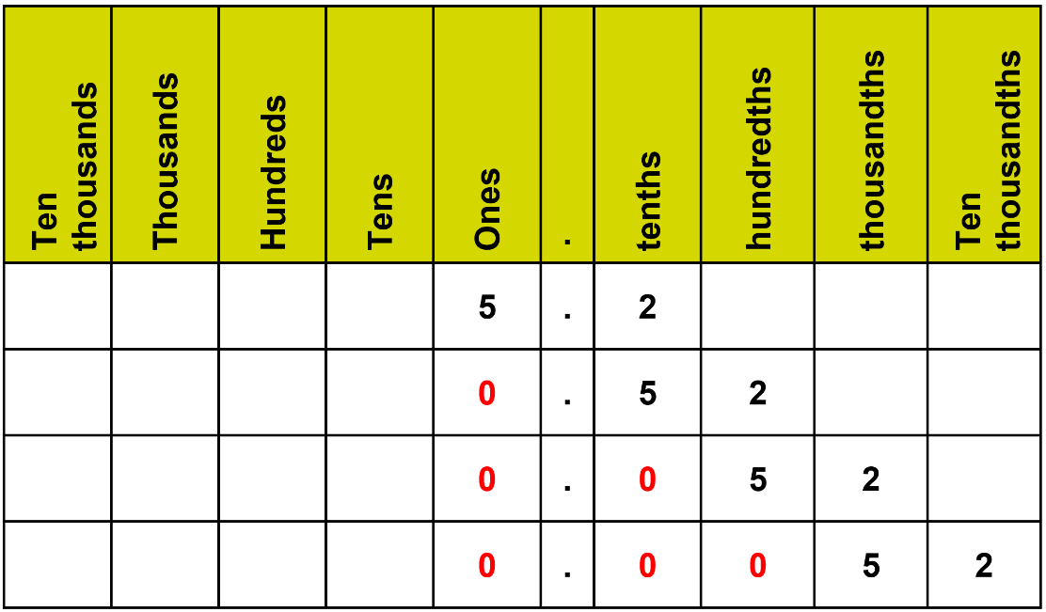
÷ 10
÷ 100
÷ 1000

5.2 ÷ 10

There is 1 place holder, or zero, in the number 10

Since we are dividing, the digits will move 1 place to the right.

5.2 ÷ 10 = 0.52

There’s no whole number before the decimal point in the answer, so we need to place a zero at the start.

5.2 ÷ 100

There are 2 place holders in the number 100, so the digits will move 2 places to the right.

5.2 ÷ 100 = 0.052

We will need 2 place holders at the start: 1 in the tenths column and 1 in the ones column.

5.2 ÷ 1,000

There are 3 place holders in the number 1,000. Since we are dividing, the digits will move 3 places to the right.

5.2 ÷ 1,000 = 0.0052

We will need 3 place holders at the start: 1 in the hundredths column, 1 in the tenths column and 1 in the ones column.

Below is a place value chart you can use to help you answer the questions in this section.

Ten thousands | Thousands | Hundreds | Tens | Ones | . | tenths | hundredths | thousandths | Ten thousandths
 |  |  |  |  | .
 |  |  |  |  | .
 |  |  |  |  | .
 |  |  |  |  | .

Question 18

Use the place value chart to divide 16.7 by:

- 10
- 100
- 1,000
(3 marks)

Ten thousands | Thousands | Hundreds | Tens | Ones | . | tenths | hundredths | thousandths | Ten thousandths
 |  |  |  |  | .
 |  |  |  |  | .
 |  |  |  |  | .
 |  |  |  |  | .

Question 19

Calculate: 0.43 ÷ 10

(Show your working out.)
(1 mark)

Question 20

Calculate: 9.9 ÷ 100

(Show your working out.)
(1 mark)

Question 21

Calculate: 5.05 ÷ 10

(Show your working out.)
(1 mark)

Question 22

Calculate: 246.3 ÷ 1,000

(Show your working out.)
(1 mark)

Exam practice 1

A recipe calls for 5.2 grams of sugar.

You need to multiply the amount by 10 to scale it up.

How much sugar will you need?

(Show your working out.)
(1 mark)

Exam practice 2

A factory produces 8,000 units each working day.

Each working day is 8 hours long.

If production is divided by 100, how many units will be produced per hour?

(Show your working out.)
(3 marks)

Answers

Multiplying whole numbers by 10, 100 and 1,000

Question 1

Hundred thousands | Ten thousands | Thousands | Hundreds | Tens | Ones
 |  |  | 8 | 3 | 1
 |  | 8 | 3 | 1 | 0
 | 8 | 3 | 1 | 0 | 0
8 | 3 | 1 | 0 | 0 | 0

Question 2

78 x 1,000 = 78,000

Question 3

7 x 10 = 70

Question 4

56 x 100 = 5,600

Question 5

930 x 1,000 = 930,000

Question 6

36 x 10p = 360p or £3.60

Multiplying decimals by 10, 100 and 1,000

Question 7

Ten thousands | Thousands | Hundreds | Tens | Ones | . | tenths | hundredths | thousandths | Ten thousandths
 |  |  | 9 | 0 | . | 4
 |  | 9 | 0 | 4 | . | 0
 | 9 | 0 | 4 | 0 | . | 0
9 | 0 | 4 | 0 | 0 | . | 0

Please note that the singular zero after the decimal point does not need to be written. This example uses it to show the number of place holders that are needed.

904
9,040
90,400 are all correct answers.

Question 8

5.6 x 100 = 560

Question 9

17.9 x 1,000 = 17,900

Question 10

3.21 x 10 = 32.1

Question 11

78.426 x 1,000 = 78,426

Dividing whole numbers by 10, 100 and 1,000

Question 12

Ten thousands | Thousands | Hundreds | Tens | Ones | . | tenths | hundredths | thousandths | Ten thousandths
 |  |  | 3 | 7 | .
 |  |  |  | 3 | . | 7
 |  |  |  | 0 | . | 3 | 7
 |  |  |  | 0 | . | 0 | 3 | 7

Question 13

640 ÷ 10 = 64

Question 14

35 ÷ 1,000 = 0.035

Question 15

5 ÷ 100 = 0.05

Question 16

17 ÷ 100 = 0.17

Question 17

4,500 ÷ 1,000 = 4.5km

Dividing decimals by 10, 100 and 1,000

Question 18

Ten thousands | Thousands | Hundreds | Tens | Ones | . | tenths | hundredths | thousandths | Ten thousandths
 |  |  | 1 | 6 | . | 7
 |  |  |  | 1 | . | 6 | 7
 |  |  |  | 0 | . | 1 | 6 | 7
 |  |  |  | 0 | . | 0 | 1 | 6 | 7

Question 19

0.43 ÷ 10 = 0.043

Question 20

9.9 ÷ 100 = 0.099

Question 21

5.05 ÷ 10 = 0.505

Question 22

246.3 ÷ 1,000 = 0.2463

Exam practice

Exam practice 1

5.2 x 10 = 52 grams

Exam practice 2

8000 ÷ 100 = 80 units per day

80 ÷ 8 = 10 units per hour

Your functional skills exam

Your functional skills exams will consist of 2 papers.
These papers will take place over the following time periods:

- Non-calculator paper – 40 minutes
- Calculator – 1 hour 50 minutes

Further information on the format that your test will take can be obtained from your training provider.

Hints and tips

- Find out what format your exam will be in. It may be paper-based
or on-screen.
- Plan what you are going to revise in advance. Don’t leave it until the last minute.
- Do as many past papers as you can so you are prepared for the day. If possible, try to complete the past papers following the same format as the actual exam.
- Find a quiet place to study and revise. It helps to sit at a table or a desk, don’t revise in bed.
- Don’t stay up all night revising the night before your exam. It’s important to have a good rest so you feel refreshed and ready to go.
- Read the question 3 times. The first time to ensure you understand what is being asked, the second time to get an understanding of what you need to do, and a third time to figure out exactly what maths techniques you should be applying.
- If you are struggling with a question, skip it and come back to it later. Try not to sit getting worked up about a difficult question, it will only waste exam time. Move on and come back to it after you have answered the other questions.
- Take note of the number of marks available. This will give you an indication of how much working out you must show. For example, 1 mark will need an answer only and more marks will need you to show your working out.
- When you’ve finished the exam, go back and check your answers. If you still have time remaining, use it to check your answers and when you have checked your answers check them again.

