

FUNCTIONAL SKILLS

Maths Level 2

Area: Measures, shapes and space
Criterion 20: Understand and use common 2-D representations of 3-D objects
Criterion 21: Draw 3-D shapes to include plans and elevations

3-D shapes, 2-D shapes and nets

A 3-D (three-dimensional) shape is a solid object that has length, width and height (or depth).

Examples of 3-D shapes:

Cuboid
Cylinder
Cone
Cube

A 3-D shape is not flat like a 2-D shape is. It takes up space and has volume.

2-D shapes are flat and only have length and width.

Examples of 2-D shapes:

Circle
Equilateral triangle
Right angle triangle
Hexagon

Nets

A net is a flat pattern you can fold to make a 3-D shape. It shows all the faces (flat sides) of the shape laid out.

When you fold the net along the edges, it makes the 3-D shape.

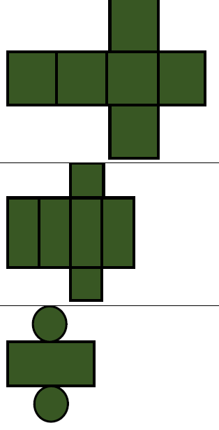
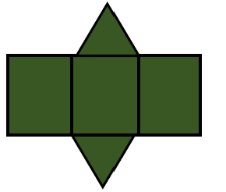

Cylinder
Cuboid
Triangular prism

Question 1

Name the 3-D shape below:

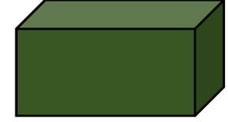

(1 mark)

Question 2

Name the 3-D shape below:

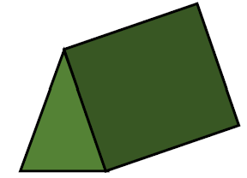

(1 mark)

Question 3

What 3-D shape does the net below represent?

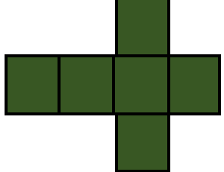

(1 mark)

Question 4

What 3-D shape does the net below represent?

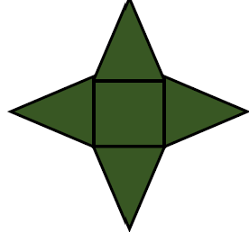
(1 mark)

Question 5

Draw a cube on the grid below.

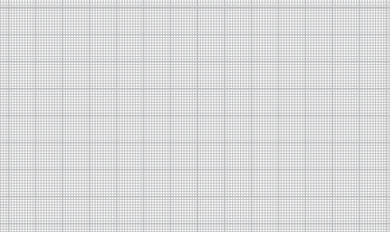

(2 marks)

Question 6

Draw the net of a triangular prism on the grid below.

(2 marks)

Question 7

Draw the net of a cuboid on the grid below.

(2 marks)

Plans, elevations and diagrams

There are different views of 3-D objects you may be asked about in your exam. Think about what 2-D shape you would see if you were looking at the shape from different angles.
Plan

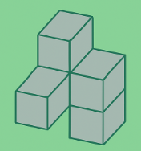

Front elevation
Side elevation

First is a plan view. A plan view is the view from above, as if you were looking down on the object. It shows the layout of the object on a flat surface.

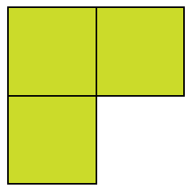

Next is the front elevation. The front elevation is the view from the front of the object. It shows what the object looks like when you are standing directly in front of it.

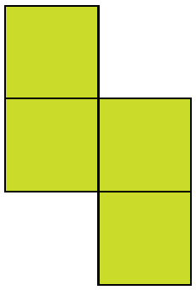

Finally, there is the side elevation. The side elevation is the view from the side of the object. It shows the object as if you are standing to the side looking at it.
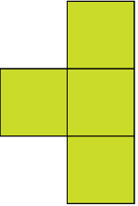

Question 8

Tick the box showing the plan of the shape below.
(1 mark)

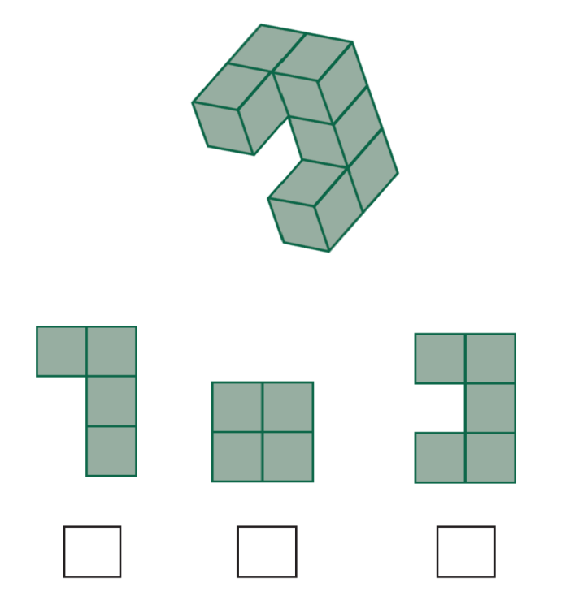

Question 9

Tick the box showing the front elevation of the shape below.
(1 mark)
Front elevation

Question 10

Tick the box which shows the side elevation of the shape below.
(1 mark)
Side elevation

Question 11

On the grid below, draw the side elevation of this shape.

(2 marks)
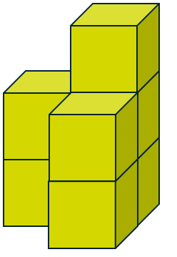

Side elevation

Question 12

On the grid below, draw the front elevation of this shape.

(2 marks)
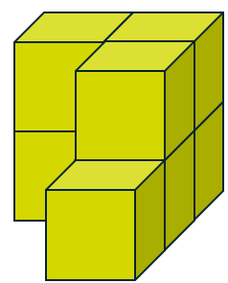

Front elevation

Question 13

On the grid below, draw the plan view of this shape.
(2 marks)

Answers

3-D shapes, 2-D shapes and nets

Question 1

Cuboid

Question 2

Triangular prism

Question 3

Cube

Question 4

Square-based pyramid

Question 5

Question 6

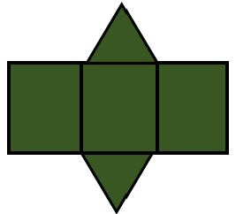

Question 7

Plans, elevations and diagrams

Question 8

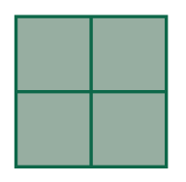

Question 9

Question 10

Question 11

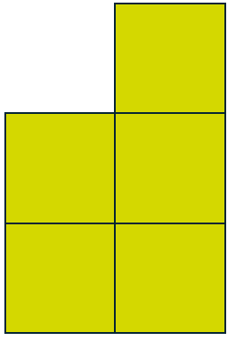

Question 12

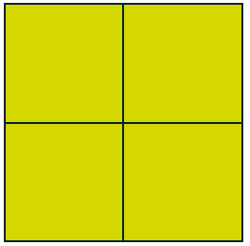

Question 13

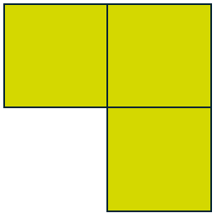

Your functional skills exam

Your functional skills exams will consist of 2 papers.
These papers will take place over the following time periods:

- Non-calculator paper – 40 minutes
- Calculator – 1 hour 50 minutes

Further information on the format that your test will take can be obtained from your training provider.

Hints and tips

- Find out what format your exam will be in. It may be paper-based
or on-screen.
- Plan what you are going to revise in advance. Don’t leave it until the last minute.
- Do as many past papers as you can so you are prepared for the day. If possible, try to complete the past papers following the same format as the actual exam.
- Find a quiet place to study and revise. It helps to sit at a table or a desk, don’t revise in bed.
- Don’t stay up all night revising the night before your exam. It’s important to have a good rest so you feel refreshed and ready to go.
- Read the question 3 times. The first time to ensure you understand what is being asked, the second time to get an understanding of what you need to do, and a third time to figure out exactly what maths techniques you should be applying.
- If you are struggling with a question, skip it and come back to it later. Try not to sit getting worked up about a difficult question, it will only waste exam time. Move on and come back to it after you have answered the other questions.
- Take note of the number of marks available. This will give you an indication of how much working out you must show. For example, 1 mark will need an answer only and more marks will need you to show your working out.
- When you’ve finished the exam, go back and check your answers. If you still have time remaining, use it to check your answers and when you have checked your answers check them again.

