

FUNCTIONAL SKILLS

Maths Level 1

Area: Handling information and data
Criterion 27: Represent discrete data in tables, diagrams and charts, including pie charts, bar charts and line graphs

Discrete data

Discrete data is information that can be counted and has clear separate values. It usually involves whole numbers.

Examples of discrete data:

- number of children in a class
- favourite drinks of people in a group
- types of pets owned
- shoe sizes
- number of goals scored in football matches

Key point: Discrete data is not measured on a continuous scale (like weight or height). You cannot have ‘2.5 pets’ or ‘half a favourite colour’.

Question 1

Which of the following is an example of discrete data?

A. Temperature in degrees Celsius
B. Height of a person
C. Number of cars in a car park
D. Time taken to run a race

(1 mark)

Question 2

Which of the following best describes discrete data?

A. Data that can take on any value within a range
B. Data that is measured in decimals
C. Data that changes continuously
D. Data that is counted in whole numbers

(1 mark)

Organising data in a table

Tables help present data clearly, so it is easy to understand and use.

How to organise data in a table:

- use headings to label each column or row. For example: ‘Fruit’ and ‘Number of People’.
- put the data in order that makes sense, such as alphabetically or by quantity.
- use tallies or numbers to show how many of each item there are.

Example table:
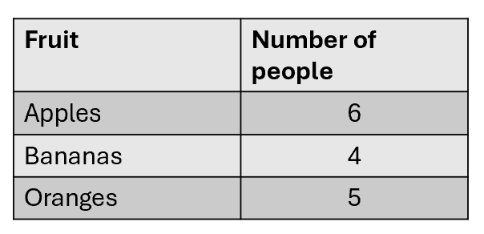

Question 3

Organise this data in a frequency table.

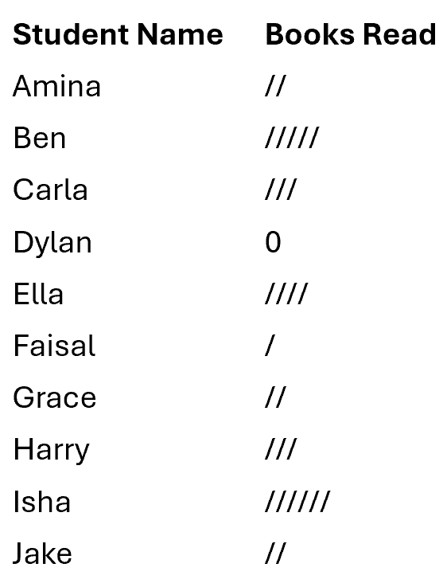

(Use the space below to draw your table.)
(2 marks)

Drawing a bar chart

When to use a bar chart:
Bar charts are useful for showing how many of each category you have. For example, how many people prefer different types of drinks.

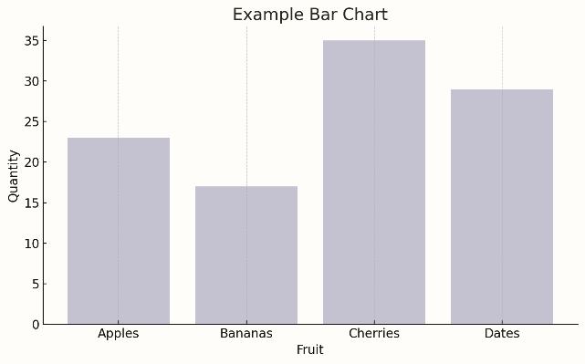

Steps to draw a bar chart:

- Draw 2 axes – vertical and horizontal lines
- Label the axes – one for the categories, for example, fruits and one for the number or frequency of each item
- Title the chart – so people know what it shows
- Choose a suitable scale for the number axis, for example, going up in multiples of 1, 5 or 10
- Draw bars – each bar should be the same width and not touch the next bar
Tip: Always use a ruler and check the height of each bar matches the data.

Question 4

Draw a bar chart to display the following data. (4 marks)

Number of books read by students | Frequency
0 | 1
1 | 2
2 | 3
3 | 6
4 | 1

If you are using a printed version of this workbook you can use the graph paper below.
If you are using this workbook on-screen, you can visit https://www.highfieldcore.com/tutorial/Maths and use the chart tutorial area on our Highfield Core platform. This is also good practice if you will be sitting your Functional Skills exam on-screen, as this is the same tool you would use in a live exam.

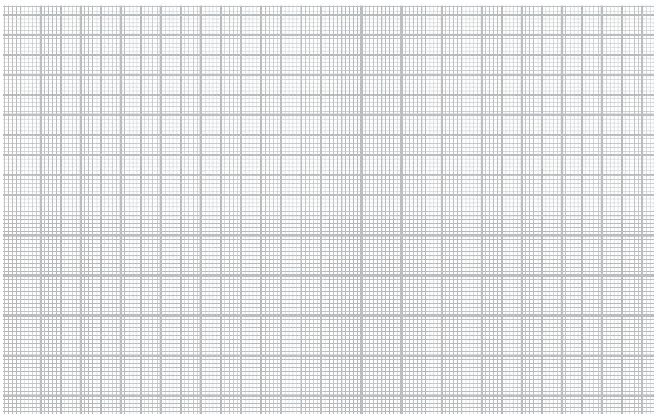

Drawing a line graph

When to use a line graph:
Use a line graph when you want to show how something changes over time, such as temperature during a week or monthly sales over time.

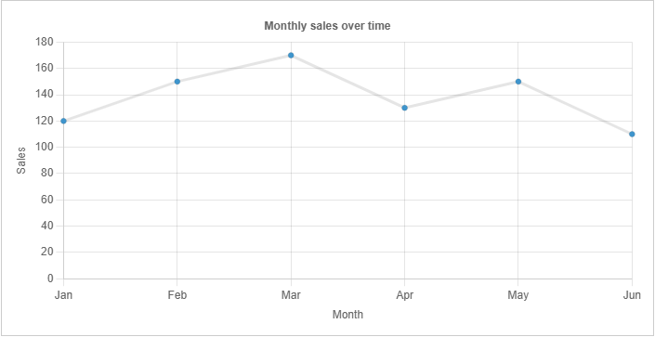

Steps to draw a line graph:

- Draw 2 axes and label them – time usually goes on the horizontal axis
- Mark regular intervals on both axes
- Plot each point carefully using the data
- Join the points with straight lines in order
- Add a title

Tip: Don’t draw bars on a line graph. Always plot points and join them neatly.

Question 5

Draw a line graph to display the following data. (4 marks)

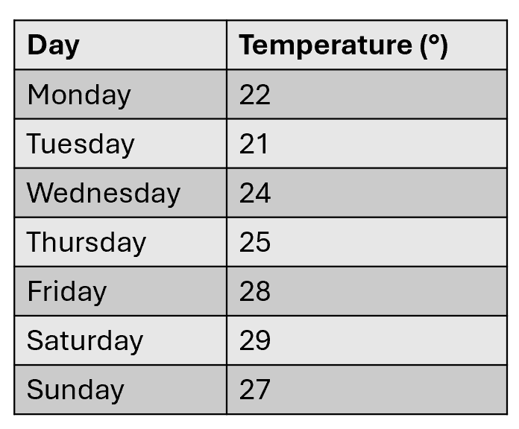

If you are using a printed version of this workbook you can use the graph paper below.
If you are using this workbook on-screen, you can visit https://www.highfieldcore.com/tutorial/Maths and use the chart tutorial area on our Highfield Core platform. This is also good practice if you will be sitting your Functional Skills exam on-screen, as this is the same tool you would use in a live exam.

Drawing a pie chart

When to use a pie chart:


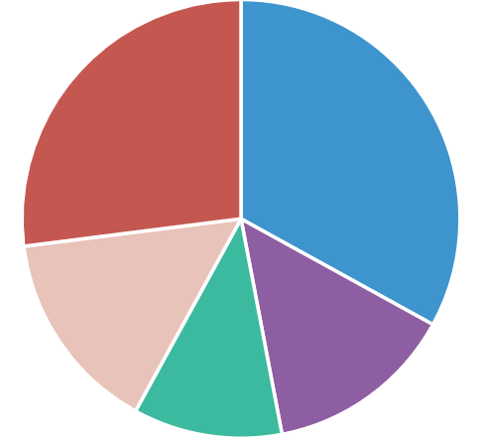
Pie charts show how a whole is shared between different parts, such as how a class of 20 students voted for their favourite sport.

Steps to draw a pie chart:

- Find the total of all values, for example, 20 students
- Convert each section into an angle using the formula:
Section angle = (section value ÷ total values) x 360
- Use a protractor to draw each slice of the circle accurately
- Label each section with its name
- Give the pie chart a title

Tip: Always check the angles add up to 360°.

Question 6

Draw a pie chart to display the following data. (4 marks)

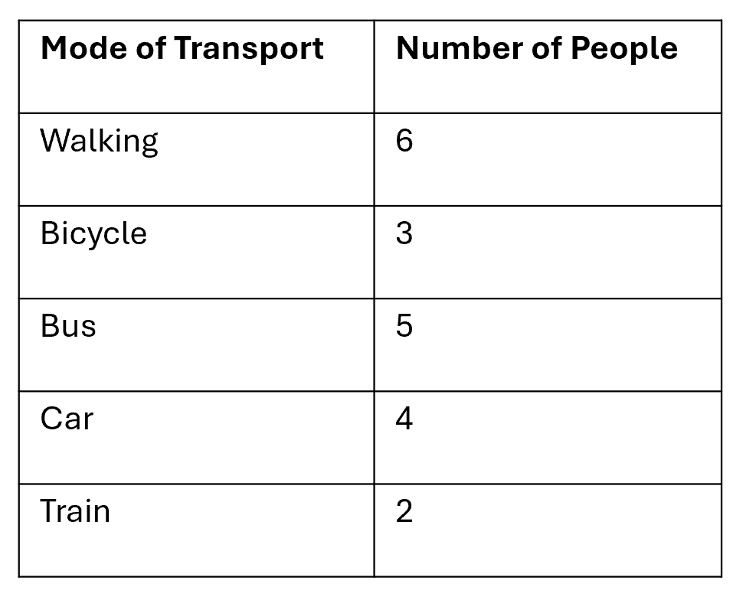

If you are using a printed version of this workbook you can use the space below to draw your pie chart.
If you are using this workbook on-screen, you can visit https://www.highfieldcore.com/tutorial/Maths and use the chart tutorial area on our Highfield Core platform. This is also good practice if you will be sitting your Functional Skills exam on-screen, as this is the same tool you would use in a live exam.

Choosing the right chart

Which chart should I use?
Choosing the right chart depends on the type of data and what you want to show.

Type of chart | Best for showing...
Bar chart | Number of items in each category
Line graph | How something changes over time
Pie chart | How something is split into parts of a whole

Examples:
- favourite takeaway meals – use a bar chart
- daily temperature over a week – use a line graph
- how a budget is spent – use a pie chart

Tip: Always check what the question is asking for and think about the type of data before choosing the chart.

Exam practice

In a survey, 20 builders were asked how many bricks they could lay in 1 day.
These are the results:

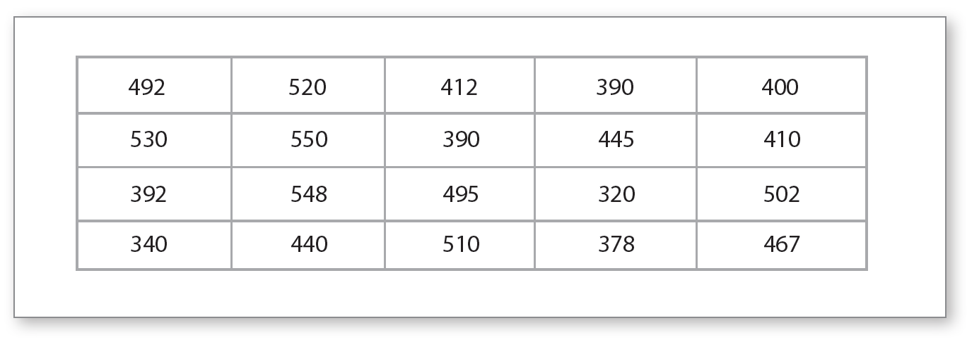

a) Use the results to complete the table below using equal groups. (2 marks)

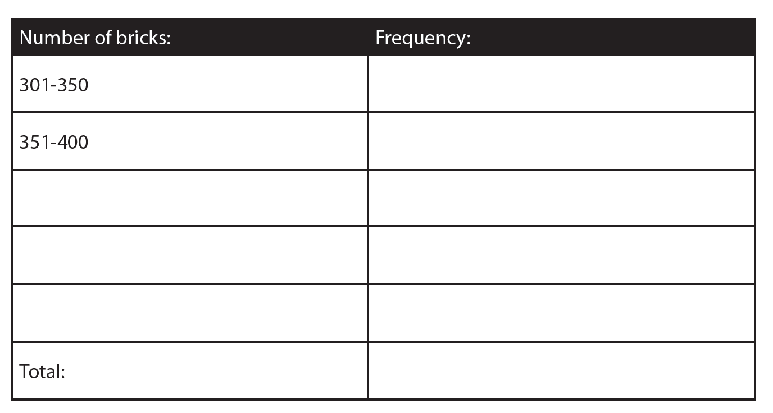

b) Using your table from (a), create a graph or chart to represent the grouped data. (4 marks)

If you are using a printed version of this workbook you can use the graph paper below.
If you are using this workbook on-screen, you can visit https://www.highfieldcore.com/tutorial/Maths and use the chart tutorial area on our Highfield Core platform.

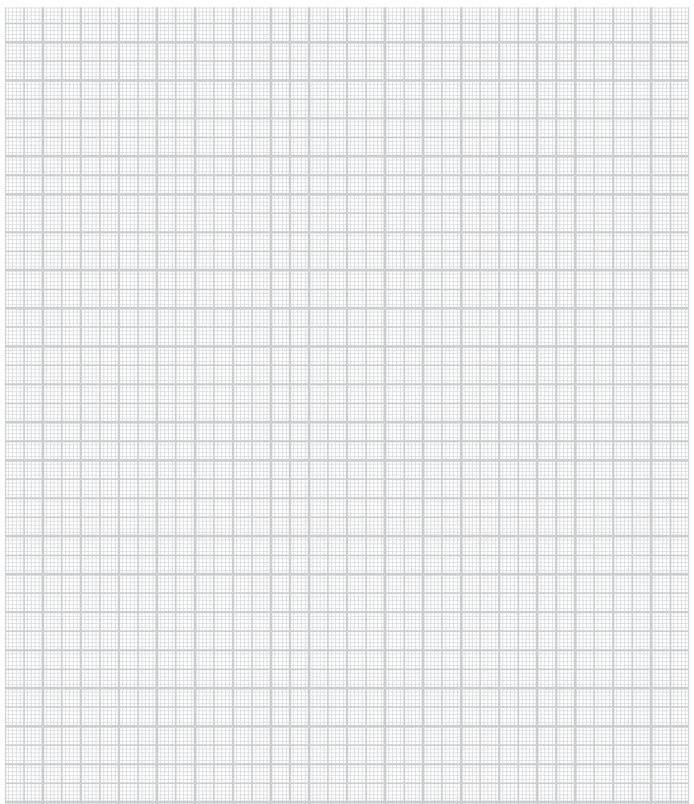

Answers

Question 1
C – Number of cars in a car park

Question 2
D – Data that is counted in whole numbers

Question 3

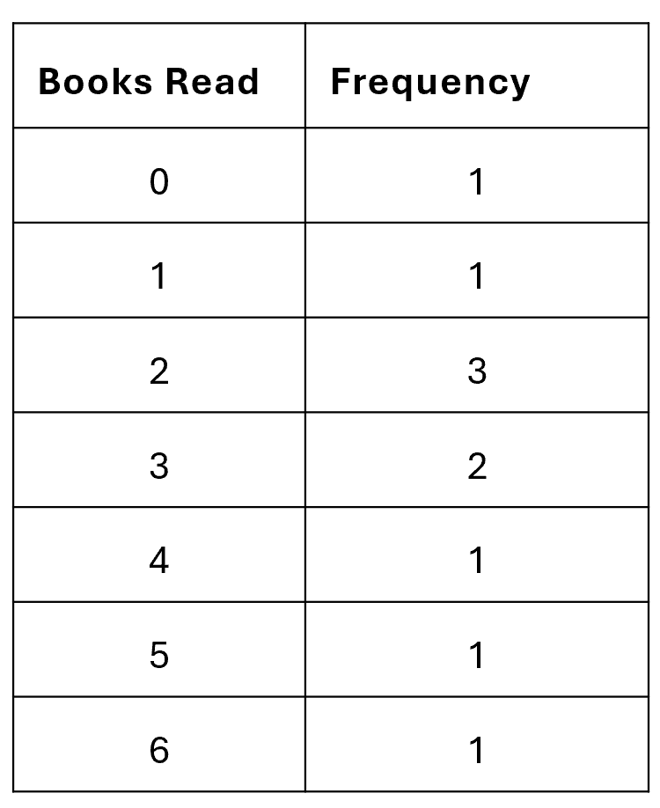

Question 4

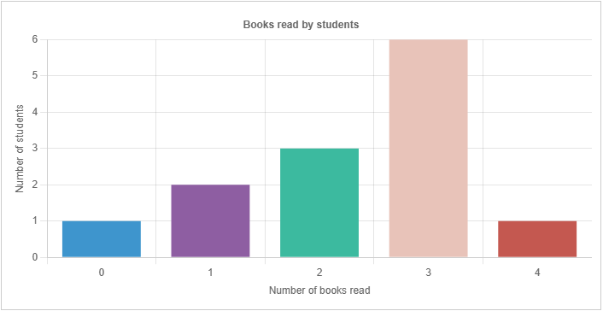

Question 5

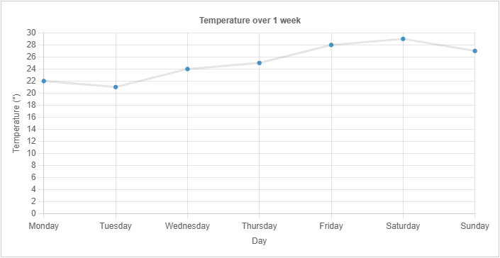

Question 6

Total number of people = 20

Walking: 6 ÷ 20 x 360 = 108°
Bicycle: 3 ÷ 20 x 360 = 54°
Bus: 5 ÷ 20 x 360 = 90°
Car: 4 ÷ 20 x 360 = 72°
Train: 2 ÷ 20 x 360 = 36°

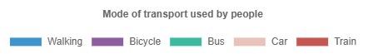
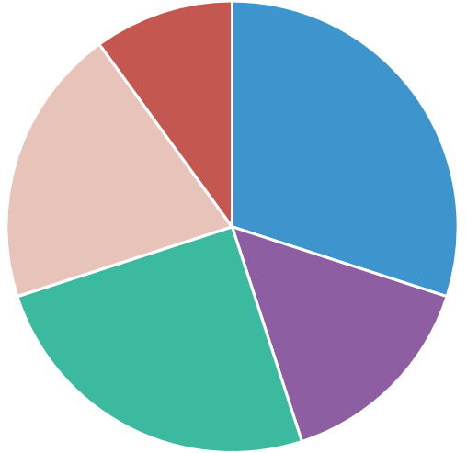

Exam practice

a)

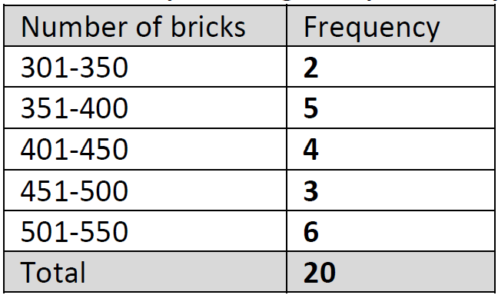

b)

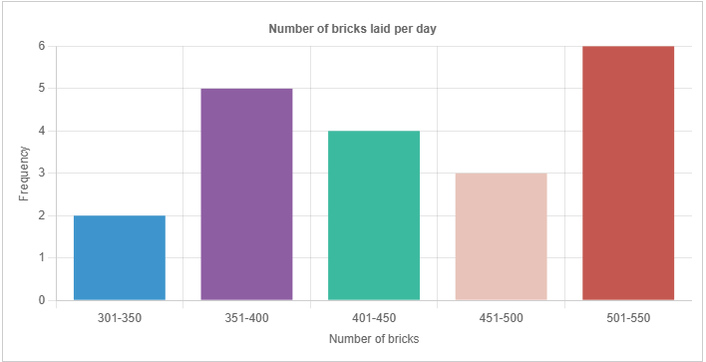

Your functional skills exam

Your functional skills exams will consist of 2 papers.
These papers will take place over the following time periods:

- Non-calculator paper – 40 minutes
- Calculator – 1 hour 50 minutes

Further information on the format that your test will take can be obtained from your training provider.

Hints and tips

- Find out what format your exam will be in. It may be paper-based
or on-screen.
- Plan what you are going to revise in advance. Don’t leave it until the last minute.
- Do as many past papers as you can so you are prepared for the day. If possible, try to complete the past papers following the same format as the actual exam.
- Find a quiet place to study and revise. It helps to sit at a table or a desk, don’t revise in bed.
- Don’t stay up all night revising the night before your exam. It’s important to have a good rest so you feel refreshed and ready to go.
- Read the question 3 times. The first time to ensure you understand what is being asked, the second time to get an understanding of what you need to do, and a third time to figure out exactly what maths techniques you should be applying.
- If you are struggling with a question, skip it and come back to it later. Try not to sit getting worked up about a difficult question, it will only waste exam time. Move on and come back to it after you have answered the other questions.
- Take note of the number of marks available. This will give you an indication of how much working out you must show. For example, 1 mark will need an answer only and more marks will need you to show your working out.
- When you’ve finished the exam, go back and check your answers. If you still have time remaining, use it to check your answers and when you have checked your answers check them again.

