

FUNCTIONAL SKILLS

Maths Level 2

Area: Numbers and the number system
Criterion: Order, add, subtract and compare amounts or quantities using proper and improper fractions and mixed numbers

Fractions

Fractions show a part of something.

- They are split into 2: the top (called the numerator) and the bottom (called the denominator).
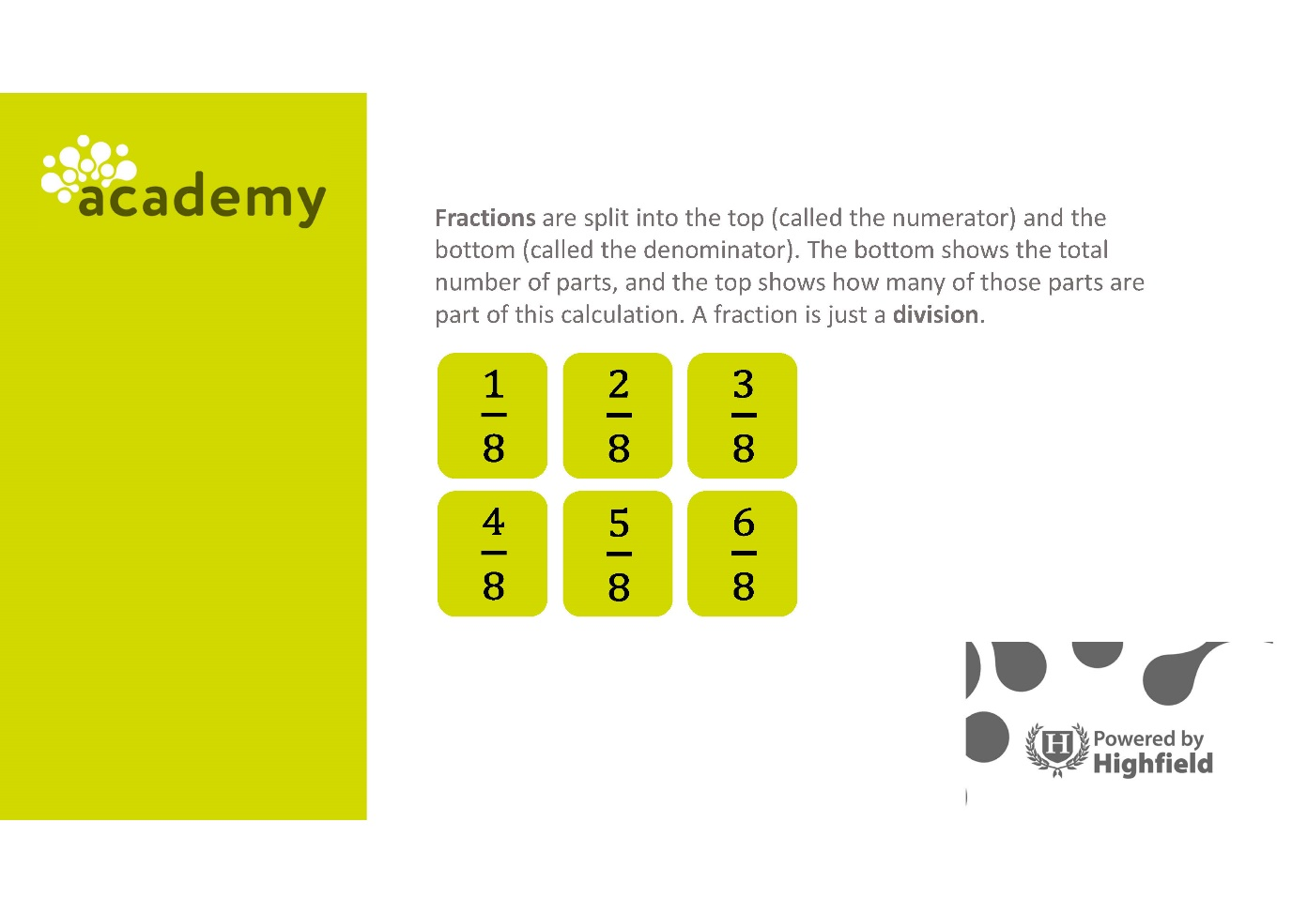
Numerator

Denominator

- The denominator shows the total number of parts an amount or quantity is split into.

- The numerator shows how many of those parts are part of this calculation. It shows how many parts of the fraction you have.

A fraction is a division.

To calculate a fraction of an amount or quantity, there are 2 steps:
- divide by the denominator
- multiply by the numerator

Proper and improper fractions

Proper fractions have a numerator that is smaller than the denominator.

$\frac{3}{5}$ $\frac{7}{12} \frac{1}{4}$

Improper fractions have a numerator that is greater than the denominator.

$\frac{9}{5}$ $\frac{8}{3} \frac{14}{4}$

Question 1

Which of the following is a proper fraction?

$\frac{5}{4}$ or $\frac{4}{5}$ or $\frac{11}{5}$
(1 mark)

Question 2

Select the improper fraction.

$\frac{1}{2}$ or $\frac{5}{4}$ or $\frac{998}{999}$ or $\frac{5}{50}$
(1 mark)

Question 3

Identify all the proper fractions.

$\frac{7}{10} \frac{2}{9}$ $\frac{12}{11} \frac{5}{2} \frac{9}{4} \frac{3}{14} \frac{1}{2}$

(3 marks)

Question 4

Identify the improper fraction.

$\frac{10}{111} \frac{110}{111} \frac{11}{110}$ $\frac{110}{101}$
(1 mark)

Question 5

Identify the improper fractions.

$\frac{12}{13}$ $\frac{9}{4}$ $\frac{5}{6}$ $\frac{14}{4}$ $\frac{15}{5}$ $\frac{22}{23}$
(2 marks)

Question 6

Identify the proper fraction.

$\frac{3}{4} \frac{9}{8} \frac{10}{7}$ $\frac{14}{13}$
(1 mark)

Mixed numbers

A mixed number is the combination of a whole number and a fraction.

$1\frac{2}{3}$ $2\frac{2}{6} 4\frac{1}{3}$

Mixed numbers can be converted into improper fractions.

Improper fractions can be converted into mixed numbers.

Mixed numbers are always greater than 1.

Converting between improper fractions and mixed numbers

Improper fractions and mixed numbers can be converted.

To convert an improper fraction to a mixed number:
- divide the numerator by the denominator. This gives the whole number.
- if there is a remainder or left over amount, this is the numerator of the fraction.

For example, write $\frac{25}{4}$as a mixed number.

$\frac{25}{4}$ = 25 ÷ 4 = 6 remainder 1 (6 r1)

The 6 is the whole number, while the 1 becomes the numerator of the fraction.

6 r1 = $6\frac{1}{4}$

To convert a mixed number to an improper fraction:
- multiply the whole number by the denominator
- add the original numerator to the improper fraction’s numerator

For example, write $5\frac{2}{3}$ as an improper fraction.

The whole number is 5 and the denominator is 3.

5 x 3 = $\frac{15}{3}$

The numerator from the original mixed number is 2. Add this to the new improper fraction.
15 + 2 = 17

$$\frac{17}{3}$$

Question 7

Convert $\frac{20}{7}$ into a mixed number.

(Show your working out.)
(1 mark)

Question 8

Convert $\frac{48}{5}$ into a mixed number.

(Show your working out.)
(1 mark)

Question 9

Convert 3 $\frac{2}{4}$ into an improper fraction.

(Show your working out.)
(1 mark)

Question 10

Convert 13 $\frac{6}{10}$ into an improper fraction.

(Show your working out.)
(1 mark)

Adding and subtracting fractions

If the denominator of the fractions in the question are the same, simply add or subtract the numerators. For example,

$$\frac{13}{14} - \frac{4}{14}$$

Both fractions above have the same denominator. Therefore, the numerators can be subtracted.

$$\frac{13}{14} - \frac{4}{14} =\frac{9}{14}$$

However, in the question below, the denominators of each fraction are different.

$$\frac{3}{5} + \frac{1}{4}$$

To successfully add these fractions, they must have the same denominator. This is known as a common denominator.

To do this, multiply each fraction by the denominator of the other fraction.

$$\frac{3}{5} x \frac{4}{4}=\frac{12}{20}$$

$$\frac{1}{4} x \frac{5}{5}=\frac{5}{20}$$

The fractions now both have a denominator of 20, so the numerators can be added.

$$\frac{12}{20} + \frac{5}{20} = \frac{17}{20}$$

Remember that the denominator does not change when performing this final addition or subtraction.

It is always best to simplify your fraction if you can.

Question 11

Calculate $\frac{11}{15}$ – $\frac{3}{5}$

(Show your working out.)
(2 marks)

Question 12

Calculate $\frac{6}{10}$ + $\frac{7}{10}$

Give your answer as a mixed number.

(Show your working out.)
(2 marks)

Question 13

Calculate $\frac{9}{12}$ – $\frac{1}{2}$

Give your answer in its simplest form.

(Show your working out.)
(3 marks)

Question 14

Calculate $\frac{1}{3}$ + $\frac{3}{4}$

Give your answer as a mixed number.

(Show your working out.)
(3 marks)

Comparing and ordering fractions

All fractions can be compared.

To order and compare fractions, convert between mixed numbers and improper fractions and use equivalent fractions.

For example, identify the largest fraction.

$$\frac{7}{5} or 1\frac{1}{3}$$

The fractions need to be in the same form.
Converting $1\frac{1}{3}$ to an improper fraction will make the fractions easier to compare.
$$1\frac{1}{3} = \frac{4}{3}$$

The denominators remain different, so you will need to find equivalent fractions:

$$\frac{7}{5} x \frac{3}{3} =\frac{21}{15}$$

$$\frac{4}{3} x \frac{5}{5}=\frac{20}{15}$$

The fractions can now be compared. We can see that $\frac{7}{5}$ has a larger numerator when converted to $\frac{21}{15}$

The larger fraction is $\frac{7}{5}$

Fractions can also be compared using symbols (>, <, =)

- > means greater than
- < means less than
- = means equal to

Question 15

Which fraction is larger?

3 $\frac{1}{3}$ or $\frac{21}{6}$

(Show your working out.)
(2 marks)

Question 16

Which fraction is smaller?

1 $\frac{1}{4}$ or $\frac{9}{6}$

(Show your working out.)
(2 marks)

Exam practice 1

Order the following fractions from smallest to largest:

$\frac{3}{5}$ $\frac{7}{10}$ $\frac{2}{3}$

(Show your working out.)
(2 marks)

Exam practice 2

A café sold the following amounts of cake:
- Monday: $2\frac{1}{4}$cakes
- Tuesday: $\frac{9}{4}$cakes

Use the correct symbol to compare the amounts sold.
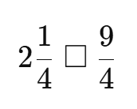
(Show your working out.)
(3 marks)

Exam practice 3

A runner completed $\frac{3}{8}$of a race in the morning and $\frac{1}{4}$in the afternoon.

How much of the race did the runner complete in total?

(Show your working out.)
(3 marks)

Exam practice 4

A rope is $5\frac{1}{ 2 }$ metres long.
$2\frac{3}{4}$metres are cut off.

How much rope is left?

(Show your working out.)
(3 marks)

Answers

Proper and improper fractions

Question 1: $\frac{4}{5}$

Question 2: $\frac{5}{4}$

Question 3: $\frac{7}{10} \frac{2}{9} \frac{3}{14} \frac{1}{2}$

Question 4: $\frac{110}{101}$

Question 5: $\frac{9}{4}$ $\frac{14}{4}$ $\frac{15}{5}$

Question 6: $\frac{3}{4}$

Mixed numbers

Question 7: $\frac{20}{7}$ = 2 $\frac{6}{7}$

Question 8: $\frac{48}{5}$ = 9 $\frac{3}{5}$

Question 9: 3 $\frac{2}{4}$ = $\frac{14}{4}$

Question 10: 13 $\frac{6}{10}$ = $\frac{136}{10}$

Adding and subtracting fractions

Question 11: $\frac{2}{15}$

Question 12: $\frac{13}{10}$ = 1 $\frac{3}{10}$

Question 13: $\frac{1}{4}$

Question 14: $\frac{13}{12}$ = 1 $\frac{1}{12}$

Comparing and ordering fractions

Question 15

3 $\frac{1}{3}$ = $\frac{10}{3}$

$\frac{10}{3}$ x $\frac{2}{2}$ = $\frac{20}{6}$

$\frac{20}{6}$ is smaller than $\frac{21}{6}$

Therefore, $\frac{21}{6}$ is larger.

Question 16

1 $\frac{1}{4}$ = $\frac{5}{4}$

$\frac{5}{4}$ x $\frac{6}{6}$ = $\frac{30}{24}$

$\frac{9}{6}$ x $\frac{4}{4}$ = $\frac{36}{24}$

1 $\frac{1}{4}$ or $\frac{30}{24}$ is smaller.

Exam practice 1

$\frac{3}{5}$ $\frac{2}{3} \frac{7}{10}$

Exam practice 2
= (both are the same)

Exam practice 3

$\frac{1}{4}$ = $\frac{2}{8}$

$\frac{3}{8}$ + $\frac{2}{8}$ = $\frac{5}{8}$

Exam practice 4

2 ¾ metres

Your functional skills exam

Your functional skills exams will consist of 2 papers.
These papers will take place over the following time periods:

- Non-calculator paper – 40 minutes
- Calculator – 1 hour 50 minutes

Further information on the format that your test will take can be obtained from your training provider.

Hints and tips

- Find out what format your exam will be in. It may be paper-based
or on-screen.
- Plan what you are going to revise in advance. Don’t leave it until the last minute.
- Do as many past papers as you can so you are prepared for the day. If possible, try to complete the past papers following the same format as the actual exam.
- Find a quiet place to study and revise. It helps to sit at a table or a desk, don’t revise in bed.
- Don’t stay up all night revising the night before your exam. It’s important to have a good rest so you feel refreshed and ready to go.
- Read the question 3 times. The first time to ensure you understand what is being asked, the second time to get an understanding of what you need to do, and a third time to figure out exactly what maths techniques you should be applying.
- If you are struggling with a question, skip it and come back to it later. Try not to sit getting worked up about a difficult question, it will only waste exam time. Move on and come back to it after you have answered the other questions.
- Take note of the number of marks available. This will give you an indication of how much working out you must show. For example, 1 mark will need an answer only and more marks will need you to show your working out.
- When you’ve finished the exam, go back and check your answers. If you still have time remaining, use it to check your answers and when you have checked your answers check them again.

