

FUNCTIONAL SKILLS

Maths Level 2

Area: Measure, shape and space
Criterion: Convert between metric and imperial units of length, weight and capacity using:
- A conversion factor
- A conversion graph

Types of lengths

There are many different units that we use to measure length.

10mm | 1cm
100cm | 1m
1000m | 1km
These can be metric or imperial.

Metric measurements for length include:
- millimetres (mm)
- centimetres (cm)
- metres (m)
- kilometres (km)

To convert millimetres to centimetres, divide by 10. To convert centimetres to millimetres, multiply by 10
To convert centimetres to metres, divide by 100. To convert metres to centimetres, multiply by 100
To convert metres to kilometres, divide by 1000. To convert kilometres to metres, multiply by 1000

Imperial measurements for length include:
- miles (mi)
- feet (ft)
- inches (in)

Imperial to metric conversions:
- 1mi = 1.6km
- 1ft = 30.48cm
- 1in = 2.54cm

To convert miles to kilometres, multiply by 1.6. To convert kilometres to centimetres, divide by 1.6
To convert feet to centimetres, multiply by 30.48. To convert centimetres to feet, divide by 30.48
To convert centimetres to inches, divide by 2.54. To convert inches to centimetres, multiply by 2.54

Example questions

- Convert 512 kilometres to miles.

1 mile (mi) = 1.6 kilometres (km).

As we already know the kilometres (and miles are lower), divide the kilometres by 1.6

512km ÷ 1.6 = 320 miles.

- Convert 60in to centimetres.

1inch (in) = 2.54 centimetres (cm).

Multiply the inches by 2.54

60 x 2.54 = 152.4cm.

You will always be given the conversion factor between imperial and metric units in an exam.

Question 1

Convert 470 centimetres to inches. Give your answer to 2 decimal places.
1 inch (in) = 2.54 centimetres.

(Show your working out.)
(1 mark)

Question 2

Convert 92 inches to centimetres.
1 inch (in) = 2.54 centimetres.

(Show your working out.)
(1 mark)

Question 3

Convert 647 miles to kilometres.
1 mile (mi) = 1.6 kilometres (km).

(Show your working out.)
(1 mark)

Question 4

Convert 522 kilometres to miles.
1 miles (mi) = 1.6 kilometres (km).

(Show your working out.)
(1 mark)

Exam practice 1

Convert 184 feet to centimetres. Give your answer to the nearest whole number.
1 foot (ft) = 30.48 centimetres (cm).

(Show your working out.)
(3 marks)

Types of weight

There are many different units that we use to measure weight.

1,000mg | 1g
1000g | 1kg
These can be metric or imperial.

Metric measurements for weight include:
- milligrams (mg)
- grams (g)
- kilograms (kg)

To convert kilograms to grams, divide by 1,000
To convert grams to kilograms, multiply by 1,000
To convert grams to milligrams, multiply by 1,000
To convert milligrams to grams, divide by 1,000

Imperial measurements for weight include:
- ounces (oz)
- pounds (lbs)
Imperial weights:
1st = 14 lbs
1lb = 16oz
- stone (st)

Imperial to metric conversions:
- 1oz = 28g
- 1lb = 450g
- 2.2lbs = 1kg

To convert ounces to grams, multiply by 28. To convert grams to ounces, divide by 28
To convert pounds to grams, multiply by 450. To convert grams to pounds, divide by 450
To convert kilograms to pounds, multiply by 2.2. To convert pounds to kilograms, divide by 2.2

It is also important to know the conversions between imperial units themselves.
To convert stones to pounds, multiply by 14. To convert pounds to stones, divide by 14
To convert pounds to ounces, multiply by 16. To convert ounces to pounds, divide by 16

Example questions

- Convert 72.25 kilograms to pounds.

2.2 pounds (lbs) = 1 kilogram (kg).

We already know the lower value in the conversion (kg). Therefore, we must multiply by 2.2

72.25kg x 2.2 = 158.95lbs.

- Convert 16lbs to kilograms. Give your answer to 2 decimal places.

1 pound (lb) = 453.6 grams (g).

As we already know the pounds, multiply by 453.6 to convert to grams.

16 x 453.6 = 7,257.6 grams.

The question is asking us to convert to kilograms.
1,000g = 1kg .

Therefore, we must divide by 1,000 to convert grams to kilograms.

7,257.6 ÷ 1,000 = 7.26kg.

Remember, you will always be given the conversion factor between imperial and metric units in an exam.

Question 5

Convert 2,475 grams to pounds.
1 pound (lb) = 450 grams (g).

(Show your working out.)
(1 mark)

Question 6

Convert 3,300 pounds to kilograms.
2.2 pounds (lbs) = 1 kilogram (kg).

(Show your working out.)
(1 mark)

Question 7

Convert 406 grams to ounces.
1 ounce (oz) = 28 grams (g).

(Show your working out.)
(1 mark)

Question 8

Convert 16.25 ounces to grams.
1 ounce (oz) = 28 grams (g).

(Show your working out.)
(1 mark)

Exam practice 2

A kitchen manager is ordering new containers. One container holds a maximum weight of 218.9lbs. The manager needs each container to hold 100kg.
2.2 pounds (lbs) = 1 kilogram (kg).
Will the containers hold the required weight?

(Show your working out.)
(3 marks)

Types of capacity

There are many different units that we use to measure capacity.

These can be metric or imperial.

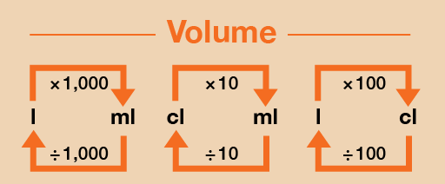
Metric measurements for capacity include:
- millilitres (ml)
- centilitres (cl)
- litres (l)

To convert millilitres to litres, divide by 1,000
To convert litres to millilitres, multiply by 1,000
To convert centilitres to millilitres, multiply by 10
To convert millilitres to centilitres, divide by 10
To convert centilitres to litres, divide by 100
To convert litres to centilitres, multiply by 100

Imperial measurements for capacity include:
- fluid ounces (fl. oz)
- pints (pt)
- gallons (gal)

Imperial conversions:
- 1gal = 8pts
- 1gal = 128fl. oz
- 1pt = 16fl. oz

Imperial to metric conversions:
- 1fl. oz = 2.95cl
- 1pt = 0.5l
- 1gal = 4.55l

To convert fluid ounces to centilitres, multiply by 2.957. To convert centilitres to fluid ounces, divide by 2.957
To convert pints to litres, multiply by 0.57. To convert litres to pints, divide by 0.57
To convert gallons to litres, multiply by 4.55. To convert litres to gallons, divide by 4.55

Example questions

- Convert 64 pints to litres.

1 pint (pt) = 0.57 litres (l).

64pts x 0.57 = 36.48 litres.

b) Convert 7 gallons to litres.

1 gallon (gal) = 4.55 litres (l).

7 x 4.55 = 31.85 litres.

Remember, you will always be given the conversion factor between imperial and metric units in an exam.

Question 9

Convert 51.3 litres to pints.
1 pint (pt) = 0.57 litres (l).

(Show your working out.)
Insert number of marks if applicable

Question 10

Convert 33 centilitres to fluid ounces. Give your answer to 2 decimal places.
1 fluid ounce (fl. oz) = 2.95 centilitres (cl).

(Show your working out.)
(2 marks)

Question 11

Convert 143 fluid ounces to centilitres.
1 fluid ounce (fl. oz) = 2.95 centilitres (cl).

(Show your working out.)
(1 mark)

Question 12

Convert 24 litres to gallons. Give your answer to 2 decimal places.
1 gallon (gal) = 4.55 litres (l).

(Show your working out.)
(1 mark)

Exam practice 3

A company orders 18 gallons of water for its water station in June.
On average, the workers use 80 litres of water each month.
1 gallon (gal) = 4.55 litres (l).
Have the company ordered enough water?

(Show your working out.)

(4 marks)

Conversion graphs

A conversion graph is a graph that shows 1 measurement on 1 axis and another measurement on the other. This means you can convert between the 2 measurements using this.

Below is a kilometres (km) to miles (mi) conversion graph. It shows how to convert 40 kilometres into miles.

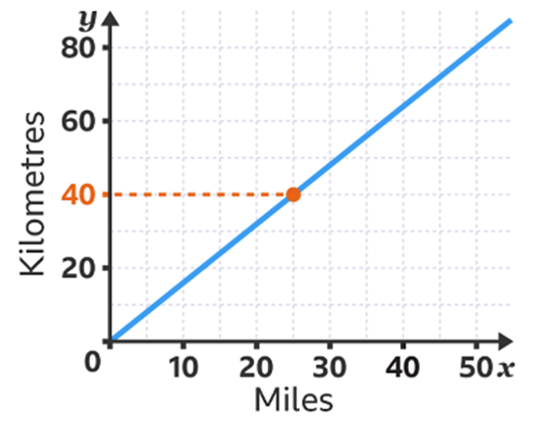

Highlight where the 40km mark is on the graph.
Then, find where that mark is on the blue line by moving horizontally across.
Next, move vertically down to the miles line. This shows 40 kilometres converted into miles, which is 25 miles.

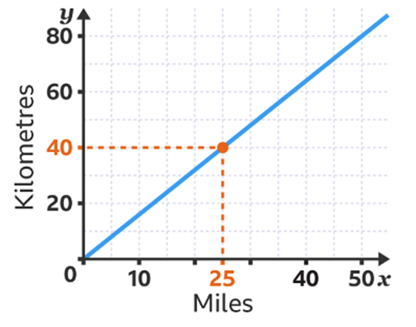

Exam practice 4

Use the graph below to convert 3 gallons to litres.

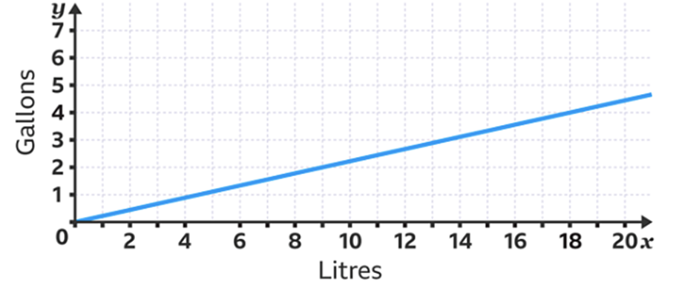

(Show your working out.)
(2 marks)

Answers

Types of lengths

Question 1
185.04in

Question 2
233.68cm

Question 3
1,035.2km

Question 4
326.25mi

Exam practice 1
5,608cm

Types of weight

Question 5
5.5lbs

Question 6
1,500kg

Question 7
14.5oz

Question 8
455g

Exam practice 2
Convert 218.9 pounds to kilograms using the conversion factor.
218.9lbs ÷ 2.2 = 99.5kg
No, the containers are not suitable as they do not hold 100kg.

Types of capacity

Question 9
90pts

Question 10
11.19fl.oz

Question 11
421.85cl

Question 12
527gal

Exam practice 3
Convert 18 gallons to litres using the conversion factor.
18 x 4.55 = 81.9 litres.
Yes, the company have ordered enough water.

Conversion graphs

Exam practice 4
13 litres

Your functional skills exam

Your functional skills exams will consist of 2 papers.
These papers will take place over the following time periods:

- Non-calculator paper – 40 minutes
- Calculator – 1 hour 50 minutes

Further information on the format that your test will take can be obtained from your training provider.

Hints and tips

- Find out what format your exam will be in. It may be paper-based
or on-screen.
- Plan what you are going to revise in advance. Don’t leave it until the last minute.
- Do as many past papers as you can so you are prepared for the day. If possible, try to complete the past papers following the same format as the actual exam.
- Find a quiet place to study and revise. It helps to sit at a table or a desk, don’t revise in bed.
- Don’t stay up all night revising the night before your exam. It’s important to have a good rest so you feel refreshed and ready to go.
- Read the question 3 times. The first time to ensure you understand what is being asked, the second time to get an understanding of what you need to do, and a third time to figure out exactly what maths techniques you should be applying.
- If you are struggling with a question, skip it and come back to it later. Try not to sit getting worked up about a difficult question, it will only waste exam time. Move on and come back to it after you have answered the other questions.
- Take note of the number of marks available. This will give you an indication of how much working out you must show. For example, 1 mark will need an answer only and more marks will need you to show your working out.
- When you’ve finished the exam, go back and check your answers. If you still have time remaining, use it to check your answers and when you have checked your answers check them again.

