

FUNCTIONAL SKILLS

Maths Level 2

Area: Handling information and data
Criterion: Draw and interpret scatter diagrams and recognise positive and negative correlation

Scatter diagrams and correlations

A scatter diagram is used to show how closely things are related.

This relationship is known as ‘correlation’.

Correlation can be either positive or negative.

Positive correlation: As one variable increases, the other variable also increases.

Negative correlation: As one variable increases, the other variable decreases.

Note: If 2 things are correlated, the points plotted on the diagram will be close to representing a straight line.

If there is no correlation, the points plotted will be scattered all over the diagram and appear random. A negative correlation is not the same as no correlation.
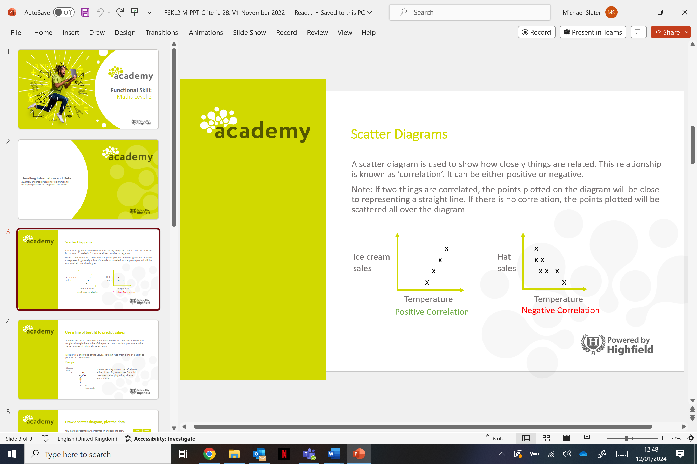

Line of best fit

A line of best fit is a line which identifies the correlation. The line will pass roughly through the middle of the plotted points with approximately the same number of points above as below (or on each side of the line).

For example,
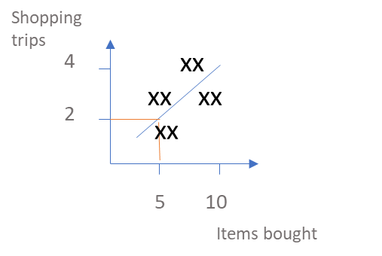

The scatter graph above shows a line of best fit. By following the line of best fit, we can see that, over 2 shopping trips, 5 items were purchased.

Note: If you know one of the values on the scatter graph, you can read from a line of best fit to predict the other value.

Question 1

What is the correlation shown in each of the graphs below?
A.
B.
C.

Write your answers in the boxes below:

Graph A

Graph B

Graph C

Question 2

The table below shows the age and value of 7 e-bikes.
Draw a scatter diagram to present this data.
You have been presented with the information below and asked to draw a scatter diagram to present the data given.
The table below shows the age and value of 7 e-bikes.
Draw a scatter diagram to present this data.
- Start by adding the graph’s title.
- Next, draw the axes and label them. Use a ruler if you are taking a paper-based exam.
Ensure your axes show ‘age’ and ‘value’.
- Ensure your scale is accurate e.g.,
‘age’ goes up to at least 6, ‘value’ goes up to at least £4800.
- Add a title.
- Plot your data.
- Draw a line of best fit to predict the value of an e-bike with an age of 4.5 years.
Always check your plotted data is accurate as it is easy to mis-position or miss one completely.

Age (Years) | Value (£)
1 | 4800
2 | 3500
3.5 | 2500
4 | 2000
5 | 1700
5.5 | 1500

Question 2b
What correlation does the scatter diagram show regarding the prices of e-bikes and the age of the e-bikes?
(Show your working out.)
(1 mark)

Exam practice 1a

The following table gives the monthly rent for 10 houses and their distances from the city centre.

Distance from city centre (km) | 8 | 9 | 7 | 5 | 3 | 1 | 5 | 6 | 6 | 9
Monthly rent (£) | 400 | 400 | 460 | 800 | 750 | 900 | 450 | 640 | 550 | 310

Draw a scatter diagram to represent this data.
(4 marks)

Question 1b

Estimate the monthly rent for a house that is 4km from the city centre.

Write your answer in the box below.
(1 mark)

Question 1c

For a house with a monthly rent of £500, estimate its distance from
the city centre.

Write your answer in the box below.
(1 mark)

Question 1d

What correlation does the scatter diagram show regarding the
cost of monthly rent and distance from the city centre?

Write your answer in the box below.
(1 mark)

Answers

Context

Question 1
Graph A: positive correlation
Graph B: no correlation
Graph C: negative correlation

Question 2

Question 2b
The scatter graph has a negative correlation.

Exam practice

Exam practice 1a

A scatter graph to show house rent prices and their distance from the city centre

Question 1b
Accept answers around £660 to £700

Question 1c
Accept answers around 6.5km.

Question 1d
The scatter graph shows a negative correlation.
Your functional skills exam

Your functional skills exams will consist of 2 papers.
These papers will take place over the following time periods:

- Non-calculator paper – 40 minutes
- Calculator – 1 hour 50 minutes

Further information on the format that your test will take can be obtained from your training provider.

Hints and tips

- Find out what format your exam will be in. It may be paper-based
or on-screen.
- Plan what you are going to revise in advance. Don’t leave it until the last minute.
- Do as many past papers as you can so you are prepared for the day. If possible, try to complete the past papers following the same format as the actual exam.
- Find a quiet place to study and revise. It helps to sit at a table or a desk, don’t revise in bed.
- Don’t stay up all night revising the night before your exam. It’s important to have a good rest so you feel refreshed and ready to go.
- Read the question 3 times. The first time to ensure you understand what is being asked, the second time to get an understanding of what you need to do, and a third time to figure out exactly what maths techniques you should be applying.
- If you are struggling with a question, skip it and come back to it later. Try not to sit getting worked up about a difficult question, it will only waste exam time. Move on and come back to it after you have answered the other questions.
- Take note of the number of marks available. This will give you an indication of how much working out you must show. For example, 1 mark will need an answer only and more marks will need you to show your working out.
- When you’ve finished the exam, go back and check your answers. If you still have time remaining, use it to check your answers and when you have checked your answers check them again.

