

FUNCTIONAL SKILLS

Maths Level 1

Area: Using common measures, shape and space
Criterion 26: Use angles when describing position and direction, and measure angles in degrees
Angles
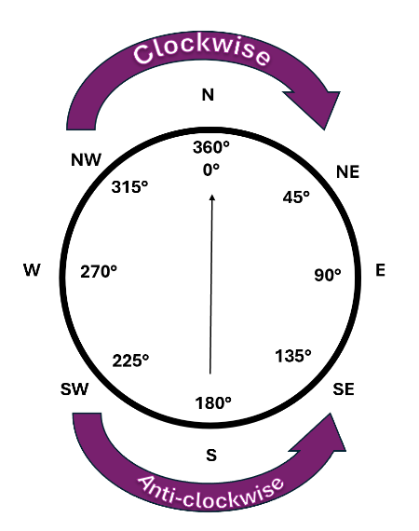
Angles are measured in degrees (°)

Key facts

- A full turn = 360 °
- A half turn = 180 °
- A quarter turn/right angle = 90 °
- Degrees are shown with the little circle symbol °

Directions

When describing directions and movements, you can go either clockwise (to the right) or anticlockwise (to the left).

When moving in a clockwise direction, the degrees are added.
When moving in an anticlockwise direction, the degrees are subtracted.

Question 1

You are facing north, you turn 90°clockwise.

Which direction are you facing now?

(Show your working out.)
(1 mark)
Question 2

You are facing east, you do a half turn.

Which direction are you facing now?

(Show your working out.)
(1 mark)
Measuring an angle accurately with a protractor

Step-by-step:

- Place the centre of the protractor exactly in the corner of the angle
- Line up the baseline of the protractor with one side of the angle
- Follow the line on the other side of the angle
- Read the number where this lines up with the second side of the angle
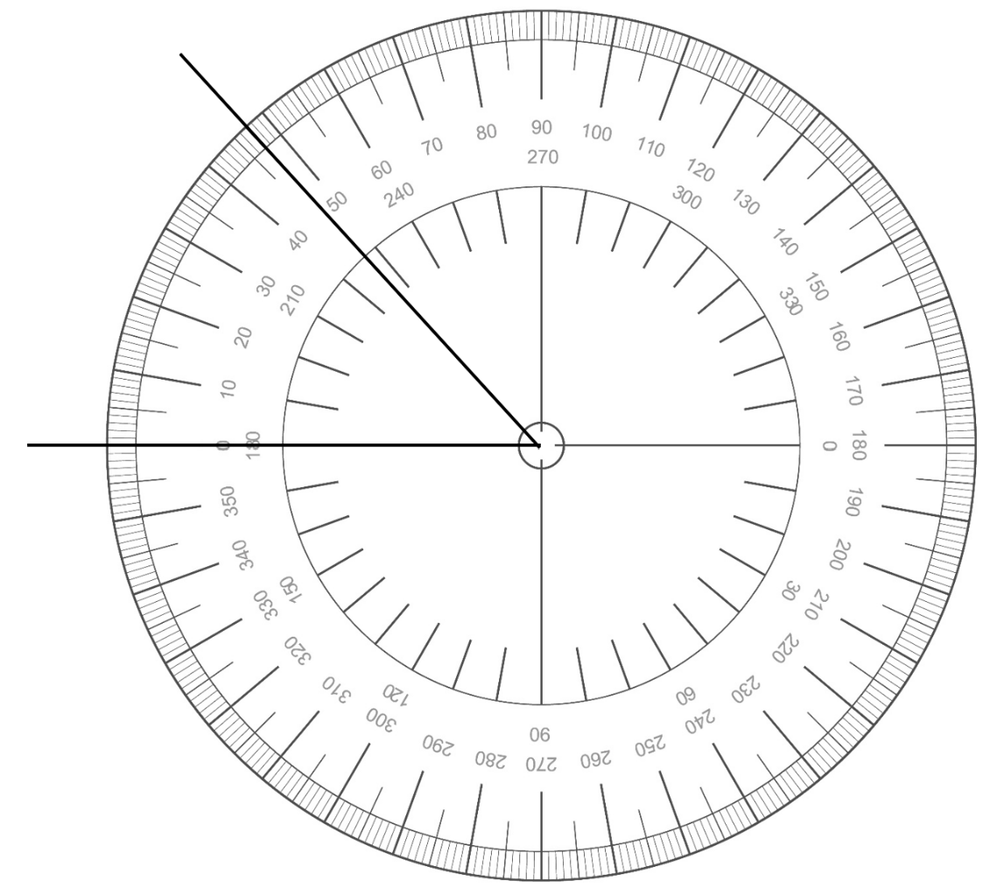

Question 3

Measure the angle shown below using a protractor.

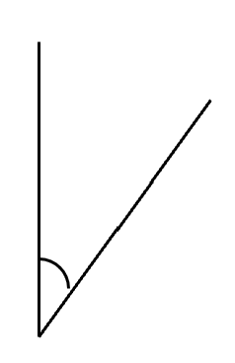
What is the angle in degrees (°)?

(1 mark)

Question 4

Measure the angle shown below using a protractor.

What is the angle in degrees (°)?

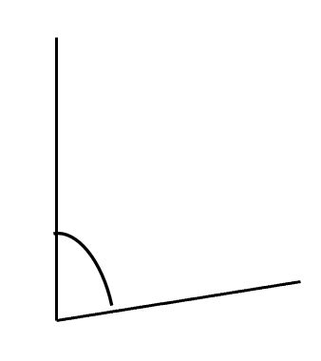
(1 mark)

Compass directions and angles
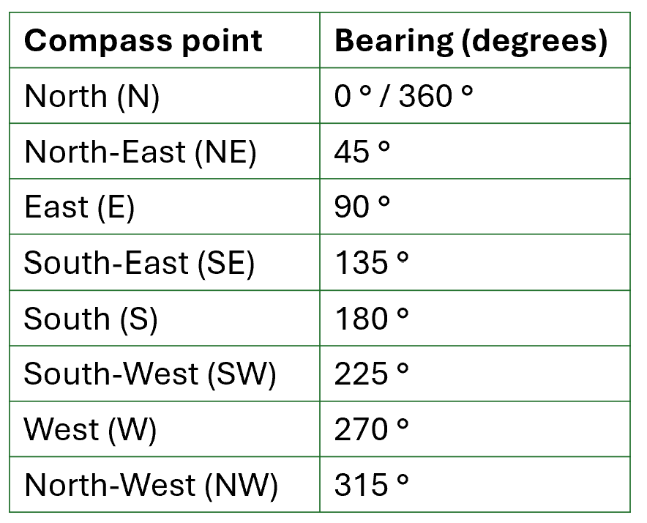
Directions:

When describing directions and movements, you can go either clockwise or anticlockwise.

When moving in a clockwise direction, the degrees are added (+).

When moving in an anticlockwise direction, the degrees are subtracted (-).
Strategy:

- Note the starting direction
- Identify turn size (degrees or quarter/half turn)
- Decide clockwise or anticlockwise
- Work out the new direction or position

Question 5

You face south (180°) and turn 45° clockwise.

Which compass point is that?

(Show your working out.)
(1 mark)

Question 6

You face west (270°) and turn 180° anticlockwise.

Which compass point is that?

(Show your working out.)
(1 mark)
Question 7

You face north (0/360°) and turn 45° anticlockwise.

Which compass point is that?

(Show your working out.)
(1 mark)

Question 8

You face east (90°) and turn 270° anticlockwise.

Which compass point is that?

(Show your working out.)
(1 mark)

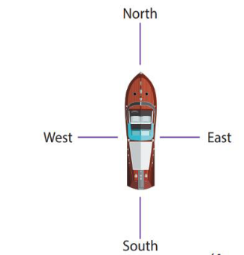
Exam practice 1

You are helping to direct a boat.

The boat starts out facing south.

It then turns 90° anticlockwise.

Next, it turns 180°.

It then turns 45° clockwise.

Finally, it turns 135° anticlockwise.

Which direction is the boat now facing?
(Show your working out.)
(3 marks)

Exam practice 2

You are facing north.

You turn 45°anticlockwise.

Next, you turn half a turn.

Finally, you turn 90° anticlockwise.

Which direction are you facing now?

(Show your working out.)
(2 marks)

Exam practice 3

On the grid below, draw a line that is 270° anticlockwise from east.

(2 marks)

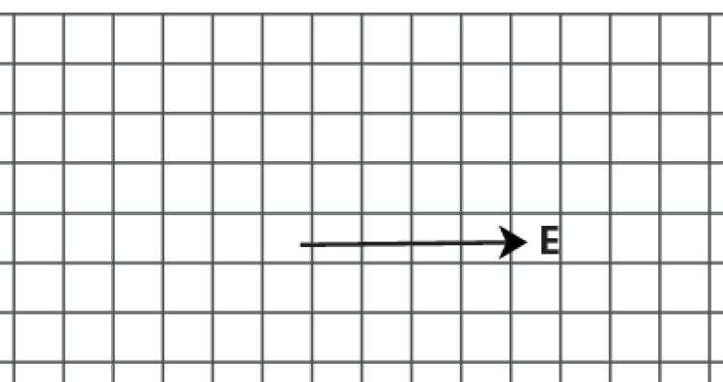

Answers

Question 1
East

Question 2
West

Question 3
30° (accept answers in the range of 27-33)

Question 4
83° (accept answers in the range of 80-86)

Question 5
180+45 = 225 South-West (SW)

Question 6
270-80 = 90 East (E)

Question 7
360-45 = 315 North-West (NW)

Question 8
90-270 = -180 South (S)

Exam practice

Exam practice 1
180-90 = 90 East (E)
+180 – 270 West (W)
+45 = 315 North-West (NW)
-135 = 180 South (S)

Exam practice 2
360-45 = 315 North-West (NW)
-180 = 135 South-East (SE)
-90 = 45 North-East (NE)

Exam practice 3
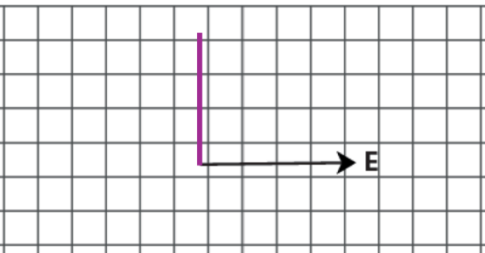

Your functional skills exam

Your functional skills exams will consist of 2 papers.
These papers will take place over the following time periods:

- Non-calculator paper – 40 minutes
- Calculator – 1 hour 50 minutes

Further information on the format that your test will take can be obtained from your training provider.

Hints and tips

- Find out what format your exam will be in. It may be paper-based
or on-screen.
- Plan what you are going to revise in advance. Don’t leave it until the last minute.
- Do as many past papers as you can so you are prepared for the day. If possible, try to complete the past papers following the same format as the actual exam.
- Find a quiet place to study and revise. It helps to sit at a table or a desk, don’t revise in bed.
- Don’t stay up all night revising the night before your exam. It’s important to have a good rest so you feel refreshed and ready to go.
- Read the question 3 times. The first time to ensure you understand what is being asked, the second time to get an understanding of what you need to do, and a third time to figure out exactly what maths techniques you should be applying.
- If you are struggling with a question, skip it and come back to it later. Try not to sit getting worked up about a difficult question, it will only waste exam time. Move on and come back to it after you have answered the other questions.
- Take note of the number of marks available. This will give you an indication of how much working out you must show. For example, 1 mark will need an answer only and more marks will need you to show your working out.
- When you’ve finished the exam, go back and check your answers. If you still have time remaining, use it to check your answers and when you have checked your answers check them again.

