

FUNCTIONAL SKILLS

English Level 2

Area: Reading
Criterion: 14. Understand the relationship between textual features and devices, and how they can be used to shape meaning for different audiences and purposes

Textual features

Textual features relate to the way a text is displayed. They are the techniques a writer uses to help the reader make sense of what they are reading and can impact the way someone reads and interprets a text.
Different types of texts have different textual features.
In your exam, you will be given an example of a textual feature and asked to explain why this feature has been used.
Below are some examples.

Textual feature | Reason a writer might use it
Bold text  Underlined text  Highlighted text | To make the words stand out and catch the reader’s attention.
Italic text | To make something stand out, or if used in a quote to highlight that it is not the writer’s words being used.
Images | To give a visual representation of the text and to grab the reader’s attention.
Emojis | To demonstrate or emphasise the writer’s emotions.
CAPITALISATION of words or phrases | To make something stand out, or to demonstrate shouting or urgency/importance.
Larger font sizes | To make the text stand out and grab the reader’s attention.
Smaller font sizes | To draw the reader away from the information, for example, terms and conditions.
Different font colours | To show different things, for example, blue words on a website show a hyperlink that the reader can use to find out more information. Red text might indicate something is important or urgent.  Different colours can help to make information stand out and draw the reader’s attention.
Different font styles | To help show who the audience of the text is and the formality of a text.

Text A

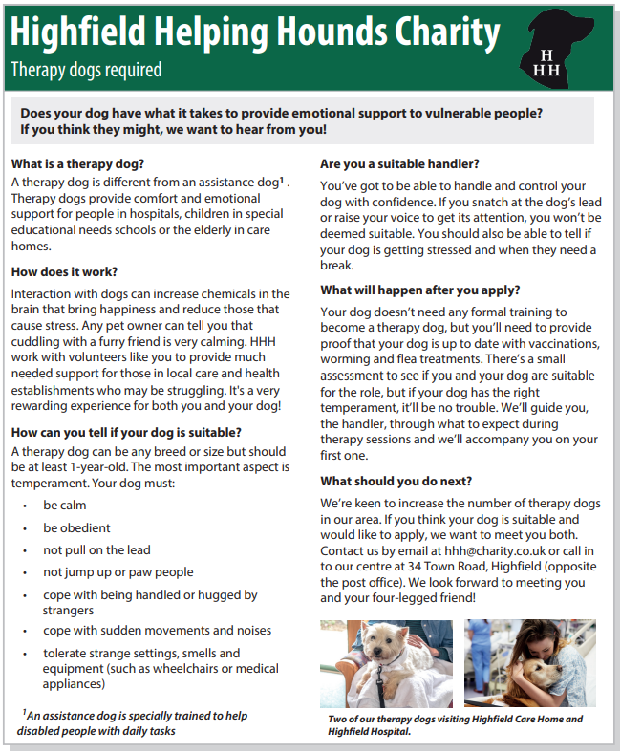

Text B

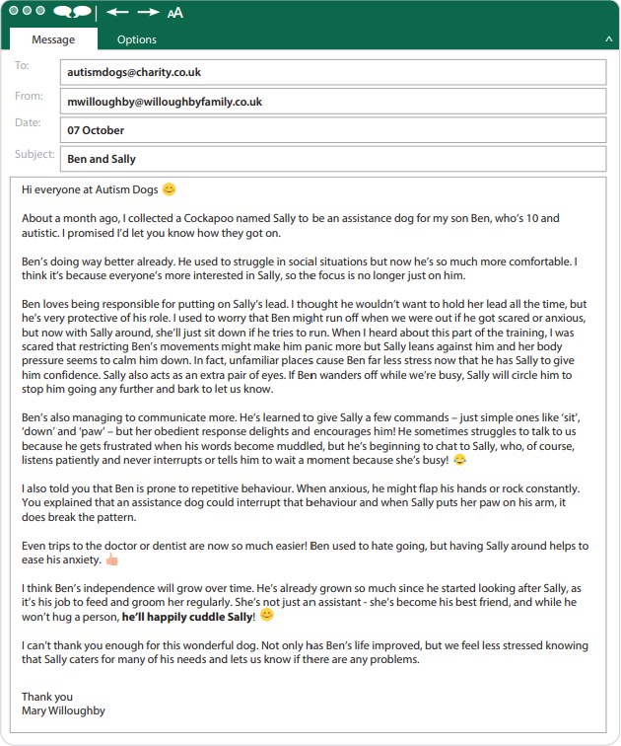

Text C


Using the information provided above, answer the following questions.

Question 1

Look at Text A.

Identify the textual features that have been used and explain why the writer has used them. Write your answers in the table below.

Textual feature | Why the writer has used the textual feature

Question 2

Look at Text C.

Explain why the writer has used images and larger font sizes.
(2 marks)

Images:

Larger font sizes:

Textual devices

Textual devices are also known as language techniques, linguistic devices or language devices. Highfield uses the term ‘textual devices’.
These are the methods that a writer uses to make their text interesting, effective and powerful. Textual devices help a writer to achieve the text’s purpose.
They can be used in both fiction and non-fiction text.
There are many textual devices. You can use the following to help you remember some of them:

 | Device | Purpose
D | Direct address (second-person perspective) | Makes the reader feel involved. Helps to persuade the reader.
A | Alliteration and anecdotes | Alliteration: helps to make the text more memorable or make information stand out.  Anecdotes: helps to make the reader think about a particular topic. They make the text more relatable to the reader.
F | Facts and statistics | Reinforce specific points within a text and help to persuade the reader to see a certain point of view.
O | Opinions | These are often used to make the reader empathise with the writer and persuade them to see their perspective.
R | Rhetorical questions | Makes the reader think about a topic and can be used to persuade.
E | Emotive language | Impacts the reader and makes them feel a specific way about a text or topic.
S | Similes and metaphors (and idioms) | Used to help create an image in the reader’s mind. They make texts more engaging and descriptive.
T | Triplets (rule of three) | Makes something more memorable or makes a specific point stick in the reader’s mind. These are sometimes used to repeat words to emphasise specific points.
P | Personal pronouns | Used to involve the reader in a text.
I | Imperatives | Used to tell the reader to do something or act. They create a sense of urgency and can be used to persuade.
E | Exaggeration (hyperbole) | Used to emphasise or draw attention to a point or particular topic.

It is important to know what the purpose of a text is and who their intended audience is. This will help you to identify why a specific textual device has been used.
Remember, there are 4 purposes you need to know for your exam:
- persuade
- instruct
- explain
- describe

You may be asked to identify the purpose of a text or explain why particular textual devices have been used.

Question 3

The main purpose of Text A is to:
Tick one box
(1 mark)
A | instruct the reader on how to train their dog to become a therapy dog
B | explain the difference between a therapy dog and an assistance dog
C | persuade the reader to apply for their dog to become a therapy support dog
D | describe what dogs do on a daily basis in their role as therapy dogs

Question 4

The main purpose of Text C is to:
Tick one box
(1 mark)
A | explain the advantages and disadvantages of owning a working dog
B | instruct the reader on how to buy specific breeds of working dog
C | describe what working dogs look like and their characteristics
D | persuade the reader that working dogs make the best pets

Question 5

Look at Text A.
The writer of Text A has used rhetorical questions and direct address to support the purpose. Using the text, give one example of each of these.

Rhetorical questions:

Direct address:

Question 5

Look at Text C.
The writer of Text C has used 3rd person perspective and alliteration to support the purpose. Using the text, give one example of each of these.

3rd person perspective:

Alliteration:

Exam practice 1

Look at Text B.

Explain why the writer has used bold text and emojis.
(2 marks)

Bold text:

Emojis:

Exam practice 2

The main purpose of Text B is to:
Tick one box
(1 mark)
A | persuade the reader to get an assistance dog
B | explain how Sally was trained
C | instruct the reader on how to care for an assistance dog
D | describe how Sally has helped Ben

Exam practice 3

The writer of Text B has used 1st person perspective and emotive language to support the purpose. Using the text, give one example of each of these.
(2 marks)
1st person perspective:

Emotive language:

Answers

Textual features

Question 1

Textual feature | Why the writer has used the textual feature
Bold text | To make words catch the reader’s attention. This makes the subheadings, such as ‘What is a therapy dog?’ stand out.
Italics | This is used for the footnote and caption and helps to show the reader they are not part of the main body of the text.
Images | These show the reader what the text is about. In this instance, they show therapy dogs helping people.
Larger font sizes | This is used to make the name ‘Highfield Helping Hounds Charity’ stand out, as well as the title ‘Therapy dogs required’.
Smaller font sizes | A smaller font size has been used for the footnote and caption, as this is extra information and does not need to grab the reader’s attention.

Question 2

Images:
- to show examples of working dogs
- to show the reader what working dogs look like
- to show the reader that the text is about dogs

Larger font sizes:
- to make the name of the vets ‘Highfield Veterinary Centre’ stand out
- to make the title stand out
- to make the information ‘ASK A VET’ stand out
- to draw attention to the information
- to grab the reader’s attention

Textual devices

Question 3

A | instruct the reader on how to train their dog to become a therapy dog
B | explain the difference between a therapy dog and an assistance dog
C | persuade the reader to apply for their dog to become a therapy support dog
D | describe what dogs do on a daily basis in their role as therapy dogs

Question 4

A | explain the advantages and disadvantages of owning a working dog
B | instruct the reader on how to buy specific breeds of working dog
C | describe what working dogs look like and their characteristics
D | persuade the reader that working dogs make the best pets

Question 5
Please note that there may be other correct answers.

Rhetorical questions
- Does your dog have what it takes to provide emotional support to vulnerable people?
- What is a therapy dog?
- What should you do next?

Direct address (2nd person perspective)
- We want to hear from you!
- HHH work with volunteers like you to provide much needed support.
- You’ll need to provide proof that your dog is up to date with vaccinations.

Question 6
Please note that there may be other correct answers.

3rd person perspective
- For centuries, dogs have been working with humans.
- Labradors and Spaniels have a keen sense of smell so can easily detect drugs and firearms.
- Prospective owners should also consider that some working breeds have inherent health issues.

Alliteration
- Sense of smell
- Detect drugs
- Physically fit

Exam practice

Exam practice 1

Bold text:
- to make the email headings stand out
- to make words in the text stand out
- to emphasise the writer’s point
- to catch the reader’s attention

Emojis:
- to show the writer’s emotions
- to emphasise how the writer is feeling
- to help the reader to understand how the writer is feeling, for example, happy or excited (other specific, positive examples can be awarded)

Exam practice 2

A | persuade the reader to get an assistance dog
B | explain how Sally was trained
C | instruct the reader on how to care for an assistance dog
D | describe how Sally has helped Ben

Exam practice 3
Please note that there may be other correct answers.

1st person perspective
- I collected a Cockapoo named Sally…
- My son Ben…
- We feel less stressed knowing that Sally…

Emotive language
- He’s now so much more comfortable
- Her obedient response delights and encourages him
- He’ll happily cuddle Sally
- I can’t thank you enough for this wonderful dog
Your functional skills exam

Your functional skills exams will consist of 2 papers.
These papers will take place over the following time periods:

- Reading – 60 minutes
- Writing – 60 minutes

Further information on the format that your test will take can be obtained from your training provider.

Hints and tips

- Find out what format your exam will be in. It may be paper-based
or on-screen.
- Plan what you are going to revise in advance. Don’t leave it until the last minute.
- Do as many past papers as you can so you are prepared for the day. If possible, try to complete the past papers following the same format as the actual exam.
- Find a quiet place to study and revise. It helps to sit at a table or a desk, don’t revise in bed.
- Don’t stay up all night revising the night before your exam. It’s important to have a good rest so you feel refreshed and ready to go.
- Read the question 3 times. The first time to ensure you understand what is being asked, the second time to get an understanding of what you need to do, and a third time to figure out exactly what maths techniques you should be applying.
- If you are struggling with a question, skip it and come back to it later. Try not to sit getting worked up about a difficult question, it will only waste exam time. Move on and come back to it after you have answered the other questions.
- Take note of the number of marks available. This will give you an indication of how much working out you must show. For example, 1 mark will need an answer only and more marks will need you to show your working out.
- When you’ve finished the exam, go back and check your answers. If you still have time remaining, use it to check your answers and when you have checked your answers check them again.

