

FUNCTIONAL SKILLS

Maths Level 2

Area: Measure, shape and space
Criterion 18: Calculate actual dimensions from scale drawings and create a scale diagram given actual measurements

Scale drawings

Scale drawings are used to represent larger or smaller objects, drawings, images or maps.

Scale factors and scale keys

Scale factors are used to scale up or down an image accurately.

Scale drawings will be shown with a key or a scale factor. These tell you what a dimension in the drawing is equal to in real life.

Usually, they are represented as ratios, with an = sign or as a line drawing as below:

1cm = 100m 1cm on the grid represents 100m
1:10000 1cm on the grid represents 10,000cm in real life
100m The distance marked represents 100m

Calculating distances using scale

Sometimes, you will be asked to measure a length or dimension to calculate an actual distance.

For example, the scale drawing below shows a section of coastline.
Calculate the distance between point A and point B.

Scale: = 5km

A B

Firstly, measure the length of the scale using a ruler.
It is 1cm.

1cm on your ruler represents 5km in real life.

Then, measure the distance between A and B.
The distance between A and B is 9.5cm.

1cm on the drawing represents 5km in real life.
The distance between A and B in real life is:
9.5 x 5 = 47.5km

Some questions will provide you with a length or dimensions, so measuring is unnecessary.

For example, this is a scale diagram of a room.

Scale factor 1:120

2cm

3.2cm

Diagram not to scale

Calculate the actual length and width of the room. Give your answer in metres (m).

Using the scale, we know that 1cm is equal to 120cm
Width = 2cm
2 x 120 = 240cm
Convert to metres.
1m = 100cm
240 ÷ 100 = 2.4m

Length = 3.2cm
3.2 x 120 = 384cm
Convert to metres
1m = 100cm
384 ÷ 100 = 3.84m

Calculating distances on a grid

The grid below shows a map of an island.

Calculate the distance between point A and Point B.
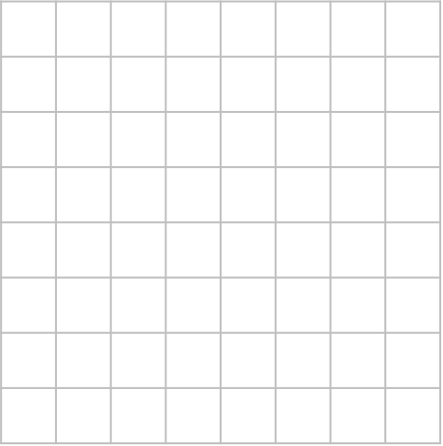

500
miles
A
B

We are given the scale as a line drawing.

Therefore, we do not need to use a ruler

Count the number of squares between the two points.

There are 5 squares.

To find the actual distance between point A and point B, multiply the distance represented by 1 square (500 miles) by the number of squares between the two points.

5 x 500 = 2,500 miles

Calculating the scale

You may be given an actual distance and then asked to calculate the scale on a map.

The diagram below is a scale drawing of a classic car.
The actual length of the car is 3.6m.


Calculate the scale used in the drawing. Give your answer as a ratio.

To calculate the scale used, we need to measure the length of the car using a centimetre ruler.

The length of the car is 6cm on the drawing.

Both measurements need to be the same unit.

Therefore, convert the length of the car from metres to centimetres.
1m = 100cm

To convert metres to centimetres, multiply by 100
3.6 x 100 = 360
3.6m = 360cm

We can now write this as a ratio.

Drawing length: Real-life length = 6 : 360

If possible, simplify the ratio by dividing both sides.

In this example, both sides of the ration can be divided by 6.
6 ÷ 6 = 1
360 ÷ 6 = 60
1:60

Therefore, 1cm on the drawing represents an actual length of 60cm.

Creating a scale drawing

To create a scale drawing, first calculate what the dimensions need to be.

For example, draw a rectangle on the grid below. It must have a height of 1.5m and a width of 2m.
Use the scale 1:50
Each square is 1cm by 1cm.

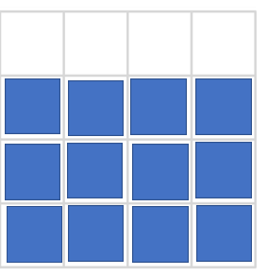

The grid uses centimetres (cm). Therefore, we need to convert the rectangle’s measurements from metres to centimetres.

1m = 100cm
Multiply the metres by 100 to convert to centimetres.

Height = 1.5m
1.5 x 100 = 150cm

Width = 2m
2 x 100 = 200cm

1:50 means that 1cm represents 50cm on the grid.

Divide the actual dimensions, which are now in centimetres, by 50 to find the measurements needed for the scale drawing.
- Height: 150 ÷ 50 = 3
- Width: 200 ÷ 50 = 4

Question 1

Calculate the distance between point A and point B.

Scale: = 10km

A B

(Show your working out.)
(3 marks)

Question 2

Calculate the distance between point A and point B. Give your answer in kilometres.

Scale: = 150m

A B

(Show your working out.)
(4 marks)

Question 3

This is a scale diagram of a living room.

Scale factor 1:150

6.5cm

7.5cm

Diagram not to scale

Calculate the actual length and width of the living room.

Give your answer in centimetres (cm).

(Show your working out.)
(3 marks)

Question 4

The diagram shows a scale drawing of a garden.

Scale 1cm:1.2m

9.2cm 3.05cm
Diagram not to scale

5.3cm

6.8cm

Calculate the actual perimeter of the garden.

(Show your working out.)
(6 marks)

Question 5

Use the grid provided to draw a scale diagram of a garden.

The garden must have a rectangular shape with the following measurements:

Length = 6.5m
Width = 3.5m

1cm:1m

Each of the squares measures 1cm x 1cm.

(Show your working out.)
(3 marks)

Question 6

The map shows part of the UK and part of France.

The scale of this map is 1cm: 20km

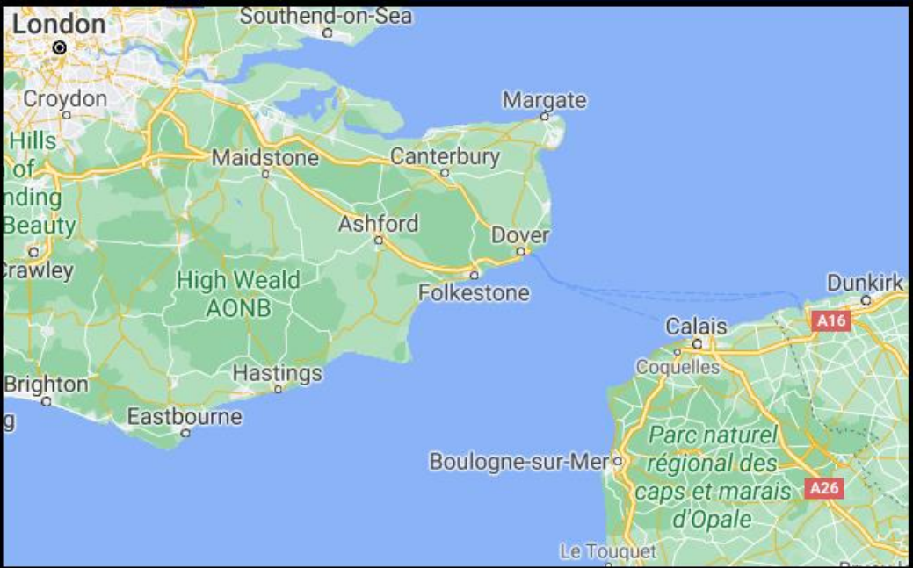

The distance between Dover and Calais on the map is 2.3cm.

Using the scale, calculate the actual distance between Dover and Calais.

Give your answer in kilometres (km).

(Show your working out.)
(2 marks)

Question 7

The distance between two villages on a map measures 8 centimetres.

The map has a scale of 1:25,000

Calculate the actual distance between the two villages in kilometres.

(Show your working out.)
(3 marks)

Exam practice 1

The diagram below has a scale of 1cm:230cm

12.9cm

Calculate the actual length, in metres.

(Show your working out.)
(2 marks)

Answers

Question 1
10 x 7 = 70km

Question 2
150 x 12.5 = 1,875m
Convert to km
1km = 1000m
1,875 ÷ 1000 = 1.875km

Question 3
Width = 6.5
6.5 x 150 = 975cm
Length = 7.5cm
7.5 x 150 = 1,125cm

Question 4
Calculate the missing lengths

9.2cm 3.05cm
5.3cm

9.2cm
6.8cm
6.8cm
6.8 – 5.3
= 1.5cm

3.05cm

Convert each length using the scale 1cm:1.20m
5.3 x 120 = 636
9.2 x 120 = 1,104
1.5 x 120 = 180
3.05 x 120 = 366
6.8 x 120 = 816

Add together all converted lengths
636 + 1,104 + 1,104 + 180 + 366 + 366 + 816 = 4,572cm
1 metre = 100 centimetres
4,572 ÷ 100 = 45.72m

Question 5
The rectangle must be 6 and a half squares long, and 3 and a half squares high.

Question 6
Use the scale 1cm: 20km
2.3 x 20 = 46km

Question 7
Use the scale 1:25,000
8 x 25,000 = 200,000
Convert cm to kilometres
There are 100,000cm in 1km
200,000 ÷ 100,000 = 2km
or
100cm in 1m and 1000m in 1km
200,000 ÷ 100 = 2,000m
2,000 ÷ 1000 = 2km

Exam practice 1
Use the scale 1:230
12.9 x 230 = 2,967cm
Convert cm to m
1m = 100cm
2,967 ÷ 100 = 29.67m

Your functional skills exam

Your functional skills exams will consist of 2 papers.
These papers will take place over the following time periods:

- Non-calculator paper – 40 minutes
- Calculator – 1 hour 50 minutes

Further information on the format that your test will take can be obtained from your training provider.

Hints and tips

- Find out what format your exam will be in. It may be paper-based
or on-screen.
- Plan what you are going to revise in advance. Don’t leave it until the last minute.
- Do as many past papers as you can so you are prepared for the day. If possible, try to complete the past papers following the same format as the actual exam.
- Find a quiet place to study and revise. It helps to sit at a table or a desk, don’t revise in bed.
- Don’t stay up all night revising the night before your exam. It’s important to have a good rest so you feel refreshed and ready to go.
- Read the question 3 times. The first time to ensure you understand what is being asked, the second time to get an understanding of what you need to do, and a third time to figure out exactly what maths techniques you should be applying.
- If you are struggling with a question, skip it and come back to it later. Try not to sit getting worked up about a difficult question, it will only waste exam time. Move on and come back to it after you have answered the other questions.
- Take note of the number of marks available. This will give you an indication of how much working out you must show. For example, 1 mark will need an answer only and more marks will need you to show your working out.
- When you’ve finished the exam, go back and check your answers. If you still have time remaining, use it to check your answers and when you have checked your answers check them again.

