Easy Read

An Equal Future:

A manifesto for change

What the next government should do to support disabled people

Easy Read
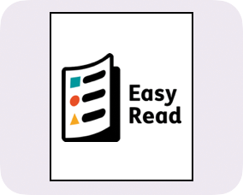
This is an Easy Read version of some information. It may not include all of the information but it will tell you about the important parts.

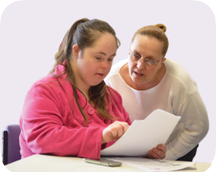
This Easy Read booklet uses easier words and pictures. Some people may still want help to read it.

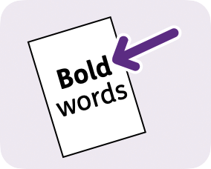
Some words are in bold - this means the writing is thicker and darker.
These are important words in the booklet.

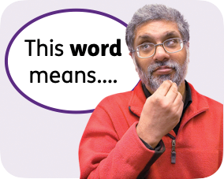
Sometimes if a bold word is hard to understand, we will explain what it means.

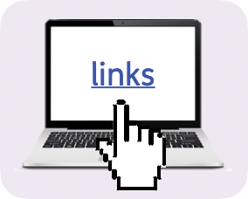
Blue and underlined words show links to websites and email addresses. You can click on these links on a computer.

What is in this booklet
About this booklet 4
What we want 5
Disabled people and money 7
Disabled people and work 12
Changing the way others think 19
Find out more 24

About this booklet
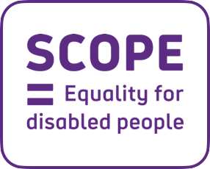
This booklet is from Scope. We are a charity that works to make sure disabled people are treated fairly.

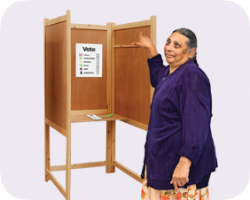

In 2024, people in the UK will vote for a new government.

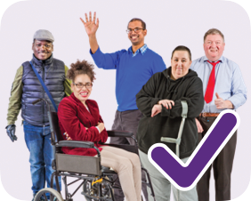
We want the new government to make sure disabled people are treated fairly.

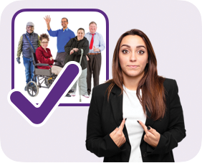
This booklet explains what we think the new government should do to make sure disabled people are treated fairly.

What we want

We know that disabled people:
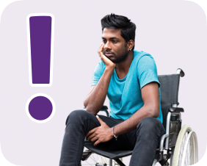
- Face lots of issues that stop them from living their everyday lives.

- Are often treated unfairly.

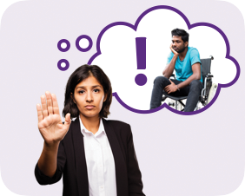
We want the government to:

- Fix these issues.

- Make sure that disabled people are treated fairly.

To make sure this happens, we think the government should:
- Support disabled people to have enough money for the things they
need.

- Support disabled people to work if they want to.

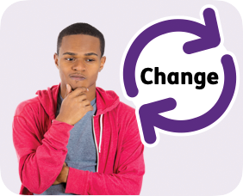
- Change the way people who are not disabled may think about disability
and disabled people.

Disabled people and money

The issues
Disabled people in the UK often struggle with having enough money.

This is because:
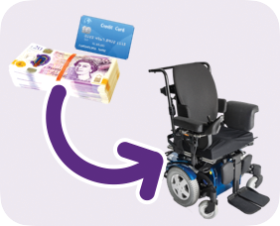
- Disabled people often have to spend money on extra things that they
need to live, like special equipment or a carer.

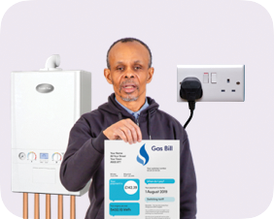
- Disabled people also spend more money than others on gas and
electricity.

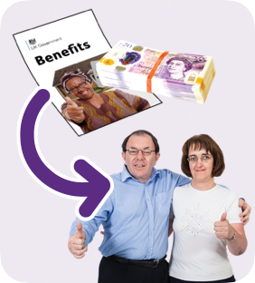
- There are problems with the way the government decides who gets
disability benefits.
Benefits are money that the government gives to some people to help pay for the things they need to live.

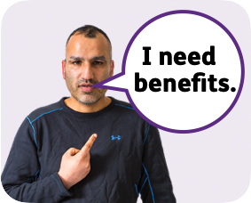
Lots of disabled people need disability benefits to be able to pay for the things they need to live.

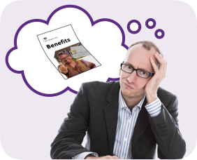
But there are problems with the way the government decides who gets benefits.

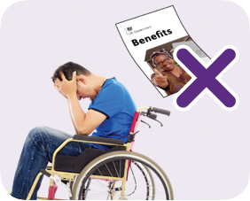
These problems mean a lot of disabled people do not get disability benefits when they need them.

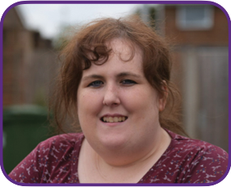
Samantha’s story
Samantha cannot move her body from her chest to her feet.

She uses an electric wheelchair to move around.

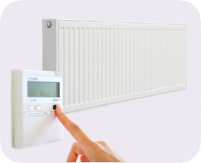
Samantha also needs different things in her home to help her live her life, like:

- Extra heating, because being cold affects her disability.

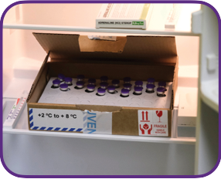
- Special furniture and equipment, like an electric door and a special
freezer for her medicines.

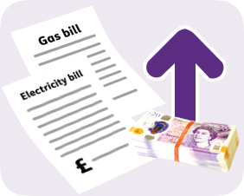
Samantha’s gas and electricity bills have gone up because of the things she needs to live.

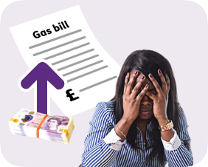
Samantha says:

- She cannot pay her gas bill because it is too expensive.

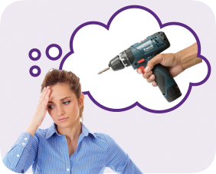
- She does not have enough money to fix her broken equipment - this is
the equipment she needs to live.

Samantha also says:
- She feels like there is no help for disabled people who are struggling
with money.

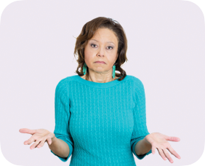
- She feels like the government does not care that disabled people are
struggling with money.

What the government should do
To help disabled people have enough money to live, the government should:
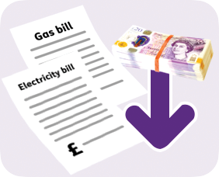

- Give disabled people cheaper gas and electricity bills.

- Find out more information about what extra things disabled people
have to pay for.

The government should also:
- Work with other organisations to come up with ideas about how to
help disabled people pay for these things.

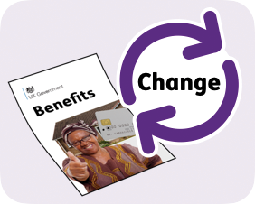
- Work with disabled people to change the way that disability
benefits are given out.

In the future, the government should also:
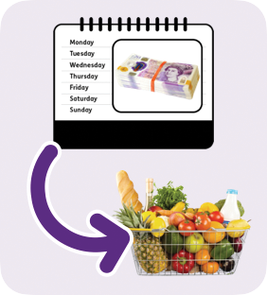
Give some disabled people an ‘Essentials Payment’ every week.
•
An ‘Essentials Payment’ is money that should be spent on important things that people need to live, like food or electricity.
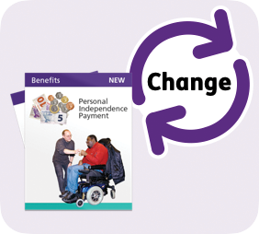
Work with disabled people to change Personal Independence Payment (PIP).
•
Personal Independence Payment (PIP) is a disability benefit.

Disabled people and work

The issues
Disabled people in the UK often find it hard to get a job.

This is because:
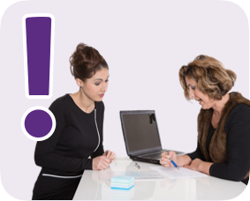
There are problems with the government’s work support services - these are services that help disabled people find a job.
•

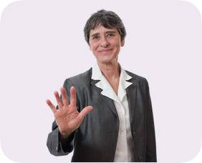
- Organisations do not ask disabled people to work for them because of
their disability.

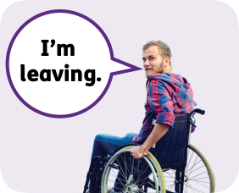
Disabled people in the UK are also more likely to leave their jobs than people who are not disabled.

This is because:
- They face discrimination at work. Discrimination is when you are treated badly or unfairly because of who you are.

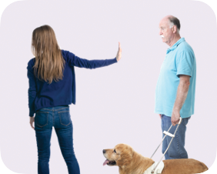
- The organisation they work for does not support them at work.

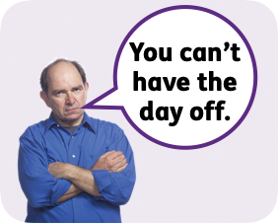

The organisation they work for does not support them if they need to take days off because of their disability.
•

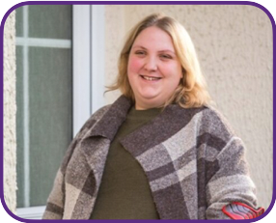
Katie’s story

Katie is disabled and looking for a job.

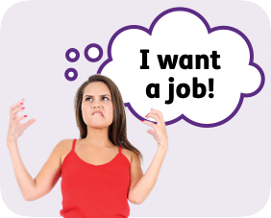
She has found looking for a job very difficult, and she thinks it should be easier.

Katie says:
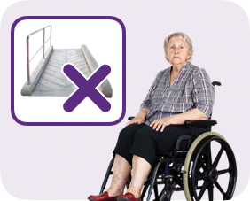
- She has been interested in jobs but then realised the organisation does
not meet her needs.

- Organisations who are looking for staff need to be clear about how
they can support a disabled person.

Katie also says:
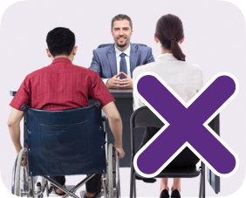
- She feels organisations do not take the time to understand disabled
people’s needs.

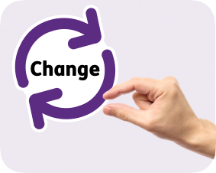
- Sometimes an organisation would just have to make a small change
for her to be able to work there.

What the government should do
To support disabled people to work if they want to, the government should:
- Work to make sure that disabled people can get a job if they want
one, in the same way that people who are not disabled can.

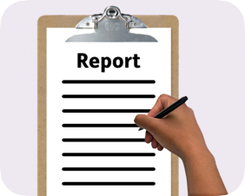
- Write a report about how this work is going every year.

The government should also:
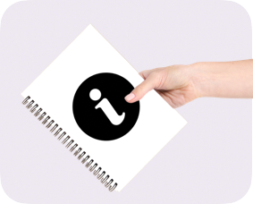
- Ask organisations to share information about how they support
the disabled people who work for them.

- Offer more kinds of work to disabled people, like volunteering work - this
is work that people do not get paid for.

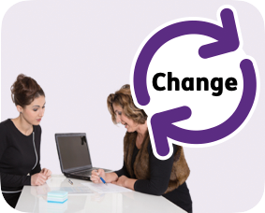
- Change how the Access to Work
service works - this service helps
disabled people find a job.

- Increase sick pay - this is the money you get paid when you are
off work because you are ill.

The government should also:
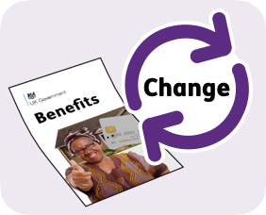
- Work with disabled people to change the way that disability
benefits are given out.

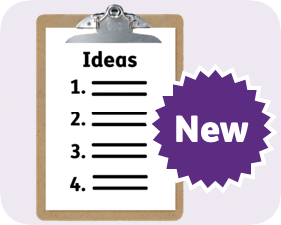
- Spend money on new ideas about how to help disabled people find
jobs.

In the future, the government should also:
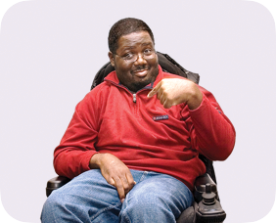
- Make sure organisations allow disabled people to work in a way
that suits them, from the first day of their job.

- Look at the Disability Confident project to see whether it is working.
The Disability Confident project supports organisations to have disabled people working for them.

In the future, the government should also allow disabled people time off work, if they need it, because of their disability.

Changing the way others think

The issues
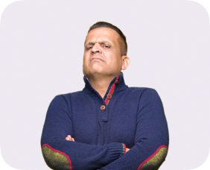
People who are not disabled often think badly of disabilities and disabled people.

People who are not disabled often:
- Think disabled people cannot do things.

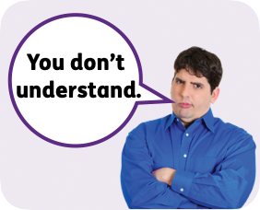
- Think disabled people cannot think or understand in the same way that
everyone else can.

- Question a person’s disability and think disabled people are lying
about their disability.

Some people who are not disabled treat disabled people unfairly or unkindly because of their disability.

Most disabled people in the UK have faced other people thinking badly of them.

Arunima’s story
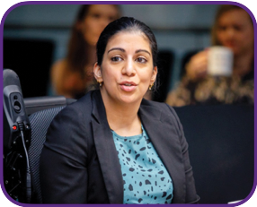
Arunima is a lawyer who lives in London. She cannot move her legs and uses a wheelchair to move around.

Arunima has faced other people thinking badly of her at work.

The people she has worked with have made unkind comments and jokes about her disability.

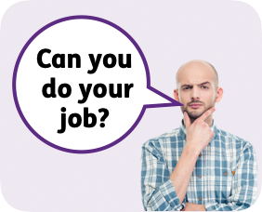
The people Arunima has worked with have also questioned whether she can do her job well because she is disabled.

Arunima says:
- She has often felt embarrassed about asking for support from the
organisations she has worked for.

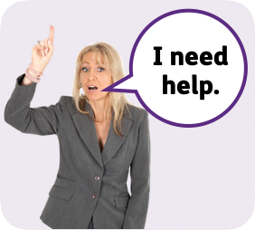
- She has always had to ask for help from the organisations she has
worked for, instead of the organisation asking her what she needs.

What the government should do
To fix these issues the government should:
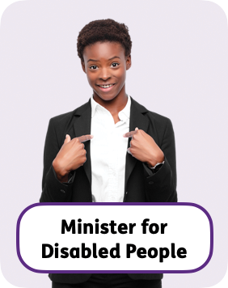
- Give the Minister for Disabled People more power to make changes that will help disabled people.
The Minister for Disabled People is a politician in the government who is in charge of disability issues.

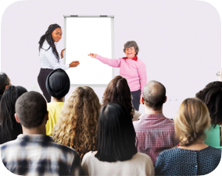
- Give disability training to all staff in public services, like healthcare staff
and public transport staff.

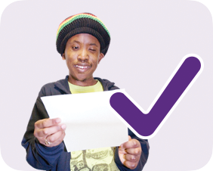

- Share information in a way that disabled people can understand.

In the future, the government should also:
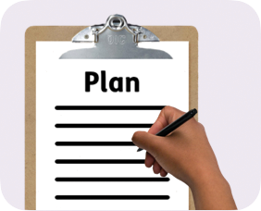
- Write a new plan for how disabled people will be supported in the
future.

- Make sure that there are fewer complaints from disabled people
about the behaviour of service staff.

- Make sure that there are fewer complaints from disabled people
about their place of work.

Find out more
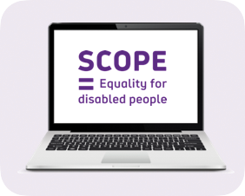
You can look at our website here: https://www.scope.org.uk/

This Easy Read booklet was produced by easy-read-online.co.uk
The booklet includes images licensed from Photosymbols & Shutterstock.

