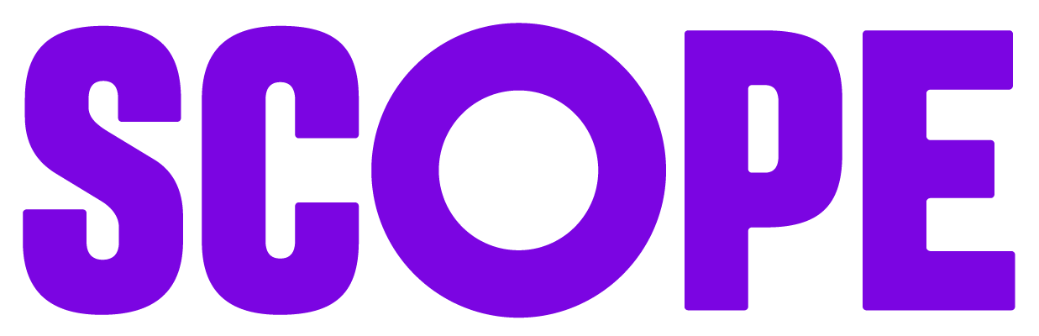
Individual media and release consent form
Name: __________________________________________
Email: __________________________________________
Role/Organisation (optional): ______________________
Date: ___________________________________________
I hereby grant (“the Organiser”) permission to record my image, voice, and any contributions through photography, video, audio, or screen capture in connection with activities taking place on or around:
Date(s) of recording: ______________________________
Location/Context (event, webinar, interview, etc.):_____________________
I authorise the Organiser, and its approved third-party partners to use, reproduce, edit, publish, share, and distribute these materials for informational, promotional, educational, or other organisational purposes. This may include, but is not limited to:
- Websites and social media
- Marketing and promotional materials
- Digital, broadcast, or online distribution
- Sharing with partner organisations for aligned purposes
I understand that:
- The Organiser may edit, adapt, or modify the materials.
- I will not receive payment or compensation for the use of these materials.
- I waive any right to inspect or approve the finished materials.
My data and recordings will be handled in accordance with the Organiser’s Privacy Policy, available at scope.org.uk/privacy.
I release the Organiser from any claims, demands, or liabilities arising from or related to the use of these materials.
Signature: ______________________________

