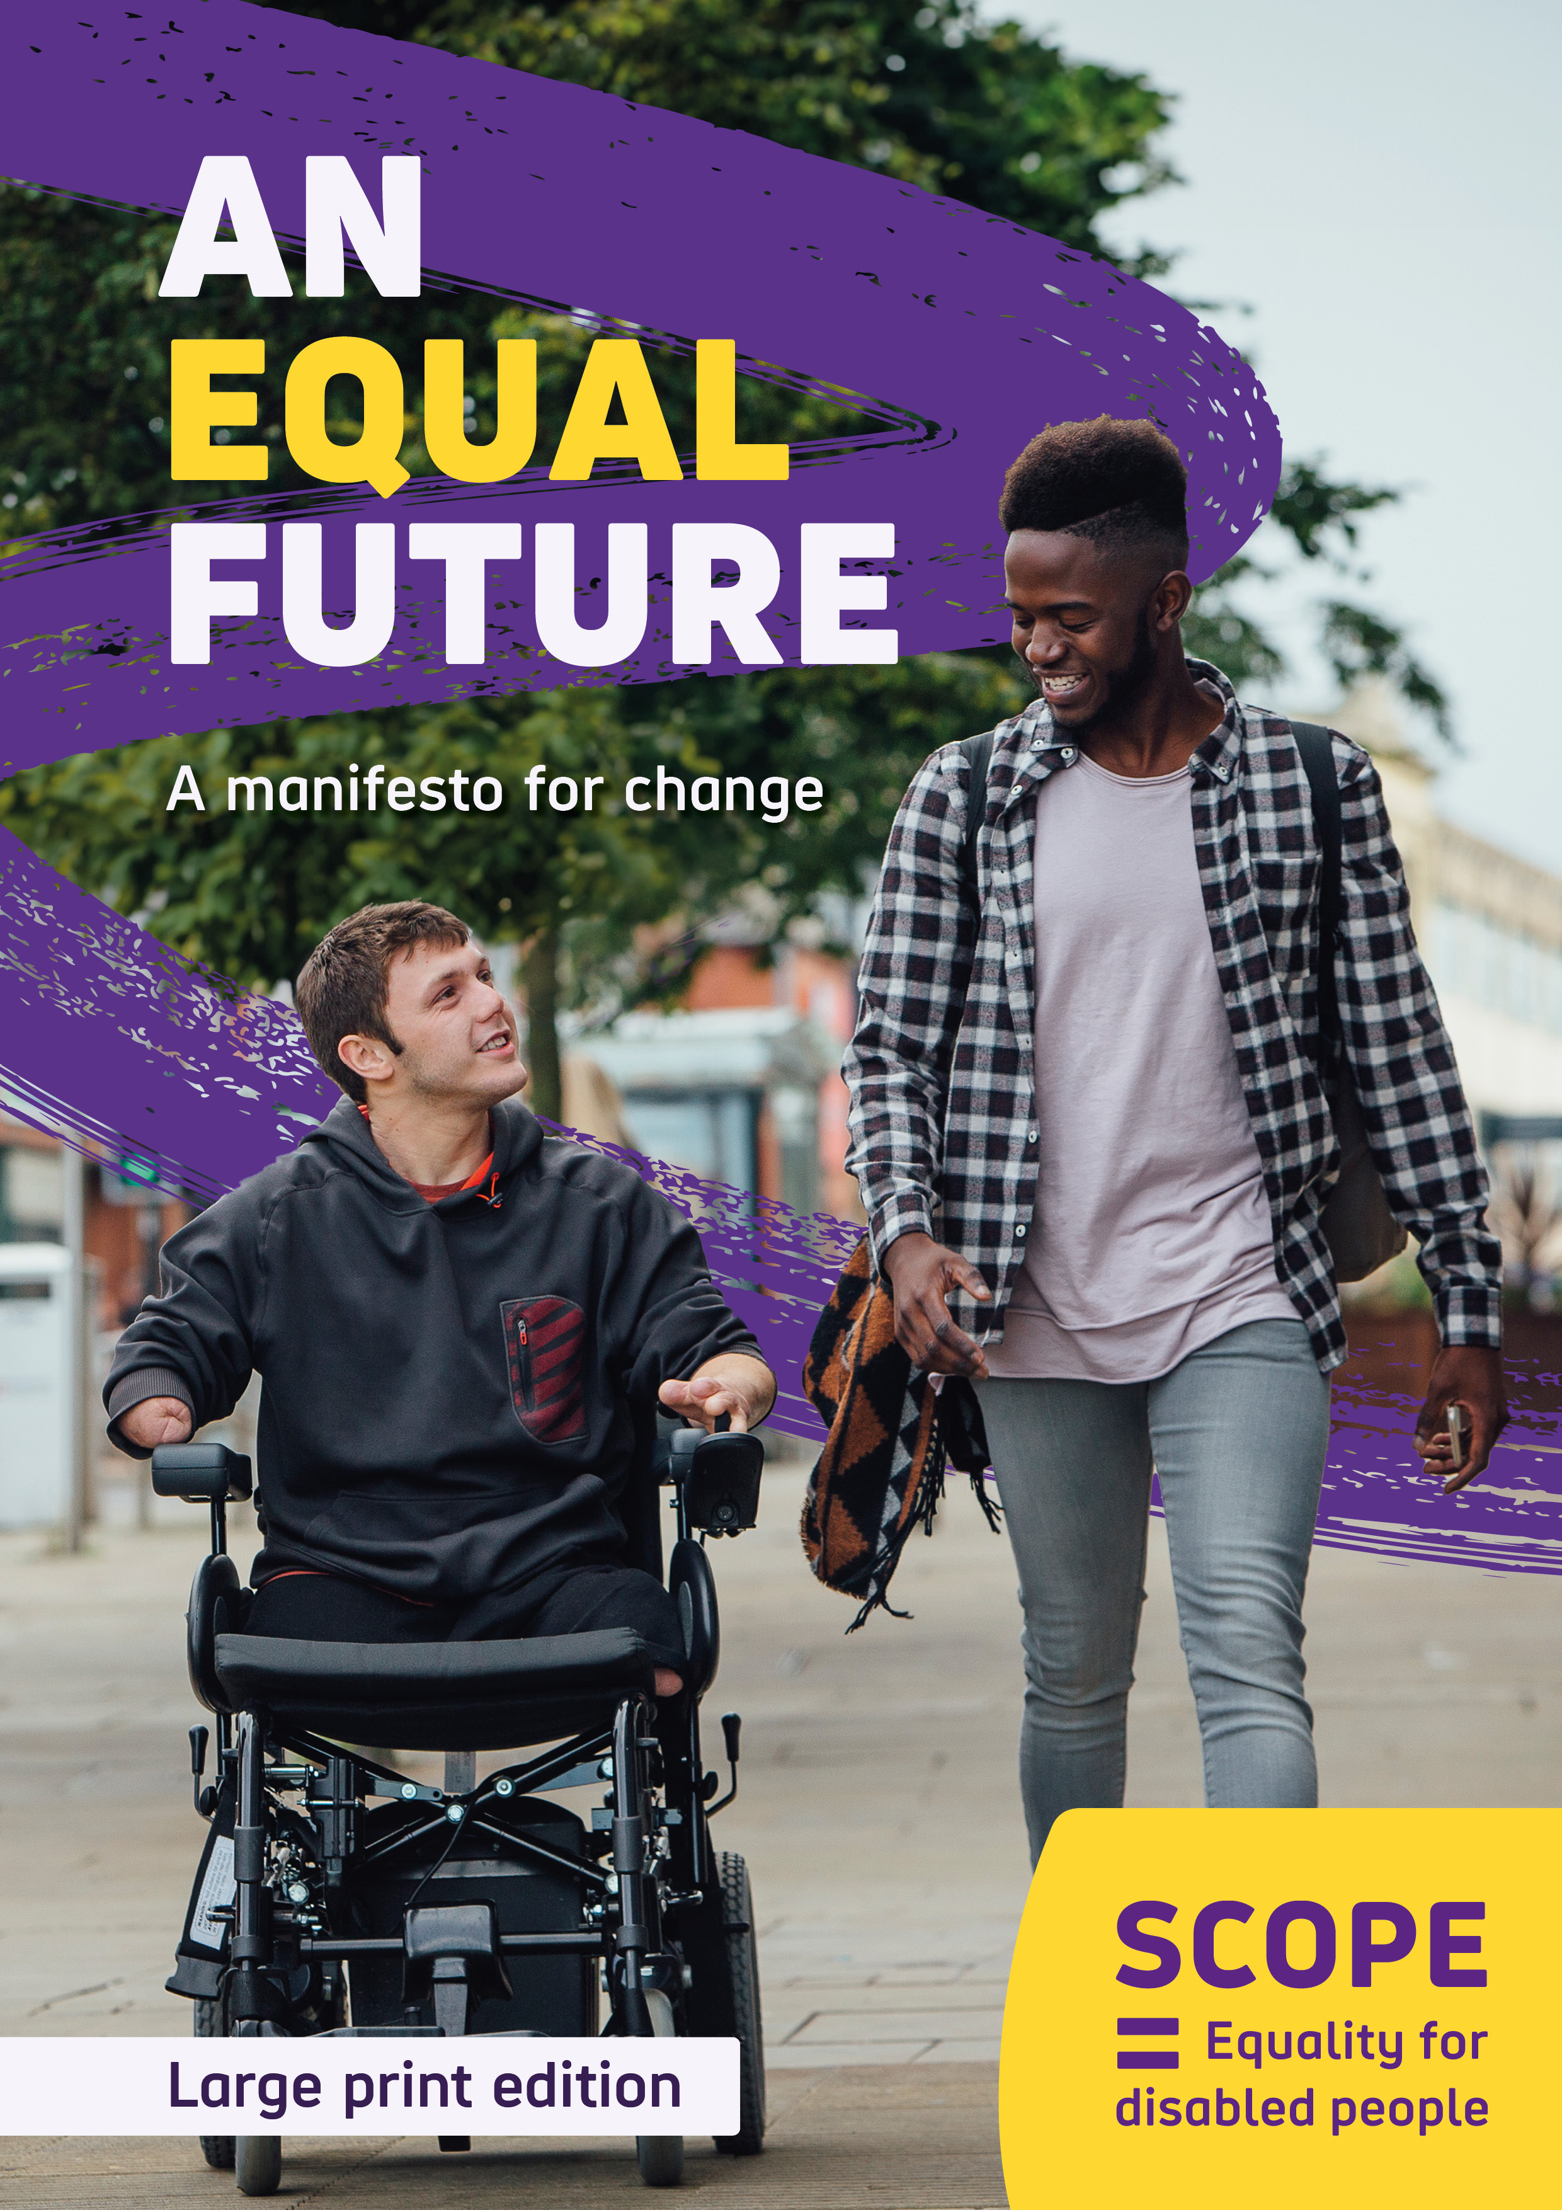

AN EQUAL FUTURE
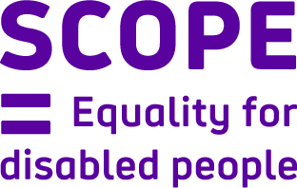
A manifesto for change
Large print edition

Contents
Our vision 4
Disability in the UK today 5
Manifesto at a glance 7
Ending the Disability Price Tag 8
Samantha’s Story 13
Our plan to end the disability price tag 15
Closing the disability employment gap 17
Katie’s Story 22
Our plan to close the Disability Employment Gap 24
Transforming attitudes 26
Arunima’s Story 31
Our plan to transform attitudes 33
Conclusion 35
To view this report on mobile, first download Microsoft Word from the Apple Store or Google Store. Then, when you open the report in Word, view in print layout mode.

Our vision
We won’t stop until we achieve a society where all disabled people enjoy equality and fairness.

Our mission
We are Scope.
We are determined to change the future.
Together, as a collective movement of disabled people, campaigners, donors, volunteers, communities, and businesses.
We work every day to challenge attitudes and end disability inequality.

Disability in the UK today
16 million people in the UK are disabled. That’s one in four, or 24% of the population. We are a force to be reckoned with and we want our potential to be recognised.
For too long disabled people have faced challenges and barriers across every aspect of our lives. Millions of us experience extra costs and financial penalties just because of who we are. Most of us have experienced negative attitudes, and too many of us are denied the opportunity to work.

Our vision for the future
At Scope we are determined to change the future and we know that change is possible. With a General Election on the horizon, we are calling on all political parties to prioritise disabled people. But we need more than nice words; we need true leadership and action. Whoever forms the next government must listen to and work with disabled people to finally end the Disability Price Tag, close the Disability Employment Gap and transform attitudes.
In this manifesto we outline challenges and barriers that disabled people face in the UK today. We will then outline actions that the next government must take.
There is huge opportunity for the next government to tackle the many barriers disabled people face. Addressing them will enable us to unleash the talent and contributions of disabled people across the country.
Our recommendations are all based on the things that disabled people tell us matter most, the things which can lead us towards an equal future. It’s time for all political parties to commit to real change.

Manifesto at a glance
Equality is a right, and this right should be afforded to every disabled person. An equal future would mean disabled people are no longer denied work opportunities, face financial penalties or subjected to negative attitudes.
We want to work with the next government to address these things so that this country is a place where:
- Disabled people don’t face a price tag just to live their everyday lives
- Disabled people who can and want to work can do so
- Disabled people are free from negative attitudes, lazy stereotypes and assumptions
In this Manifesto we outline the need for change. We share research and the lived experiences of disabled people, and recommendations for the next government to adopt.

Ending the Disability Price Tag
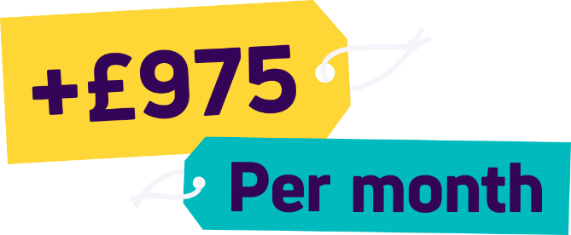
Life has always cost more for disabled people. The high cost of specialist products, the extra money disabled households need to spend on essential services to charge equipment, and the penalties associated with purchasing everyday goods like insurance or using transport. These all add up.
Scope’s Price Tag research shows on average, disabled households need an additional £975 a month to have the same standard of living as non-disabled households. This figure is calculated after accounting for benefit payments such as Personal Independence Payment (PIP).
It’s not just the big things; we know that disabled people have to spend a bigger proportion of their income on basic essentials too, like food and heating. On average, disabled people need to find £12 a week, or £625 a year, more than non-disabled households, to cover these essentials.

Energy Costs:
Disabled people have been hit hard by spiralling energy costs in the last two years. Over a third of disabled adults say that their condition or impairment affects how much energy they need to use. As a result over 90% are worried about energy bills and many are building up worrying levels of debt. In 2023, the average debt of callers to Scope’s energy helpline was £1,103.
Many disabled people need to use more heating because they can’t regulate their body temperature. Some disabled people also need to charge equipment like electric wheelchairs and hoists. We’ve heard from people who use lifesaving machines like ventilators to breathe, or dialysis machines. This is lifesaving equipment; these costs can’t be avoided.
“It costs me a fortune to afford to run an electric bed, 2 powered wheelchairs, and everything else. I’ve had to stop charging my wheelchairs as much because the electricity bill is so expensive. My wheelchair is my legs. How would other people manage if they couldn’t use their legs because they can’t afford the electricity? I’m disadvantaged with my energy costs because of my disability. But a social tariff would level the playing field.” – Debra

Benefits:
The welfare system is supposed to support disabled people with the extra costs they face and provide an income for those who cannot work. But the system is broken.
Navigating the process is distressing and complex. Disabled people tell us that disability benefits assessments do not capture the reality of their lives. Assessors who know little about disabled people’s conditions and impairments leave claimants feeling misunderstood, and make the wrong decisions time and time again. Around three quarters of disabled people who go to tribunal over their PIP decisions have the decision reversed in their favour. However, this is a challenging and lengthy process that disabled people should not have to go through.
“We’re too exhausted to contest it anymore, because right now, we’re just happy with what we’ve got. We’re still recovering financially, because we had to use credit cards when they took the money away without any notification.” – Chris
Low benefit rates have been pushing disabled people into debt and poverty for years. 50% of people in poverty in the UK are disabled or live with a disabled person. Disabled people of working age are three times more likely to use a food bank than non-disabled people.

“Benefits were a pittance in the first place, but now we’re expected to meet significantly increased costs in so many areas, with pathetically inadequate extra support. Benefits might help me to ‘survive’ with a disability, but they certainly don’t help me to actually live with a disability” – Simon
Our vision is a society where disability is no longer linked to poverty. Where disabled people no longer face extra costs. The next government must end the disability price tag and redesign the welfare system to ensure it provides an adequate level of support.

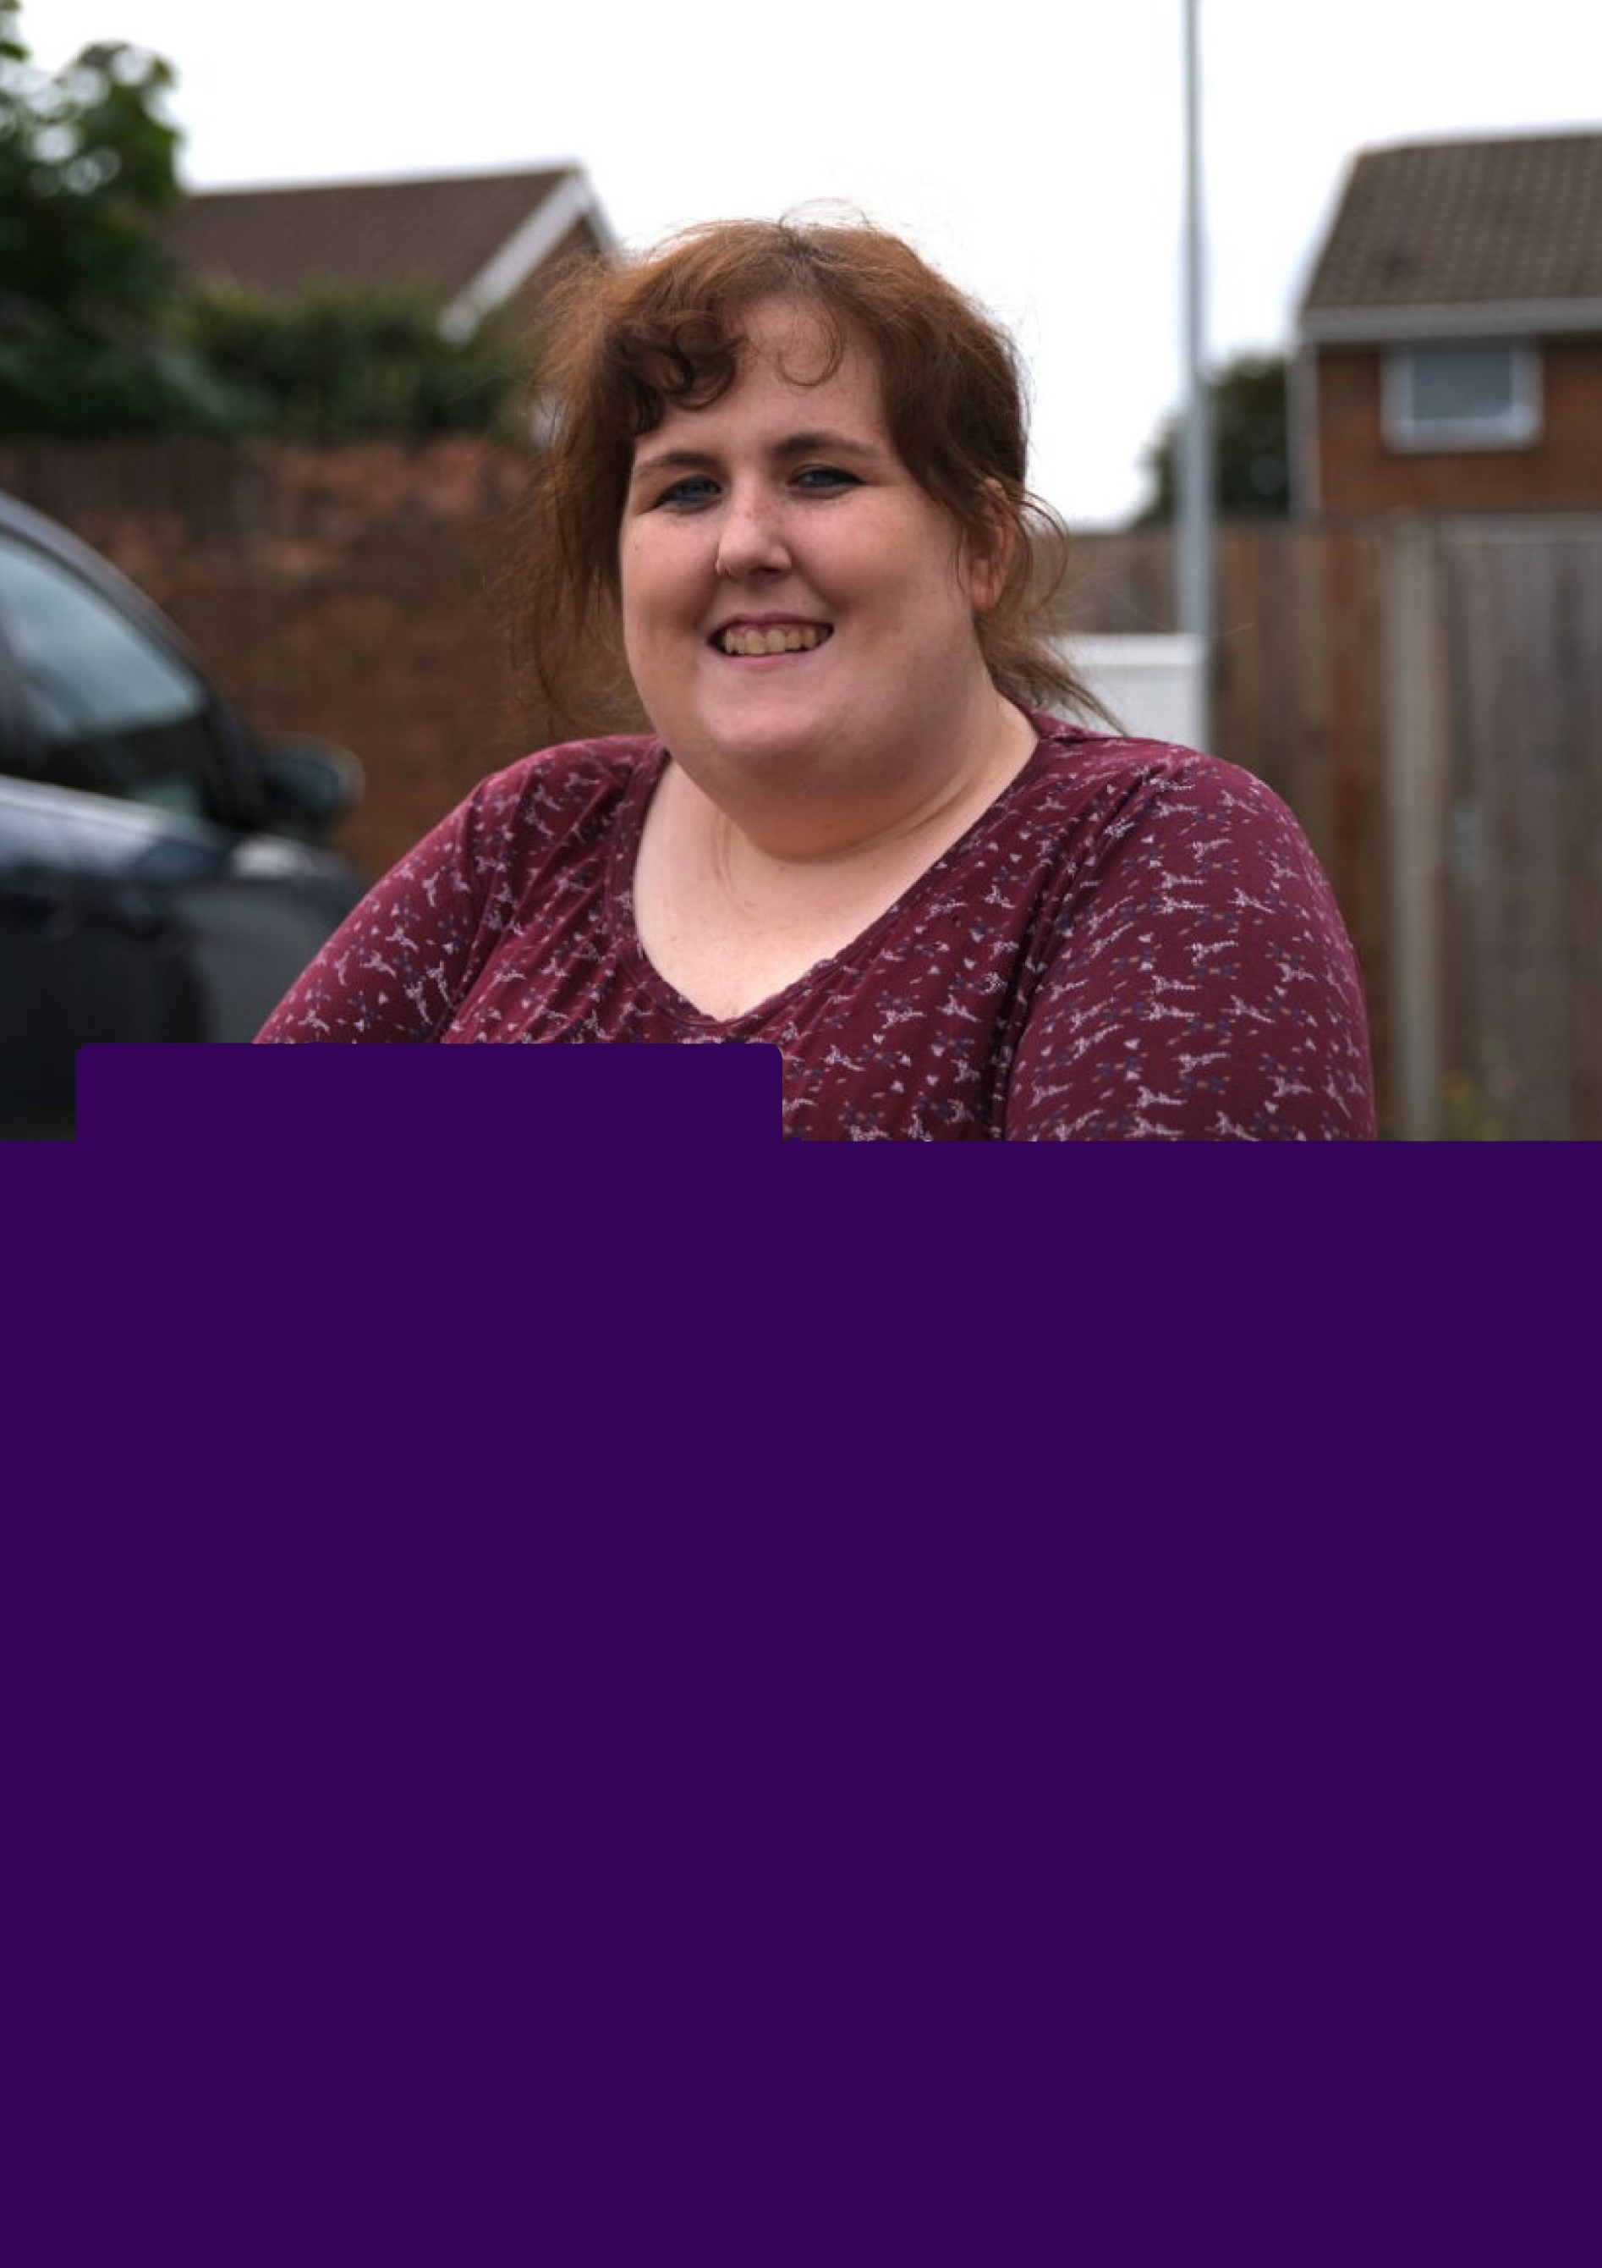
Samantha’s Story
Samantha has a spinal cord injury, is paralysed from the chest downwards and uses several aids in her day-to-day life. She is a full-time wheelchair user, has an assistance dog, an adaptive bed, and a personal alarm.
Due to her condition, Samantha faces extra costs. Cold weather impacts her condition. This means she uses more energy during the winter months to keep warm, which has contributed to increased energy bills. Her electric wheelchair, electric door, adaptive kitchen and freezer for her medication have also led to increased energy bills.
I’m currently in debt over a £1,000 on my gas because I can’t afford it. I haven’t got any money at the moment to pay it off. I have a transfer board and a power chair that need fixing, but I can’t afford it. So, it is just like pushing our hand on a broken chair, which is quite upsetting.
The cost of living crisis led me into debt. Everything was going up – food, bills. People, like the local welfare, were cutting back. It’s like having to ask for help, but there’s no help out there anymore. For disabled people, it’s non-existent. I feel like I have to beg before I even get help.
It feels like the government don’t consider disabled people as living people. It just feels like we’re a burden to them, to the world, and they just don’t care”.

Our plan to end the disability price tag
To end the unfair Disability Price Tag, the next government should:

By the end of the first year:
- Establish a discounted energy bills scheme to provide disabled households with affordable tariffs.
- Complete a root-and-branch review of the extra cost of disability and develop cross-government solutions in partnership with market regulators.
- Work with disabled people to design a fairer, more dignified and supportive approach to disability benefits. This includes:
  - Appropriate assessors who are qualified to understand a person’s impairment or condition
  - Increasing trust amongst disabled people in the welfare system

By the end of the third year:
- Provide disabled people on a low income with a weekly “Essentials Payment”. Ensuring that everyone can afford food, energy and essentials.
- Redesign the Personal Independence Payment, in co-production with disabled people, to ensure it truly captures the extra costs of disability and provides people with appropriate financial support.

Closing the disability employment gap
At Scope we believe it is scandalous that disabled people are denied the opportunity to enter employment and thrive at work.
The disability employment gap (DEG) has stubbornly remained at around 30% points for over a decade. More than a million disabled people want to work, but poor employer attitudes, insufficient employment support programmes, and a lack of flexibility and adjustments at work make it impossible.
Our research has also found that disabled people are nearly twice as likely to leave their jobs as non-disabled people.
Closing the Disability Employment Gap will bring huge benefits not just to individuals but to companies and society. If we were to halve the gap, we would see a £17 billion increase to the economy each year. This could also make significant progress against the skills gaps in this country.

Employment support:
Government-run employment support just isn’t working. Disabled people tell us that the coaches don’t understand the true impact of conditions and impairments, and that they feel forced to apply for unsuitable roles or face sanctions.
In addition, the Work Capability Assessment is no longer fit for purpose. For years, disabled people have told us that they feel forced to take steps towards work that are not appropriate for them and their health. Many fear sanctions and financial pressures if they don’t comply. It should be redesigned and replaced by a new structured assessment that more accurately reflects the job market.
“I got referred to the careers service at the Jobcentre and they said, ‘Wow your CV is amazing, what’s your problem?’ and I said “I’ve got RSI and basically I can’t do the office work anymore so I need to find a job that I can do.” But they just weren’t geared up to work with someone who has an impairment.” - Simone
There is a better way. Scope supports disabled people into employment through our own services. We run programmes such as ‘Support to Work’ and ‘Support to Work Extra’’. Over the past five years, 7,128 disabled people have found employment with our help.

The principles that underline our employment support services should be adopted by the Department for Work and Pensions if we are to make real progress in supporting people back to work:

A supported employment scheme will consist of the following:
- Customer engagement: encouraging disabled people to explore employment opportunities.
- Vocational profiling: the adviser and participant identify the aspirations, learning needs, individual skills, past experiences and job interests. This ensures the adviser is able to gather the right information needed to find a good match for that participant.
- Employment engagement: The adviser liaises with employers to arrange working interviews and other alternative forms of interviews.
- Job matching: an assessment of the job description and the environment of a potential job to ensure it is right for the participant, and to identify any adjustments or alterations to the environment if needed.
“The main thing that Scope’s Support to Work service helped me with was my confidence. Because my confidence had taken such a huge knock, I didn’t feel worthy. Scope have been invaluable. I feel like they’ve got me out of a black hole that I’d been stuck in. My adviser was brilliant at helping me refocus and believe in myself again. Scope were the only ones who helped me” – Simone

Retaining disabled people in work:
Disabled people are nearly twice as likely to leave their jobs as non-disabled people. Our research has identified four factors behind this:
- Negative attitudes and discrimination towards disabled people at work
- A lack of reasonable adjustments and flexible working
- Inadequate employment support programmes
- Poor support during periods of sickness and inflexible return-to-work processes
“I worked at a large retail chain for nearly nine years and they couldn’t offer me the support I needed. They just weren’t willing to adapt. I had to quit and try and find a less physical job” – Katie

A huge amount of disabled talent is going to waste. Closing the Disability Employment Gap requires action from employers, from government, from charities and from employment support providers so that disabled people can not only find work but stay there and reach their full potential.

Katie’s Story
Katie came to Scope’s employment services after a negative experience with the Jobcentre. Katie explained some of the barriers she has faced as a disabled job seeker and the current issues with the Disability Confident scheme.
Even with companies saying they’re ‘disabled friendly’, they need to be clear what that actually means. Maybe it should be a separate web page saying, ‘We’re disabled friendly, this is what our facilities offer, this is how we can support you. If you’re disabled, this is what we do.’

Disability shouldn’t just be a line at the very bottom of a form. It seems to always be that last little bit, squeezed on the end. It’s not very big text or clear if a company is disabled friendly.
If an employer is ‘disabled aware’, I think it does need to be clearer, so disabled people looking for work can say, ‘Oh, they’re aware. Right, let’s actually look at this job a bit more and see how they can offer support’.
Sometimes, you’re reading through a whole job application only to realise they’ve got no lifts. So, that’s no good because they’re not accessible. Or they’ve got no disabled parking, or no parking at all, and you’re thinking, ‘actually, that’s not going to work for me.’
I don’t feel employers take the time to understand disabled people’s needs, or how unique we are, that we’re individuals. That lack of understanding about disability is still the biggest issue. Understanding how we might need to have just a little bit more support here and there, but we’ll still give 110% in our role.
My disability doesn’t stop me from doing anything, it’s just means I might have to adapt things a little bit differently. But most of the time, it doesn’t stop me from doing anything.”

Our plan to close the Disability Employment Gap
To permanently close the disability employment gap the next government should:

By the end of the first year:
- Formally commit to closing the DEG within a decade. The Government must adopt the DEG as a formal measure of success and provide annual reports on progress.
- Commit to introduce mandatory disability reporting for organisations with at least 250 employees, including data on:
  - The number of disabled people they employ.
  - The number of adjustments offered and satisfaction rates.
  - Average earnings for disabled and non-disabled staff.
  - The number of disabled employees in each pay bracket.
- Adopt the Supported Employment model of voluntary, tailored, bespoke and localised employment support for disabled people.
- Overhaul the Access to Work scheme so that more disabled people benefit from fast, effective adjustments at work.
- Increase Statutory Sick Pay, in line with the Living Wage.
- Work with disabled people to design a fairer, more dignified and supportive approach to disability benefits. This includes:
  - Removing the threat of sanctions and conditionality.
  - Scrapping the Work Capability Assessment.
- Stimulate innovation in solutions to close the disability employment gap by creating a What Works Fund.

By the end of the third year:
- Introduce a right to flexible working from day one of employment.
- Conduct a thorough review of the successes and failures of the Disability Confident scheme, and make an honest assessment of its impact on the DEG.

By the end of five years:
- Introduce dedicated ‘disability support leave’ for disabled employees.

Transforming attitudes
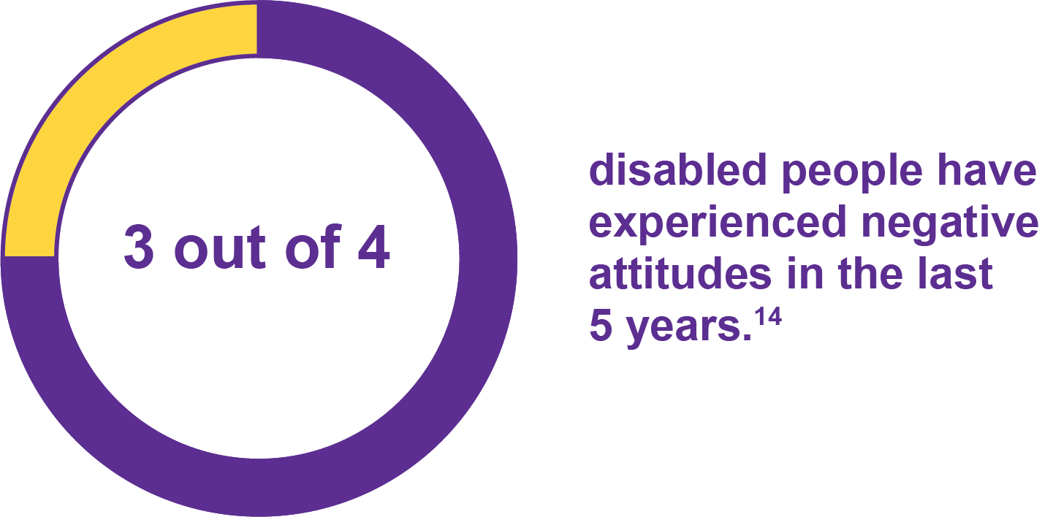
From the judgement of others about what disabled people are capable of, the constant questioning and having to justify yourself, to confrontation, discrimination and physical abuse. Disabled people still face huge barriers to full inclusion and equality in society.

The social model of disability
The social model of disability states that people are disabled due to the barriers in society, not by their impairment or condition. These could be a physical barrier, such as a building not having accessible toilets. It could also be a barrier that is a result of people’s attitudes and assumptions on disability.
Scope’s research on attitudes highlights the impact of these poor attitudes. 87% of those who encountered negativity said it had a detrimental impact on their daily lives. This figure rises to a staggering 96% amongst those age 18 to 34.
“Growing up it’s knowing that you’re not accepted, and that you are different, and knowing that actually you’re not accepted in society. Yes, my family accepted me, but they didn’t understand really, and that caused a lot of mental health issues.” - Jacqueline

Disabled people told Scope they most often experienced poor attitudes:
42% from the general public
39% on public transport
42% from management at work
52% from benefit assessors when accessing the benefits system

Attitudes at work
Negative attitudes in the workplace have a particularly long-lasting impact. Scope research found that 90% of disabled people who had experienced discrimination at work said it led to them leaving the workplace.
There is a long way to go to transform employer attitudes. Our research also found that 54% of employers had concerns over a disabled employee’s ability to do a job as well as a non-disabled employee. Many also said this would stop them hiring someone with a disability.
“I worked for a pub chain for a time, and that was horrendous. I told them I’ve got a disability and it effects my processing, so it might take me a bit longer to understand things, but once I do, I’m okay.
They were really horrendous with training. When they did my month review they said, ‘Your colleagues say you haven’t listened to what they’ve been saying.’ I told them it’s not that I haven’t been listening, it’s just I can’t quite process it as I have a disability. They didn’t offer anything for that, they just let me go. I think my anxiety has only come more into place now, after having experiences like that. It’s become more prominent and noticeable” - Bethany

Lead by Example
At Scope we have a proud history of challenging negative and outdated attitudes towards disabled people. And we now call on the next Government to lead by example when it comes to transforming attitudes. This is a job for the whole of Government to work together on.
This should start with accessibility. It is unacceptable that in 2024, governments are still putting out inaccessible documents and communications. All forms of government communication should be accessible. This includes consultation documents, social media posts and policy publications.
Government employs vast numbers of people, too, and there is much it can do to improve its own practices towards disabled colleagues. At Scope, we believe this starts with training for all frontline public sector staff. This includes benefit assessors and those working on public transport. This will ensure that disabled people no longer have to face negative attitudes in those spaces.
It is vital that the next government sets out an ambitious strategy for disabled people when it takes office – one that will transform the lives of disabled people in this country, including through improved attitudes across all spaces.

Arunima’s Story
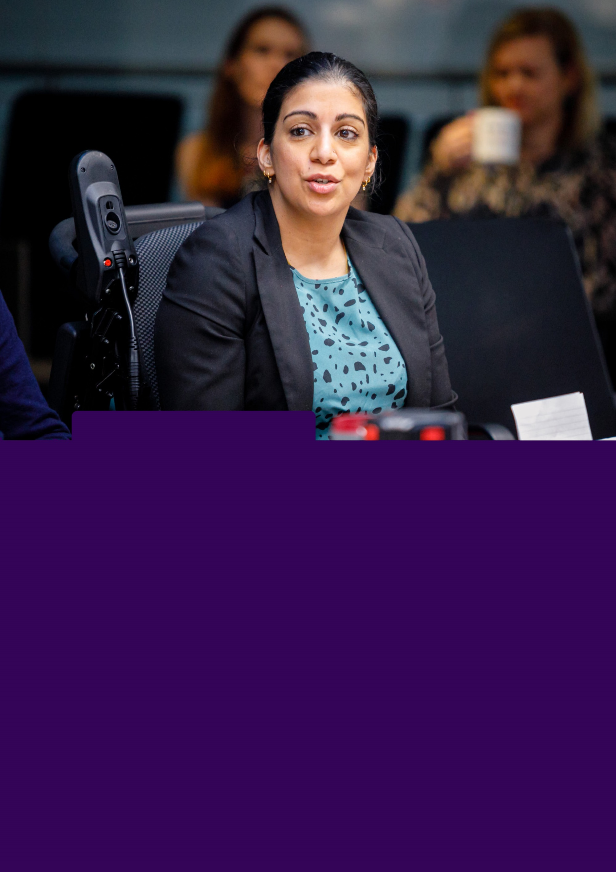
Arunima is a banking and finance lawyer who lives by herself in London. As a baby, she had neuroblastoma in her spine. This led to partial paralysis in her legs and as a result Arunima is a wheelchair user and also uses crutches for shorter distances.
Arunima encountered negative attitudes in the workplace; she has experienced ignorant comments, awkward jokes, and misconceptions about her capabilities from colleagues. Arunima believes these attitudes stem from societal perceptions of disabled people.
At the start of my career, I only asked for the practical adjustments - an accessible bathroom, a desk that would raise up and down, for example. The more material things. I felt too ashamed to ask for any adjustments with regards to my health.
Everywhere I’ve worked at, it has always been something I have had to raise. Or I’ve got to venues before where they’ve organised parties and I’ve not been able to get in and people have carried me up the stairs – at this age, this feels like a compromise to my dignity. I should not have to be carried to a bathroom or at a venue, when I have my own way of independent mobility; the barrier is not my condition, it is the fact that I cannot access the venue.
Or, sometimes the access is so bad, I’ve turned around and gone back home again. Imagine spending all that time getting ready, spending the taxi money to get to the venue and then having to go back home again, alone, with all the frustrations and emotions that this kind of experience ignites”

Our plan to transform attitudes
To improve attitudes towards disabled people government should:

cBy the end of the first year:
- Commit to and upgrade the role of Minister for Disabled People. And make sure this role has the power and seniority to work across Government, creating change for Britain’s 16 million disabled people.
- Commit to providing disability awareness training for all public sector staff. This should include frontline staff across JobCentre's, healthcare, and transport.
- Embed accessibility in all government communications, with champions in each Department.

By the end of the third year:
- Set out a clear and positive vision for disabled people in the UK via a new, ambitious Disability Strategy.

By the end of five years:
- Oversee a measurable decline in the number of disabled people reporting negative attitudes from frontline public sector staff.
- Oversee a measurable decline in the levels of disabled people reporting negative attitudes from their employer.

Conclusion:
Using our recommendations as well as co-production with disabled people, the next government has a real opportunity to create an equal future for disabled people.
If the next government takes these important and bold steps to tackle disability equality, disabled people will be able to thrive in all areas of life. Disabled people would no longer be burdened with disproportionate extra costs and have equal opportunity to enter and flourish at work.
With disabled people’s lived experience informing the government agenda, we believe an equal future is possible.

Endnotes
0808 800 3333
scope.org.uk
@Scope
@ScopeCharity
facebook.com/scope
linkedin.com/company/scope
View this manifesto online at scope.org.uk/manifesto
Call 0808 800 3333 to let us know if you would like this information in a format that’s accessible for you.
SC1161. Copyright Scope March 2024. Scope is a company limited by guarantee registered in England (00520866) and a charity (208231) registered in England and Wales. Registered Office: Here East Press Centre, 14 East Bay Lane, London, E15 2GW

Family Resources Survey: financial year 2021 to 2022 - GOV.UK (www.gov.uk)
Scope Price Tag Research - Disability Price Tag 2023: the extra cost of disability, Disability charity Scope UK
Scope and WPI ‘Life Costs More’ report https://www.scope.org.uk/campaigns/research-policy/life-costs-more/
Cost of Living: the impact for disabled people, Scope, https://www.scope.org.uk/campaigns/research-policy/cost-of-living-report/
Data from Scope Disability Energy Service, 2023
Ministry of Justice. Tribunal Statistics Quarterly: July to September 2023. December 2023
Poverty Strategy Commission, https://povertystrategycommission.org.uk/wp-content/uploads/2023/09/PSC-Framework-Report-230831-Web.pdf
State of Hunger 2021 Report, Trussell Trust, https://www.trusselltrust.org/wp-content/uploads/sites/2/2021/05/State-of-Hunger-2021-Report-Final.pdf
Employment for Disabled People 2023, UK Government, https://www.gov.uk/government/statistics/the-employment-of-disabled-people-2023/employment-of-disabled-people-2023
Scope derivations based on the Quarterly Labour Force Survey, April-June 2023 microdata SN 9131, from the UK Data Service, https://beta.ukdataservice.ac.uk/datacatalogue/studies/study?id=9142
Disabled Employee Retention, Scope https://www.scope.org.uk/campaigns/research-policy/employee-retention/
Time to think again: disability benefits and support after COVID-19 - Social Market Foundation. https://www.smf.co.uk/publications/time-to-think-again/
Data from Scope’s Employment Service
Scope’s Attitudes Research, https://www.scope.org.uk/campaigns/research-policy/attitudes-towards-disabled-people/
Scope’s Attitudes Research, https://www.scope.org.uk/campaigns/research-policy/attitudes-towards-disabled-people/
Scope’s Attitudes Research, percentages are presented as a proportion of disabled people who indicated the individuals or areas of life they were asked about were applicable to them. https://www.scope.org.uk/campaigns/research-policy/attitudes-towards-disabled-people/
Scope’s Employee Retention Report, https://www.scope.org.uk/campaigns/research-policy/employee-retention/
Scope and Opinium polling of 269 HR decision makers in the UK. 27 January – 2 February 2023, https://www.scope.org.uk/campaigns/research-policy/employee-retention/

