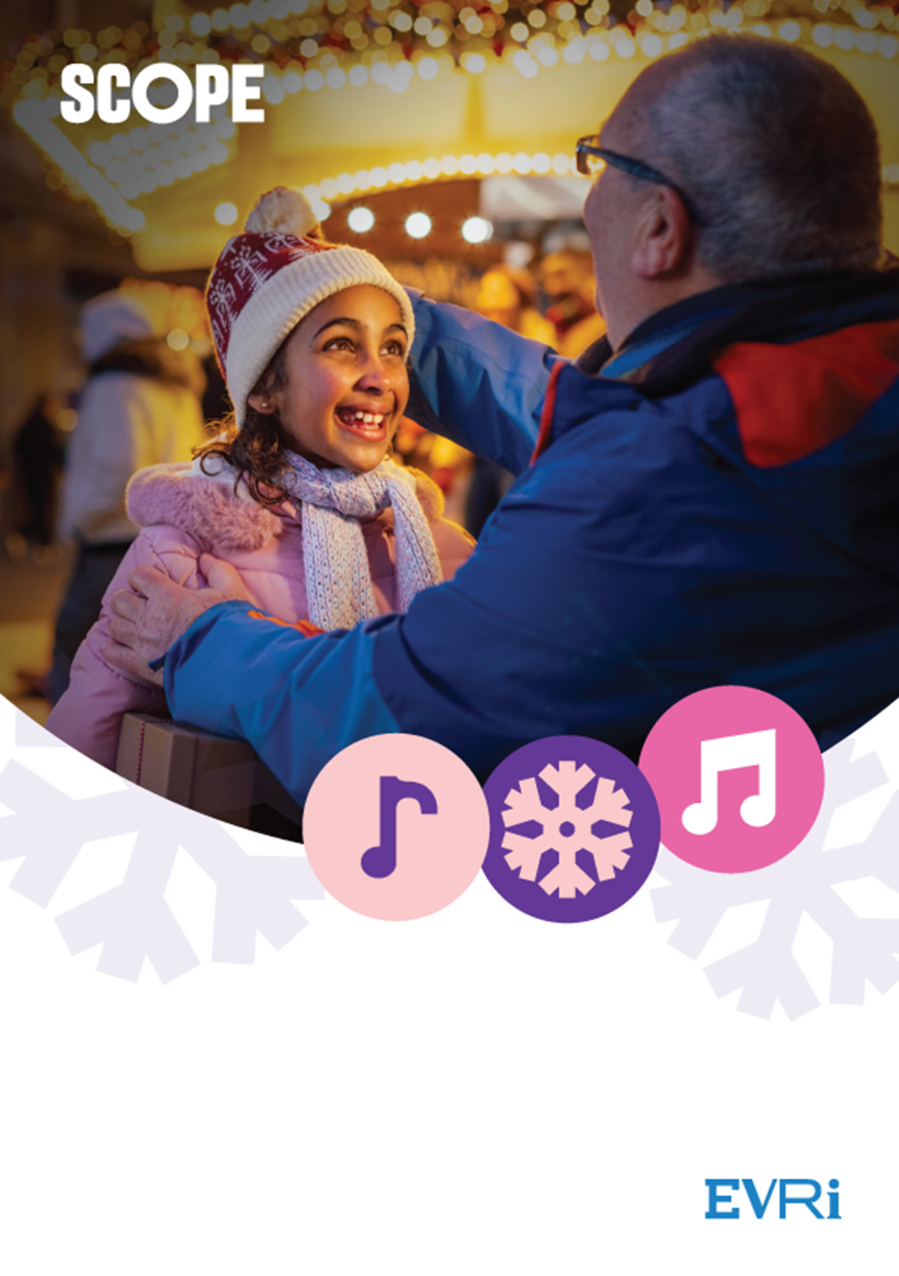

**Proudly sponsored by**

**10 December 2024**

**St Mary’s Church**

**Marylebone, London W1**

**Christmas  
Carol Concert**

# **Scope Carol Concert**

Tuesday 10 December 2024

St Mary’s London, Wyndham Place, York Street, London W1

## Presenter

Adam Hills MBE

## Readers

Richie Brave

Cerrie Burnell

Ben Elton

## Music

Presented by the HSBC Choir

## Doors open

Doors open 6.30 pm

Concert 7.00 to 8.00 pm

All proceeds from the concert will benefit Scope

# **The hidden cost of Christmas**

## Help us reduce the hardship disabled families face this season

It’s always shocking how much Christmas costs. The big family meal. Presents for the little ones. Simply filling up the car to visit relatives. It all adds up.

But for disabled families, the list is even longer. Over and above the normal costs of Christmas, many will face a whole host of higher costs this December.

Sitting down and enjoying a festive meal together comes with extra costs.

There are the hidden medical costs families need to budget for over the festive period. Like stocking up on enough medical wipes and gloves or paying for the electricity needed to charge specialist equipment.

They’ve been battling hidden costs every day this year – and, as the festive season approaches, things will be even harder.

Just £4 could help us answer a call to Scope’s helpline – and provide vital information and advice, to help disabled families find ways to make the extra costs of caring for their loved ones more bearable.

It could also help support families via Scope’s website. Our online information pages provide information on financial assistance and eligibility for benefits. With the right support, disabled families can enjoy the kind of Christmas that others take for granted.

Your support could help Scope give a lifeline they urgently need and the chance to give their family the Christmas they deserve.

# **A message from our Chief Executive**

On behalf of everyone at Scope, I am delighted to welcome you back to our Carol Concert.

My sincere thanks go to the companies and individuals who have supported this wonderful event. You have enabled us to all be here this evening. Special thanks go to our brilliant partner, Evri, who has sponsored the event.

Tonight, we are raising money to fund vital services such as our Helpline. Life costs more if you are disabled. With the cost of living continuing to rise, disabled people and their families need our support now more than ever. Your generosity allows us to provide free, practical advice and reassurance when it’s needed most.

So, I would like to thank you all for attending our Carol Concert. We are delighted to share this celebration with you. I would like to take this opportunity to wish you all a wonderful holiday and a very happy New Year.

Mark Hodgkinson's signature
**Mark Hodgkinson**

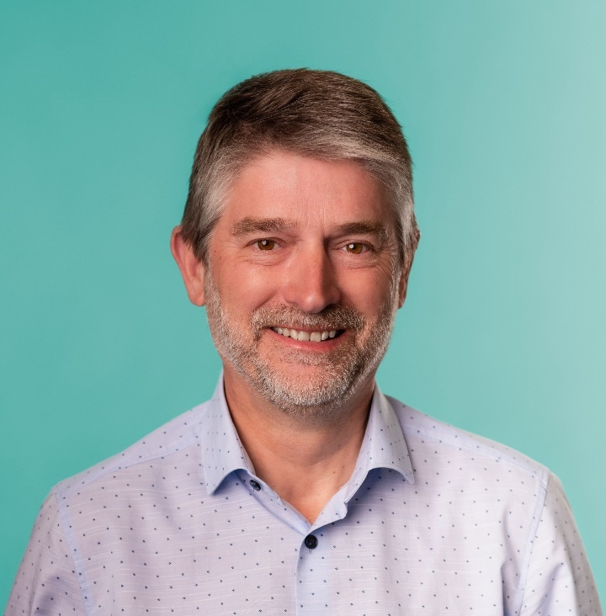

Chief Executive, Scope

# **Anne Vivian-Smith’s Story**

Anne Vivian-Smith lives in Nottingham with her husband David. She has a Neurodegenerative congenital autoimmune disorder and uses a wheelchair.Anne was referred to Scope’s Disability Energy Service (DES), because she had been affected by the rising cost of energy.

To try and find the money to pay for energy bills, Anne disconnected her fall alarm, which would be able to help her if she had a fall at home. 

Anne and her husband David had to cut down on food to try and find the money to pay for their gas and electric bills. There had been real concern that they might be forced to turn their fridge off, because they couldn’t afford to keep it on.

Anne said there was little else she could cut down on to pay for her energy bill, because she requires a hoist and lift to go to the toilet and move chairs. 

Anne and David used to top up Anne’s care package, so that Anne could go out to church or swimming and David could have respite. Due to the increase in energy costs, they are now unable to do this.

Stress and worry from the rising cost of energy bills and living, had a significant impact on Anne’s wellbeing. Anne avoids listening to the news because it frightens her so much.

Anne was referred to Scope’s Disability Energy Service (DES) and found their support very helpful. As a result, she had a smart meter fitted and is on the Disability Priority Register for British Gas. She also found the way the DES supported her to be extremely clear and accessible. 

Before accessing the DES, Anne was not sure what one-off payments or grants she was eligible for.

**Our Host**

## Adam Hills MBE

Host of the Broadcast and RTS-award-winning Channel 4 series The Last Leg, Adam Hills is one of the most popular comedians in the UK. With 16 solo shows that have toured internationally, his combination of positive, uplifting comedy, and effervescent spontaneity has seen him receive innumerable accolades, glowing reviews, and a legion of fans around the planet.

Adam can also be seen in the critically acclaimed feature length documentary Take His Legs, which followed the remarkable story of the Warrington Wolves Physical Disability Rugby League team. The film recounts how Adam and his team-mates prepare for the biggest game of their lives, playing against the South Sydney Rabbitohs at the world-famous ANZ Stadium in Australia.

His last show Clown Heart toured the UK and was recorded for DVD at the Hammersmith Apollo. In 2018, Adam also wrote his collection of stories from a life in comedy, entitled Best Foot Forward. It featured anecdotes from his early days on the Sydney stand-up scene to landing on British television, and his many encounters with such famous faces as Whoopi Goldberg and Billy Connolly.

In addition to this, Adam has also written his debut children’s novel Rockstar Detectives.

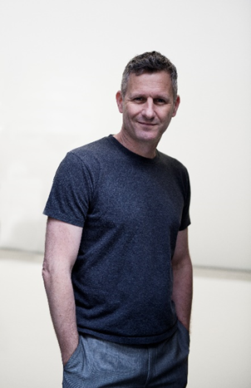Adam was also awarded an MBE for services to Paralympic Sport and disability awareness in the 2022 New Year Honours List.

# Richie Brave who is a man with a black beard and black hat in a dark grey t-shirt. He has a neck tattoo of his name.**Our Readers**

## Richie Brave

Richie Brave is a Presenter, Broadcaster and Writer. He is known for his hard-hitting interviews and honest social criticism, which challenges people to think and reflect on themselves. Richie is one of judges for Scope’s annual awards.

Aside from his media experience, he has amassed over a decade’s worth of work in the community and uses this to shape and create engaging dialogue and interviews.

Richie is host of BBC 1Xtra's "1Xtra Talks" exploring the lived experiences of Black people across the UK. Richie has interviewed the likes of Whoopi Goldberg, Ryan Coogler, Angela Bassett, HER, Master P, Mr Eazi, Wale and many others.

Through 2018/19 he regularly co-hosted the Sunday Morning show with Penny Smith on Talk Radio, exploring the tabloids, politics and debating current affairs. Richie is also Head of Diversity and Inclusion for Hearst magazines.

## Cerrie Burnell who is a woman with shoulder length blonde hair wearing a striped black and white dress. She has an upper-body limb difference. Cerrie Burnell

Cerrie Burnell is an actress and writer best known for her work on CBeebies. Cerrie works very closely with a number of charitable organisations linked to childhood and diversity.

Her credits prior to CBeebies include Eastenders, The Bill, Holby City, and Comedy Lab for Channel Four and various plays, including Winged, an original play she wrote and starred in at the Tristan Bates theatre.

In 2011, Cerrie was named in the Observer’s top ten children’s presenters and in the Guardian’s list of 100 most inspirational women.

## Ben Elton who is a man standing up wearing black glasses and a blue chequered shirt with his arms crossed.Ben Elton

Ben Elton is an award-winning novelist with 16 novels, playwright, television writer, screenwriter and lyricist. He is also a theatre, screen and TV director, a stand-up comedian, and actor. Ben is a long- standing Scope ambassador.

Ben was part of Britain’s alternative comedy movement in the 80’s and he has won three BAFTA Awards for Best Comedy Series (The Young Ones, Blackadder the Third, and Blackadder Goes Forth). His other accolades, include: The Royal Television Society Writer’s Award (The Man From Auntie), and a British Comedy Award (The Thin Blue Line).

Ben’s theatre writing includes Gasping, Silly Cow, and Popcorn and he has written and directed two films – Maybe Baby, and Three Summers.

Ben Elton is currently touring the UK with his new show Authentic Stupidity.

# **HSBC choir**

HSBC Choir was started with support from Arts Business to celebrate a partnership between HSBC and Trinity College of Music. The HSBC Choir – coupled with a series of foyer concerts in the HSBC tower – was an ideal way to share a passion for recreational music making with the HSBC employees.

Since these beginnings, the Choir has taken on a life of its own, managed by its members and led by composer and conductor, David Knotts, between 2005 and 2023. The choir also has a new Soprano & Music Director, Anna Sideris. They meet once a week in term time to rehearse in the Bank’s foyer at Canary Wharf.

Singers from all backgrounds are welcome – some members are seasoned singers whilst other sing-in-the-shower enthusiasts are making their first forays into choral singing. The Choir regularly performs and raises money for various charities.

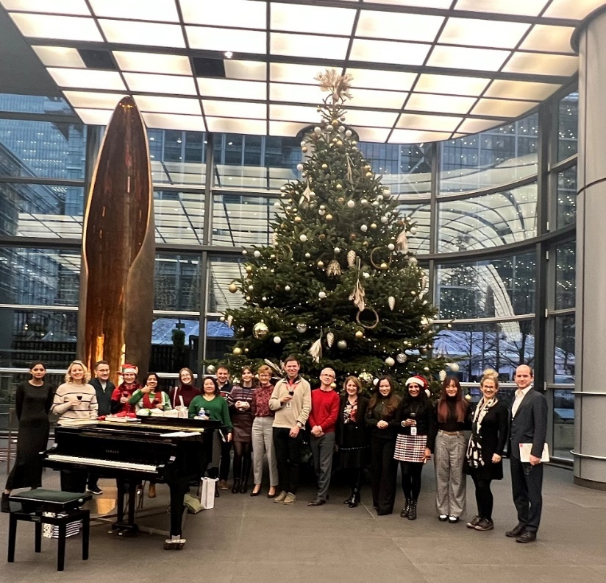

# **First Reading**

## Read by Richie Brave

### The Kindness of Trees by Jackie Kay

Deep in the forest there stood

A tree whose heart beat in the winter wood

Who understood everything that was bad

And everything that was good.

It extended long arms to woo you

As the winter wind blew and blew

And every thing a child could think,

The tree already knew.

And every time a boy was sad,

The tree dropped a pine.

And every time a girl got mad,

The tree roared in the wind.

In the dead mid-winter night,

The tree blew a hello, goodbye;

When every child was asleep in bed,

The tree sang a lullaby.

And when Christmas time came round

The tree’s song soared and soared.

And when gifts adorned the ground,

The tree blushed, made a sssh sound.

And people gathered round the tree:

To sing the winter song, in harmony;

One to keep the bright light glowing,

A song of what we know without knowing.

It had a sad and piercing melody –

A worry for the ash, sparrow, bee.

The polar bear, the ice melting.

A worry for you, me, dear tree.

In the depths of the winter wood,

The friendly tree stood, kind and good,

And breathed a word that caught the mood:

A pledge, a promise, a plea for good.

# **Jingle bells**

Jingle bells, jingle bells,

jingle all the way,

Oh what fun it is to ride in a one horse open sleigh!

Jingle bells, jingle bells,

jingle all the way,

Oh what fun it is to ride in a one horse open sleigh,

Dashing through the snow,

in a one horse open sleigh,

through the fields we go, laughing all the way,

Bells on bob tails ring, making spirits bright,

Oh what fun it is to sing a sleighing song tonight.

Jingle bells, jingle bells,

jingle all the way,

Oh what fun it is to ride in a one horse open sleigh!

Jingle bells, jingle bells,

jingle all the way,

Oh what fun it is to ride in a one horse open sleigh.

# **Second Reading**

## Read by Cerrie Burnell

### The Night before Christmas

'Twas the night before Christmas, when all through the house

Not a creature was stirring, not even a mouse;

The stockings were hung by the chimney with care,

In hopes that St. Nicholas soon would be there;

The children were nestled all snug in their beds,

While visions of sugar-plums danced in their heads;

And mamma in her ’kerchief, and I in my cap,

Had just settled our brains for a long winter’s nap,

When out on the lawn there arose such a clatter,

I sprang from the bed to see what was the matter.

Away to the window I flew like a flash,

Tore open the shutters and threw up the sash.

The moon on the breast of the new-fallen snow

Gave the lustre of mid-day to objects below,

When, what to my wondering eyes should appear,

But a miniature sleigh, and eight tiny reindeer,

With a little old driver, so lively and quick,

I knew in a moment it must be St. Nick.

More rapid than eagles his coursers they came,

And he whistled, and shouted, and called them by name;

"Now, Dasher! now, Dancer! now, Prancer and Vixen!

On, Comet! on, Cupid! on, Donder and Blitzen!

To the top of the porch! to the top of the wall!

Now dash away! dash away! dash away all!"

As dry leaves that before the wild hurricane fly,

When they meet with an obstacle, mount to the sky;

So up to the house-top the coursers they flew,

With the sleigh full of Toys, and St. Nicholas too.

And then, in a twinkling, I heard on the roof

The prancing and pawing of each little hoof.

As I drew in my head, and was turning around,

Down the chimney St. Nicholas came with a bound.

He was dressed all in fur, from his head to his foot,

And his clothes were all tarnished with ashes and soot;

A bundle of Toys he had flung on his back,

And he looked like a pedler just opening his pack.

His eyes—how they twinkled! his dimples how merry!

His cheeks were like roses, his nose like a cherry!

His droll little mouth was drawn up like a bow

And the beard of his chin was as white as the snow;

The stump of a pipe he held tight in his teeth,

And the smoke it encircled his head like a wreath;

He had a broad face and a little round belly,

That shook when he laughed, like a bowlful of jelly.

He was chubby and plump, a right jolly old elf,

And I laughed when I saw him, in spite of myself;

A wink of his eye and a twist of his head,

Soon gave me to know I had nothing to dread;

He spoke not a word, but went straight to his work,

And filled all the stockings; then turned with a jerk,

And laying his finger aside of his nose,

And giving a nod, up the chimney he rose;

He sprang to his sleigh, to his team gave a whistle,

And away they all flew like the down of a thistle,

But I heard him exclaim, ere he drove out of sight,

"Happy Christmas to all, and to all a good-night."

# **Deck the Halls**

Deck the halls with boughs of holly, Fa la la la la, la la la la.

Tis the season to be jolly, Fa la la la la, la la la la.

Don we now our gay apparel, Fa la la la la, la la la la.

Troll the ancient Yuletide carol, Fa la la la la, la la la la.

See the blazing Yule before us, Fa la la la la, la la la la.

Strike the harp and join the chorus. Fa la la la la, la la la la.

Follow me in merry measure, Fa la la la la, la la la la.

While I tell of Yuletide treasure, Fa la la la la, la la la la.

Fast away the old year passes, Fa la la la la, la la la la.

Hail the new, ye lads and lasses, Fa la la la la, la la la la.

Sing we joyous, all together, Fa la la la la, la la la la.

Heedless of the wind and weather, Fa la la la la, la la la la.

# **Third Reading**

## Read by Ben Elton

### A Boy Called Christmas by Matt Haig

You are about to read the true story of Father Christmas.  
Yes. Father Christmas.  
You may wonder how I know the true story of Father Christmas, and I will tell you that you shouldn't really question such things. Not right at the start of a book. It's rude, for one thing. All you need to understand is that I do know the story of Father Christmas,

or else why would I be writing it?  
Maybe you don't call him Father Christmas. Maybe you call him something else.  
Santa or Saint Nick or Santa Claus or Sinterklaas or Kris Kringle or Pelznickel or Papa Noël or Strange Man With A Big Belly Who Talks To Reindeerm And Gives Me Presents. Or maybe you have a name you've come up with yourself, just for fun. If you were an elf, though, you would always call him Father Christmas. It was the pixies who started calling him Santa Claus, and spread the word, just to confuse things, in their mischievous way.  
But whatever you happen to call him, you know about him, and that's the main thing.  
Can you believe there was a time when no one knew about him? A time when he was just an ordinary boy called Nikolas, living in the middle of nowhere, or the middle of Finland, doing nothing with magic except believing in it? A boy who knew very little about the world except the taste of mushroom soup, the feel of a cold north wind, and the stories he was told. And who only had a doll made out of a turnip to play with.  
But life was going to change for Nikolas, in ways he could never have imagined. Things were going to happen to him.  
Good things. Bad things. Impossible things.  
But if you are one of those people who believe that some things are impossible, you should put this book down right away. It is most certainly not for you.  
Because this book is full of *impossible things*.

Are you still reading the book?  
Good. (Elves would be proud.)  
Then let us begin...

# We wish you a Merry Christmas

We wish you a merry Christmas  
We wish you a merry Christmas  
We wish you a merry Christmas  
And a happy New Year

We wish you a merry Christmas  
We wish you a merry Christmas  
We wish you a merry Christmas  
And a happy new year

Good tidings we bring to you and your kin  
Good tidings for Christmas  
And a happy new year

We wish you a merry Christmas  
We wish you a merry Christmas  
We wish you a merry Christmas  
And a happy new year

Now bring us a figgy pudding  
Now bring us a figgy pudding  
Now bring us a figgy pudding  
And bring some out here

Now bring us a figgy pudding  
Now bring us a figgy pudding  
Now bring us a figgy pudding  
Then bring some out here

Good tidings we bring to you and your kin  
Good tidings for Christmas and a happy new year

Good tidings for Christmas and a happy new year

# **Adonis and his mother Shellie**

18-month-old Adonis was born with Down Syndrome and a chronic bowel disease. He had to undergo major bowel surgery, which means he now has 2 stomas.

Adonis’s condition requires lots of extra care and support. His mum and dad face hidden extra costs that most parents never have to worry about. Things like all the extra wipes and nappies needed to manage his condition. The expensive fresh ingredients required to replace the micronutrients lost through his stoma. And the cost of petrol and parking for his many hospital visits.

Thankfully, the family has had the support of Scope, who helped them find ways to make these hidden costs more manageable. As Shellie told us: “Scope provided me with vital information about what I was entitled to claim for as a carer, and how I could get support with my finances. They pointed me in the right direction and I was able to apply for more funding, to help with things like travel expenses and sensory equipment.”

After all he’s been through, Adonis’s parents really want to make this Christmas special for him “We are hoping to get him one nice gift and go to see his grandparents for the day,” says Shellie. “Fingers crossed we don’t have to cancel because of medical issues.” This Christmas will be still hard for Adonis’s family, as it will be for thousands of disabled families around the country.

**That’s why Scope’s Helpline is so important. With the help of our supporters, we can be there for them when they need us most this Christmas.**

Photo of Shellie and Adonis smiling with a christmas tree



# **Thank you page**

Scope would like to thank the following organisations, companies and individuals for their kind and generous support of our Carol Concert. Thank you! A very special thank you to EVRI.

## Host

Adam Hills MBE

## Readers

Richie Brave, Carrie Burnell, Ben Elton

## HSBC choir

Anne Vivian-Smith, Scope Storyteller

## Raffle prizes

Bottomless brunch cookery class

**Kindly donated by The Avenue Cookery School**

Diptyque candle

**Kindly donated by Diptyque**

An Olivia von Halle Silk robe

**Kindly donated by Olivia von Halle**

Gilpin's Cask Aged Gin, Aged for 3 years (Speyside Single Malt)

**Kindly donated by Gilpin's Gin**

Bonsoir London women’s silk pyjama set

**Kindly donated by Bonsoir London**

McLaren F1 cap signed by Lewis Hamilton

**Kindly donated by McLaren**

Two tickets to any film at any Picturehouse cinema

**Kindly donated by Picturehouse**