

Parenting cerebral palsy (CP)

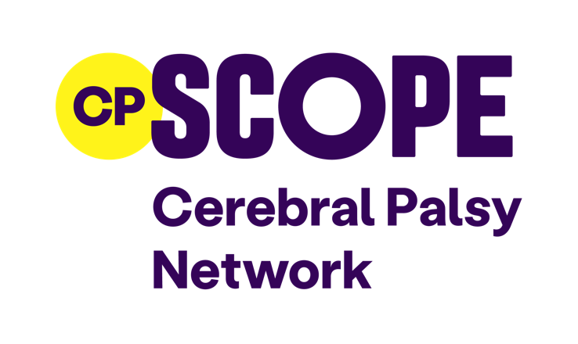

Contents
What is cerebral palsy (CP) 3
Issues and trends 3
The brain 3
Types of cerebral palsy 4
Spastic cerebral palsy 4
Ataxic cerebral palsy 4
Athetoid cerebral palsy 5
Other terms you may hear 5
Other ways of categorising CP 5
Associated impairments 6
Ways of categorising mobility 7
Gross Motor Function Classification System (GMFCS) 7
Diagnosis 8
Hidden aspects of CP 8
Treatment and therapies 9
Ageing with cerebral palsy 10
Peer support 11
Useful links 12
General advice 12
Daily task help 12
Books on CP 12
Products for sale 13
Support groups 13
Contact us 13
About this handout 14
Your information 14

What is cerebral palsy (CP)?
Cerebral palsy is a condition that affects muscle control and movement. It affects about one in every 400 children in the UK.
It is usually caused by an injury to the brain before, during or after birth. There may be no obvious single reason. The main causes include:
- infection in the early part of pregnancy
- lack of oxygen to the brain
- abnormal brain development
- a genetic link, but this is quite rare

Issues and trends
- The rates of cerebral palsy in the UK have stayed the same since before World War Two. Medical advances have not lowered these rates. More small and premature babies survive. This increases the number of babies with additional support needs.
- Information on the number of people with cerebral palsy is not routinely collected. There are about 130,000 adults with cerebral palsy in the UK. This is similar to the number of people with multiple sclerosis or Parkinson's.
- Defining and diagnosing cerebral palsy is challenging. Cerebral palsy varies in type and cause. It can be hard to identify in young children. Some people are diagnosed later in life.

The brain
Different types of cerebral palsy depend on which part of the brain is affected. This affects muscle tone.
Cerebral palsy causes mixed messages from the brain to the muscles. This results in uncoordinated, clumsy or stiff muscles.
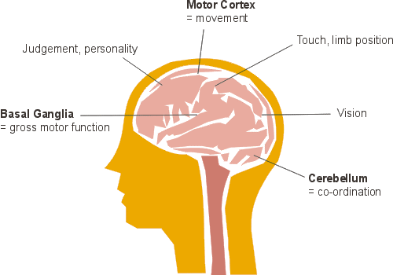
Basal ganglia = gross motor function
Motor cortex = movement
Cerebellum (base of the brain) = coordination

Types of cerebral palsy
The most common types include:
- spastic cerebral palsy or spasticity
- ataxic cerebral palsy or ataxia
- athetoid or dyskinetic cerebral palsy – athetosis or dyskinesia
- Some people will have ‘mixed cerebral palsy’, a combination of 2 or more types.

Spastic cerebral palsy

Spasticity occurs in three-quarters of people with cerebral palsy.
- The outer layer of the brain, called the cortex, is affected.
- Spasticity increases muscle tone, causing tight muscles and limited joint movement.
- Stiffness, known as hypertonia, can also affect speech.

Ataxic cerebral palsy

Ataxia
Ataxia is caused by damage to the cerebellum, the base of the brain.
- People with ataxia experience unsteadiness, poor balance and uncoordinated movements.
- It is the least common form of cerebral palsy.
- All 4 limbs are usually affected. Spatial awareness is often difficult.

Athetoid cerebral palsy

(also known as dyskinetic cerebral palsy)
Dyskinesia involves slow, writhing movements with fluctuating muscle tone.
- Athetosis is a type of dyskinesia that involves general incoordination.
- The basal ganglia area of the brain is affected.
- Fluctuating muscle tone can affect eating, drooling, breathing and vocal cords.
- Hearing is also likely to be affected.

Other terms you may hear
- Hypertonia: high muscle tone
- Hypotonia: low muscle tone
- Dystonia: fluctuating between stiffness and floppiness

Other ways of categorising CP
Cerebral palsy can be categorised by the type of muscle movement:
Spastic, ataxic and athetoid types describe different muscle movements.
Cerebral palsy can also be categorised by the area of the body and the number of limbs affected:
- Hemiplegia or unilateral: one side of the body is affected.
- Diplegia or bilateral: legs are affected more than the arms.
- Triplegia: 3 limbs are affected.
- Quadriplegia/tetraplegia: all 4 limbs are affected.

Associated impairments
- Epilepsy: 86% of people with spastic CP have epilepsy.
- Hearing: 1 or 2% of people with CP have no useful hearing.
- Vision: 10% of people with CP have no useful vision.
- Learning: 25% have some learning difficulty.
- Mobility: A third of people with CP are unable to walk.
- Other effects: include those related to facial movement (tongue, jaw and lips) such as drooling, eating difficulties and verbal communication
Ways of categorising mobility
Some health professionals use the Gross Motor Function Classification System (GMFCS).
It categorises the motor function of children and young people with cerebral palsy into 5 levels.
GMFCS looks at movements like sitting, walking and the use of mobility devices to give:
- a description of a child’s current motor function
- an idea of what equipment or mobility aids may be needed in the future.

GMFCS levels
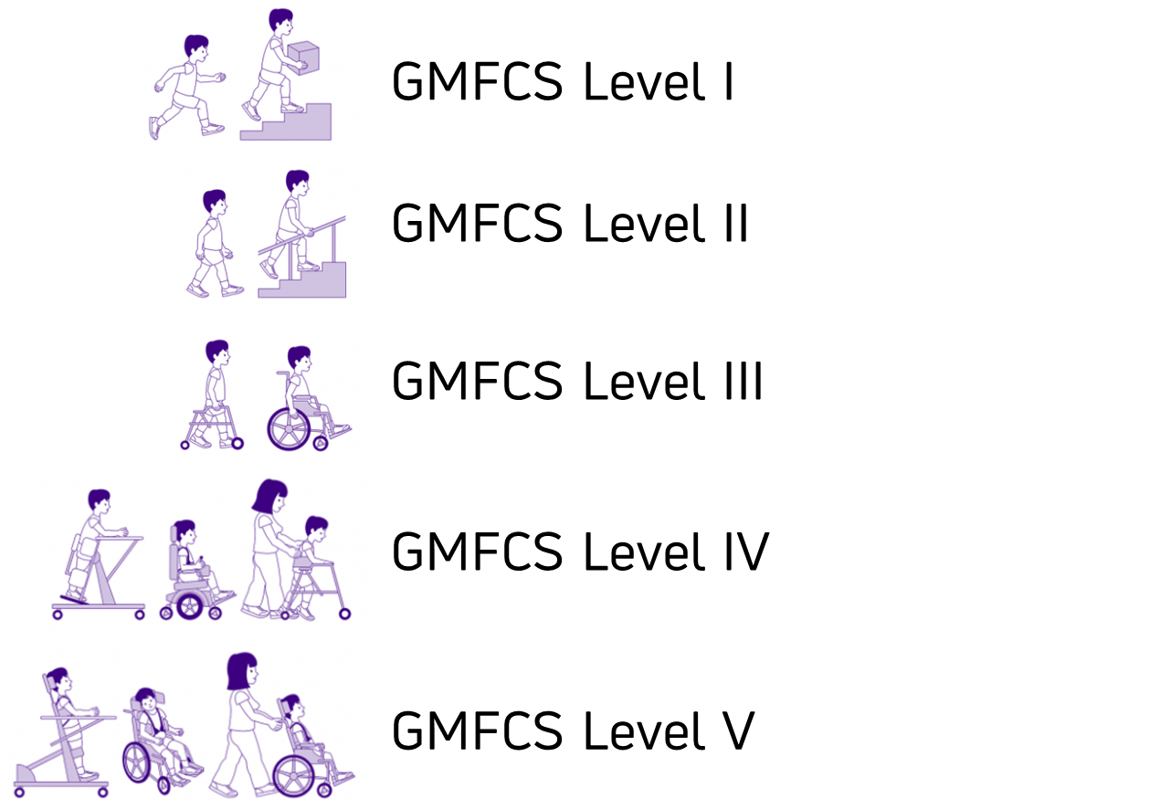
Read more about Gross Motor Function Classification System (GMFCS)

Diagnosis
A paediatrician usually diagnoses cerebral palsy. They will:
- watch how your child moves
- rule out other conditions
- use tests and scans to look at the brain
There is no single test for cerebral palsy. Doctors gather information from:

- your child’s medical history
- observations
- brain scans (if needed)
Most children are diagnosed by 18 months. But some are diagnosed later, especially if symptoms are mild or other health issues are present.

Hidden aspects of CP
- Some effects of cerebral palsy are hard to see. Health professionals may miss them.
- Sometimes, even the person with cerebral palsy does not notice these hidden effects.
These effects can affect tasks like:
- visual perception (telling shapes apart)
- visual motor/spatial awareness (using vision with movement, like hand-eye coordination)
- short-term memory and memory retrieval
There are issues with transitions from child to adult services. Clinical services may be lacking.

Treatment and therapies
Treatments that may be available from the NHS:
- Physiotherapy
- Speech therapy (including swallowing and drooling)
- Occupational therapy
- Medication
- Surgery
Private options may include:
- Conductive Education (Peto)
- Private physiotherapy
- Different types of special suits (Mollii, Adeli, Thera suit, Lycra Dynamic)
- Craniosacral therapy
- Hyperbaric oxygen therapy
- Amino-acids
- Stem cells treatments
Take time to research each therapy. Decide if it might help your child. Their symptoms and therapy needs are unique.
To discuss treatments, contact Richard Luke, Cerebral Palsy Programme Lead, at richard.luke@scope.org.uk
Note: Richard offers non-medical advice. He can discuss treatments for clarification. Always consult a medical professional before starting any treatment for your child.
Peer support
The best support comes from other parents and carers of children with cerebral palsy. They understand your journey because they have lived it. You can also support parents new to cerebral palsy.
Reaching out can be hard, but try these steps to build a support network:
- Use message boards and online communities. Scope’s online community have sections for cerebral palsy and parents.
- Find other parents through your local Parent Carer forum.
- Check Local Offer pages for groups.
- Create WhatsApp groups or regular Zoom meetings. Share the responsibility with others to save time.
- Start by meeting for coffee. Choose an accessible venue for comfort: AccessAble.
- If you want a bigger meet-up, speak to churches, community centres and schools about free venue hire. Supermarkets and shopping centres may also provide free community spaces.
Support groups for parents

CP resources

General advice
Scope online community
Coming to terms with a diagnosis (Scope)
Cerebral palsy advice and support (Scope)
Government's SEND guide for parents
Managing cerebral palsy in under 25s pathways (NICE)
Transition from children’s to adults’ services for young people using health or social care services (NICE)

Daily task help
One-handed dressing techniques (OT Dude)
One-handed dressing aids (The Wright Stuff)

Books on cerebral palsy (CP) for parents
Cerebral Palsy: A Parents’ Guide by Elaine Geralis
Cerebral Palsy from Diagnosis to Adult Life by P. Rosenbaum and L. Rosenbloom
Cerebral Palsy - Complete Care Giving by Freeman Miller and Steven J. Bachrach
Books for children
Xander's Cerebral Palsy Superpowers by Lori Leigh Yarborough
The Abilities in me: Cerebral Palsy by Gemma Keir
The Amazing Edie Eckhart by Rosie Jones
Max and the Magic Wish by Gavin Clifton

Useful products
Handmade bandana bibs for children with CP (Tate Rose Bibs)
Products for wheelchairs for adults and children (Bundlebean)
Wheelchair accessories (Trabasack)

Footwear for orthotics
Nike Easy On and Off Shoes
Easy access footwear (Billy Footwear)

Organisations that offer social and sporting opportunities
Cerebral Palsy Teens UK
Cerebral Palsy Sport
Opportunities for disabled and non-disabled people of all ages (Phab)

Contact us
For cerebral palsy information
Richard Luke, Cerebral Palsy Programme Lead
richard.luke@scope.org.uk
Sara Edwards, Cerebral Palsy Specialist, Wales
sara.edwards@scope.org.uk
Lucy Hindmarch, Cerebral Palsy Specialist, Leeds and the North lucy.hindmarch@scope.org.uk
Call 0808 800 3333 if you would like this information in a format that is accessible for you.

About this handout
The information from Scope is confidential and for your use only. We cannot give legal advice or offer case work or advocacy.
Scope is not liable for third-party information, like websites we refer you to. Our information is for England and Wales only.

Your information
You are in control. You can change your preferences at any time by emailing data.protection@scope.org.uk or calling us on 020 7619 7296.
You can also read about how we protect and use your personal information in our Privacy Policy.

