

Retail roles vacancy information pack

This pack will support your application to Scope Retail.
Scope, creating equal futures with disabled people,



Contents

A welcome from our Chief Executive

Who are we?

Our strategy and plans

Scope Retail

Meet the team

Benefits of working at Scope


How to apply

Frequently asked questions




A welcome from our
Chief Executive
Thank you for your interest in joining our Retail Team at Scope.
Working in a Scope charity shop means being part of something that matters. Together, you will help your local community, raise important funds, and make the shop a friendly place for customers, donors, and volunteers. Everyone who joins us helps to make a difference.
We are looking for people who share our values, bring energy to what they do, and want to be part of a caring team.
When you join Scope, you become part of a charity that supports its people, values difference and works together to make change happen.
I hope you will take a look at this opportunity and think about joining us.
Together with disabled people we can create an equal future.
See you in store soon?
John McLachlan
Interim Chief Executive


Who we are?
We are Scope.
We’re here to create an equal future with disabled people.
We campaign to remove barriers, tackle injustice and inspire action.
We create opportunities and provide information and support
that empowers.
One in four of us in the UK are disabled. We are a diverse,
proud, and vibrant community.
We are part of a powerful movement of disabled people, allies,
organisations and businesses.
And together, we will be unstoppable.

Our strategy and plans
In October 2023, we launched our ambitious strategy, An Equal Future.
The strategy sets out how we’ll transform society with disabled people at its heart, in the next decade.
Our goals are based on things that disabled people tell us matters most to them:

Ending the Disability Price Tag
We want to see disabled people and their families have an equal standard of living as non-disabled people.

Closing the Disability Employment Gap
We want all disabled people who want to work, to move into, stay in, and progress in work.
An Equal Future was co-produced with over 450 disabled people, colleagues, volunteers, and our Trustees.

Our values
Our strategy sets out what we do. But how we do it is just as important. At Scope, we have a set of 5 values that guide everything we do.
We are:
- Pioneering
- Courageous
- Connected
- Open
- Fair

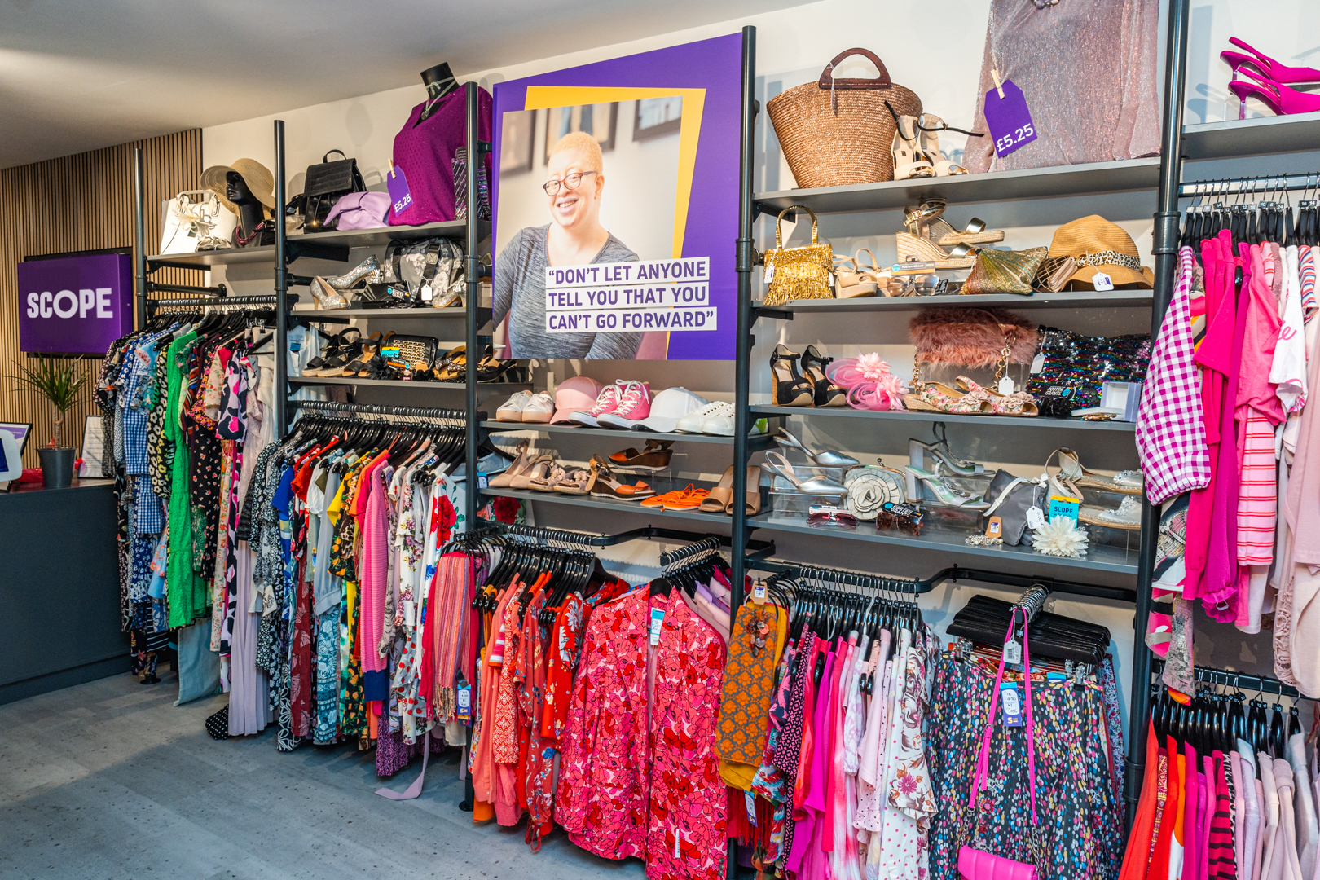

Scope Retail
Scope has 66 shops across England and Wales. We opened our first charity shop in Sevenoaks, Kent in 1970. There are now shops nationwide which raise vital funds for our work. Our high street shops sell a wide range of new and second-hand goods including clothes, shoes, accessories, furniture and electricals, CDs and DVDs, and more.
Our shops offer a fantastic way to support our work while discovering quality pre-loved items at affordable prices. Whether you are shopping in person or online, every purchase helps us create a fairer society for disabled people.
Scope shops and our online shop play a vital role in raising essential funds for disabled people and their families.


Meet the team

A ‘Day in the Life’ of working in the
Scope Retail team
No 2 days in our charity shops are ever quite the same. Each day begins with opening the shop, welcoming the team, and checking what needs to be done. This could include sorting donations, replenishing stock, setting up displays, or preparing the till and shop floor for customers.
Throughout the day, everyone plays a part in creating a friendly, well-organised shop. Supporting customers, handling donations, and keeping the space clean and inviting are all part of the role.
Shop Managers and Assistant Shop Managers also help keep things running smoothly by monitoring sales and stock, making decisions about pricing and displays and completing tasks such as rotas and cash handling.
Above all, working in our shops is about being part of a supportive team, making a positive difference in the local community, and helping raise vital funds for Scope.

Testimonials from our colleagues

Bridport
I am a shop manager and Area Support Lead. I have spent more than half of my life with Scope, which in itself reflects what an incredible charity it is to work for.
I began my journey with Scope in 1998 as a volunteer. Even after all these years, I still wake up every morning looking forward to coming to work. Scope is more than a charity, it is an organisation dedicated to making the world a fairer, more inclusive place for disabled people and their families. It provides a safe, supportive environment for our volunteers, many of whom find confidence, purpose, and a sense of belonging through their time with us.
The dedication shown by our teams, and the way volunteers describe Scope as feeling like a family, is something I am incredibly proud to be part of. Scope has shaped my career, my values, and my life, and I am honoured to continue supporting its mission and the people who make it such a special place to work.
Shop Manager and Area Support Lead

Dover
As a Store Manager of Scope in Dover I have built a family friendly environment, I have great support from my Area Support Managers (ASMs) and volunteers. We encourage a good work life balance with amazing growth opportunities.
I encourage strong leadership, a positive attitude and encourage equal opportunities. We support each other through our highs and lows. We are a big crazy work family.
Shop Manager and Area Support Lead

Grimsby
My role as a Charity Shop Manager goes much deeper than its job description.
My mission is for both staff and customers, when they step through the front door of Scope (Grimsby), is that they will experience a greater employee and customer satisfaction on every shift or visit.
My goal is to tap into staff/volunteers’ unseen talents and help them discover their potential. Boosting their overall happiness and job satisfaction.
In my charity shop, every voice is heard, and every word has substance. Which helps me, unite a culture and dialogue that builds a bridge between staff and customers.
“I’m proud to meet you,” is a greeting you may be lucky enough to hear on your next visit
Shop Manager

Dover

Scope is my dream job. It's my safe haven. We have a fantastic manager who has been very supportive of all our staff and volunteers. We are one big family that takes care of and looks out for each other.
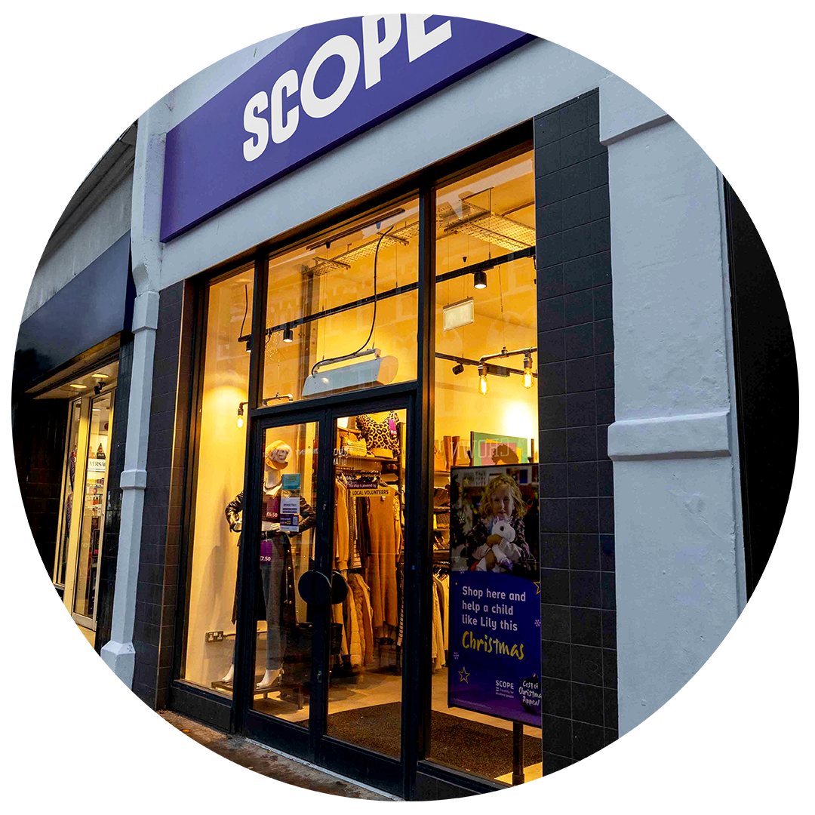

Assistant Shop Manager



Benefits of working at Scope

Scope benefits
We believe hard work deserves reward and recognition.
We offer a wide range of benefits including:
- 35 days annual leave
- company pension
- excellent training and career development
- strong colleague networks across disability, LGBTQ+, race equality, carers, women and young colleagues
- Long Service awards and Employee Recognition awards
- Wellbeing incentives like a discounted gym membership, cycle to work scheme, and much more



How to apply
Thank you for your interest in working for Scope.
To apply for this position, please click the apply button on the jobs page of our website. The application process requires you to submit your CV along with a short application form including a supporting statement that highlights your interest in the role and demonstrates how you meet the criteria outlined in the person specification. Please ensure both are completed.
All applications are managed by our Recruitment team. If you wish to speak with a member of the team regarding the role and your application or require any adjustments, please email recruitment@scope.org.uk
Before you apply, please take a moment to read through the frequently asked questions below which are designed to support your application and help you understand our recruitment processes at Scope.



Frequently asked questions

Disability Confident Scheme
We are proud to be a charity committed to disability equality. We welcome applications from disabled people and anyone with an impairment, long-term condition, or access need. We want our colleagues to reflect the diverse communities we serve.
Scope is a Disability Confident Leader. We are committed to making sure disabled people have fair and equal access to work. As part of this, we aim to offer an interview to disabled applicants who meet the essential requirements of the role.
To be considered under our Offer an Interview Scheme (previously the Guaranteed Interview Scheme), please tick the relevant box on your application form.
If you need any adjustments or support during the recruitment process, please email recruitment@scope.org.uk.
You can also find more information about requesting adjustments for interviews on our website.
Important to know
- You must meet all the essential requirements listed in the job description.
- If we receive a high number of applications for a role, we may need to prioritise interviews for disabled applicants who best meet the role criteria.

Visa Sponsorship
Unfortunately, we do not offer visa sponsorship for any roles at Scope.
Can I apply for a role if I don’t meet all the essential criteria?
We encourage you to apply if you meet most of the essential criteria and can demonstrate your ability to perform the role.
What happens after I submit my application?
Once your application is received, it will be reviewed by the shortlisting panel. Shortlisted candidates will be invited for an interview or further assessments.
How soon will I find out if I have been shortlisted?
Each recruitment process varies depending on how quickly the panel can review applications, but we do advise this can take up to a couple of weeks from advert closure. If you are not shortlisted, we will notify you via email.
Can I receive feedback after my interview?
We understand that feedback can be valuable for your development. If you are unsuccessful after the interview stage, we are happy to provide feedback upon request.

Do you provide volunteering opportunities?
Yes, we do. Please visit our volunteering page to find out about our volunteering roles.
Where can I get help?
If your query has not been answered above, you can contact the Recruitment Team recruitment@scope.org.uk for support.
SPN_260. Copyright Scope July 2026.
Scope is a registered charity in England and Wales (208231), Scotland (SC053490) and operates in Northern Ireland. Scope is a company limited by guarantee, registered in England and Wales company number (00520866). Registered office: Here East Press Centre, 14 East Bay Lane, London, E15 2GW.

