
Work Without Barriers
A blueprint for achieving employment equality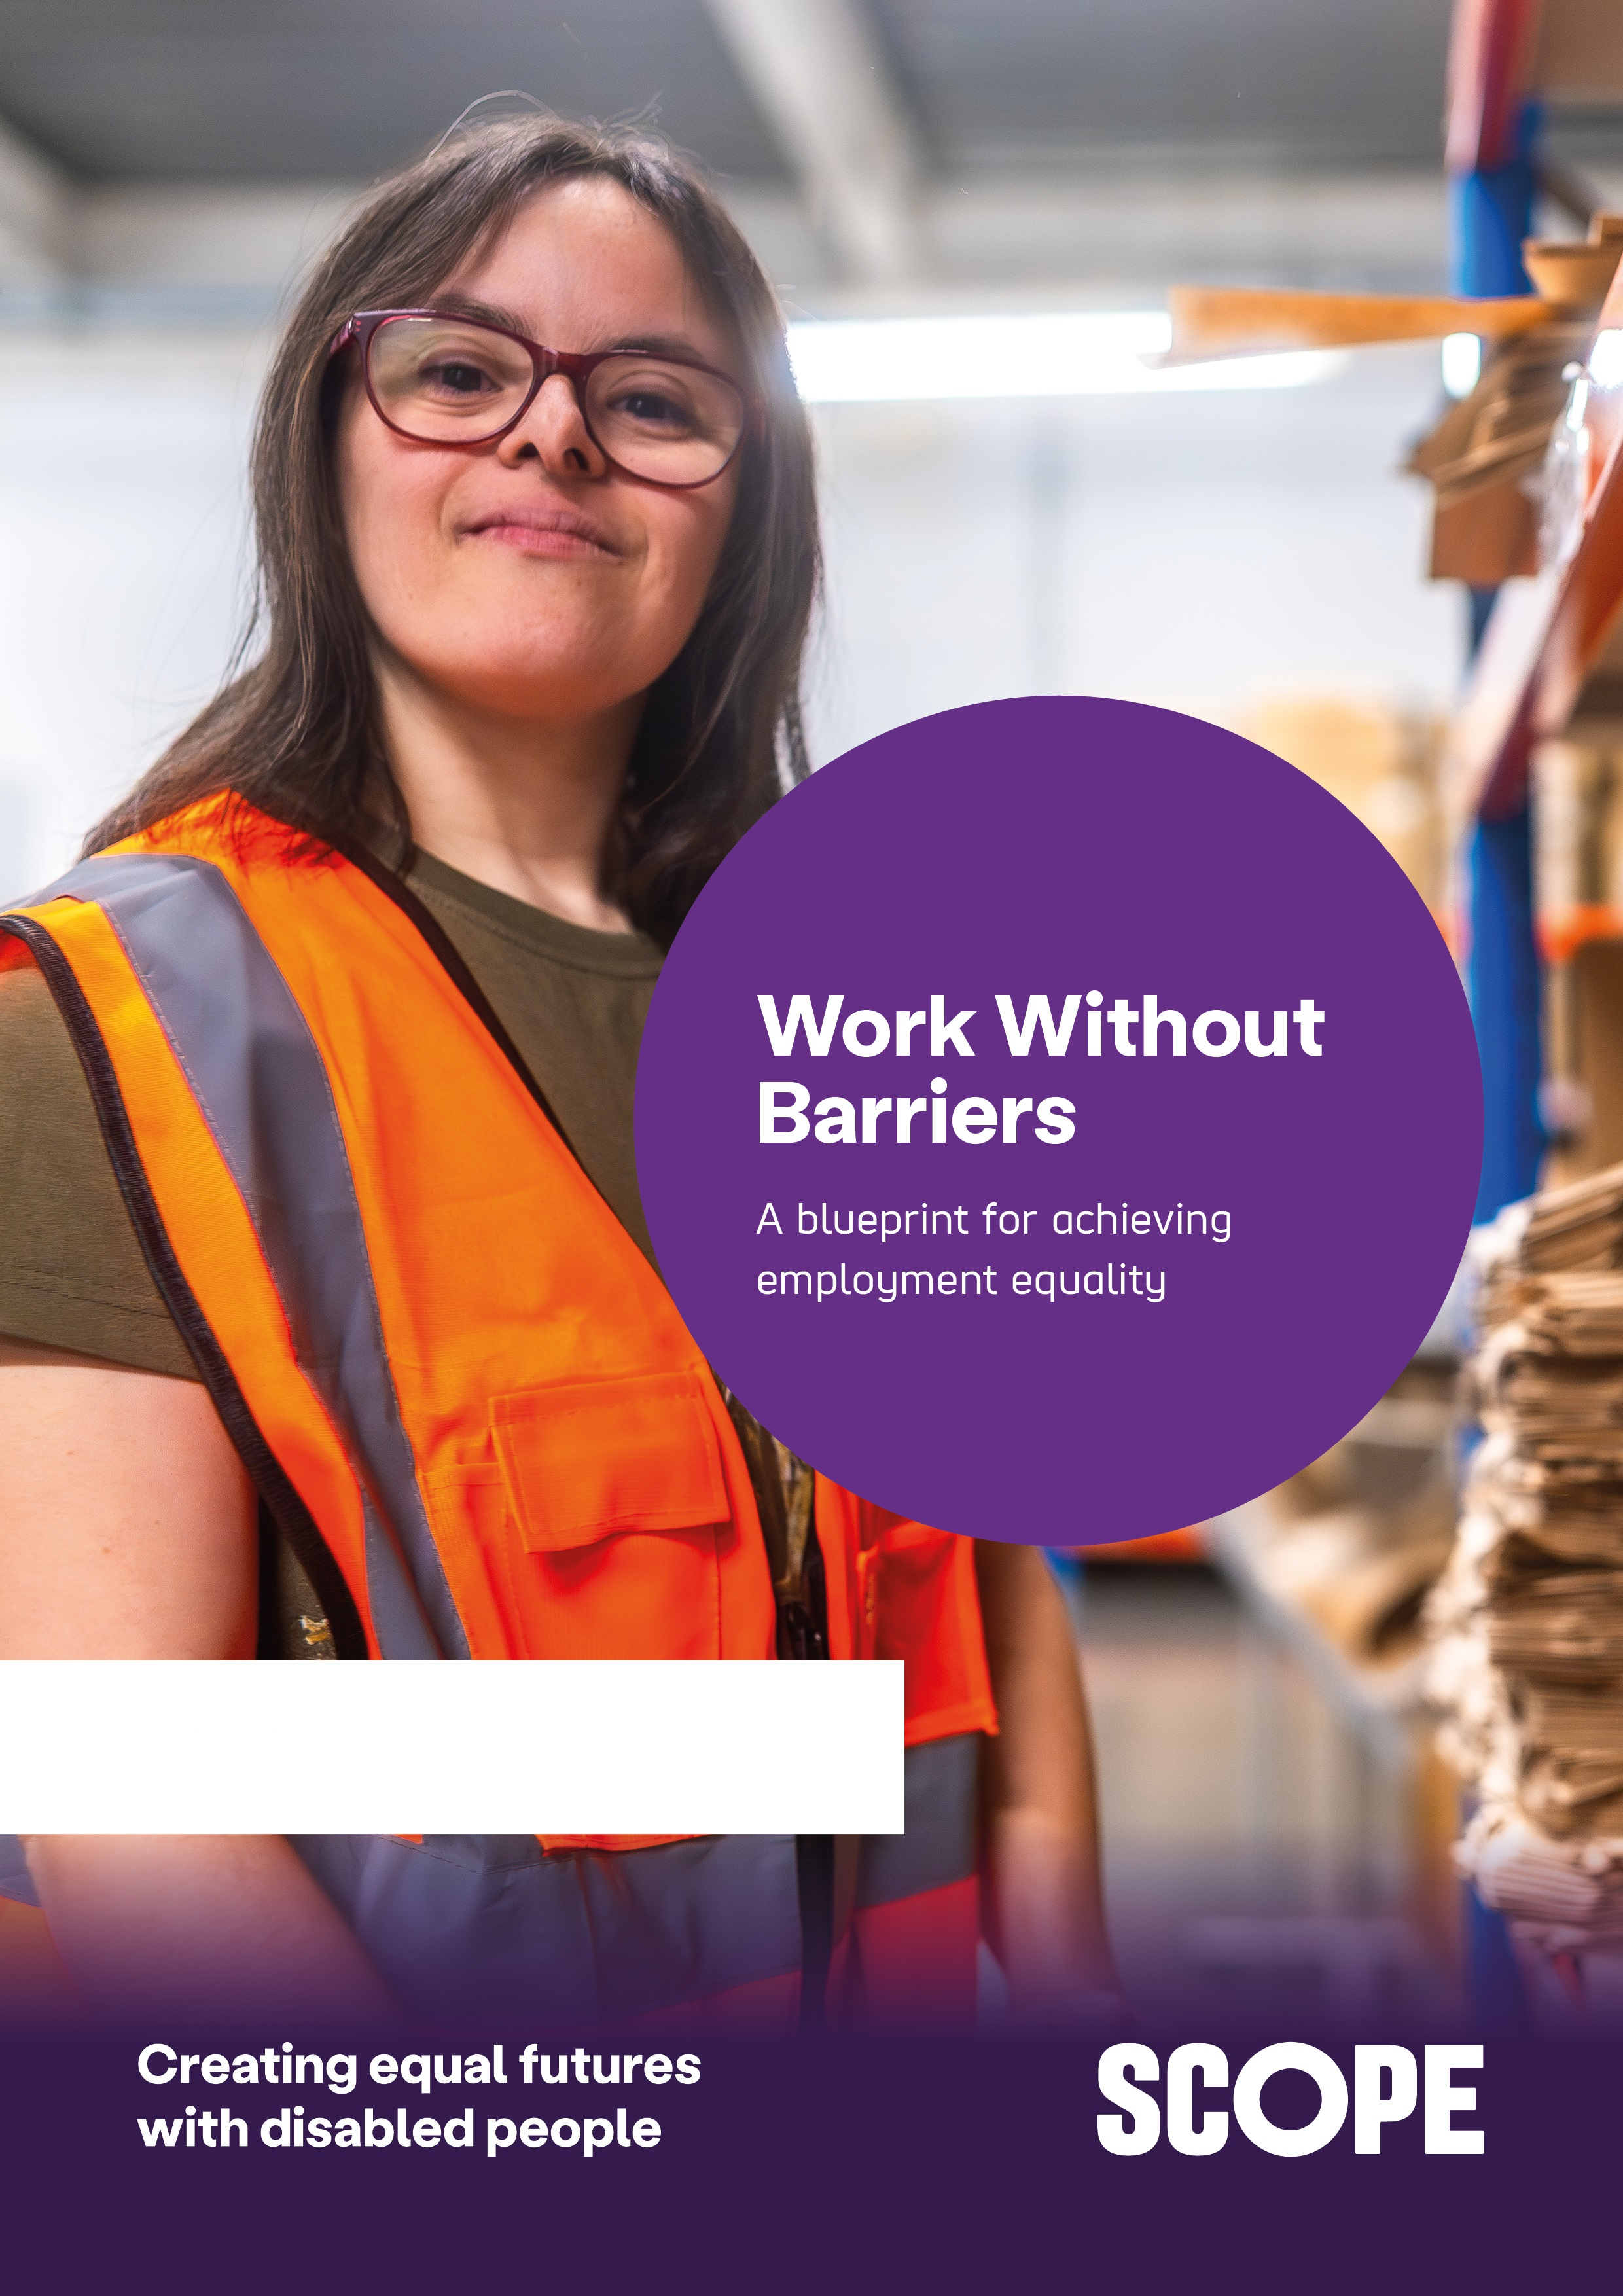

Contents
Work Without Barriers 1
Work Without Barriers 3
Publication 1: Introduction and structural barriers 4
Executive Summary 4
Findings and recommendations 6
Barriers along the disability employment journey 8
Employment journey 10
Aubrey’s story: “I don’t see a career in my future” 11
Structural Barriers 13
Flexible working 20
Reasonable adjustments 23
Access to Work 29
Disability Confident Scheme 33

Work Without Barriers
A blueprint for achieving employment equality
Disabled people should have the same opportunity to get into work, stay in work and build a career as everyone else. Yet across Britain, too many are still being locked out of opportunity by barriers that can - and must - be removed.
This is the first paper in a planned series that will form Scope’s Work Without Barriers programme for halving the Disability Employment Gap.

Together, they will examine how different types of barriers block disabled people’s work ambitions and plans. And what government and employers can do to break down these barriers.
Our analysis highlights the important areas where barriers persist:
- Structural barriers to employment including limited flexible working, delays to adjustments, restrictive policies, inaccessible environments and negative employer attitudes all hinder entry, retention and progression.
- The job market and its changes that create regional and sectoral disparities and often push disabled people into insecure lower paid roles.
- Education including the transition to work, the qualifications gap, and inaccessible education settings and discrimination.
- Employment and complementary support that is voluntary and tailored to the individual, covering in-work support as well as financial, housing, and health and wellbeing needs.
- Financial barriers that prevent the return to the workplace such as insufficient or overly sanctioned or conditioned benefits.
- Targeted population groups who face specific barriers and challenges along their disability employment journey, such as young people with mental health or neurodivergent conditions or older workers with physical or mental health conditions.
Structural barriers are the majority drivers of the Disability Employment Gap. We will focus on them in the first three papers. Before moving onto the other important aspects for employment of disabled people.
Papers will be published throughout autumn and winter 2026.

Publication 1: Introduction and structural barriers

Executive Summary
For almost two decades, the Disability Employment Gap – the difference between the employment rate for disabled people and non-disabled people – has remained persistently stuck at around 30 percentage points.
As a result, the UK is wasting talent. And wasting capability.
The size of the Disability Employment Gap is a clear demonstration of how the UK is failing disabled people.
For a long time, the UK has thought the solution to the Disability Employment Gap is to ‘change’ disabled people. Disabled people ‘just need to do what we tell them’. Disabled people need more motivation, and fewer benefits, to ‘encourage’ them to get a job.
But this does not work.
Our new analysis suggests that the Disability Employment Gap is not primarily explained by differences amongst disabled and non-disabled people. Instead, the majority of the gap reflects the barriers disabled people encounter.
These barriers include:
- structural barriers to accessible and flexible work
- negative attitudes and discrimination
- an evolving job market and recruitment culture
- unmet healthcare needs
- and a lack of financial support.
More than one million disabled people can and want to work, but are locked out of employment. A significant waste of human potential. Halving the Disability Employment Gap would bring huge returns to this country. If we were to do so, we would experience a £17 billion increase to the economy each year.
Too often the solution has been to focus on the individual – skills, support, incentives, requirements and sanctions.
These solutions cannot overcome a labour market that too often prevents disabled people getting in and staying in work. And these solutions ignore the ambitions, health, goals and skills of disabled people in favour of simplistic narratives such as ‘a life being stuck on benefits’.
The solution is to remove the barriers that block disabled people getting good work and to stop disabled people falling out of work. If the structural barriers against disabled people working were removed, evidence suggests the Disability Employment Gap could be cut by over a half.
This requires a shift in current thinking. From thinking about trying to change the individual. To focusing on removing the barriers around them at every stage in the employment journey – preparing for, finding, entering, staying in, progressing in, or re-entering work.
Successive governments have spent decades trying to reduce the gap. Progress has been far too slow. Interventions often operate against a labour market that continues to exclude disabled people. This has to change.
We want work without barriers.
It’s good for disabled people.
It’s good for business.
It’s good for Britain.

Findings and recommendations
Closing the Disability Employment Gap requires the Government and employers to work together. To invest in disabled people. And to join up disparate programmes under a unified strategy.
New polling from Scope found that:
- Over two fifths (43%) of disabled adults who have looked for a job in the last 10 years feel their condition or impairment may have played a role in them being turned down for a job or not progressing through the recruitment process.
- 28% of disabled workers or jobseekers have had adjustment requests rejected or agreed adjustments not put in place – rising to 45% for 18 to 34-year-olds.
Many disabled people experienced negative impacts because their employer did not adequately support their needs:
- More than 1 in 3 (35%) disabled adults say their mental health worsened
- More than a quarter (28%) say their physical health worsened
- 1 in 4 (26%) couldn’t perform their best at work
- Almost 1 in 5 (18%) had to leave a job
- Nearly 1 in 5 (19%) had to reduce working hours
- 1 in 7 (14%) had to pay for support or equipment themselves.
Almost two thirds (63%) of the public think that disabled people face more barriers when finding and keeping a job compared to non-disabled people
- 38% of the UK population think employers have the biggest responsibility in making it easier for disabled people to get into work
- 32% think the main responsibility lies with the government
- Only 3% believe the main responsibility lies with disabled people themselves.
The most significant contributor to the Disability Employment Gap is structural barriers. To address these structural barriers the Government should:
- Establish a national disability employment strategy with clear outcomes and an ambition to halve the Disability Employment Gap. The strategy should be overseen by multiple Secretaries of State, incorporating employment, business, education, health, benefits and national and local investment policy. All other initiatives should flow through this, as an aligned strategy will have the most significant impact.

- Reform Access to Work and ensure access to reasonable adjustments including flexible working. This includes funding Access to Work to ensure demand is met, that assessments are made in a timely fashion, and there is measurement of employment outcomes and retention.

- Overhaul Disability Confident and expand employers’ access to information about how to support disabled workers, provide incentives and funding for the hiring and retaining of disabled employees, link accreditation to employment outcomes.

- Introduce Disability Pay Gap reporting and enforce employer accountability and transparency of their employment of disabled people.
Reducing the Disability Employment Gap requires both investment and strategic oversight. Workplaces and working cultures must be adapted to enable disabled employees to thrive in their jobs. This requires partnership between Government and employers. To ensure that disabled people can get into and stay in work. There must be a balance between incentives and requirements for employers of all sizes.
Disjointed and diverging reviews, interventions and programmes only continues to provide limited benefits. An overarching national strategy. That has Secretary of State level authority. Which must bring together the multiple levels of government necessary. To remove the barriers which prevent disabled people entering or remaining in work.
If the structural barriers are addressed, the Disability Employment Gap will start to reduce. The Government should aim for no less than cutting the Gap by half.

Barriers along the disability employment journey
Scope’s strategy aims to close the Disability Employment Gap by 15 percentage points by 2033. Ensuring disabled people can stay in work. Pressing national government to deliver a long-term, well-resourced employment support strategy. Progress is achievable but depends on sustained ambition, coordinated national leadership. With a commitment to removing systemic barriers to entering, staying in and progressing in work.
There have been, and continue to be, many governmental interventions to increase disabled people’s participation in the workforce, directly and indirectly. Sir Mayfield’s Keep Britain Working Review addresses ill health and disability and economic inactivity. The Milburn Review is investigating the high proportion of young people who are not in education, employment or training (NEET), nearly half of whom are disabled. The Timms Review will suggest reform of welfare support addressing financial needs around disability, unemployment and low pay. The Prime Minister has announced wide reaching plans to devolve skills and employment support to the regions and local authorities.
Each of these interventions approach the problem from an incomplete angle. The individual disabled person trying to have a successful and meaningful working life is not fully seen. They are seen as a young person out of work. They are seen as an individual with ill health who is economically inactive. They are seen as a claimant of a benefit. How their personal life experiences, and the discrimination and challenges they have faced, have impacted their employment journey is ignored.
When looking at the whole employment journey of a disabled person, we see multiple problems that occur again and again at different stages.
A young disabled person may have had access to tailored training where they developed crucial skills and qualifications. But if local employers are not providing reasonable adjustments, they cannot put their skills to use.
A disabled worker with conditions affecting their mobility may get their first job with accessibility support funded by Access to Work. But if they try to progress to a new role in a new company without that support, their career trajectory stalls.
A director may hold decades of leadership and specialised professional experience. But if their workplace doesn’t offer flexible working options. Such as a lack of support for a newly acquired health condition in their 50s. This may force them to make a decision between their health and early retirement.
The ‘leaky boat’ problem
Tackling barriers across the disability employment journey does not only address how barriers arise at different moments from individual perspective. It also addresses a serious problem of approaching the Disability Employment Gap by only thinking about how to get unemployed disabled people into work.
The problem is that disabled people are leaving work at a higher rate than they are entering work. The number of disabled people in employment rose significantly to 5.6 million between 2014 and 2024. Yet disabled workers were over twice as likely to leave employment as non-disabled workers.
On average, disabled workers moved out of work at more than twice the rate of non-disabled workers over this period, at 10.1% compared with 4.6%. Moving back into work is also a significant issue, with ‘workless disabled people moving into work at nearly a quarter of the rate of workless non-disabled people, at 7.6% compared with 28.3%’.
More recently, it is estimated that ‘12% of disabled workers leave employment each year, 1.5 times the rate for non-disabled workers. With twice as many people flowing from work into inactivity due to ill health (304,000) than those who flow from inactivity due to ill health into work (151,000)’.
The entire disability employment journey must be addressed when tackling the Disability Employment Gap. Otherwise, we risk spending significant amounts supporting disabled people into work that they fall right back out of again.
This presents a specific problem for schemes that incentivise employers to employ disabled people for a period of months. Employers will take the money and an individual will have a job for a short period. And when the government removes the funding, the job disappears.

Employment journey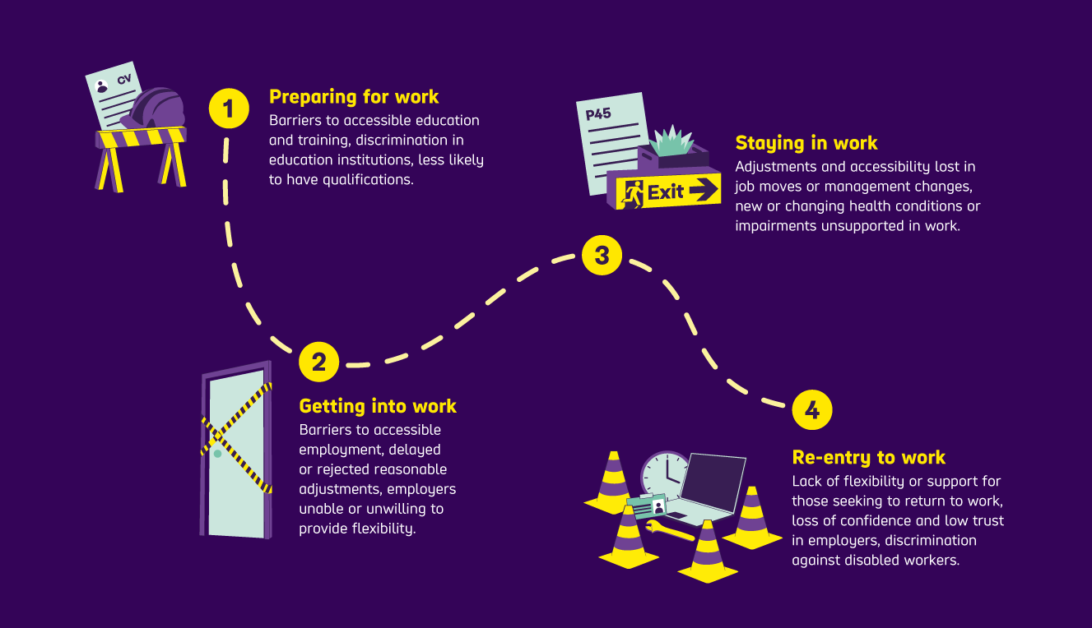

Aubrey’s story: “I don’t see a career in my future”
Aubrey has multiple conditions and impairments. At 19, they were forced to leave full-time education. And after several years thriving in full-time work, a series of changes and a lack of support pushed them out of employment. Aubrey has no intention of returning to the labour market. Structural barriers are the biggest factor in Aubrey’s journey to economic inactivity.
Higher education barriers lead to qualification disparities
Aubrey’s university pushed them out of full-time education. Staff refused to make alternative provision for lectures that clashed with Aubrey’s medication regime, leaving them too ill to attend. No catch-up sessions or resources were offered. Sessions were frequently moved at short notice into venues that were inaccessible to wheelchair users. Worse still, inflexible attendance processes brought punitive responses, with staff advising Aubrey to drop out and attend an online course instead. Aubrey explained that the lack of disability awareness and any support to resolve the many barriers that existed were “why I ultimately ended up dropping out”.
Disabled people hold lower levels of higher education qualifications than their non-disabled peers. Not only do barriers at this level create an ongoing disadvantage, but they often embed negative self-perspectives of disabled people’s capabilities due to be treated as a ‘problem’.

Adjustments open the possibility to entry to the labour market
After dropping out of university, Aubrey quickly secured full-time supermarket work. Aubrey spoke with enthusiasm about their employer’s membership of the ‘Disability Confident’ scheme, which “saved” them from being unemployed. Aubrey described a series of adjustments that kept them in work through significant ill health. For instance, no expectation of the same duties during a flare-up, short but regular shifts, and seated shifts close to a bathroom. Managers also exercised discretion over sickness triggers, despite company policy. Aubrey valued the positive attitudes and corresponding actions of their colleagues, particularly senior decision makers, that facilitated the removal of barriers to work. Aubrey reported that this period was “the closest to thriving” at work they’d ever come.
Reasonable adjustments and employers’ commitments through schemes like Disability Confident can break down the barriers to entering work for disabled people. Supporting this approach for all employers would significantly increase disabled people’s entry into the labour market.
Lack of adjustments prevent career progression and can lead to worsening health and leaving work altogether
Seeking a higher-paid role unavailable at the supermarket, Aubrey became a fast-food supervisor. On application, Aubrey did not disclose their conditions because barriers had previously been removed so effectively that they “forgot” about their conditions. Yet rigid expectations around 4am starts disrupted Aubrey’s medication regime. To ‘address this’ their manager offered only the option of a lower paid demotion. Needing greater financial security, Aubrey successfully applied for a full time remote, seated call centre job. However, the work quickly became back-to-back calls for 8 hours daily, exacerbating Aubrey’s existing conditions and triggering painful new ones. Offered only reduced hours and a lower disciplinary threshold for toilet breaks, Aubrey was signed off sick. Because nothing changed, Aubrey left work after a year.
Aubrey’s case is all too familiar and highlights the ‘leaky boat’ problem. Aubrey was able to enter work due to adjustments. But when adjustments were not made in future roles when they tried to progress, Aubrey was forced to leave employment.
Negative experiences and fears of barriers prevent re-entry into work
Aubrey now volunteers 3 hours each week in a wildlife trust café. Where an understanding manager, informal flexibility and a largely disabled volunteer team make participation possible.
However, at present, this environment feels a world away from Aubrey’s more recent paid employment. And these experiences left them feeling that, at just 25 years old, there is no accessible place for them as a disabled person in the full-time labour market:
“[Before volunteering], I did toy with the idea of paid employment again but, you know, that was a bit of a pipe dream really. I don’t see a career in my future”.
By just 25, Aubrey has experienced all of the stages of the disability employment journey. Barriers have stripped their passion and ambition for their future. In both educational and employment settings, refusal to make adjustments, to allow for flexibility, to reassess policies, or to make spaces accessible, locked Aubrey out of opportunities and good work. The national impact of needlessly overlooked talent, potential and ambition is economic waste and reduced producvity. The personal impact for disabled people like Aubrey, on their confidence and long term financial security, is devastating.

Structural Barriers
The largest proportional share of barriers to disabled people entering, remaining in, progressing in and returning to work are structural barriers.
Economic analysis conducted by the University of Sheffield estimated the proportion and impact on the Disability Employment Gap over 3 main areas:
- 55% structural barriers
- 33% observable characteristics, such as age, ethnicity, gender, region
- 12% differences in educational attainment
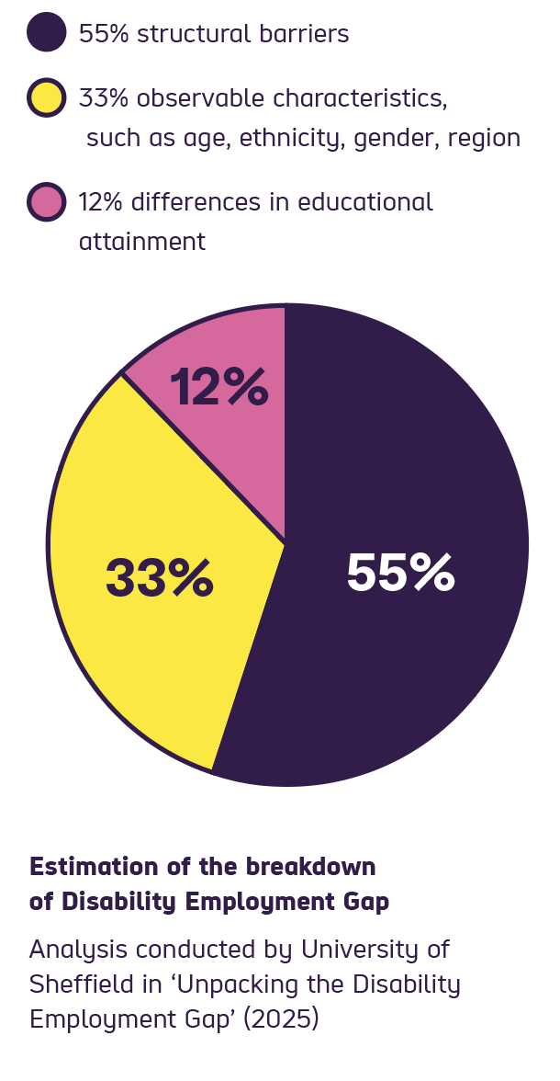
Scope’s own research similarly found the Disability Employment Gap to be driven by a disability penalty. Created by systemic barriers throughout disabled people’s education, training and employment journey.
Overall, this points to the most significant barriers throughout the disability employment journey being structural rather than individual. Discrimination, negative attitudes and inaccessible workplaces. Or a lack of adjustments and inadequate disability support systems. As well as the cumulative impact these barriers have on ambition, confidence and motivation.
The implication is that improving qualifications, employment support and job assistance will help some disabled people. But a substantial Disability Employment Gap would still remain.
To cut the Disability Employment Gap we must remove the structural barriers that stop disabled people entering, remaining in, and re-entering work.

What are structural barriers?
Structural barriers are the obstacles that the workplace or the employer present that can stop a disabled person entering a job, stop them progressing in their job, or push them out of a job.
Scope’s new polling exploring Employment and Barriers has revealed the issues which structural barriers present for the employment of disabled people:
A survey of 1,000 disabled adults, carried out by Opinium on behalf of Scope and weighted to be nationally representative, found in the last 10 years:
- 28% of disabled workers or jobseekers have had adjustment requests rejected or agreed adjustments not put in place – rising to 45% for 18 to 34-year-olds
- Over two fifths (43%) of disabled adults who have looked for a job in the last 10 years feel their condition or impairment may have played a role in them being turned down for a job or not progressing through the recruitment process.
Among disabled adults who have worked in the past 10 years, many report experiencing negative impacts because their employer did not adequately support their needs:
- More than 1 in 3 (35%) disabled adults say their mental health worsened
- More than a quarter (28%) say their physical health worsened
- 1 in 4 (26%) couldn’t perform their best at work
- Almost 1 in 5 (18%) had to leave a job
- Nearly 1 in 5 (19%) had to reduce working hours
- 1 in 7 (14%) had to pay for support or equipment themselves.
A survey with 2,000 adults, also carried out by Opinium and weighted to be nationally representative, found:
- Almost two thirds (63%) of the public think that disabled people face more barriers when finding and keeping a job compared to non-disabled people
- 38% of the UK population think employers have the biggest responsibility in making it easier for disabled people to get into work
- 32% think the main responsibility lies with the government
- Only 3% believe the main responsibility lies with disabled people themselves.
Evidence was also collated from Scope’s groundbreaking longitudinal study Our Lives, Our Journey, which follows the lives of 80+ disabled people and their families from 2016 to 2026. In addition to insight from Scope’s Work Without Barriers campaign respondents in the summer of 2026 (June to August). Analysis of the lived experiences of these people told us that:
- Experiencing barriers at every stage compounds the challenges
Disabled people describe repeated setbacks across education, recruitment and work, where each negative experience makes the next step feel harder.

- Attitudes frequently determine whether support works
Supportive managers and staff can remove barriers and help people stay well at work. However, disabled people are often viewed as a "risk" or with disbelief or stigma. This can lead to rejection, bullying or exclusion.

- Adjustments and flexibility are essential, but often insecure
Flexible hours, remote working, accessible equipment and changes to workload and patterns can make employment possible. But when support is delayed, withdrawn or dependent on sole individuals, disabled people can be forced to reduce hours, resign or avoid future disclosure.

- Families and carers experience the same structural pressures Flexibility can help caregivers remain in work. However, a lack of alternative flexible roles can also create a “job lock”, limiting new opportunities for better pay, progression and security.

- The emotional, health, and financial impacts are significant
Disabled people and families describe anxiety, loss of confidence, worsening health, extra costs and reduced income when systems fail to remove barriers.

- Lasting impact on disabled employees and job seekers
These impacts are not separate from employment outcomes; they directly affect the resilience and ability of disabled people to apply for work, stay in work or return to work after multiple negative experiences.

Compounding structural barriers over time lead to hopelessness, loss of ambition, and disengagement
Structural barriers have a deep and cumulative impact on disabled people’s lives. Shaping not only whether people can get work. But whether they feel equal, valued and able to build secure futures.
These barriers are not created by disabled people’s impairments or individual circumstances. They are created by systems, workplaces, policies and attitudes. Which fail to anticipate, understand or remove the barriers that disabled people face.
This impact builds up over time. Disabled people often encounter barriers repeatedly across education, in the job market and throughout employment journeys. Each experience may appear isolated, but all together they create a pattern of exclusion.
This cumulative impact reduces trust in employers and support systems. And makes disclosure of conditions or disability too much of a risk. This leaves disabled people carrying the emotional and practical burden of trying to make work accessible themselves. This is all too often unsustainable, making employment unviable and destroying individual confidence and ambition.

Structural barriers to employment
We classify structural barriers into three main areas:
- Practical
Adaptations to workplaces and ways of working can be critical in enabling a disabled person to do their job. Reasonable adjustments, flexible working, and support provided by schemes like Access to Work can all contribute to removing barriers that lock disabled people out of work.

- Procedural
Lacking the correct processes can create unnecessary delays and problems for disabled workers and jobseekers. This includes employers being unaware of their responsibilities. Such as lack of processes for accessible recruitment or handling reasonable adjustment requests. Or not having digitally accessible internal communications and workflow processes.

- Attitudinal
Discrimination against disabled people, both direct and indirect, is still common throughout educational and employment journeys. Assumptions about what disabled people can and cannot do. What the cost or ‘burden’ of them being in a role will be on a workplace. And outright bias and hostility towards disabled people both blocks and pushes disabled workers out of roles they are qualified to fulfil.
No single intervention will address all 3 areas. Government therefore needs to move away from treating disability employment as a collection of individual programmes. And towards a coherent system of prevention, support, rights, and accountability.

Practical barriers to disability employment – recommendations
Make flexible working the expectation
As a major employer, the Government should lead by example by mandating that all jobs across the public sector be flexible unless there is a specific need for exemption. Designing roles as flexible as standard would help demonstrate what is possible, challenge assumptions about which jobs can be done flexibly, and set wider expectations for the labour market.
Improve access to reasonable adjustments
The Government should introduce further legal measures for employers to meet when dealing with reasonable adjustment requests. Specifically, these are:
- Strengthen the definition of what ‘reasonable’ means in law to remove ambiguity for employers, to ensure they meet their legal duty.
- Introduce statutory timelines for responding to and implementing adjustments from when request is first made.
- Introduce a legal duty to provide written reasons for refusal.
- Introduce a legal duty to consult with disabled person when request is denied.
Increase funding of and improve Access to Work
The Government must continue to address the backlog of Access to Work applications. Provide the scheme with expanded funding to meet current and future demand. Reform it to monitor and evaluate cost-benefit. And ensure the scheme is future-proofed and able to meet demand.
Expand and improve the Disability Confident Scheme
Increase membership of the scheme, targeting sectors where disabled people remain underrepresented, reaching employers who have the greatest potential to improve their recruitment and retention of disabled staff.

Flexible working
Flexible working allows individuals to work from home or adjust their hours or working patterns to suit their needs. Disabled people consistently highlight flexible working as a primary positive aspect of employment.
Those experiencing the greatest satisfaction in their job roles often cited this flexibility as an important factor alongside supporting their condition(s). Remote working positions are commonly requested by customers starting on Scope’s Support to Work employment support service (1 in 6 of the initial appointments for the service).
When exploring remote and hybrid working situations, disabled people with multiple or ‘severely limiting’ impairments or health conditions were particularly likely to report they only wanted to work from home.
85% disabled people said that having access to remote or hybrid working would be essential or very important if looking for a new job. And 4 out of 5 disabled people (79%) would not apply for a job without remote options.
Disabled people whose workplaces offered flexible working as standard rather than having to request it, felt a stronger sense of equality. These individuals were not required to share their specific conditions as reasons for needing flexible hours or home working.
This workplace approach to flexible working can support disabled people not to feel they are being treated differently from other colleagues. Or singled out by colleagues or managers as ‘being given special treatment’ when receiving the support they required.

Barriers along the disability employment journey – losing access to flexible working
Access to flexible working is not consistent. This can push disabled people out of work. It can also trap them in unsatisfactory roles. Many disabled people have had positive experiences of flexible working. But they can lose this support when they move to a new role. This can happen with a new employer, but even current employers can remove support previously provided. Without this flexibility, some disabled people risk being pushed out of employment altogether.
“Working from home gave me the flexibility and focus I needed to truly thrive; without the constant interruptions of an office environment, I was productive, balanced, and supported by a fantastic management team. However, since losing that role, the transition back into the workforce has been devastating. Despite a lifetime of resilience, balancing full-time work as a single parent with part-time studies. I now face constant rejection. It feels as though my disability has become a barrier to even reaching the interview stage, leaving me feeling discarded and overlooked by a professional world I've given so much to.”
(Joanne, Scope’s Work Without Barriers campaign).

Progression in careers or job mobility can halt for disabled workers who cannot find new roles with the same access to flexible working options. This creates a form of “job lock”, where people remain in roles that are manageable but may limit pay, progression and long-term security.
The lack of flexible working options forces many disabled workers to reduce their hours or leave employment altogether. Despite the positive impact flexible working can have, 3 in 5 disabled people who have fallen out of work (60%) had not been offered the chance to try hybrid or remote working. Furthermore, a third of employers (33%) told Scope they did not offer staff a flexible working hours policy.
25% of disabled people currently not in work said they could work if the job was entirely from home. Unfortunately, the availability of flexible roles is too limited and unevenly distributed across employers. This makes it harder for disabled people who can and want to work to find the right job for them.
Worryingly, only 1 in every 26 vacancies (3.8%) on the DWP’s ‘Find a Job’ portal include options for remote or hybrid working. Despite indications that workforce participation would significantly increase if disabled people currently out of work were offered remote employment.

Recommendations
Government:
- As a major employer, the Government should lead by example by mandating that all jobs across the public sector be flexible unless there is a specific need for exemption.
- Job adverts should be required to publish information on adjustments and flexible working arrangements, and flexible working should be established as the expectation for all job opportunities where possible.
- The Government should work with employers to encourage and support adoption of output-based flexible working models (where performance is measured by results, not hours).
- Government should ensure the Jobs/Youth Guarantee includes remote and flexible roles for disabled young people who are eligible.
Employers:
- To support the recruitment and retention of disabled people, employers should advertise new desk-based roles as remote or hybrid wherever possible.

Reasonable adjustments
Reasonable adjustments are one of the most important tools for closing the Disability Employment Gap. Reasonable adjustments are changes an employer makes to remove or reduce barriers that prevent a disabled worker from doing their job safely or at all. When they are delivered well and quickly, they allow disabled people to do the jobs they were hired to do, manage their conditions, stay in work and progress.
As providing reasonable adjustments are a legal duty under the Equality Act 2010, they should be a reliable and protected form of support for disabled people in work. However, accessing reasonable adjustments continues to be an incredibly difficult and often damaging process for many disabled people trying to enter and stay in work.
Common reasonable adjustments can include:
- assistive technology and specialist equipment, such as screen readers or mobility aids
- standard office equipment to support conditions, such as specialised, adjustment chairs or desks, ergonomic keyboard or mouse, and audio-visual equipment
- support worker or personal assistant (PA) to support with tasks and daily administration
- support for transport and accommodation to conduct job role activities and attend work-related events
- flexible working patterns, such as flexible working hours or remote or hybrid working
- changes to the work environment or accessible features, such as parking for disabled people, ramps or modifying entrances and doorways, lowered desks, natural daylight bulbs.

The struggle for adjustments
Too many disabled people struggle to either secure support or get adjustments implemented. More than a quarter of disabled people (28%) have had adjustment requests rejected or not put in place. And among 18 to 24 year olds, this rises to 2 in 5 young disabled workers (40%).
Issues with reasonable adjustment requests are even more common when looking employment attrition. Almost half of all disabled people who had fallen out of work had encountered issues with a reasonable adjustment request (48%). Or they did not have all the reasonable adjustments they needed to work (50%).
“I kept asking [for reasonable adjustments], but my requests were ignored. If they had been met, I would still be working now”.
(Bethany, Scope’s Work Without Barriers campaign)
Many employers are refusing to provide reasonable adjustments or delay their implementation. It is common for disabled employees to wait many months for the adjustments they need to support them. This leads to disabled people being unable to do their jobs or leaving employment due to a lack of support.

Paying for workplace adjustments
Many employers still view workplace adjustments as a financial burden and underestimate their importance. 65% of employers say the cost of reasonable adjustments is a significant barrier to hiring disabled people, along with the perceived inconvenience of implementing those adjustments.
Unsurprisingly, not all disabled employees are confident that employers will provide the adjustments they need. Over 1 in 5 disabled workers (28%) chose not to request support because they believed their employer would not deliver the correct adjustments. And 1 in 7 disabled people who have worked in the last decade (14%) have had to resort to paying for support or equipment themselves, adding to their disability-related extra costs for work.
“I mean, I could [ask for financial support with taxis]…and I’m sure Access to Work would pay some of it. But then they’d ask [my employer] for a contribution, and that would make me a burden to the employer if I’m not careful…And I don’t want to chance it, because I also know that…[my employer is] in financial difficulties.”
Jodie (OLOJ Wave 2 employment cohort)

Without reasonable adjustments disabled people are forced to make impossible decisions between health and work
Disabled people experience a range of negative impacts where their needs were not adequately supported at work. Over a third (35%) of disabled people who had a job over the last decade said this led to their worsening mental health. While 28% reported worsening physical health. And 1 in 4 disabled people said they were unable to perform their best at work (26%).
Employers’ approach to support can lead directly to disabled people having to make difficult choices about their jobs. Nearly 1 in 5 disabled people had no choice but to reduce their hours at work (19%) or even resign (18%).
In some cases, this financial instability leads to profound impact on the disabled person’s life and their ability to engage with employment.
“Employers do not want people like me working for them. They want healthy abled-body workers [sic]; who don’t frequently take time off sick at short notice, who don’t need time allowed to attend hospital appointments. And they don’t want to pay for workplace adaptations.”
(Amanda, Scope’s Work Without Barriers campaign)

What is considered ‘reasonable’
The Access to Work scheme provides support for costs for adjustments which are not considered ‘reasonable’ as defined in the Equality Act 2010.
Yet the definition of what is reasonable can be open to interpretation. It is dependent on the situation, with provision of adjustment often varying and inconsistently applied by employers.
Understanding of reasonable adjustments is low. With many people (both employers and disabled workers) believing that what is considered reasonable is solely up to the discretion of the employer.
The Trade Union Congress (TUC) surveyed disabled workers and for those who were given a reason for their adjustments request being rejected:
- 24% of employers said the adjustment was “not practical to implement”
- 22% said their employer did not think the adjustment would “resolve the disadvantage”
- 19% said the “financial cost was too high”.
Disabled people frequently share their experiences of their employers refusing to make reasonable adjustments. Unfortunately, this often results in many of these disabled workers leaving their jobs.
“Employers do not want people like me working for them. They want healthy abled-body workers [sic]; who don’t frequently take time off sick at short notice, who don’t need time allowed to attend hospital appointments. And they don’t want to pay for workplace adaptations.” (Amanda, Scope’s Work Without Barriers campaign)
The definition of reasonable adjustments set out in the Equality Act is not specific enough. Where there is a dispute over a discrimination claim that cannot be resolved between the disabled employee and employer, it can only be determined by a judge at tribunal. This can lead to inconsistent interpretations of the law.
Larger employers with established Human Resources or legal teams are generally more confident in dealing with disability discrimination claims, especially if they had prior experience. With smaller employers can struggling more to keep up with best practice in managing disability issues.
Disabled claimants typically had limited understanding of what legally counts as disability discrimination. And often could not judge the strength of their case, leading many to seek advice from support organisations.
The Government must address the essential challenge of a lack of clarity on what is considered ‘reasonable’ for suitable adjustments provision for disabled employees.

Recommendations
Government:
Improve the definition of what is reasonable
- The Government must strengthen the definition of what ‘reasonable’ means in law to remove ambiguity for employers, to ensure they meet their legal duty. This could be done by:
  - Introducing further regulations defining the factors of reasonableness, created by secondary legislation under the Equality Act.
Prevent delays in reasonable adjustments being implemented
- The Government should introduce further legal measures for employers to meet when dealing with reasonable adjustment requests.
- Introduce statutory timelines for responding to and implementing adjustments from when request is first made.
- Introduce a legal duty to provide written reasons for refusal.
- Introduce a legal duty to consult with the disabled person when request is denied.
Reduce the number of requests being wrongfully denied
- Introduce alternative, early-resolution mechanisms for when reasonable adjustments requests are denied. This ensures disabled people are not forced into lengthy and distressing tribunal processes. And that damage wellbeing and deter action.
Ensure the adjustments being delivered are appropriate
- The Government should ensure that the Draft Race and Equality Bill includes mandatory reporting on the number of adjustments an employer makes and their satisfaction rates. This will help employers monitor if the adjustments they are making are removing all the barriers their disabled employees face.

Employers:
When designing and delivering reasonable adjustments, employers should:
- Involve the employee in identifying barriers and agreeing the adjustment.
- Put adjustments in place as close to the employee’s first day as possible.
- Assign a named contact responsible for coordinating adjustments.
Where Access to Work is delayed, consider covering the upfront costs temporarily so the employee can receive support they need to do their job, without delay.

Access to Work
Access to Work is a vital element of the UK’s employment support system. It funds the specialist equipment and support that go beyond what would usually be considered a reasonable adjustment. Without it, many disabled people could be left with only some, or none, of the adjustments they need. To fully remove the barriers they face to access and thrive in the workplace.
This is where Access to Work plays a crucial role. It fills a potentially harmful gap in the adjustments process by funding support that disabled people need, but that an employer could not reasonably be expected to provide. In doing so, it helps ensure disabled people do not have to turn down a job, or leave work, because the barriers they face have not been addressed.
For smaller businesses, or employers with limited resources, Access to Work can be the difference between hiring a disabled person or not. It funds adjustments that may be financially impossible for an employer. This enables disabled people to do their jobs. And supports employers to recruit disabled talent without costs they may not be able to afford.
The Access to Work assessment process provides guidance when needs change. And when the correct support is unclear. As well as when employers lack the training. Or occupational health support to advise disabled staff effectively.
Access to Work also provides free interview support. This includes support with communication. As well as support workers and accessible travel, where needed. This helps disabled candidates participate fully and fairly in recruitment before they are employed and without requiring an employer contribution.

Current issues with the Access to Work scheme
Yet Access to Work has not worked as it should, for many years. Disabled people, employers and suppliers report multiple issues with the scheme. This poses a significant threat to the hiring and retention of disabled workers. These issues include:
- Low awareness of Access to Work - Only 40% of working age disabled people had heard of the scheme, while employer awareness was just 21% and only 20% among small and medium-sized enterprises (SMEs). This leaves many disabled people unsure of where to get support and many employers unaware that support is available.
- Delays in accessing support - In March 2025, the average processing time for an application was 109 days compared to DWP's target of 25 working days. This leaves disabled people starting jobs without vital adjustments in place. This can lead to delays in starting work or having job offers withdrawn. Our research in 2023 found that delays to getting support from Access to Work was one of 4 main themes which contributed to disabled people falling out of work.
- Delays in reimbursement payments - In March 2025 there were 31,700 outstanding payment claims, more than four times as many as in March 2022. Disabled people and employers are often required to cover costs upfront, causing financial pressures. And discourage the recruitment and retention of disabled staff while waiting for reimbursement.
- Complexity of the scheme – Smaller employers can struggle to understand the process and requirements of the scheme. Especially those with less HR capacity. This then limits scheme uptake for SMEs.
A significant issue with the scheme is that it does not collect data on whether the scheme helps disabled people move into work, remain in work or progress in employment. This means that the Government cannot effectively assess the scheme's impact, demonstrate value for money, or make informed decisions about future investment and reform.
The effectiveness of Access to Work is undermined by weaknesses in the reasonable adjustments system. There is evidence that the scheme is funding adjustments that should be provided by employers. Particularly larger employers with the resources to do so.
Until it is clearer what constitutes a reasonable adjustment and employers are better supported to meet their responsibilities, Access to Work will continue to fill these gaps. Clarifying employer responsibilities and improving access to reasonable adjustments could reduce pressure on Access to Work. Allowing it to focus on funding support that falls beyond the scope of an employer's legal duty.

What needs to change to unlock the schemes full potential
A well-funded and future-proofed Access to Work scheme. Would meaningfully reduce practical barriers to employment for disabled people. To unlock the full potential of Access to Work, the Government must invest in the scheme. To clear the current backlog. And restore its ability to provide timely, effective support to disabled people and employers.
Investment is also needed to modernise the scheme's IT systems and improve data collection. Enabling more efficient delivery and a clearer understanding. Of how Access to Work supports disabled people to enter, stay in and progress in work. Reform should be focused on making Access to Work better known and used by smaller employers in all regions of the country.

Recommendations
Investment to ensure the scheme works now and, in the future
The Government should provide additional funding for the scheme to be used to:
- Reach significantly more disabled employees and their employers than it is currently. Access to Work currently only supports less than 100,000 people, while there are over 1 million disabled people who can and want to work.
- Hire more staff and use additional resources to urgently address the backlog of applications.
- Update the schemes IT infrastructure. This investment should be in addition to the funding provided to run the scheme. The update to the IT infrastructure must deliver:
  - More efficient delivery of the scheme, reducing inefficient administration, and speeding up application processing time.
  - The ability for the scheme to track, analyse and report on its own impact on the employment and retention of disabled people in work.
Improve the scheme’s delivery so it provides more effective support
- Simplify the process of application for both employers and disabled people. This will reduce the administrative burden applying for support through the scheme requires. Particularly for smaller employers with less HR capacity.
- The Government should work to raise awareness of the scheme among both employers and disabled people. Particularly smaller employers in areas of higher unemployment.
- Ensure the scheme remains based in the social model of disability so that it continues to meet the needs of disabled people. This should mean:
  - Not introducing further funding limits to support. Caps on Access to Work awards risk excluding disabled people who require specialist support to stay in work.
  - Not introducing the need to provide medical evidence to access support. This would risk disabled people facing further delays to accessing support and excludes disabled people who are awaiting diagnosis.
Improve access to reasonable adjustments so the scheme can fund adjustments which would not be considered reasonable
- Access to Work is not designed to cover costs reasonable adjustments which should be provided by employers. However, without a clear definition of what is considered ‘reasonable’, what the scheme should and should not cover remains ambiguous. Strengthening the definition of reasonable adjustments will provide clarity on what Access to Work should fund.

Disability Confident Scheme
The Disability Confident scheme is a voluntary initiative. That aims to support employers to hire and retain disabled people. Employers can move through 3 levels of membership, with each one requiring a different set of criteria to meet before they can move to the next level. In 2026, there are around 19,000 employers currently signed up to the scheme. It is the largest recognised group of employers. Committed to improving the employment prospects of disabled people.
The scheme has the potential to be a significant factor in closing the Disability Employment Gap. The scheme provides employers with guidance. On how they can make their recruitment processes inclusive and accessible. It also provides tools to help employers support their disabled staff. Addressing the barriers they may face and improving retention.
Members of the scheme are also provided with accreditation which is visible to potential jobseekers. Employers using the scheme will offer disabled applicants a guaranteed interview. If they meet the essential criteria of the role.

Issues with the Disability Confident scheme
Despite its potential, the scheme has so far failed to deliver the transformative change it was designed for. In 2023, 43% of Disability Confident members had not employed a disabled person as a result of joining the scheme.
The most widespread activity employers reported since joining was promoting the fact they were Disability Confident. Rather than substantive changes. Such as making adjustments for disabled people during the recruitment process and recruitment practices (30%). Or actively looking to attract and recruit disabled people (37%).
To be effective for both employers and disabled people, the Disability Confident scheme needs to move beyond signalling commitment and towards driving consistent change in practice.
Further reform of the scheme must focus on providing clear and consistent guidance. As well as supporting members to understanding how remove the barriers disabled people face, both when applying for roles and once in work.
Stricter requirements should be met before employers are able to progress to higher levels of the scheme. This will ensure that advancement reflects action, not just intent alone. The scheme should also offer more tailored support depending on employers’ size and the sector they operate in. Alongside this, the Government should work to expand membership of the scheme. Particularly in sectors where disabled people remain underrepresented.

Recommendations
Government:
- Continue to reform and improve the Disability Confident Scheme so that it meaningfully works to close the Disability Employment Gap. This reform should:
  - Include requiring employers at levels 2 and 3 of the scheme to meet minimum thresholds for the proportion of their workforce that is disabled.
  - Include a focus on young disabled people, ensure employers demonstrate how they support new employees through accessible recruitment, early adjustments, and progression routes.

- Increase membership of the scheme, with targeted action to increase uptake in sectors where disabled people remain underrepresented, ensuring the scheme reaches employers who have the greatest potential to improve their recruitment and retention of disabled staff.

- Introduce a digital portal for sharing, quality assured information and support. The portal can also be used to connect members and encourage them to share best practice. The portal should:
  - Draw on the sector’s expertise to provide high quality, trusted advice and support to member organisations, particularly those at Level 1. This will build their confidence in recruiting, retaining and advancing disabled employees. Which collectively will reduce the DEG.
  - Clearly accredit partners (disability sector organisations) featured on the portal to assist members in progressing through the levels.

Social Market Foundation (2021) ‘Time to think again’
ONS (March 2025) Employment of disabled people 2025
Resolution Foundation (2025) Opening doors: How to incentivise employers to create more opportunities for disabled workers
University of Sheffield (2025) Unpacking the Disability Employment Gap (DEG) – detailed economic analysis on the drivers of the DEG, funded by the Nuffield Foundation. For the analysis, the DEG was calculated as 33% points in 2019 for people aged 25 to 64.
Scope analysed the Disability Employment Gap using the ONS Labour Force Survey quarterly longitudinal data for Oct to Dec 2019 and Jan to Mar 2020. The Oaxaca decomposition method was used to explore the gap: the first part utilising data on personal characteristics, such as age, gender, and qualifications. And second part representing unexplained factors not included or observable in the data, such as lived experiences. Our unpublished analysis found that personal characteristics explain only a fifth of the gap (19.5%). The remaining unexplained part of DEG (80.5%) is associated with disability.
Scope (2021) Our Lives Our Journey: Achieving and maintaining equality in employment for disabled people (unpublished)
Lancaster University, Work Foundation and partners (2026) Inclusive Remote and Hybrid Working Study. Conducted between June 2023 and June 2025 UK-wide survey of 1,221 disabled people who were working remotely or in a hybrid way, in addition to in-depth interviews with 45 survey participants.
Ibid.
Ibid.
Scope (2021) Our Lives Our Journey: Achieving and maintaining equality in employment for disabled people (unpublished)
Scope (2023) Disability in the workplace: how to retain staff in the workplace Opinium survey of 1000 disabled adults who had fallen out of work.
Scope (2023) Disability in the workplace: how to retain staff in the workplace Opinium survey of 1000 disabled adults who had fallen out of work.
Lancaster University, Work Foundation and partners (2026) Inclusive Remote and Hybrid Working Study.
Scope polling on Employment and Barriers conducted by Opinium with 1,000 disabled UK adults and 2,000 UK adults 31 March to 09 April 2026.
Scope (2023) Disability in the workplace: how to retain staff in the workplace Opinium survey of 1000 disabled adults who had fallen out of work.
Scope (2023) Disability in the workplace: how to retain staff in the workplace Scope and Opinium polling of 269 HR decision makers in the UK. 27 January – 2 February 2023.
Business Disability Forum (2020). The Great Big Workplace Adjustments Survey.
Scope polling on Employment and Barriers conducted by Opinium surveying disabled UK adults who have had a job in the last 10 years (n=466) 31 March to 09 April 2026.
Ibid.
Ibid.
UK Government Equality Act 2010 Section 20
TUC (2025) Disabled workers' access to reasonable adjustment
ACAS (2024) Characteristics and drivers of disability discrimination employment tribunal claims
Ibid.
UK Parliament (2026) The Access to Work Scheme
Scope (2023) Disability in the workplace: how to retain staff in the workplace Opinium survey of 1000 disabled adults who had fallen out of work.
Department for Work and Pensions (2018) Disability Confident scheme: Summary findings from a survey of participating employers

