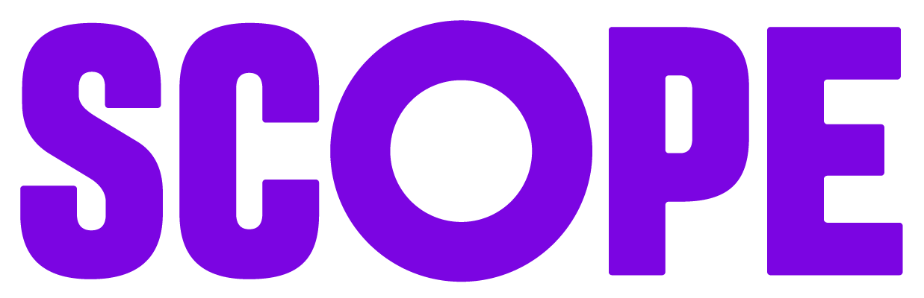
Partner guidance for photography at fundraising events
We’re grateful for every pound our partners raise for our vital work to support disabled people. And we love to see the events and activities you put on to raise donations. We know how much hard work it takes to make these happen.
Sharing photos and videos of your fundraising event with us is incredibly valuable. It can help us to demonstrate the fantastic work you do for donations to inspire others.
This document outlines steps you need to take to capture photos and videos.

Consent
It’s important to get consent for any photos or videos you take. This can look different depending on the type of content you’re capturing.

Event consent disclaimer
Most of the time, you’ll just need to use our event consent form. This is an opt-out disclaimer that should be included during event sign-up, communications and mentioned on the day.
It tells attendees that they’re entering a space where photos and videos may be captured of the group. People don’t have to sign a form, but they have to be made aware that attending the event is taken as consent to be captured.
It allows attendees and participants to say no if they don’t want to be in photos or videos. Anyone who opts out will need to be:
- mentioned to the person taking photos or videos so they can avoid capturing them
- potentially positioned away from the main group of attendees if needed
For example, you host a bake sale in the kitchen in your office. You would include the disclaimer in any communications or promotional materials you share. And on the day of the bake sale, you put up a few copies of the disclaimer around the area you’re in. You’d make it clear photography will be taking place if someone enters that space.
[event consent disclaimer link]

Individual consent form
You would need to use an individual consent form if you’re capturing a photo or a video of a person alone or directly talking to camera.
It tells the person what you will do with those photos and videos. This means how they might be used and how they will be stored. It also gives them the necessary information to request those files are destroyed if they change their mind.
[individual consent form link]
For example, someone is interviewed on camera talking about the fundraiser. They would need to sign the individual consent form.

Capturing photos and videos
Depending on the size and nature of your event, you could take photos and videos yourself on a phone. Or you might want to hire a photographer or videographer.
If you’d like to hire someone, we can recommend disabled photographers and videographers to help. It’s really valuable to centre your event around lived experience of disability. And it’s a great way to get more disabled people involved in the event.

