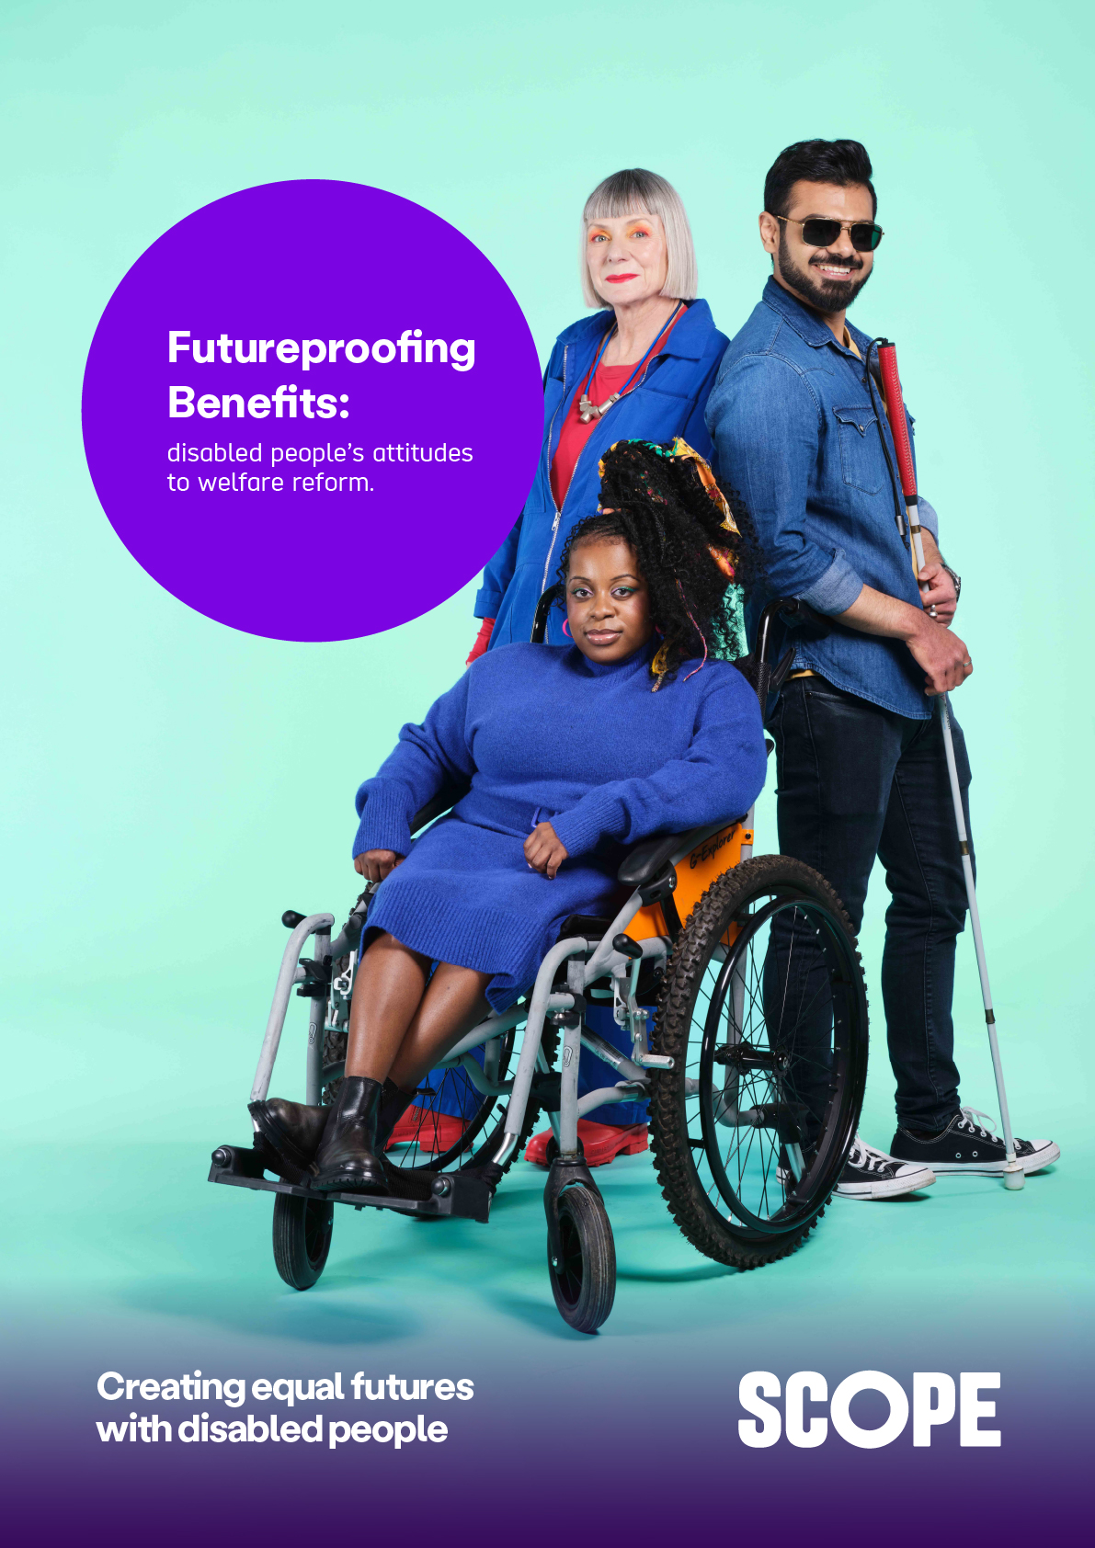
Futureproofing Benefits: disabled people’s attitudes to welfare reform


About Scope

We are Scope. We are here to create an equal future with disabled people.
We campaign to transform attitudes to disability, tackle injustice and
inspire action. We create opportunities and provide information and support
that empowers.
One in four of us in the UK are disabled. We are a diverse, proud, and
vibrant community.
We are part of a powerful movement of disabled people, allies,
organisations and businesses.
And together, we will be unstoppable.


Executive summary

Over 4.4 million people claim an incapacity or disability benefit. For more
than 10 years, Personal Independence Payment (PIP), the health element of Universal Credit (UC), and Employment and Support Allowance (ESA) - have been key pillars of the disability benefits system for working age disabled adults. Disability benefits are a lifeline for millions of disabled people. Nearly
a third of disabled people are in poverty, with working age disabled adults almost twice as likely to live in poverty, compared to non-disabled people
(33% compared to 17%). In 2025 we found that a further 700,000 disabled households would be pushed into poverty without PIP.
But over a decade of research tells us that accessing disability benefits is a stressful, degrading, and an arbitrarily complex experience. The system is
not working for disabled people with too many delays, degrading and inaccurate assessments, overwhelming forms and inadequate support.
Major reforms to disability benefits are being developed over the next year. The Sir Stephen Timms Review, known as the Timms Review, of PIP is exploring the reforms the Government has proposed. These include the abolition of the Work Capability Assessment (WCA) in 2028 and restricting eligibility for the health element to only those who receive the PIP daily living component. Both benefits would then be assessed using only the PIP assessment.
It is crucial that such significant reform to the benefits system is based upon, and consistently informed by, the needs and experiences of disabled people. For this Futureproofing Benefits report, Scope has gathered the views of disabled people on their thoughts on the current system and the proposed reforms. Disabled people have told us clearly that these priorities must be incorporated to reform and futureproof the disability benefits system:


- Assessments for PIP and capability to work must be kept separate. More than 2 in 3 disabled people (71%) do not want PIP to assess capability to work.

- Extra costs benefits (PIP) and income support for disabled people unable to work (UC health element) must be kept separate. 4 in 5 disabled people (79%) fear losing support following changes to disability benefits.

- The benefit system needs change, not cuts. Combining PIP and the UC health element would mean cuts for over 740,000 disabled people. Benefit cuts will push disabled people into poverty, not jobs.

- The benefit assessment system is punitive and degrading. 4 in 5 disabled people (80%) want any reforms to make the system more dignified.
- The benefit assessment system is ineffective and overly complex. Over 2 in 3 disabled people (70%) want any reforms to help prevent unnecessary reassessments.
Years of successive cuts, piecemeal changes, and restrictions to eligibility have led to stagnating progress in the welfare system. Problems that were identified more than 10 years ago have persisted and cuts have done little to improve the major challenges that disabled people face. Scope is clear that cutting disability benefits and restricting eligibility will never be the answer to the ongoing challenges within the welfare system.
Instead, the Government must commit to long term and wider systematic reform. This must place trust and the social model of disability at the foundation of the benefits system, address the full scale of the extra costs of living with disability, and address the wider problems of extra costs for disabled people and barriers to and lack of opportunity for employment.
A benefit cutting approach to reform will continue to fail disabled people, and 2025 showed cuts have little parliamentary or public support.
We are calling on the Government to reform the benefits system by focusing on what disabled people need to live good, safe and healthy lives. Not how to reduce costs through cuts.

Principles of a new welfare system

The Government must have a long-term vision for the welfare system. Key to the success of all welfare reform is having a unified set of principles which drive all activity to operate and improve welfare systems:
- A dignified assessment system based on the social model of disability
- An accessible support system that recognises the full extra costs of disability
Together these principles inform our recommendations for reforming the disability benefits system:
- Keep extra costs and work capability benefits separate
- Empower disabled people as the experts of their experience and lives
- Address the real needs and extra costs disabled people face
- Reduce administrative burdens and unnecessary reassessments



- Support disabled people to find appropriate work without conditionality



About this report

This report brings together findings from 2026 research into disabled people’s views about benefit reform, in the context of the Timms Review. Submissions made by disabled people and carers through Scope’s campaigner action to respond to the Timms Review call for evidence in April 2026. These gathered over 1,000 written contributions.
We have also built on our previous research findings from Making Benefits Work, by Scope and Joseph Rowntree Foundation.
Quotes throughout this report are from disabled people, who either responded to our survey or submitted their views through our campaigner action.



The Benefits System isn’t working

PIP is a lifeline, but the assessments are stressful, degrading, and inaccurate

Over 5 million people receive a Personal Independence Payment (PIP), or its predecessor a Disability Living Allowance (DLA).
PIP is a non-means assessed benefit for disabled people or people with health conditions that affect their life. It has two parts. The daily living component is for those who need help with daily tasks such as preparing food, using the bathroom, eating and drinking, managing money, dressing, socialising, reading, talking, listening or understanding. The mobility component is for those who need help with leaving the house, planning or following a route, or physically getting around their home.
There is often confusion about PIP and its relation to work status. PIP is not a work-related benefit. PIP is a benefit to support with the impact of disability in daily life. Disabled people can receive PIP while working, looking for work, or when they are unable to work.

Disabled people we heard from shared the impact of PIP:


“PIP means I am no longer housebound. I can afford to get a taxi if I want to go out…I have a raised toilet seat and bars around it to make it easier to use. None of this was possible without PIP. It has greatly increased my quality of life. I am so grateful.”
Denise, Wales
Disabled people have consistently reported that the disability benefits system is stressful and increasingly difficult to navigate. Applications are complicated and burdensome, and assessments are humiliating and unnecessarily stressful. Criteria for eligibility are simplified tick boxes that do not reflect the reality of the impact of a person’s disability or health condition on their everyday lives. Assessors often do not have sufficient medical knowledge to understand claimants’ conditions, and either confuse or misrepresent claimants’ actual experience in assessment reports. The process often takes months or even years to get the support people need. This is not only a psychological burden on disabled people, but an arduous and expensive system that does not work for any of us.
The current assessment process does not just affect the health of claimants. It also creates significant strain on the administration of the benefits system. Disabled people continue to tell the Government that the assessment processes impact the accuracy of awards. Around 64% of PIP decisions get overturned in the claimants’ favour at tribunal. In 2025, DWP spent over £50 million on staff costs towards defending PIP decisions at tribunals. This is enough to cover the full rate of PIP for 5,200 people a year.
“I have applied 3 times for PIP, each time I was turned [down] but went all the way to court each time, and each time I won. The last time when I was sent for assessment, the assessor said he would recommend no change, meaning my PIP would continue. The DWP didn’t take any notice and stopped it. I had to go all the way to court for a third time and won for a third time. The judge awarded [PIP] to me indefinitely. I later had backpay and a letter from DWP stating they wouldn’t contact me for at least 10 years.”
Anonymous, West Midlands
Reform of the benefits system needs to centre disabled people’s knowledge of their own conditions and lives, focus on trust and accuracy, and actively dismantle the punitive, suspicion-based assessment model that is ineffective and wastes public money.


WCA is not fit for purpose

The WCA (Work Capability Assessment) is the eligibility test for disability benefits related to employment status, ability and income. The WCA assesses eligibility for both the health element of Universal Credit and higher rates of ESA (Employment and Support Allowance). Claimants are assessed to either:
- Be fit for work (also known as ‘capable for work’).
- Have limited capability for work (LCW).
- Have limited capability for work and work-related activity (LCWRA).
- Have LCWRA and have a severe, lifelong health condition.
Despite successive governments’ commitments to improving disabled people’s employment outcomes, the Disability Employment Gap has hovered around 30 percentage points for over a decade. The current Disability Employment Gap for the first quarter of 2026 is 29.1 percentage points .
Scope research shows there are around 1 million disabled people who want to work. Halving the Disability Employment Gap would generate a £17 billion increase to the economy each year.
The main barriers to work for disabled people are not lack of motivation or willingness to work. In 2024, our research with the Joseph Rowntree Foundation (JRF) asked disabled people which potential barriers were significant in making it difficult for them to move into work or work more.

The most common challenges were:

- 94% not being well enough.
- 92% thinking that work could make their condition worse.
- 86% a lack of accessible and flexible employment.
- 86% being pressured into work which does not suit their needs and capabilities

But the WCA fails to support disabled people into work. Having gone through the process, 53% of disabled people had a negative opinion of the WCA, and only 49% said the assessment had accurately captured their capability for work and work-related activity. Conditionality-based benefits push disabled people further away from seeking support to return to work.
In 2014, the Work and Pensions Committee’s inquiry into the WCA found that the assessment failed to provide accurate records of claimants’ individual health related employment barriers or their distance from the labour market. The Committee found the same in 2018, concluding that the activities and descriptors used in the WCA were not “fit for purpose” and discriminated against people with mental health conditions. The Committee also reported that claimants were not taken seriously and that assessors had insufficient knowledge of claimants’ conditions.
Accessing secure, accessible and sustainable employment and employment support is vital to ensuring that disabled people who want to work can work. Cutting benefits will not push disabled people into work, only poverty. Tailored support for individuals’ capacity is vital.


Reform attempts have only been about cost cutting

Repeated changes to the disability benefit systems by successive governments have been primarily cost-cutting exercises. The actual problems with the benefit systems, both for disabled people and for government, have been ignored while disabled people’s financial security has been attacked again and again.
- Replacing Disability Living Allowance (DLA) with PIP was estimated to reduce the number of claimants by 28% - around 607,000 disabled people
- and save £1.5 billion a year by 2016-17. But the Office for Budget Responsibility in 2017 observed the PIP rollout achieved no savings relative to DLA.
- The 2017 abolition of the Work Related Activity Component for new claimants has denied disabled people £158.76 per month, an effective cut to half a million people.
- The 2023 proposed reform of WCA to restrict access was predicted to make savings of £1.3 billion a year by 2028, with changes that would have meant 371,000 disabled people facing cuts of more than £4,681 a year. The High Court ruled the consultation was unlawful because it didn’t adequately consult disabled people or clarify cost saving was the rationale for proposed changes.
- The Government’s UC and PIP Bill was heavily watered down because the impact of restricting eligibility for PIP and associated proposals would have led to cuts for more than 3.2 million families, pushing 400,000 people into poverty, and hitting a further 700,000 families already below the poverty line.
Cuts have worsened disabled people’s lives while barely improving the public finances and having no effect on the Disability Employment Gap. The Government’s first attempts at legislative reform in 2025 were challenged precisely because they continued this disastrous approach. The Timms Review was launched in response to the overwhelming public backlash against proposed cuts.


Proposed changes must reform the system, not simply make cuts

The Government must abandon the failing pattern of previous attempts at reform which have focused on short term cost savings. Instead, the Government must design benefits reforms based on the needs and experiences of disabled people.
The Government is planning to abolish the WCA in 2028 and have the PIP assessment also assess for the UC health element. Eligibility for the health element would be attached to the daily living component of PIP, which means that only people who get the daily living component of PIP would receive the health element. Both benefits would be assessed using a single assessment. The overall impact of this is to remove support from hundreds of thousands of people, and to conflate the impacts of disability and health conditions on daily life with work capacity.
The Government is also considering removing the health element from all claimants under the age of 22. This would result in devastating cuts for thousands of young disabled people and their families.
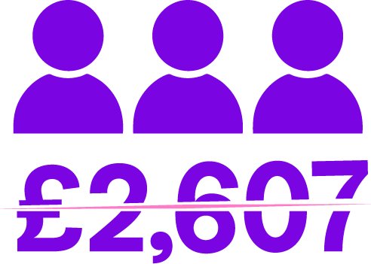
Scope estimates that if the Work Capability Assessment is abolished leading to eligibility for the UC health element being determined by PIP assessment, more than around 740,000 disabled people would face cuts of at least £2,607.12 a year.

This includes:

- Disabled people (aged 22 and over) who only receive the health element of UC (633,457).
- Disabled people (aged 22 and over) who receive the health element of UC and the mobility component of PIP, but not the daily living component (44,261).
- This also includes disabled people (aged under 22) who currently receive the UC health element (64,525) if reforms make this benefit age restricted.
The impact of the current proposals would simply be to strip unemployed and low income disabled people of vital support, without any additional employment support, employer responsibility or services to help them find alternative financial income.
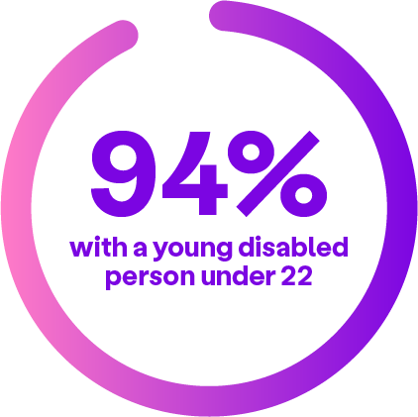
The restriction of the health element by age similarly removes support, in a discriminatory manner that treats young people as though they are less deserving of support. Or worse perpetuates discriminatory beliefs that young people cannot be disabled. Nearly half (49%) of households where a young disabled person claims the health element are already in poverty.
Our research found that, if the health element is cut from claimants under 22, 94% of households with a young disabled person under 22 claiming the health element would be in poverty.
Reforming and simplifying the benefits system is a necessity for disabled people, but reforms must be based on addressing structural challenges not simply finding ways to remove financial support.
“My complex physical health issues are not going to improve. For people like me, constant reassessment is pointless and not cost effective. Reforms dressed up as making the system better, while the main consideration is to reduce the cost, will never be reform in any meaningful sense. PIP does not cover the additional expenses of being disabled, it is already low. To cut it further would push more of us into poverty and destitution. No more cuts please.”
Sam, South East England



What we’ve found

Hearing from disabled people

To gather disabled people’s perspectives on the future of the benefits system, we surveyed over 400 members of Scope’s Lived Experience Research Panel about disability benefits. Our Lived Experience Research Panel is exclusively made up of disabled people and their families.
We asked disabled people for their thoughts and experiences of PIP assessments and the criteria. We then asked for their perspectives on the Government’s plans for reform.
We carried out our survey between 14 January and 2 February 2026. 466 disabled people took part in total.
We also reviewed and collected written contributions from disabled people who took part in our campaigner action to respond to the Timms Review call for evidence in April 2026.
Through these exercises, we received over 1,000 written contributions from disabled people.
Quotes in this report are from disabled people, who either responded to our survey or submitted through our action for evidence.


Experiences of PIP

Less than a fifth of disabled people find PIP easy to apply for

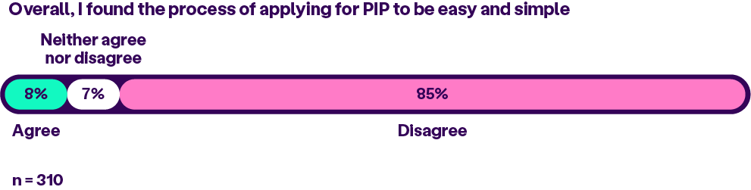
85% of disabled people surveyed who had had a PIP assessment did not agree that PIP was easy and simple to apply for.
Disabled people regularly tell us that applying for PIP can be time consuming and stressful, with many people needing support just to fill in the form:
“Applying for PIP and filling the forms is so tedious as a lot of the questions tend to repeat themselves, then you have to find and send all sorts of proof and evidence. Also, at the assessment the people look down on you and treat you like dirt. I found it stressful and demeaning.”
Karen, location not shared

“I have 16 conditions and take 40 plus medications, two conditions requiring 4 weekly injections. It took me quite a time to fill in the form as there was so much repetition for each condition it ran to 120 pages. I was not able to write on the booklet provided as I have severe Rheumatoid Arthritis. [The assessor] did try to confuse me, telling me that I had written a particular answer to a condition but referred to a different condition. I had to keep telling her that I had a particular difficulty with that one condition and how it would cause difficulties with living and the other condition she had muddled up. I felt as if she was trying to catch me out. She made me feel as if I was going around in circles.”
Jennie, North East
“I asked the woman who used to be my MS Specialist Nurse to help me fill in the application form. If had had to complete it on my own it would have taken me weeks, I would have had a nervous breakdown. My ex-MS nurse ended up filling in the form pretty much on her own, occasionally asking me questions I could understand, and then writing my answers in language an assessor could understand.”
David, East Riding of Yorkshire
“The assessor was a general nurse and had no experience of my medical condition. She had a list of questions and did not deviate from them to clarify anything. When I received the report, I was furious. Parts of the report did not even relate to me. It was clear there had been a cut and paste job from someone else's report. It didn't reflect our conversation. I felt powerless to do anything about the content of the report.”
Sheila, location not shared


More than half of disabled people say the PIP criteria do not reflect their reality

We shared the list of activities included in the PIP assessment criteria with our survey respondents and asked them about how well they reflected their needs.
59% told us that the list of activities included in the criteria were not a true reflection of their daily living needs. 24% thought that they were.
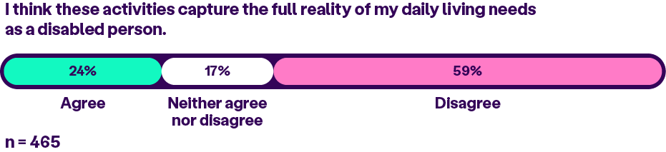
64% did not think that the list of activities was fair and inclusive of diverse types of conditions and impairments. 20% felt that the activities were fair and inclusive.
Disabled people described to us how they felt that their own conditions were not accounted for in the criteria. These included mental health, neurological conditions, less visible disabilities, visual impairments and neurodivergence. People felt that the criteria do not effectively assess the effect of pain, medication, fatigue or cognitive ability on people's ability to function.
"The assessment didn't really allow me to discuss my particular issues as the assessor was extremely focused on me keeping my answers short. This unfortunately led to the decision maker unilaterally deciding that I just flat out didn't have the conditions (Autism, Anxiety, Depression Disorder) that make me disabled.”
William, North West

Disabled people with multiple or fluctuating conditions described to us how the PIP criteria do not represent them or accurately assess their needs. Particularly the impact of having needs which change over time, not always in a progressive manner:
“The biggest problem was that the form is so standardised. My conditions fluctuate, so I probably can do the things, but not all in the same day/week. The form doesn't allow for this. The assessor is reading from a form based on the same assumptions: can you do this or not. I am pretty sure that there were no disabled people involved in creating this form and assessment process."
Louise, Norfolk
"It doesn't understand the nature of fatigue, fluctuating conditions, and the flare up of chronic conditions. It doesn't understand how all the conditions affect one another and most people have a host of co-morbidities."
Anonymous
Disabled people also described how inconsistencies in the way criteria are interpreted and applied impact how well claimants are understood by their assessor, or how well their eligibility is captured.
“I was very fortunate to have assessors who listened to my lived experience of day-to-day difficulties, rather than just treating me as a tick-box exercise.”
Anonymous

In particular, activities which needed to be carried out “repeatedly, in a timely manner, safely and reliably” were noted as being applied inconsistently, with people’s needs and experiences often taken out of context:
“Some of the questions were obviously designed to trick you, or catch you out. For example, can you chop a carrot. I can chop a carrot, but holding the knife causes pain and my fatigue from ME means that I don't do it because I'm too tired to move. They don't seem interested in explanation, they just have standard and rather random questions. I use a wheelchair most times I go out, and am often too fatigued or in pain to walk anywhere and yet the assessor decided that I only need basic rate mobility.”
Claire, South West
"They are taken in isolation, rather than as a whole. So for example, if I walked round the block, as I can on a good day, I may not even be able to speak when I get back for an hour or more due to fatigue."
Anonymous

More than half of disabled people thought the PIP assessment was unfair and inaccurate

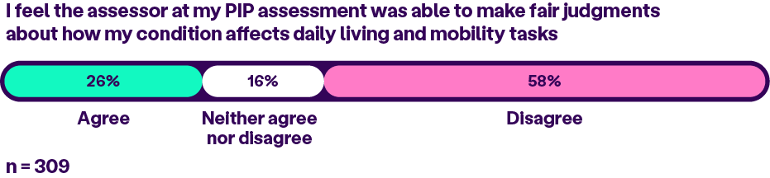
58% of disabled people disagreed that the assessor at their PIP assessment was able to make fair judgments about how their condition affects daily living and mobility tasks.

Scope’s previous qualitative research for Making Benefits Work explored both PIP and work capability assessment experiences. Many disabled people shared that assessors lacked expertise and understanding of their condition. They reported poor treatment, avoidable distress and inaccessible practice. All of these factors were felt to impact the quality of their assessment outcome.

PIP assessments are stressful, difficult and degrading

We asked our survey participants to describe their experiences of PIP assessments by choosing from a list of 12 positive and negative adjectives. The overwhelming majority of disabled people described PIP assessments negatively, choosing words such as difficult (63%), degrading (59%) and complicated (48%).
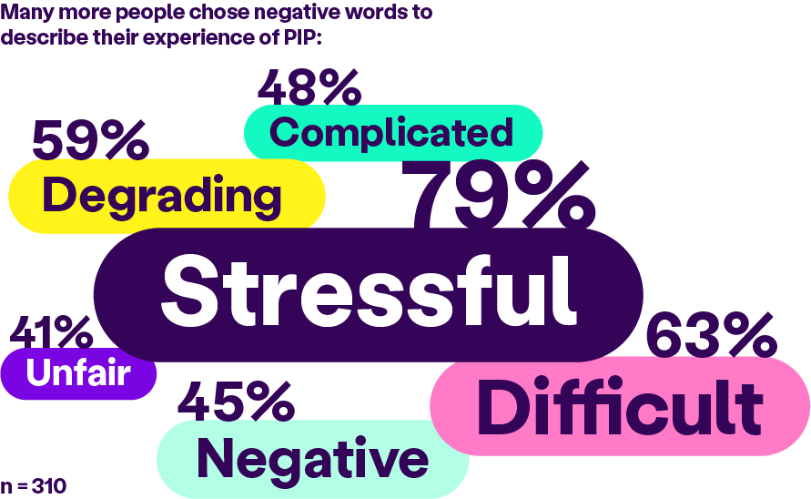
79% of disabled people described the PIP assessment as stressful. 41% described it as unfair. This demonstrates a profound strength of feeling amongst disabled people that PIP assessments are emotionally taxing experiences. 48% described it as complicated, demonstrating that the complexity of the assessment process makes it an even more burdensome process.


Disabled people’s thoughts on a single assessment

The majority of disabled people do not want PIP to assess capability to work

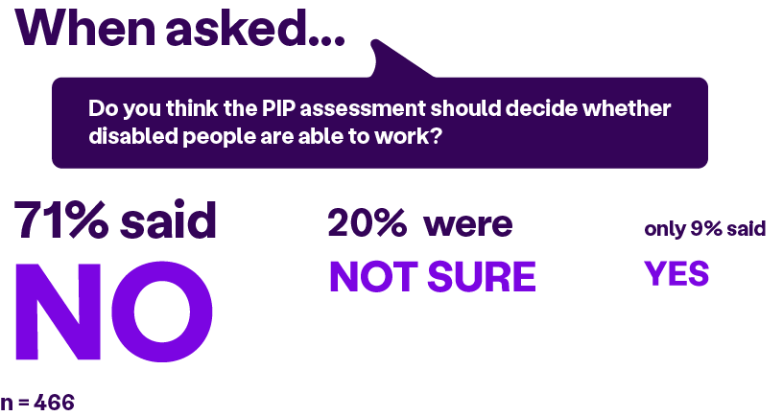
Disabled people do not want PIP and UC health to be assessed using the PIP assessment. 71% of our survey participants said that PIP should not assess ability for work.
Disabled people told us why PIP and ability for work assessments should remain separate. There was a strong consensus that assessing for work capability would go against the core purpose of PIP as an extra costs benefit:
“They are not deciding if people can work, they are deciding what support they need to be able to do daily tasks. You can work full time and get PIP.”
Anonymous
“It is not relevant to work capacity, it is meant to support you with the additional costs of being disabled, regardless of your working status."
Anonymous
Disabled people do not consider the PIP assessment as capable of assessing capability to work. 62% of respondents told us that the activities listed in the PIP assessment criteria do not reflect their ability to work.
Disabled people described their distrust of PIP assessors, saying that they feared they would not be qualified to assess capability to work. Participants told us that employment experts should be involved in assessing work capability, and medical experts in assessing the impact of disabilities:
“PIP should be a medical needs assessment. An employment expert should decide about work capability.”
Anonymous
In previous research, we asked disabled people about alternative ways of reducing the number of assessments. 86% of disabled people surveyed said that they would support a proposal to keep PIP and Work Capability Assessments separate, and claimants able to apply for either separately, but with automatic entitlement to the health element of UC for PIP claimants who meet basic UC criteria
Across all our findings we found that, above all, disabled people want to see assessments become less repetitive and stressful without limiting routes to entitlement. We did not hear that disabled people want PIP and UC health to be combined into a single benefit.


Disabled people’s attitudes to reform

In the final part of our survey, we gathered disabled people’s views on the Government’s plans for disability benefits.

We shared the Government’s plans for a single assessment for UC health and PIP. We asked disabled people about how helpful they think the change will be, how they are feeling about reforms and whether they felt represented in the ways the Government is making changes. As well as what they would like to see come out of the reforms.

4 in 5 disabled people fear change will result in more cuts

It has long been known that disabled people experience a lack of trust in the benefit system. Many disabled people depend on benefits to support their independence, wellbeing, or meet basic living costs. Disabled people do not have confidence that changes will be designed with disabled people or to make their lives better.
81% of our survey respondents told us they feared that their award would be reduced after changes to disability benefits. 79% also said that they feared losing their benefits altogether.
Political and media coverage about disability benefits and welfare fuels public stigma. This contributes to disabled people feeling vulnerable and uncertain about the future. 90% of our survey respondents said they worried about their future as a disabled person in the UK.

More than two thirds felt the Government’s plans will not have a positive impact

When we asked disabled people for their outlook on the reforms the Government intends to make, many of our survey respondents had little faith that they would have a positive impact. Few people we surveyed felt that the proposed changes would improve disabled people’s lives. Only 6% of respondents thought that the changes would make it easier for them to get support. 72% said that they would not.
There was also little faith that the reforms would improve the effectiveness of PIP at supporting disabled people. 66% of our respondents said that they did not believe that changes would improve their ability to manage the extra costs they face as a disabled person. Whilst only 7% said that they would.

Looking more broadly, disabled people also felt that these changes would do little to promote a cultural shift around welfare or disability. 77% of respondents did not believe the changes would help combat stigma around disabled people claiming benefits, compared to just 8% who thought that they would.

What do disabled people want to see from reforms?

We asked our survey participants what they wanted to see changes to disability benefits achieve. 70% agreed that changes needed to help prevent unnecessary reassessments. 80% agreed that changes needed to make the benefit system more dignified.
Our research echoes what disabled people have been telling the Government for more than a decade. Problems which were identified when PIP was first introduced have persisted, unaddressed, creating profound inefficiencies in our benefits system now. These include long waiting times, high rates of reassessment and huge expenditure on unnecessary tribunals.
Disabled people want to see a more accurate and less burdensome benefits system, one that protects routes to support and entitlement without taking a punitive approach.



What reform should look like
Disabled people have been clear that positive and lasting change starts by creating a trust-based benefits system. One which has the right approach and tools to identify people’s needs the first time around. The Government has an opportunity to listen to disabled people and reform a system that has not provided the support disabled need.


Below we set out a range of principles for what a reformed benefits system should look like.


Two principles of success

The Government must have a long term vision for the welfare system. Key to the success of all welfare reform is having a unified set of principles which drive all activity to operate and improve the work and welfare systems:

A dignified assessment system based on the social model of disability

The social model of disability sets out that disabled people are disabled by barriers in society, not by their impairment or condition. This does not mean that disabled people’s conditions are not present or have no impact on their life. But rather the barriers disabled people face are not the fault of and cannot be overcome by the individuals themselves; the barriers need to be removed by society.
At present eligibility for disability benefits is benchmarked against what someone cannot do, or the level of aid or assistance required, with higher points given to the greater the level of difficulty or support needed. For instance, criteria such as “cannot prepare and cook food” are worth 8 points or higher in the PIP assessment. Meanwhile, activities that claimants can do on their own are awarded no points, such as “can express and understand verbal information unaided.” WCA descriptors follow a similar methodology, with claimants scoring points if they meet criteria such as “cannot raise either arm as if to put something in the top pocket of a coat or jacket.”
These criteria assess disabled people on what they cannot do. As such they do not capture the barriers that disabled people may face. Neither do they capture the workarounds which disabled people have to go through in order to accomplish the tasks. Or the impact of doing so. All of which can incur extra costs. Furthermore, these criteria follow the medical model of disability, looking at what is ‘wrong’ with the disabled person, to determine whether they are eligible for disability benefits.
In previous research, 99% of disabled people felt that changes to the assessment process should be designed in collaboration with disabled people. This would increase fairness and trust. And 82% thought that the assessor and the claimant should agree the impact of somebody’s condition and their barrier to work, as part of the WCA.
The social model of disability recognises the barriers that make life harder for disabled people. A benefit assessment utilising the social model of disability would seek to remove these barriers offering disabled people more independence, choice and control. This could include:

Person and trust centred
The medical model of disability questions what is wrong with a person, this leads to an external judgment and the problems of assessors interrogating claimants over their lived experience or telling them in person or in reports that the claimant is lying. A social model focus would ask claimants what barriers they face, support they need, informed by expertise in disability and health conditions of assessors.

Assessors ask questions to identify barriers
Assessors should be trained to identify where claimants face barriers to inclusion, what workarounds they have to use and where they need support. To identify barriers, assessors must ask questions such as “what makes it difficult for you to do this?” to invite the claimant to describe their difficulties. Assessors should ask follow up questions such as “how do you manage this?” to understand where the claimant has had to adapt. Lastly, assessors should ask questions such as “what support do you need with this?” to identify any further areas of need.


Barriers criteria and scoring
Instead of what a disabled person can and cannot do, the criteria focus on how their physical living space, local environment, inaccessibility of shops and services and public spaces, public transport options, digital or other access forms for banking and employment, limits claimants’ access and freedoms in day to day activities. Eligibility should account for how claimants can or cannot fully participate in social, cultural, and recreational activities and to what extent they can access everyday services in their area.

Measure extra costs
The value of support should be linked to the real extra costs disabled people face in overcoming these barriers. This includes adjustments for home, additional costs towards heating, utilities, equipment and therapies, adjustment needs and support around accessing services.

Coproduced assessment materials
Guidance and training for assessors must be codesigned with disabled people to ensure that disability benefit assessments are designed and delivered fairly and accurately.

Extra costs of disability come from all areas of life, including barriers to inclusion and the hoops that disabled people must jump through. Disability benefit assessments must capture this to assess disabled people’s needs and extra costs accurately.


An accessible support system that recognises the full extra costs of disability

Life in the UK costs more if you are disabled. The current Disability Price Tag
– the average extra costs faced by disabled people to have the same standard of living as non-disabled people – is £1,095 a month. Disabled people need to spend more on key essentials like food, energy, transport. For example, different conditions can require specific foods, keeping rooms at a specific temperature, running medical equipment overnight or continuously, and needing to take taxis to reach accessible public transport. And as the cost of living increases, so do these costs. By 2029/30, the Disability Price Tag is predicted to reach £1,224 per month.
Yet with the typical weekly PIP payment being around £135 per week, the reality is that awards often fall short of what is needed just to cover the essentials. Scope’s research shows that PIP awards barely offset the extra costs related to disability. We found that there is a £625 shortfall between the average PIP award and the Disability Price Tag. This shortfall is set to reach £704 by 2029/30.
Political and media narratives around disability benefits have wildly misconstrued the financial realities of the lives of most disabled people receiving support for their daily living costs. In 2024 a Resolution Foundation report found that more than 4 in 10 PIP claimants (42%) are in the poorest
20% of income distribution in the country.
Reform of the benefits system must be grounded in the evidence of the real
and varied additional costs being disabled in the UK carries.


Futureproofing Benefits Recommendations

Keep extra costs and work capability benefits separate

Work capability (the UC health element and ESA) and PIP, or subsequent
new versions of these, as both benefits and as assessments, must be kept separate.
The needs of disabled people in daily life, and the specific support for in work or out of work support, are separate issues that require different systems. Trying to combine them will lead to an “all or nothing” benefit system that
will cause more stress and anxiety for disabled people.
PIP should remain a non-means tested, extra costs benefit that is not attached to work status.
The UC health element and ESA should remain universal support available to any working age disabled adult. The Government should drop plans to restrict access to the UC health element for people aged under 22.

Empower disabled people as the experts of their experience

The PIP assessment process should be changed to ensure that assessors capture an accurate picture of a claimant's life and how they are impacted by disability. While criteria are useful, they should no longer be tick box exercises that do not take in account the context of a person’s life.
Criteria for daily living need to be realistic and contextualise everyday activities such as moving around the house, leaving and entering the house, being independent in activities such as cooking, shopping, cleaning, bathing, and having social connection.
To empower disabled people, the PIP assessment process should:
- Be conversational, involving prompting questions about the claimant’s life and how disability affects them.
- Identify barriers in society that limit or burden the claimant’s daily life, and ask what support is needed to handle these.
- Be carried out by assessors with appropriate healthcare expertise in a claimants’ conditions. Claimants should have a choice in their assessor.
- Be accessible and adaptable. Assessment times and locations should be arranged with claimant, be time limited to two hours with breaks, and allow for rearrangement accounting for the claimant’s condition(s).
- Be supported by contextual evidence. Case managers and assessors must consider a wide range of factors including where claimants live, local services, support networks and their caring responsibilities.

- Have wraparound support. Taking lessons from the Health Transformation Programme, there should be optional pre and post decision calls with their case manager.

Address the real needs and extra costs disabled people face

The level of support a disabled person needs varies with their conditions and situation, and the extra costs these incur must always be accounted for. For some, support will need to be lifelong, while others will need PIP for specific time intervals, or have changing needs over time.
As part of the Disability National Action Plan, the Government should establish an Extra Costs Commission to investigate the additional costs disabled people face in their everyday life and to provide evidence for awards.
PIP awards must adapt to the realities of disabled people’s lives and should:
- Always cover the essentials, with the Extra Costs Commission reviewing PIP awards annually to ensure that they reflect the extra costs of disability. In 2024, Scope worked with WPI Economics and found there to be a £625 shortfall between the average PIP award and the Disability Price Tag. The Government should commit to an “Extra Costs Guarantee” that ensure PIP awards are always uplifted by this amount, adjusted for inflation.
- Be free from conditionality as a non-means tested benefit, not attached to work status.
- Be the right length. Maintain a minimum award length of 3 years before reviews, with claimants having the option to request an earlier review if their circumstances change.

- Maintain a tiered system that recognises different levels of need. Claimants must have the option of appealing or requesting a review to receive the right support.

Reduce administrative burden and unnecessary reassessments

The stress and burden of the assessment system disproportionately falls on claimants, with insufficient guidance to a complex situation of competing entitlements, unnecessary repeat assessments that can take weeks to prepare for, and follow-up required meetings and check-ins that have strict conditionality causing fear and anxiety.
We welcome the Government’s legislative intention to extend PIP award lengths to 3 years before the first review, with subsequent reviews 2 years after that. This is to “mitigate challenges with assessment capacity”, responding to the growing backlog of PIP and Work Capability assessments. Fewer assessments will decrease uncertainty for disabled people and reduce pressure and costs for assessment providers.
- Ensure automatic qualification to PIP and the UC health element for claimants with lifelong and terminal conditions. Claimants whose medical, functional and environmental evidence pack satisfies the eligibility criteria should not have to undergo an assessment.
- Introduce automatic entitlement to the standard rate of PIP for those who have been assessed as having LCWRA.
- Share Work Capability Test evidence or assessment results as contextual evidence for their PIP assessment.
- Require case managers to seek out additional evidence where needed, rather than the claimant.

Support disabled people to find appropriate work without conditionality
The Disability Employment Gap has hovered around 30 percentage points for over a decade. There will always be a proportion of the population who cannot work due to disability or health conditions, but many disabled people can and want to work. The problems are not due to lack of trying, but the barriers in society and the job market to finding, remaining in, and progressing in work as a disabled person – barriers that don’t disappear when benefits are removed. Cuts and conditionality push disabled people into poverty, not jobs.
The DWP should work with disabled people to develop a new and effective work capabilities assessment that must:
- Have fair and realistic assessment criteria of people’s needs and their abilities to work, centring disabled people’s ambitions and experiences of employment.
- Be undertaken by specialist appropriate assessors who understand claimants’ conditions and circumstances. Claimants should have a choice in their assessor.
- Have outcomes that work alongside the Right to Try guarantee to ensure that disabled people who want to work can explore employment without fear of reassessment, sanctions or losing their benefits entitlement.
- Identify work aspirations, not benefit conditions. Outcomes of the assessment should create a work passport which set out the claimant’s needs, ambitions, adjustments and capabilities.
- Be integrated with employment support. Work passports and assessment outcomes should be used by Jobcentres and support schemes such as Access to Work.


Conclusion

Our welfare system should be there to support all of us. Anyone can be disabled and face unprecedented financial challenges. At the core of our welfare system should be a commitment to supporting people to live independently and thrive in society. A key part of that is creating a supportive and person driven disability benefits system which enables us to feel and be included in society.
The Government now has a crucial chance to move away from previous failings, take stock of the lessons learned and bring a new approach to reform. We cannot fall into familiar, ‘sticking plaster’ habits of short term cuts that simply delay a long term problem. By working with disabled people, not against us, the Government can get this right. Futureproofing benefits starts by working with disabled people on a long term vision for supporting disabled people to thrive. We urge the Government to look to the future and work with disabled people to design it.

Acknowledgements

Scope would like to thank the Lived Experience Research Panel for taking part in our survey and contributing to this research.
We would also like to thank all disabled people and households who took Scope’s action to respond to the Timms Review call for evidence and who shared their responses with us.

Annex

Survey participants

466 disabled people from Scope’s Lived Experience Research Panel responded to our survey.
The majority of the participants in our survey were in receipt of PIP (86%). Whilst a small minority (6%) received adult DLA or Adult Disability Payment (ADP) in Scotland, with some unsure (1%). Of those who received PIP, 83% received both the Daily Living and Mobility components whilst a smaller minority only received the Daily Living component (14%) or the Mobility component (2%), with some unsure (1%). 12% of our respondents were not in receipt of any disability related benefits.
Of those currently receiving PIP, just over half of respondents receive the higher weekly rate for both components of PIP (51%). Meanwhile around a fifth (21%) got the lower rate for one or both components, and a similar number received the higher rate for one component and lower for the other (18%).
67% (310 people) of those surveyed had gone through a PIP assessment in
the last 5 years. Of these, 80% (106 people) had also gone through a WCA in the same time period.

Benefit Combinations: Official Statistics to February 2025 - GOV.UK
The cost of cuts to disability benefits: Our open letter to the Chancellor | Disability charity Scope UK
Disability | Joseph Rowntree Foundation
The cost of cuts to disability benefits: Our open letter to the Chancellor | Disability charity Scope UK
DWP benefit statistics: February 2026 - GOV.UK
Tribunal Statistics Quarterly: October to December 2025 - GOV.UK
Big Issue, 2025. DWP blew millions in taxpayer cash fighting disability benefit claims. DWP blew millions in taxpayer cash fighting disability benefit claims
Office for National Statistics. Labour market status of disabled people [19 May 2026].
Scope, 2026. Analysis using the Labour Force Survey microdata to determine the number of disabled people who are economically inactive and want to work.
An Equal Future | Disability charity Scope UK
Scope, 2024. Making benefits work: Improving support for disabled people
Scope, 2024. Making benefits work: Improving support for disabled people, p8.
Work and Pensions Committee, 2014
House of Commons Work and Pensions Committee, 2018. PIP and ESA assessments. (link)
Claimant experience of the Personal Independence Payment process p.3
Universal Credit: what you could get if you have a health condition or disability - GOV.UK
ESA changes from April 2017 will improve “life chances” of 500,000 people by making them poorer
Autumn Statement 2023: A summary - House of Commons Library
WCA Reforms Will Reduce Claimant Caseload by 37 Times More Than It Will Increase Employment | Disability Rights UK
Clifford-v-SSWP-Judgment-16-January-2025-1.pdf
No workaround • Resolution Foundation
Iain Porter on X, 2025.
The Guardian, 2025. Disability benefit cuts to hit 700,000 families already in poverty, DWP forecasts show
Scope, 2026. Analysis of StatXplore and Family Resources Survey data, January 2026.
Making benefits work: Improving support for disabled people | Disability charity Scope UK
Scope, 2024. Making benefits work: Improving support for disabled people, p82.
Scope, 2024. Making benefits work: Improving support for disabled people, p82.
Social model of disability | Disability charity Scope UK
Work Capability Assessment | Disability Rights UK
Scope, 2024. Making benefits work: Improving support for disabled people, p93.
Scope, 2024. Making benefits work: Improving support for disabled people, p89.
Disability Price Tag 2025 | Disability charity Scope UK
Disability Price Tag 2025 | Disability charity Scope UK
Scope analysis of DWP PIP statistics, 2024. This analysis utilised Stat-Xplore to calculate the totals claiming each PIP payment type and the average value of benefit payments for PIP awards in January 2024.
Scope, Disability Price Tag 2025, https://www.scope.org.uk/campaigns/disability-price-tag
Resolution Foundation, 2024. Under Strain: Investigating trends in working-age disability and incapacity benefits, p36
Life costs more | Disability charity Scope UK
The Universal Credit, Personal Independence Payment, Jobseeker’s Allowance and Employment and Support Allowance (Decisions and Appeals) (Amendment) Regulations 2026, p2.
PIP reassessments moving to 5 years – what’s the catch? | Purpl Disabled Discounts

