Yorkshire & North East Hockey - Junior Competitions Coordinator (YNEJCC)

The YNEJCC role deals with all, but not limited to, aspects set out below:
- Inviting entries to all levels of leagues across the Yorkshire & North East (YNE) Area (using EH systems and central entry process)
- Work with the league entry information to support planning with the Junior Competition Coordinators.
- Create junior club league fixtures for the following levels of leagues:
- U10 & U12 In2Hockey Area Final
- All League Tiers for U14
- All League Tiers for U16
- All League Tiers for U18
- Ensure there is a Junior County Hockey competitions programme for YNE counties either separately or working in partnership with neighbouring Areas/EH.
- In2Hockey - booking the pitches for the In2Hockey Area Finals events (U10 & U12) and attending/running these competitions.
- Dealing with all emails and communications from the clubs ensuring prompt replies and timely sending out of information.
- Managing the day-to-day requirements that come with running leagues (U14/16/18) such as weekly checking of results, assisting clubs with postponed or cancelled games, setting new fixture dates/times/venues on the website and act as go-between when situations arise that are covered by the rules.
- Monitoring the leagues (U14/16/18) to ensure fixtures are being played in good time and by the ‘play-by’ dates.
- Maintaining good relations with the primary Junior Contacts of the clubs, always remembering that these are volunteers, striking the right balance between helping the clubs to manage their junior teams and enforcing the rules and protocols agreed.
- Supporting the YNE Junior Leagues & Competition Chair in running the Annual YNE Juniors meeting
- Attending periodic meetings of the YNE Junior Competitions Committee
- Attending YNE meetings as necessary
- Effective use of appropriate website and core administration systems.

Access to own car, computer and mobile device/smart phone is essential.

It is anticipated that the role will take up the equivalent of 1 to 2 days per week in busy periods, and anticipate that the workload will not be spread evenly across the year due to the seasonal nature of the sport.

This is a self-employed role with remuneration around £2,000-£2,500 pa. Send your CV and Cover Letter to admin@yne.hockey by 15th January 2026

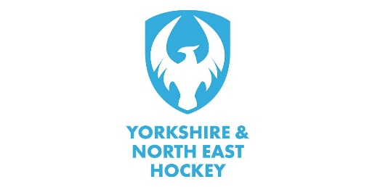
Interviews (if required) and commencement date to be confirmed after closing date for applications.

