

ENGLAND HOCKEY AREA MASTERS TOURNAMENT
Men’s O35

25th/26th April 2026
Hosted by


at

Nottingham Hockey Centre

Welcome from Midlands Hockey to the England Hockey MO35 Area Tournament for 2026. We are delighted along with Nottingham Hockey Centre to be hosting this event and look forward to a weekend of great Master’s Hockey and hopefully the renewing and forging of friendships off the pitch.

We would like to thank Andy Barnes for leading the organisation of the events and all the volunteers who have contributed to organisation of the weekend. Midlands Officiating Committee members and the Tournament Director Jo Barnes. All Officials and their support have been appointed by Midlands Area Officiating. In addition, our thanks to members of Nottingham Hockey Centre Sports Club, for their support and enthusiasm in hosting this event.

We hope you all have a great weekend.

Tim Lorimer Chair of Midlands Hockey

A Warm Welcome from David Griffiths, Chairman of Nottingham Hockey Centre
Welcome to the England Hockey Area Masters Tournament 2026 at Nottingham Hockey Centre. We are delighted to host players, officials and supporters for what promises to be a fantastic celebration of Masters hockey.

Nottingham Hockey Centre is proud to be one of the UK’s leading hockey venues, and we hope you enjoy both the high-quality facilities and the friendly, welcoming atmosphere throughout the tournament. We trust you’ll have a great experience on the pitch and also take the opportunity to enjoy your time here in Nottingham.

During the event, our ground floor cafeteria and the Stick & Pitcher bar upstairs will be open, offering a wide selection of hot and cold food, drinks, cask ales, lagers, ciders and wines. Our Griff Coffee Kiosk will also be serving freshly brewed coffee and snacks to keep you energised throughout the day. If the weather is kind, don’t forget to visit the fully stocked ice cream freezer in the cafeteria or the kiosk out on the patio for a well-earned treat.

On behalf of the entire Nottingham Hockey Centre team, we wish everyone taking part a very enjoyable and successful England Hockey Area Masters Tournament 2026. Good luck to all teams, and we hope you have a memorable weekend of hockey with us.

David Griffiths

Tournament Officials

Tournament Director Tom Roberts

Umpire Manager’s Richard Kirk
Colin Jones

Umpire Coaches:
Rob Crosson, Bill Holdforth, Craig Langton, Colin Reed and Josh Robinson

Umpires:
Ian Austin, James Barnes, Ian Bradley, Mckenzie Brailsford, David Halkyard, Jason Horne, James Middleton, James Pennington, Richard Perry and Charlotte Royal

Technical Officials:
Angela Buckley, Lesley Evans and Amo Soar

Tournament Organiser Andy Barnes on behalf of Midlands Hockey

FIXTURES

Saturday
Time | Pitch 1 | Pitch 2
11:00 | North West v Midlands | Yorkshire NE v West
12:00 | London v South East | Morth West v East
13.00 | Midlands v Yorkshire NE | West v South East
14.00 | London v East | North West v Yorkshire NE
15.00 | London v West | Midlands v South East
16.00 | North West v South East | East v West
17.00 | Midlands v East | Yorkshire NE v London

Fixtures

Sunday

Time | Pitch 1 | Pitch 2
10:00 | London v North West | East v South East
11:00 | Yorkshire NE v South East | London v Midlands
12:00 | Yorkshire NE v East
13:00 | PRESENTATION
 | Pitch 4
10:00 | West v Midlands
11:00 | West v North West

 | EAST
1 | Thomas |  | Franks GK
2 | Ali |  | Charlton
3 | Dylan |  | Parker
4 | Harry |  | Andrews
5 | James |  | O’Keeffe
6 | Frankie |  | Bell
7 | Grant |  | Ward ©
8 | Rob |  | Turner
9 | Andrew |  | McArthur
10 | Verinder |  | Channa
11 | Chris |  | Wardale
12 | Grant |  | Gilmour
13 | David |  | Guy
14 | Jack |  | Wheaton
15 | Richard |  | Hesketh
16 | Steve |  | George
17 | Jack |  | Barlow
18 | Dan |  | Brown GK
Manager | Dan Brown/Thomas Franks
Coach | Grant Gilmour
KIT (H) | Shirt | Short |  | Socks
KIT (A) |  | Short

 | MIDLANDS
0 | Kiran Singh |  | Kular (GK)
1 | Chris |  | Burton (GK)
4 | Calum |  | Slaney
5 | Tom |  | Higginson
6 | James |  | Ewing (C)
7 | Yuvender |  | Prashar
8 | Jake |  | Vincent
9 | Jack |  | Sykes-wood
10 | Adam |  | Foster
13 | Michael |  | Birch
16 | James |  | Gough
17 | Will |  | Walker
19 | Aaron |  | Cambden
20 | Sam |  | Mitchell
21 | Kabir |  | Bowry
24 | John |  | Proctor
35 | Warrick |  | Laverick
99 | Jake |  | Foster
Manager | James Ewing
Coach
KIT (H) | Shirt | Short |  | Socks
KIT(A) | Shirt | Short |  | Socks

 | LONDON
1 | Graeme |  | Morrison GK
2 | Joe |  | Trickett GK
3 | Doug |  | Corbishley
6 | Rob |  | Gopinath
7 | Chris |  | Popplewell
8 | Jonathan |  | Palmer
9 | Jared |  | Oliver
10 | Dom |  | Oliver
11 | Chris |  | Tipple
12 | Luke |  | Tucker
13 | David |  | McLean
14 | Graeme |  | Larkin
15 | Sam |  | Kirk
16 | Mike |  | McLean ©
17 | Matt |  | Mabin
18 | Aswin |  | Nair
19 | Andrew |  | Wilkie
20 | Manu |  | Sidhu
Manager | Charlie Ferguson/Mike McLean
Coach
KIT (H) | Shirt | Short |  | Socks
KIT (A) | Shirt | Short |  | Socks

 | NORTH WEST
Manager
Coach
KIT (H) | Shirt | Short |  | Socks
KIT (A) | Shirt | Short |  | Socks

 | SOUTH EAST
3 | Chris |  | Smith
4 | Sean |  | Pearcy
5 | Oliver |  | Spiers
6 | Tom |  | Henton ©
8 | Ben |  | Hawkins
9 | Ian |  | Harvey
21
24 | James |  | Elkin
44 | Richard |  | Turner (VC)
53 | Mark |  | Forshaw
105 | Bono |  | Vincent (VC)
117 | Terry |  | Skeet
147 | Ashley |  | Jugnarain (GK)
186 | Ross |  | Donaldson
187 | Tom |  | Nixon
190 | David |  | Roche (GK)
196 | Matt |  | Goodwin
204 | Lewis |  | Elgar
Manager | Matt Sharpe
Coach | Adam Nordone
KIT (H) | Shirt | Short |  | Socks
KIT (A) | Shirt | Short |  | Socks

 | WEST
GK | Tristan |  | Andrews
GK | Ed |  | Johnson
2 | Scott |  | Davidson
4 | Mark |  | Symons
5 | Tom |  | Tridgell
6 | Martin |  | Johnson
7 | Tom |  | Gogarty
8 | Scott |  | Voisey
9 | Tom |  | Fox
10 | Rich |  | Edwards ©
12 | Grant |  | Skinner
14 | Lewis |  | Duchezeau
15 | Chris |  | Fasey
16 | Ben |  | Creedy
17 | Ross |  | Hardwick
19 | Tom |  | O’Boyle
20 | Tom |  | Blewett
21 | Adam |  | Tatlow
Manager | Martin Jenkins
Coach | Rob Stevens
KIT (H) | Shirt | Short |  | Socks
KIT (A) | Shirt | Short

 | YORKSHIRE & NORTH EAST
GK | Mike |  | Gillingham
GK | Simon |  | Hibbert
2 | Luke |  | Staveley
3 | David |  | McCollum
4 | Callum |  | Franks
5 | Simon |  | Moriarty
7 | Jacob |  | Till
8 | Sam |  | Shute
9 | Jesmeet |  | Notay
10 | Anthony |  | Allison
11 | Jon |  | Woodhouse ©
12 | Alex |  | Owen
13 | Hans |  | Cowx
14 | Viv |  | Balachandar
15 | James |  | Dean
16 | Scott |  | Kennedy
17 | McCrossan |  | Craig
18 | Jack |  | Burn-de-Vries
Manager | Paul Hatton
Coach | Ally Allison
KIT (H) | Shirt | Short |  | Socks
KIT (A)

Site Plan

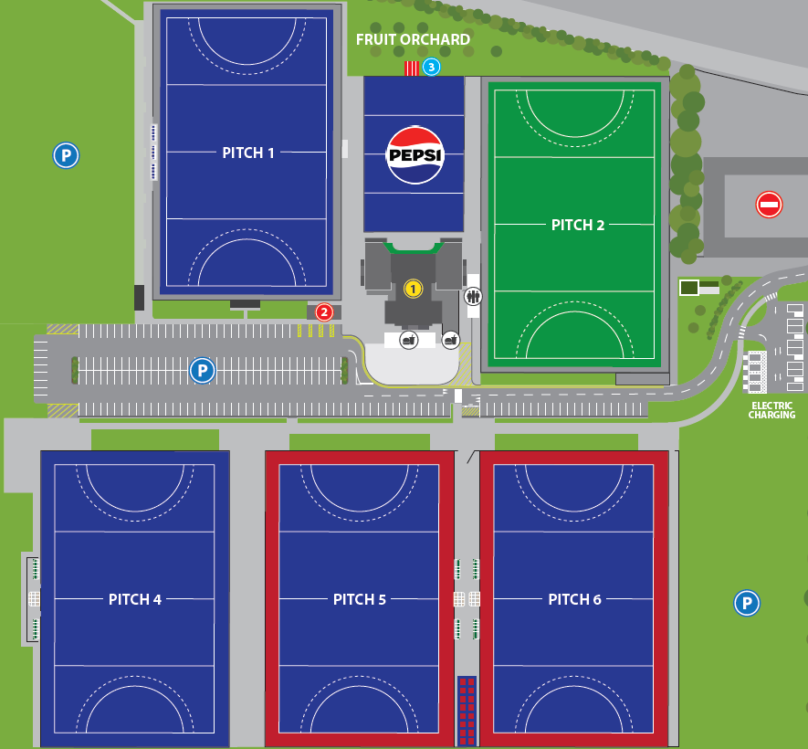

Clubhouse is 1

The parking next to pitch 6 is unlikely to be open
 | NORTH WEST/YORKSHIRE & NORTH EAST
1 | Sue Catton |  | Phoenix
2 | Helen Evans |  | Bromley & Beckenham
3 | Rosie Field |  | No club
4 | Gail Gerrard |  | Spen Valley
5 | Philippa Glassford |  | Ben Rhydding
6 | Sharon Holford |  | Wilmslow
7 | Deb Hurst |  | Bowden
8 | Bev Jackson |  | Crewe Vagrants
9 | Di Kirby |  | Hull
10 | Caz Kirkland |  | Bowden
11 | Helen Lightburn |  | Epworth
12 | Liz McVey |  | Phoenix
13 | Helen Royan |  | Wakefield
14 | Marian Simpson (Cpt) |  | Morpeth
15 | Alison Taylor |  | Skipton
GK | Eleanor Townend |  | Colne Valley
Coach
Manager | Chris Davies
KIT (H) | Shirt | Skort |  | Socks

