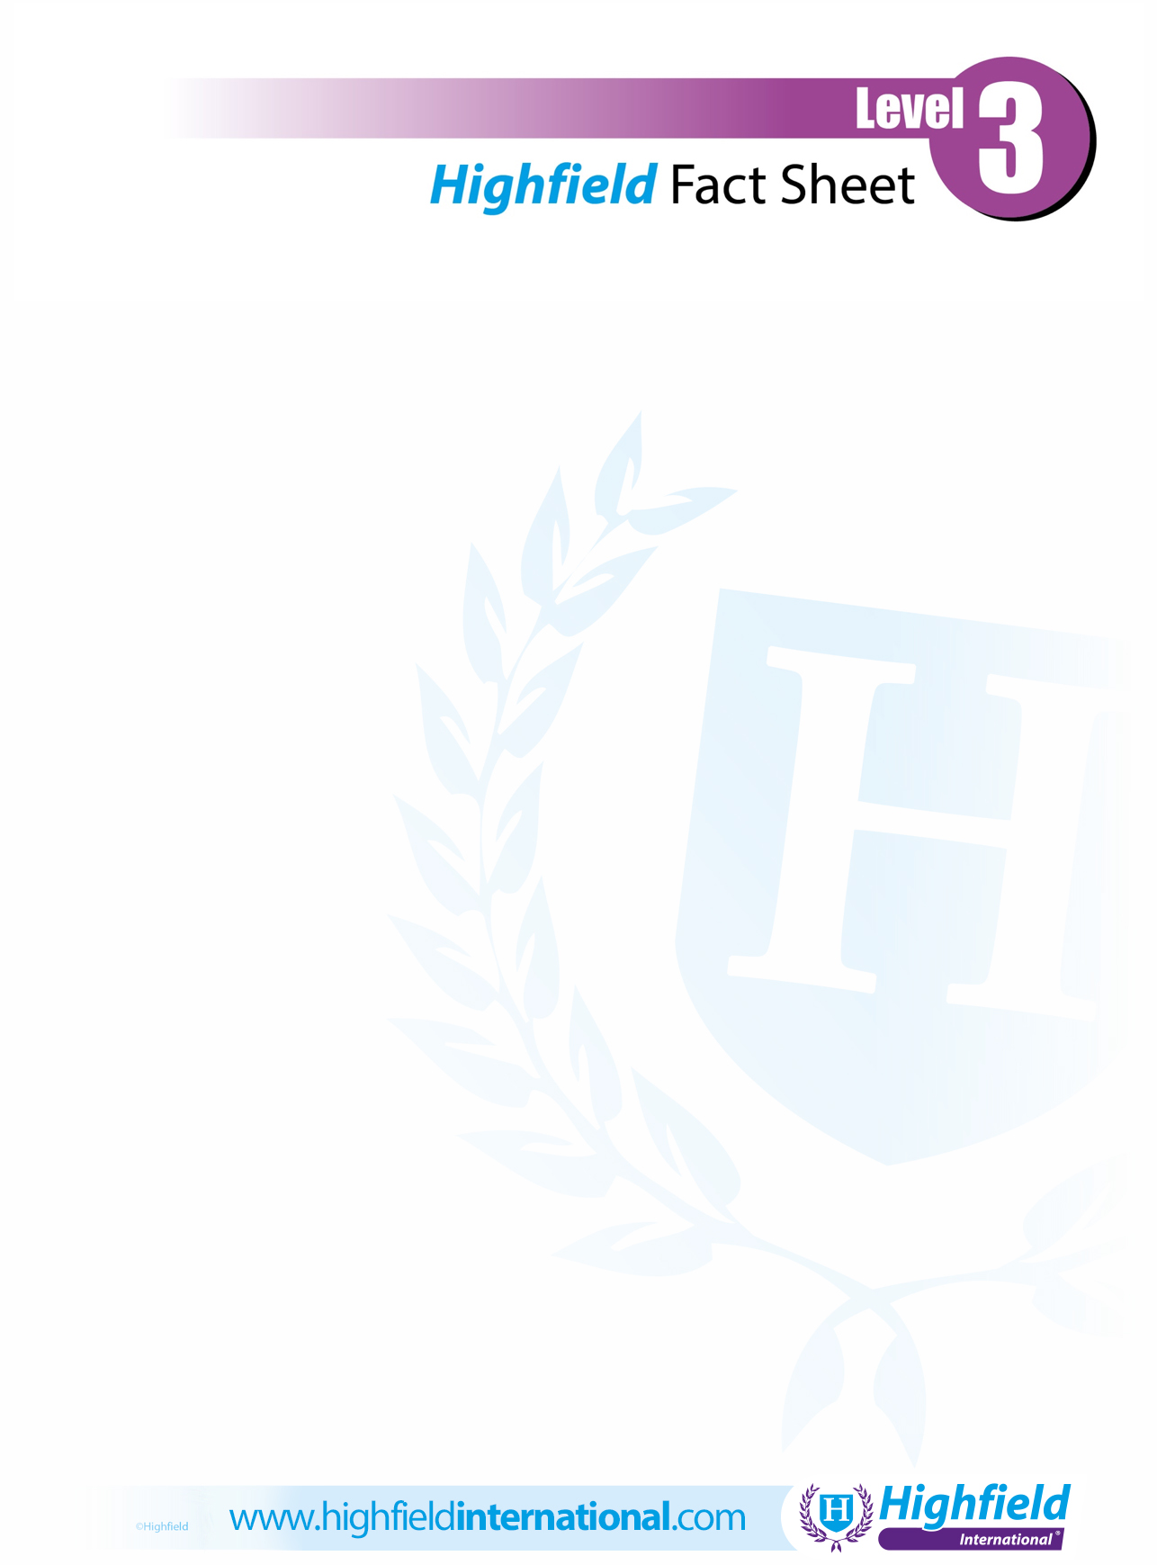

You can use this space to add your logo/contact details. If you prefer to leave the space blank, please delete this text prior to printing.
Security
Highfield Level 3 International Certificate in Close Protection

The Highfield Level 3 International Certificate in Close Protection is a qualification developed by Highfield, the Middle East’s leading supplier of compliance-based qualifications. The qualification has been designed with sector experts specifically for international learners who wish to become close protection operatives. It has taken into account recognised best-practice principles of close protection. The qualification provides an excellent basis for international learners who may wish to undertake further security qualifications.

How long will it take me to achieve this qualification?
This qualification is usually achieved by completing approximately 138 hours of learning.

How is the qualification assessed?
This qualification is assessed in two parts:
Part 1: Assessed by a multiple-choice examination of 60 questions and a duration of 2 hours.

Part 2: Assessed through completing of a portfolio of evidence by learners.

What next?
Individuals achieving this qualification can progress onto the following:
Highfield Level 2 International Award in CCTV Operations (Public Space Surveillance)
Highfield Level 3 International Certificate in Security Guarding

Where can this course be taken?
Through any Highfield approved training centre.

