Public transport guide HERUG congress
Monday the 23rd of March 2026
Route VU Royal Palace Dam square (Paleis op de Dam)
Address: Nieuwezijds Voorburgwal 147, 1012RJ

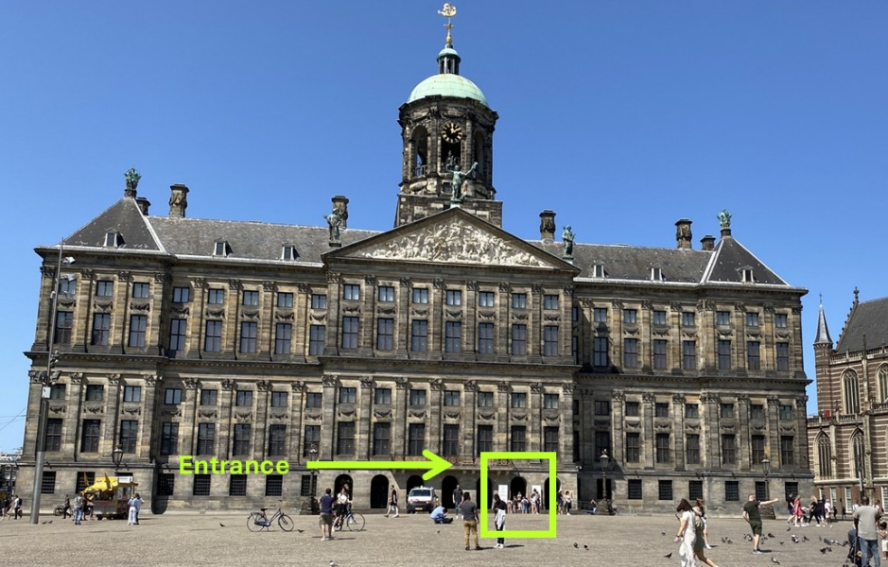
Scheduled arrival: 14:00

Starting point from VU:
NU building VU, Boelelaan 1111. Exit the building next to Bar Boele.
Metro 52 (30 min travel – departs every 6 min)

- 13:17 – Walk 15 min (1.1km) to the metro station Zuid
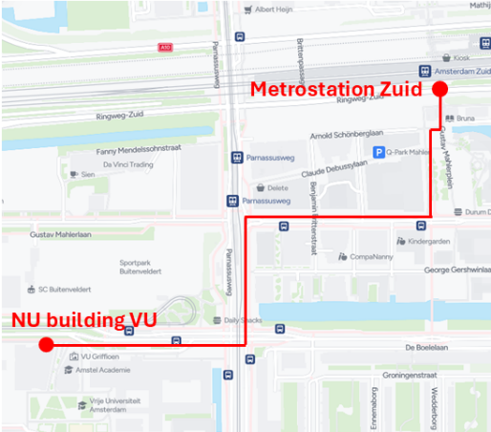
Walking directions:
Exit the NU building next to bar Boele.
Turn right, then turn left at the large intersection.
Turn right onto the second street (Gustav Mahlerlaan) and continue walking along the street until you reach a square on your left (Gustav Mahlerplein).
Walk along the square to reach the metro entrance.
When entering the station, Metro 52 is on your right.
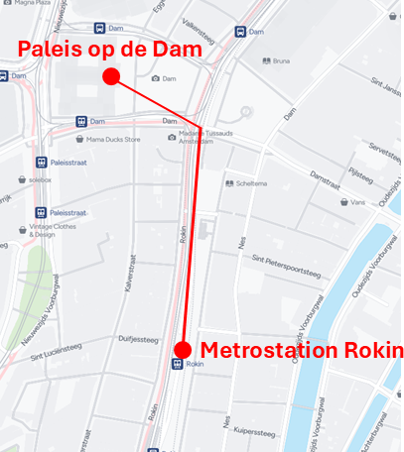
- 13:37– Take Metro 52 (blue Line)
Direction: Noord
Ride 3 stops
- 13:45 – Exit at Rokin
In the station follow the exit sign towards Dam.
- Walk 8 min (555m) to Dam Square
Walking directions:
Exit the station at Dam exit.
Follow the street straight ahead.
At the large intersection you will see the Royal Palace on Dam Square on your left.

RETURN: Royal Palace VU
Address: Boelelaan 1111A
Scheduled arrival: 16:30

Metro 52 (31 min travel – departs every 6 min)

- 15:53 – Walk 8 min (620m) to the metro station Rokin
- 16:08 – Take Metro 52 (blue line)
Direction: Zuid
Ride 3 stops
- 16:16 – Exit at Zuid
- Walk 15 min (1km) to the NU building VU

