Public transport guide HERUG congress
Wednesday the 25th of March 2026

Note: you can pay for Dutch public transport (bus/metro/tram) with your bank card. Please check-in AND check-out when exiting.

Route VU Restaurant de Waag
Address: Nieuwmarkt 4, 1012 CR Amsterdam

Scheduled arrival: 18:45-19:00
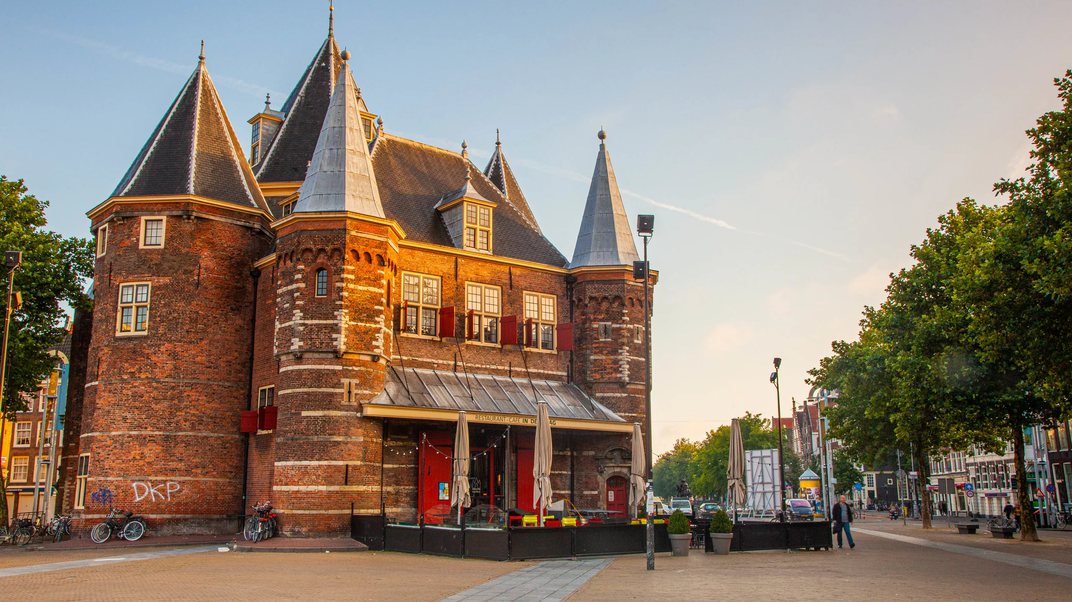

Starting point from VU:
NU building VU, Boelelaan 1111. Exit the building next to Bar Boele.
Metro 51 (32 min travel – departs every 10 min)

- 18:11 – Walk 15 min (1.1km) to the metro station Zuid
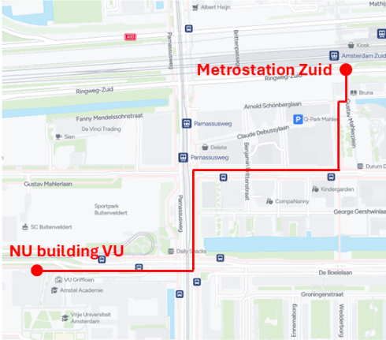
Walking directions:
Exit the NU building next to bar Boele.
Turn right, then turn left at the large intersection.
Take the first right and walk along the street until you reach a square on your left (Gustav Mahlerplein).
Walk along the square to reach the metro entrance.
When entering the station, Metro 51 is on your right.
- 18:31 – Take Metro 51 (orange Line)
Direction: Centraal Station
Ride 7 stops
- 18:46 – Exit at Nieuwmarkt
Exit the station by following the signs for Nieuwmarkt. You will arrive at a square (with a market) where the restaurant should be visible.
- Walk 2 min (139m) to Restaurant de Waag

