Public transport guide HERUG congress
Tuesday the 24th of March 2026

Note: you can pay for Dutch public transport (bus/metro/tram) with your bank card. Please check-in AND check-out when exiting.

Route VU Boat dock Olympic stadium
Address: Olympisch Stadion 2, 1076 DE Amsterdam

Scheduled arrival: 17:30
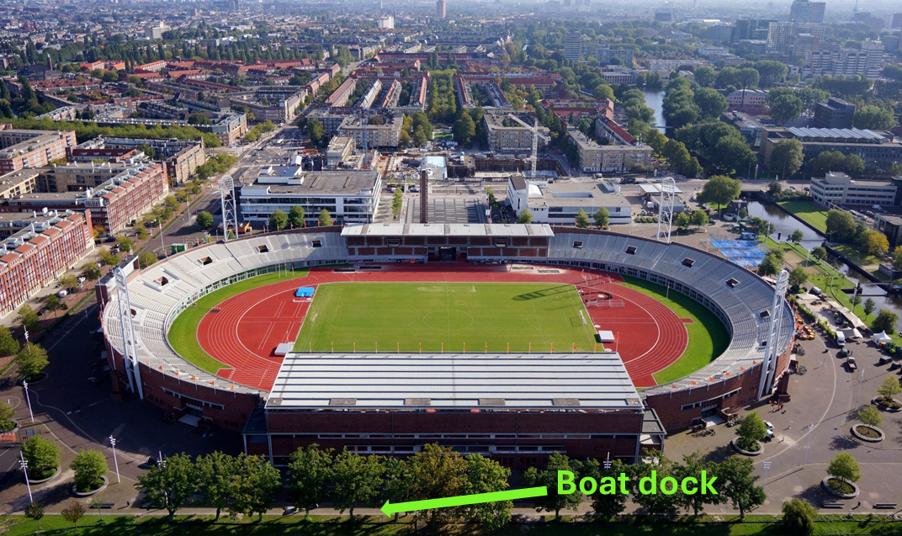

Starting point from VU:
NU building VU, Boelelaan 1111. Exit the building next to Bar Boele. The boat dock is located behind the Olympic Stadium (see image above). You can reach it on foot or by public transport.

Walking (~25 min travel)

- 17:00 – Exit the NU building next to Bar Boele
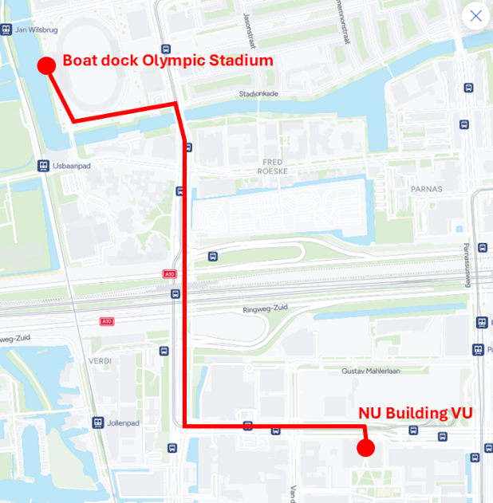
Turn left and go straight at the intersection.
At the T-junction, turn right.
Continue following this road and turn left after crossing the bridge.
Walk along the canal; the Olympic Stadium will appear on your right.
Walk around the stadium; the boat dock is located behind the stadium.
- 17:30 – Arrival boat dock

Tram 14 (16 min travel – departs every 10 min)

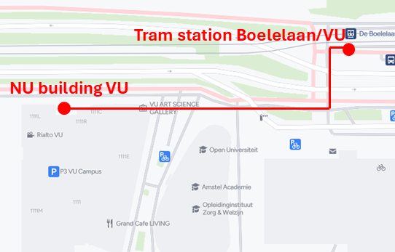
- 17:07 – Walk 2 min (137m) to tram stop De Boelelaan/VU
Walking directions:
Exit the NU building next to bar Boele.
The tram stop is across the street on the right.
- 17:12 – Take Tram 14
Direction: Centraal Station (via Artis)
Ride 3 stops
- 17:18 – Exit at Olympisch Stadion
- Walk 8 min (600m); when you exit the tram you are in front of the Olympic Stadium, the boat dock is located behind the stadium (see image above).

Note: There is no return route to the VU. You will be dropped off near Vondelpark (address: 1071 AA Amsterdam).

