Public transport guide HERUG congress
Monday the 23rd of March 2026

Note: You can pay for Dutch public transport (bus/metro/tram) with your bank card. Please check-in AND check-out when exiting.

Route VU Heineken Experience
Address: Stadhouderskade 78, 1072 AE, Amsterdam

Scheduled arrival: 13:45 (Please arrive before 14:00)
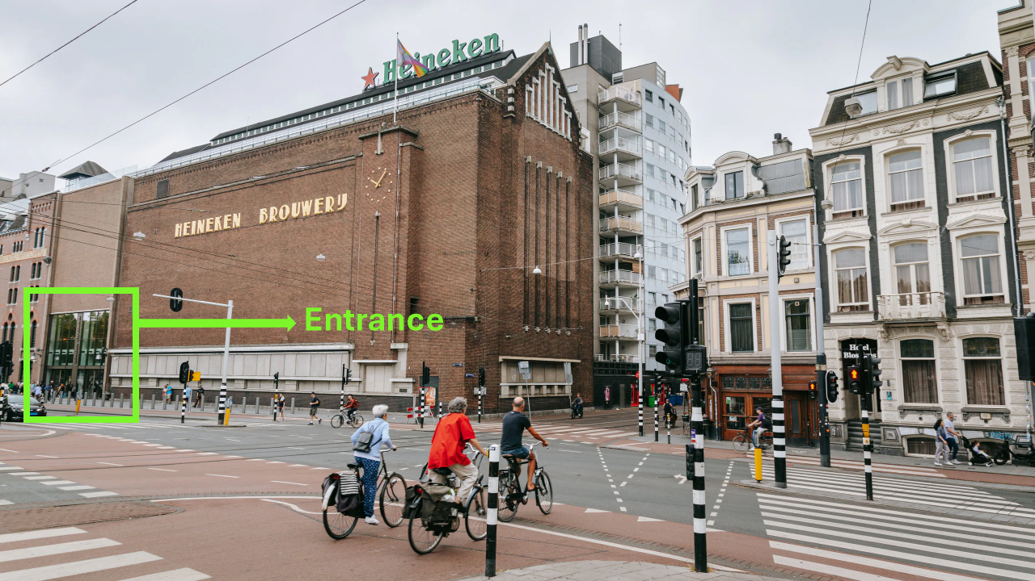

Starting point VU:
NU building VU, Boelelaan 1111. Exit the building next to Bar Boele. There are two options to reach the Heineken Experience: Tram 14 (less walking) or Metro 52.

Tram 14 (24 min travel – departs every 10 min) Less walking

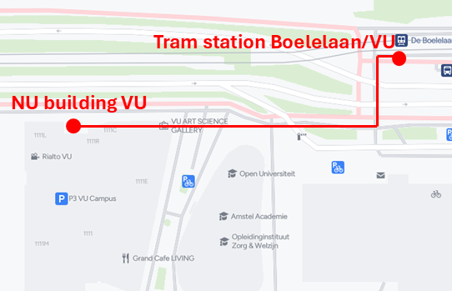
- 13:17 – Walk 2 min (137m) to the tram stop
De Boelelaan/VU
Walking directions:
Exit the NU building next to bar Boele.
The tram stop is across the street on the right.
- 13:22 – Take Tram 14
Direction: Centraal Station (via Artis)
Ride 11 stops
- 13:42 – Exit at Marie Heinekenplein
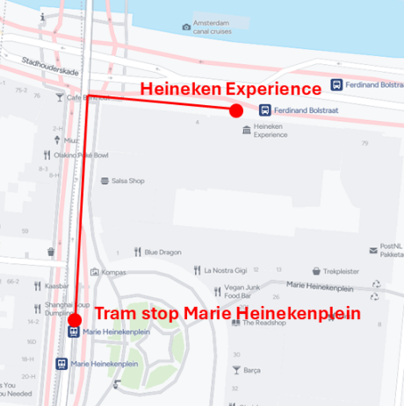
- Walk 2 min to the Heineken Experience
Walking directions:
When you exit the tram, a square will be on your right.
Walk straight up the street.
At the traffic lights, turn right.
The Heineken Experience will be on your right-hand side (entrance see image above).

Metro 52 (26 min travel – departs every 6 min)

- 13:11 – Walk 15 min (1.1km) to the metro station Zuid
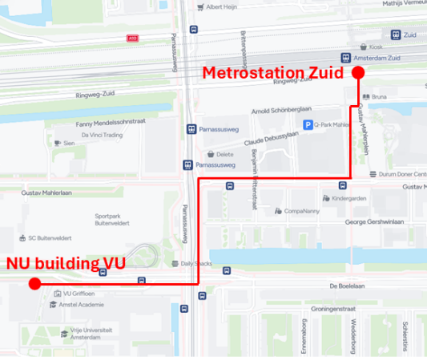
Walking directions:
Exit the NU building next to bar Boele.
Turn right, then turn left at the large intersection.
Turn right onto the second street (Gustav Mahlerlaan) and continue walking along the street until you reach a square on your left (Gustav Mahlerplein).
Walk along the square to reach the metro entrance.
When entering the station, Metro 52 is on your right.
- 13:31 – Take Metro 52 (blue Line)
Direction: Noord
Ride 2 stops
- 13:37 – Exit at Vijzelgracht
Within the station, follow the exit signs towards Weteringcircuit/Weteringschans
- Walk 5 min (311m) to the Heineken Experience
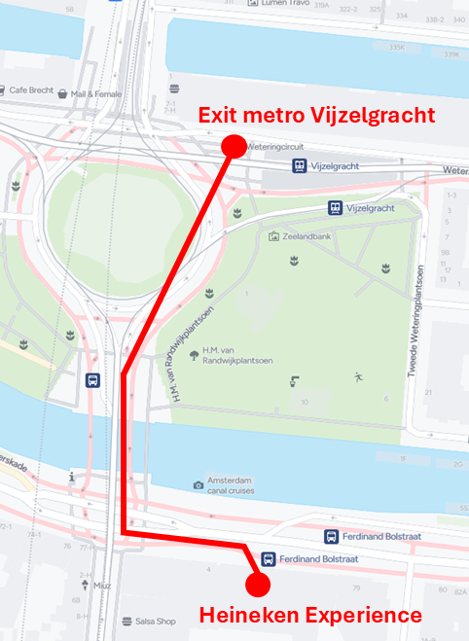
Walking directions:
Exit the station at Weteringsschans/Weteringcircuit, walk across the roundabout and over the bridge.
The Heineken Experience will be on the right side after crossing the bridge.
The entrance is at the front of the building (see image above)

RETURN: Heineken Experience VU
Address: Boelelaan 1111A

Scheduled arrival: 16:30

Tram 14 (26 min travel – departs every 10 min)

- 15:56 – Walk 2 min (202m) to the tram stop Marie Heinekenplein
- 16:06 – Take Tram 14
Direction: Vu medisch centrum via Artis
Ride 11 stops
- 16:28 – Exit at De Boelelaan/VU
- Walk 2 min (153m) to the NU building VU

Metro 52 (26 min travel – departs every 6 min)

- 15:49– Walk 5 min (340m) to the metro station Vijzelgracht
- 16:04 – Take Metro 52 (blue line)
Direction: Zuid
Ride 2 stops
- 16:10 – Exit at Zuid
- Walk 15 min (1km) to the NU building VU

